Each time log in Step by Step to code:

1. Start env

cd C:\Users\angel\OneDrive\Desktop\Python Django\env\Scripts

activate

1. Display the packages install in the env

pip freeze

1. Run server to start coding

cd C:\Users\angel\OneDrive\Desktop\Python Django\env\Scripts

activate

cd C:\Users\angel\OneDrive\Desktop\Python Django

python manage.py runserver

http://127.0.0.1:8000/

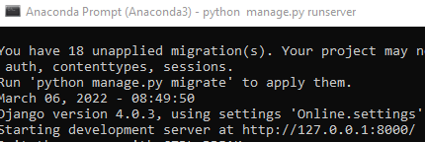

<https://github.com/dev-rathankumar/greatkart-course>

python manage.py makemigrations

python manage.py migrate

online django business account

[onlinedjango@gamil.com](mailto:onlinedjango@gamil.com)

!q2w3e4R

Website development Step by Step:

1. Find out the path name of the web development folder

cd C:\Users\angel\OneDrive\Desktop\Python Django

1. Installing virtualenv

py –m pip install –-user virtualenv

1. Creating a virtual environment folder

py –m venv env

1. Pointing to the activate the env folder

cd C:\Users\angel\OneDrive\Desktop\Python Django\env\Scripts

activate

1. Install Django package

pip install django

1. Display the packages install in the env

pip freeze

1. create project folder

cd C:\Users\angel\OneDrive\Desktop\Python Django

django-admin startproject Online .

1. Python start web site server

python manage.py runserver

http://127.0.0.1:8000/

1. Create a views.py in the online folder together with urls.py
2. Web Testing thru HTTP Response

urls.py

from django.contrib import admin

from django.urls import path

from . import views

urlpatterns = [

path('admin/', admin.site.urls),

path('',views.home, name='home'),

]

Views.py

from django.http import HttpResponse

def home(request):

return HttpResponse('homepage')

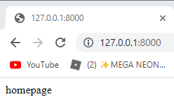

1. Create templates folder in the project folder
2. Create home.html in the templates folder

<h2>This is templates</h2>

1. Add templates folder name in the setting.py file in the project folder

TEMPLATES = [

{

'BACKEND': 'django.template.backends.django.DjangoTemplates',

'DIRS': ['templates'],

1. Adjust the view filer from HttpResponse to Render

#from django.http import HttpResponse

from django.shortcuts import render

def home(request):

#return HttpResponse('homepage')

return render(request, 'home.html')

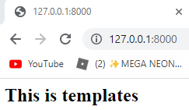

1. Copy and paste the index.html codes into home.html in the templates folder

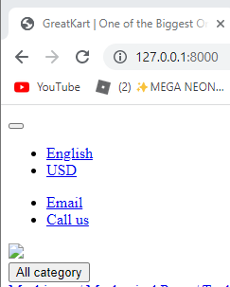

1. Create static folder in the Online folder and copy and paste the 4 folders into the static folder

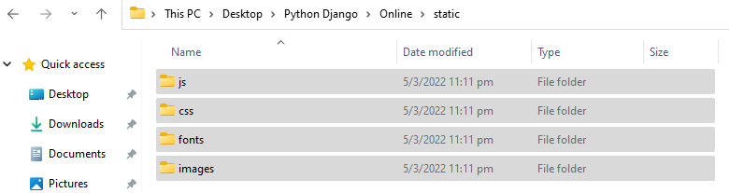

1. Adjust settings/py to prepare the linkage with pictures with the website from images folder

STATIC_URL = '/static/'

STATIC_ROOT = BASE_DIR /'static'

STATICFILES_DIRS =[

'online/static',

]

1. Change website logo with codes adjustment on home.html

Insert 1 sentence in the 1st line in home.html

{% load static %}

<!DOCTYPE HTML>

<html lang="en">

Replace old code with new codes

<link href="images/favicon.ico" rel="shortcut icon" type="image/x-icon">

<link href= {% static 'images/favicon.ico'%} rel="shortcut icon" type="image/x-icon">

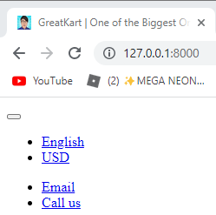

1. Repeat the replacement process on js, css png, jpg

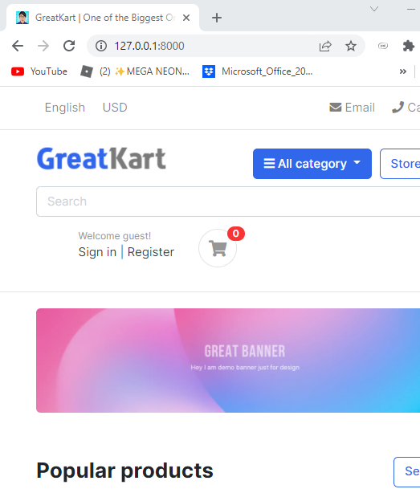

1. Create base.html in the templates folder
2. Copy the 1st line to </header> <!-- section-header.// --> from home.html to base.html
3. Add lines in base.html

1st line

{% load static %}

<!DOCTYPE HTML>

Last few lines

</header> <!-- section-header.// -->

{% block contents %}

<!-- content -->

{% endblock %}

1. Add lines in the homt.html

1st 3 lines

{% extends 'base.html' %}

{% load static %}}

{% block contents %}

<!-- ========================= SECTION MAIN ========================= -->

<section class="section-intro padding-y-sm">

Last 1 line

</html>

{% endblock %}

1. Create includes folder in the templates folder
2. Create footer.html & navbar.html in the includes folder
3. Copy the footer codes from home.html to footer.html

<!-- ========================= FOOTER ========================= -->

<footer class="section-footer border-top">

<div class="container">

<section class="footer-bottom border-top row">

<div class="col-md-2">

<p class="text-muted"> &copy 2019 Company name </p>

</div>

<div class="col-md-8 text-md-center">

<span class="px-2">info@pixsellz.io</span>

<span class="px-2">+879-332-9375</span>

<span class="px-2">Street name 123, Avanue abc</span>

</div>

<div class="col-md-2 text-md-right text-muted">

<i class="fab fa-lg fa-cc-visa"></i>

<i class="fab fa-lg fa-cc-paypal"></i>

<i class="fab fa-lg fa-cc-mastercard"></i>

</div>

</section>

</div><!-- //container -->

</footer>

<!-- ========================= FOOTER END // ========================= -->

1. Copy header sets of codes from base.html to navbar.html
2. Add lines in the base.html at bottom of the codes

<body>

<!-- navbar -->

{% include 'includes/navbar.html' %}

{% block contents %}

<!-- content -->

{% endblock %}

<!-- footer -->

{% include 'includes/footer.html' %}

1. Add 1 line at navbar.html

{% load static %}

1. Add 1 line in the foorer.html

{% load static %}

1. Create an category folder in the online folder

python manage.py startapp category

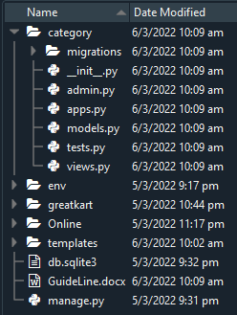

1. Register the category folder in the settings.py under online folder

INSTALLED_APPS = [

'django.contrib.admin',

'django.contrib.auth',

'django.contrib.contenttypes',

'django.contrib.sessions',

'django.contrib.messages',

'django.contrib.staticfiles',

'category',

]

1. Create Models and Admin code for migration preparation

models.py

from django.db import models

# Create your models here.

class Category(models.Model):

category_name = models.CharField(max_length=50, unique = True)

slug = models.CharField(max_length=100, unique=True)

descprtion = models.TextField(max_length=255, blank=True)

cat_image = models.ImageField(upload_to='photos/categories', blank=True)

def __str__(self):

return self.category_name

admin.py

from django.contrib import admin

from .models import Category

# Register your models here.

admin.site.register(Category)

1. Install pillow package to use ImageField (Cannot use ImageField because Pillow is not installed.)

Pip install pillow

1. Type command in the Anaconda Prompt (Anaconda3) to create migrations folder

python manage.py makemigrations



1. Python run the migrate files 0001_initial.py

python manage.py migrate

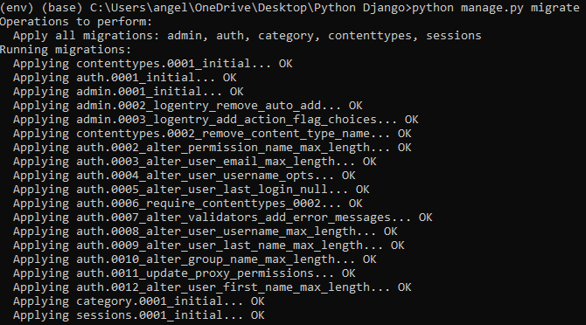

1. Create a super user

python manage.py createsuperuser

1. Create ID and Password for super user

Username: djangoadmin

Email: huangkai8652@gamil.com

Password: !q2w3e4R

Password: !q2w3e4R

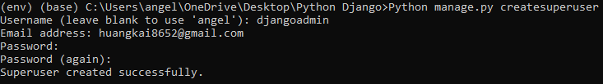

Django Admin Page (Logged In)

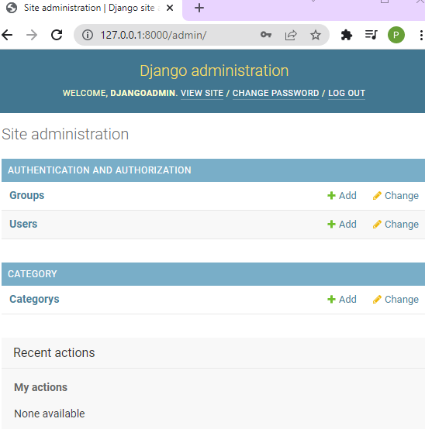

1. Edit the Categorys as above picture

Add lines in the models.py

cat_image = models.ImageField(upload_to='photos/categories', blank=True)

class Meta:

verbose_name = 'Category'

verbose_name_plural = 'Categories'

def __str__(self):

1. Run migration command again

python manage.py makemigrations

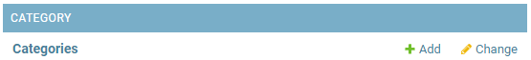

1. Create account folder for email log in

python manage.py startapp accounts

1. Create linkage with settings.py in the online folder

INSTALLED_APPS = [

'django.contrib.admin',

'django.contrib.auth',

'django.contrib.contenttypes',

'django.contrib.sessions',

'django.contrib.messages',

'django.contrib.staticfiles',

'category',

'accounts',

]

1. Add lines of code in the models.py in the accounts folder

from django.db import models

from django.contrib.auth.models import AbstractBaseUser, BaseUserManager

# Create your models here.

class MyAccountManager(BaseUserManager):

def create_user(self, first_name, last_name, username, email, password=None):

if not email:

raise ValueError('User must have an email address')

if not username:

raise ValueError('User must have an username')

user = self.model(

email = self.normalize_email(email),

username = username,

first_name = first_name,

last_name = last_name,

)

user.set_password(password)

user.save(using=self._db)

return user

def create_superuser(self, first_name, last_name, email, username, password):

user = self.create_user(

email = self.normalize_email(email),

username = username,

password = password,

first_name = first_name,

last_name = last_name,

)

user.is_admin = True

user.is_active = True

user.is_staff = True

user.is_superadmin = True

user.save(using=self._db)

return user

class Account(AbstractBaseUser):

first_name = models.CharField(max_length=50)

last_name = models.CharField(max_length=50)

username = models.CharField(max_length=50, unique=True)

email = models.EmailField(max_length=100, unique=True)

phone_number = models.CharField(max_length=50)

# required

date_joined = models.DateTimeField(auto_now_add=True)

last_login = models.DateTimeField(auto_now_add=True)

is_admin = models.BooleanField(default=False)

is_staff = models.BooleanField(default=False)

is_active = models.BooleanField(default=False)

is_superadmin = models.BooleanField(default=False)

USERNAME_FIELD = 'email'

REQUIRED_FIELDS = ['username', 'first_name', 'last_name']

objects = MyAccountManager()

def full_name(self):

return f'{self.first_name} {self.last_name}'

def __str__(self):

return self.email

def has_perm(self, perm, obj=None):

return self.is_admin

def has_module_perms(self, add_label):

return True

1. Add links in the settings.py file

WSGI_APPLICATION = 'Online.wsgi.application'

AUTH_USER_MODEL = 'accounts.Account'

# Database

1. Delete the database db.sqlite3 in the online folder

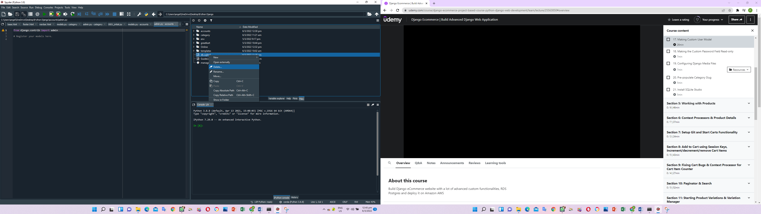

1. Add lines in the admin.py in the accoutns folder

from django.contrib import admin

from .models import Account

# Register your models here.

admin.site.register(Account)

1. Delete the 0001_initial.py & 0002_alter_category_options.py in the migrations folder.

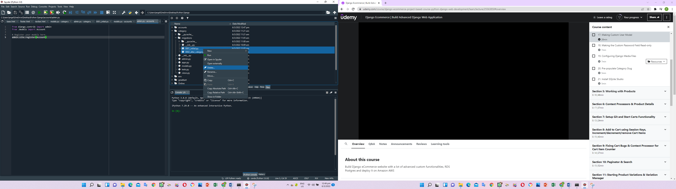

1. Create a db.sqlite3 in the online folder

python manage.py runserver

1. Migration folder again for the 0001_inital.py

python manage.py makemigrations



1. Migrate the folder

python manage.py migrate

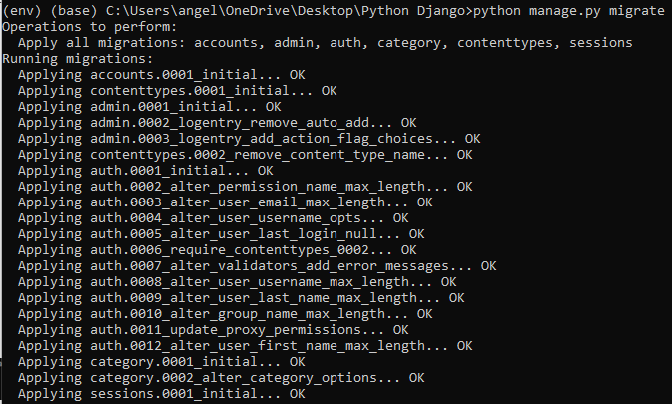

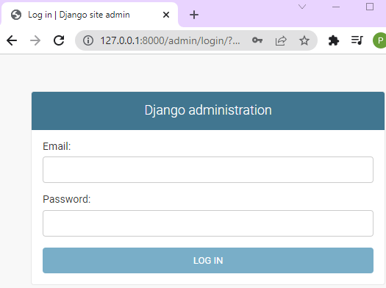

1. Create super user

Email: huangkai8652@gmail.com

Username: Poon

First name: Levin

Last name: huangkai

Password: !q2w3e4R

Password (again): !q2w3e4R

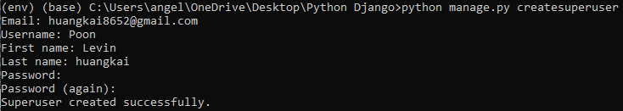

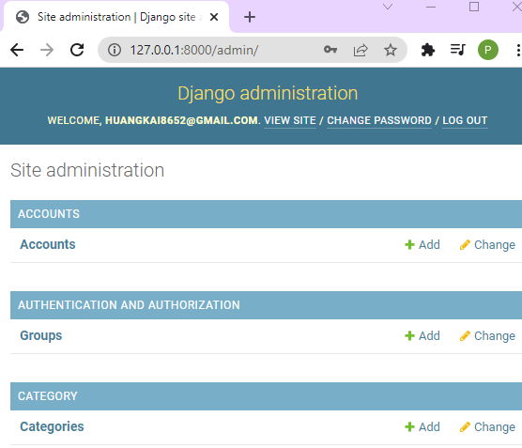

User able to log in thru email instead of username

1. Change password view to read only, create linkage between first name and last name to profile and seem last login timing

Add lines in admin.py under accounts

from django.contrib import admin

from django.contrib.auth.admin import UserAdmin

from .models import Account

# Register your models here.

class AccountAdmin(UserAdmin):

list_display = ('email', 'first_name', 'last_name', 'username', 'last_login', 'date_joined', 'is_active')

list_display_links = ('email', 'first_name', 'last_name')

readonly_fields = ('last_login', 'date_joined')

ordering = ('-date_joined',)

filter_horizontal = ()

list_filter = ()

fieldsets = ()

admin.site.register(Account, AccountAdmin)

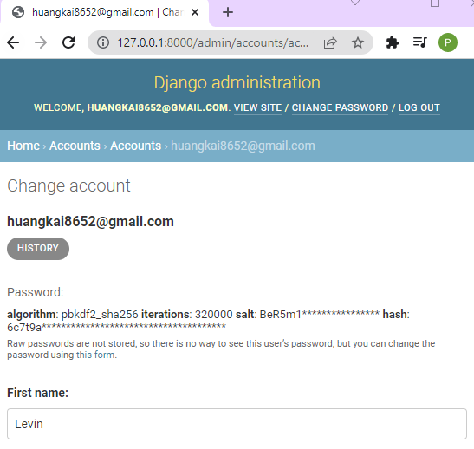

1. Add lines in the settings.py in the online folder (Configuring Media Files)

STATICFILES_DIRS =[

'online/static',

]

# media files configuration

MEDIA_URL = '/media/'

MEDIA_ROOT = BASE_DIR /'media'

1. Add lines in the urls.py in the online folder

from . import views

from django.conf.urls.static import static

from django.conf import settings

urlpatterns = [

path('admin/', admin.site.urls),

path('',views.home, name='home'),

] + static(settings.MEDIA_URL, document_root=settings.MEDIA_ROOT)

1. Save information on the django admin website under category

Category name: Shirts

Slug: shirts

Descriptions: This is the demo shirt category

Cat Image: shirts.jpg

1. Slug name will auto copy from Category name

slug = models.CharField(max_length=100, unique=True) change to =>

slug = models.SlugField(max_length=100, unique=True)

1. Once the model in the category completed, user have to make migrate and migrate in CMD

python manage.py makemigrations



python manage.py migrate

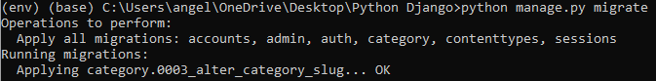

1. Add lines in the admin.py under the category folder

# Register your models here.

class CategoryAdmin(admin.ModelAdmin):

prepopulated_fields = {'slug':('category_name',)}

list_display = ('category_name','slug')

admin.site.register(Category,CategoryAdmin)

1. Add new item of t shirt and slug will auto populate

Category name: T shirt

Slug: t-shirt

Descriptions: This is the test description

Cat Image: tshirts.jpg

Add the rest 4 category into the Django admin

1. The database is in the db.sqlite3 and download sqlitestudio from Goggle to view in human readable format

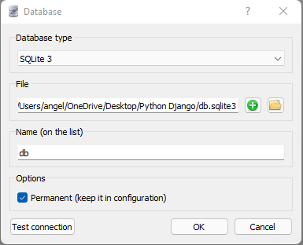

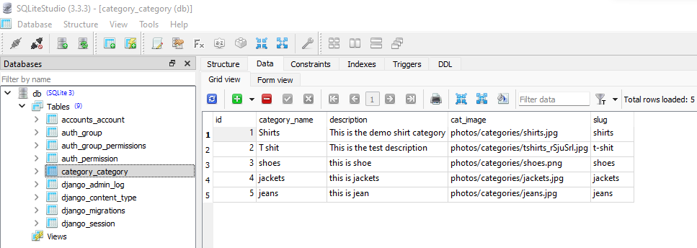

1. Crate store folder in the online folder

Python manage.py startapp store

1. Add store in the setting.py under online folder

'category',

'accounts',

'store',

]

1. Add line in models.py under store folder

from django.db import models

from category.models import Category

# Create your models here.

class Product(models.Model):

product_name = models.CharField(max_length=200, unique=True)

slug = models.SlugField(max_length=200, unique=True)

description = models.TextField(max_length=500, blank=True)

price = models.IntegerField()

images = models.ImageField(upload_to='photos/products')

stock = models.IntegerField()

is_available = models.BooleanField(default=True)

category = models.ForeignKey(Category, on_delete=models.CASCADE)

created_date = models.DateTimeField(auto_now_add=True)

modified_date = models.DateTimeField(auto_now=True)

def __str__(self):

return self.product_name

1. Add lines in the admin.py under the store folder

from django.contrib import admin

from .models import Product

# Register your models here.

class ProductAdmin(admin.ModelAdmin):

list__display = ('product_name','price','stock','category','modified_date','is_available')

prepopluated_fields = {'slug': ('product_name',)}

admin.site.register(Product, ProductAdmin)

python manage.py makemigrations

python manage.py migrate

User able to see product appear on the admin page

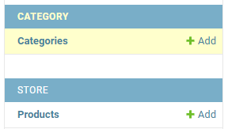

1. Add all products under each category

Product name:

Slug:

Description:

Price:

Images:

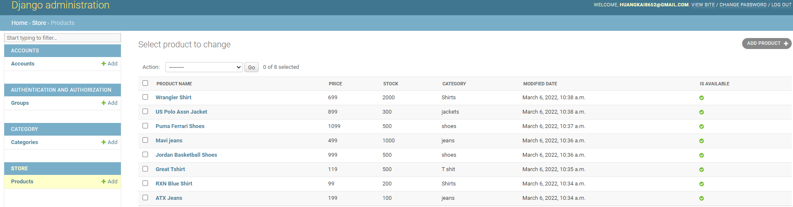

1. Add lines in the view.py in the online folder to display the products from database admin page

#from django.http import HttpResponse

from django.shortcuts import render

from store.models import Product

def home(request):

#return HttpResponse('homepage')

products = Product.objects.all().filter(is_available = True)

context = {

'products': products,

}

return render(request, 'home.html', context)

1. Delete the static image from 2 to 9 in the home.html from templates folder

{% static 'images/items/2.jpg' %} to {% static 'images/items/9.jpg' %}

<!-- ========================= SECTION ========================= -->

<section class="section-name padding-y-sm">

<div class="container">

<header class="section-heading">

<a href="./store.html" class="btn btn-outline-primary float-right">See all</a>

<h3 class="section-title">Popular products</h3>

</header><!-- sect-heading -->

<div class="row">

<div class="col-md-3">

<div class="card card-product-grid">

<a href="./product-detail.html" class="img-wrap"> <img src={% static 'images/items/1.jpg' %}> </a>

<figcaption class="info-wrap">

<a href="./product-detail.html" class="title">Just another product name</a>

<div class="price mt-1">$179.00</div> <!-- price-wrap.// -->

</figcaption>

</div>

</div> <!-- col.// -->

</div> <!-- row.// -->

</div><!-- container // -->

</section>

<!-- ========================= SECTION END// ========================= -->

1. Add for loop to display the 8 products (we have insert manually at step 65)

<div class="row">

{% for product in products %}

<div class="col-md-3">

<div class="card card-product-grid">

<a href="./product-detail.html" class="img-wrap"> <img src={% static 'images/items/1.jpg' %}> </a>

<figcaption class="info-wrap">

<a href="./product-detail.html" class="title">Just another product name</a>

<div class="price mt-1">$179.00</div> <!-- price-wrap.// -->

</figcaption>

</div>

</div> <!-- col.// -->

{% endfor %}

</div> <!-- row.// -->

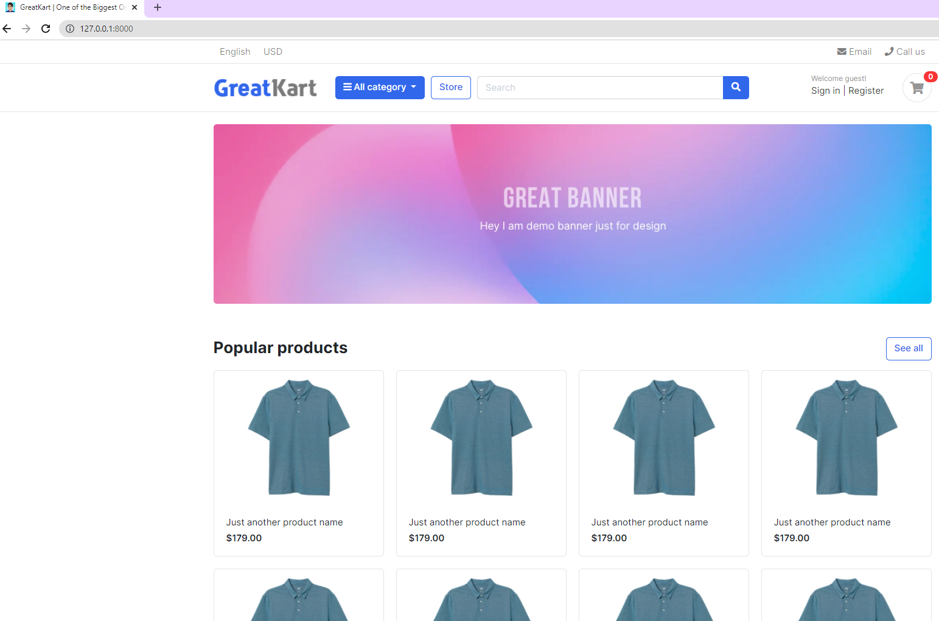

1. Adjust the link to display the correct images, price and product name

<div class="row">

{% for product in products %}

<div class="col-md-3">

<div class="card card-product-grid">

<a href="./product-detail.html" class="img-wrap"> <img src="{{ product.images.url }}"> </a>

<figcaption class="info-wrap">

<a href="./product-detail.html" class="title">{{product.product_name}}</a>

<div class="price mt-1">${{product.price}}</div> <!-- price-wrap.// -->

</figcaption>

</div>

</div> <!-- col.// -->

{% endfor %}

</div> <!-- row.// -->

</div><!-- container // -->

</section>

<!-- ========================= SECTION END// ========================= -->

1. Copy urls.py from online folder to store folder (making store button working)

from django.urls import path

from . import views

urlpatterns = [

path('', views.store, name='store'),

]

1. Add lines in urls.py in the online folder

from django.contrib import admin

from django.urls import path, include

from . import views

from django.conf.urls.static import static

from django.conf import settings

urlpatterns = [

path('admin/', admin.site.urls),

path('',views.home, name='home'),

path('store/', include('store.urls')),

] + static(settings.MEDIA_URL, document_root=settings.MEDIA_ROOT)

1. Add lines in views.py under store folder

from django.shortcuts import render

# Create your views here.

def store(request):

return render(request, 'store/store.html')

1. Chang the link at home.html in the template folder

<!-- ========================= SECTION ========================= -->

<section class="section-name padding-y-sm">

<div class="container">

<header class="section-heading">

<a href="{% url 'store' %}" class="btn btn-outline-primary float-right">See all</a>

<h3 class="section-title">Popular products</h3>

</header><!-- sect-heading -->

1. Create store.html in the store folder in the template folder and refresh the website

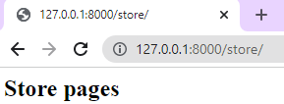

1. Replace codes in the store.html under the store folder under templates folder

{% extends 'base.html' %}

{% block content %}

{% endblock %}

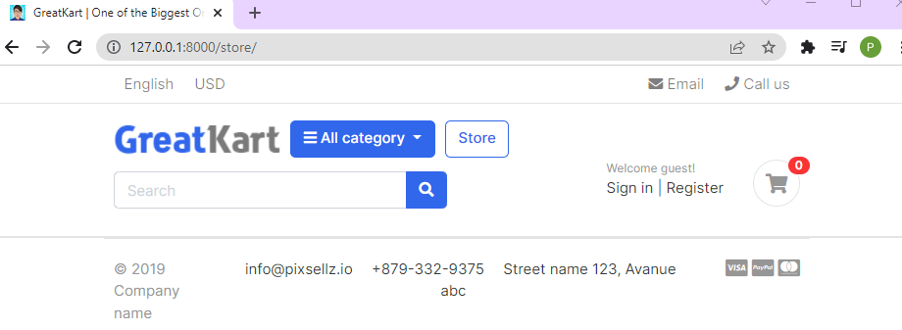

1. Copy the codes store.html under sample project file and paste in store.html under store folder under templates folder

{% block content %}

<!-- ========================= SECTION PAGETOP ========================= -->

<section class="section-pagetop bg">

<div class="container">

<h2 class="title-page">Our Store</h2>

</div> <!-- container // -->

</section>

<!-- ========================= SECTION INTRO END// ========================= -->

1. Adjust line in the base.html under templates folder

<!-- navbar -->

{% include 'includes/navbar.html' %}

{% block content %}

<!-- content -->

{% endblock %}

<!-- footer -->

{% include 'includes/footer.html' %}

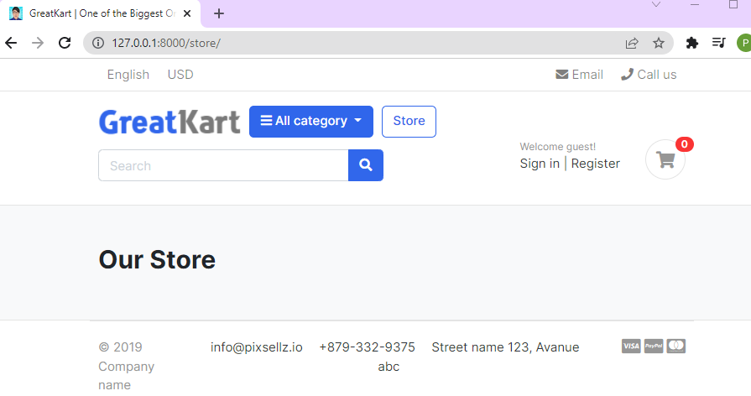

1. Copy SECTION CONTENT to SECTION CONTENT END from store.html under sample project folder

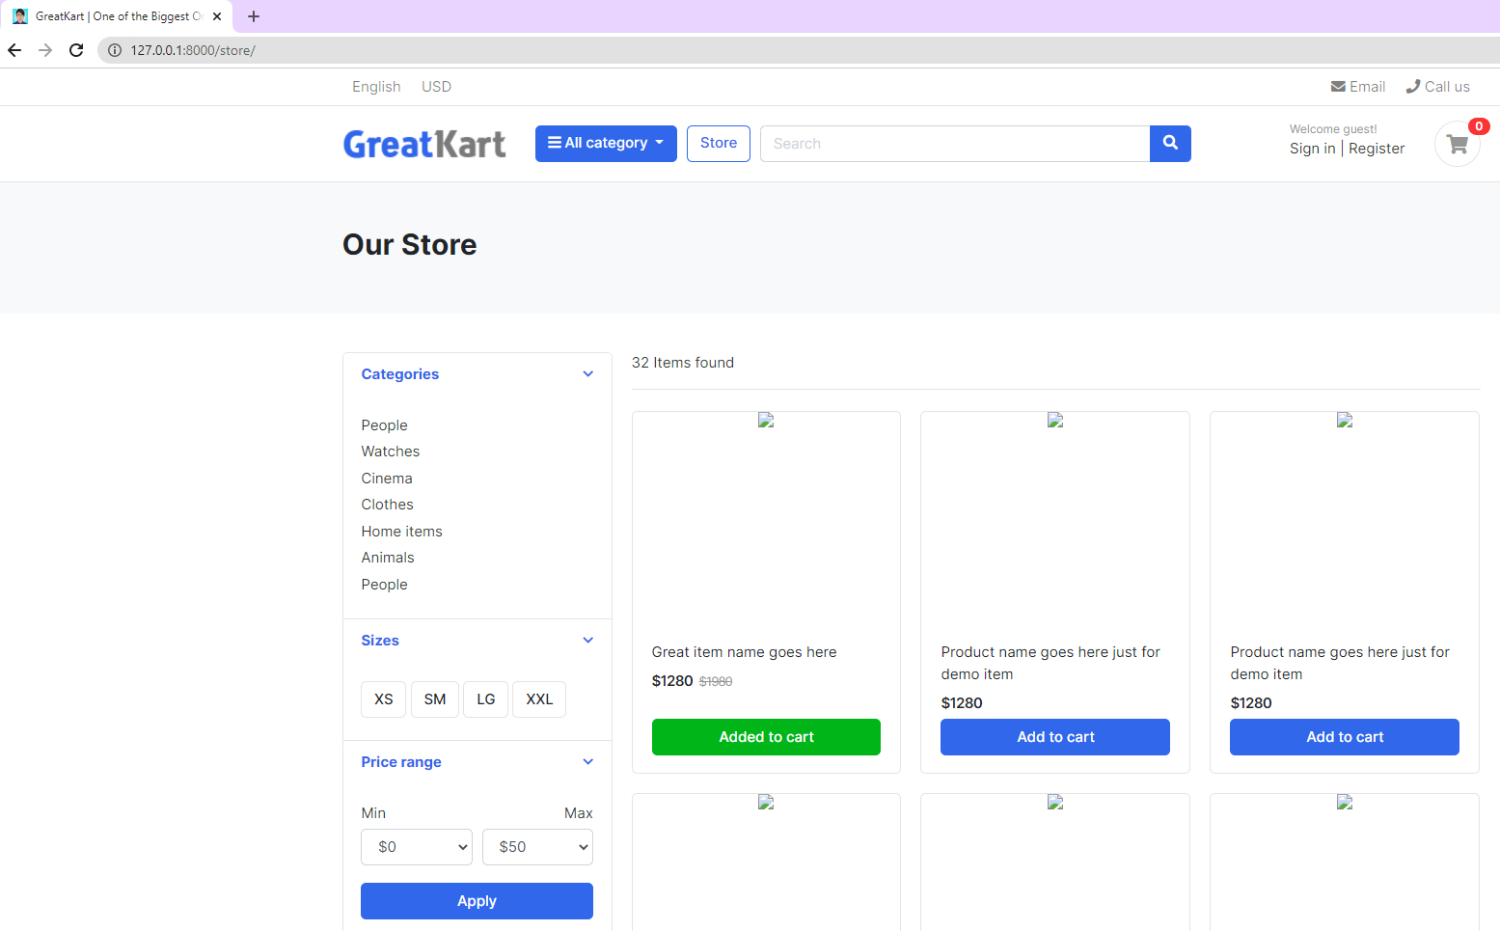

1. Load pictures into the store.html under store at 2nd line

{% extends 'base.html' %}

{% load static %}

{% block content %}{% load static %}

1. Replace image code

<img src="images/items/1.jpg">

<img src="{% static 'images/items/1.jpg' %}">

1. Add lines in the views.py in the store folder

from django.shortcuts import render

from .models import Product

# Create your views here.

def store(request):

products = Product.objects.all().filter(is_available = True)

context = {

'products': products,

}

return render(request, 'store/store.html', context)

1. Delete the image 2 to last image in the store.html under store folder under templates folder

<img src="{% static 'images/items/1.jpg' %}">

</div> <!-- img-wrap.// -->

<figcaption class="info-wrap">

<div class="fix-height">

<a href="./product-detail.html" class="title">Great item name goes here</a>

<div class="price-wrap mt-2">

<span class="price">$1280</span>

<del class="price-old">$1980</del>

</div> <!-- price-wrap.// -->

</div>

<a href="#" class="btn btn-block btn-success">Added to cart </a>

</figcaption>

</figure>

</div> <!-- col.// -->

</div> <!-- row end.// -->

1. Add loop to display the pictures

<div class="row">

{% for product in products %}

<div class="col-md-4">

<figure class="card card-product-grid">

<div class="img-wrap">

…

</figcaption>

</figure>

</div> <!-- col.// -->

{% endfor %}

</div> <!-- row end.// -->

1. User able to see the same short appear on web screen with blue button of add to cart

<a href="#" class="btn btn-block btn-primary">Add to cart </a>

1. Add line to adjust the prices

<span class="price">$ {{ product.price }}</span>

1. Delete 1 line

<del class="price-old">$1980</del>

1. Final adjustment to diplay the photo, product name and product price

<div class="row">

{% for product in products %}

<div class="col-md-4">

<figure class="card card-product-grid">

<div class="img-wrap">

<img src="{{ product.images.url }}">

</div> <!-- img-wrap.// -->

<figcaption class="info-wrap">

<div class="fix-height">

<a href="./product-detail.html" class="title">{{ product.product_name }}</a>

<div class="price-wrap mt-2">

<span class="price">$ {{ product.price }}</span>

</div> <!-- price-wrap.// -->

</div>

<a href="#" class="btn btn-block btn-primary">Add to cart </a>

</figcaption>

</figure>

</div> <!-- col.// -->

{% endfor %}

</div> <!-- row end.// -->

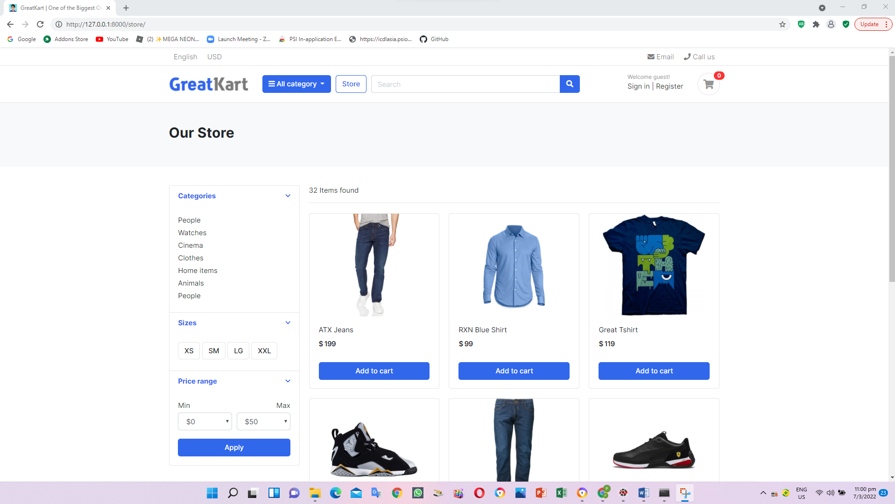

1. Add 2 lines in the view.py under store folder

from django.shortcuts import render

from .models import Product

# Create your views here.

def store(request):

products = Product.objects.all().filter(is_available = True)

product_count = products.count()

context = {

'products': products,

'product_count': product_count,

}

return render(request, 'store/store.html', context)

1. Adjust the found item from static to link to database items under store.html under store folder under template folder

<span class="mr-md-auto">32 Items found </span>

<span class="mr-md-auto"><b>{{ product_count }}</b> items found </span>

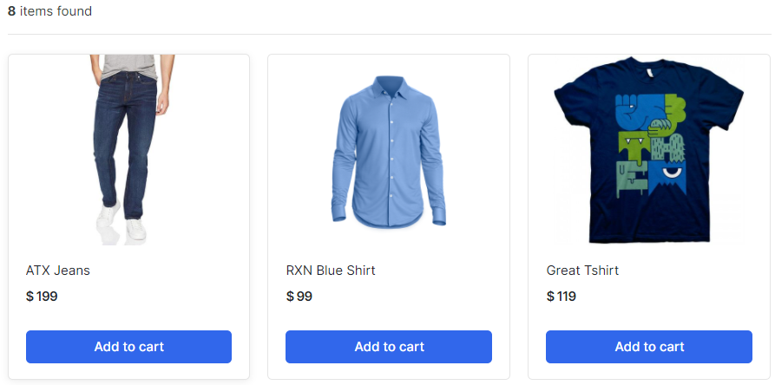

1. Adjust the lines in the urls.py under store folder (fetch the items by categories)

from django.urls import path

from . import views

urlpatterns = [

path('', views.store, name='store'),

path('<slug:category_slug>/', views.store, name='products_by_category'),

]

1. Adjust the lines in the views.py under store folder

from django.shortcuts import render, get_object_or_404

from .models import Product

from category.models import Category

# Create your views here.

def store(request, category_slug=None):

categories = None

products = None

if category_slug != None:

categories = get_object_or_404(Category, slug=category_slug)

products = Product.objects.filter(category=categories, is_available=True)

product_count = products.count()

else:

products = Product.objects.all().filter(is_available=True)

product_count = products.count()

context = {

'products': products,

'product_count': product_count,

}

return render(request, 'store/store.html', context)

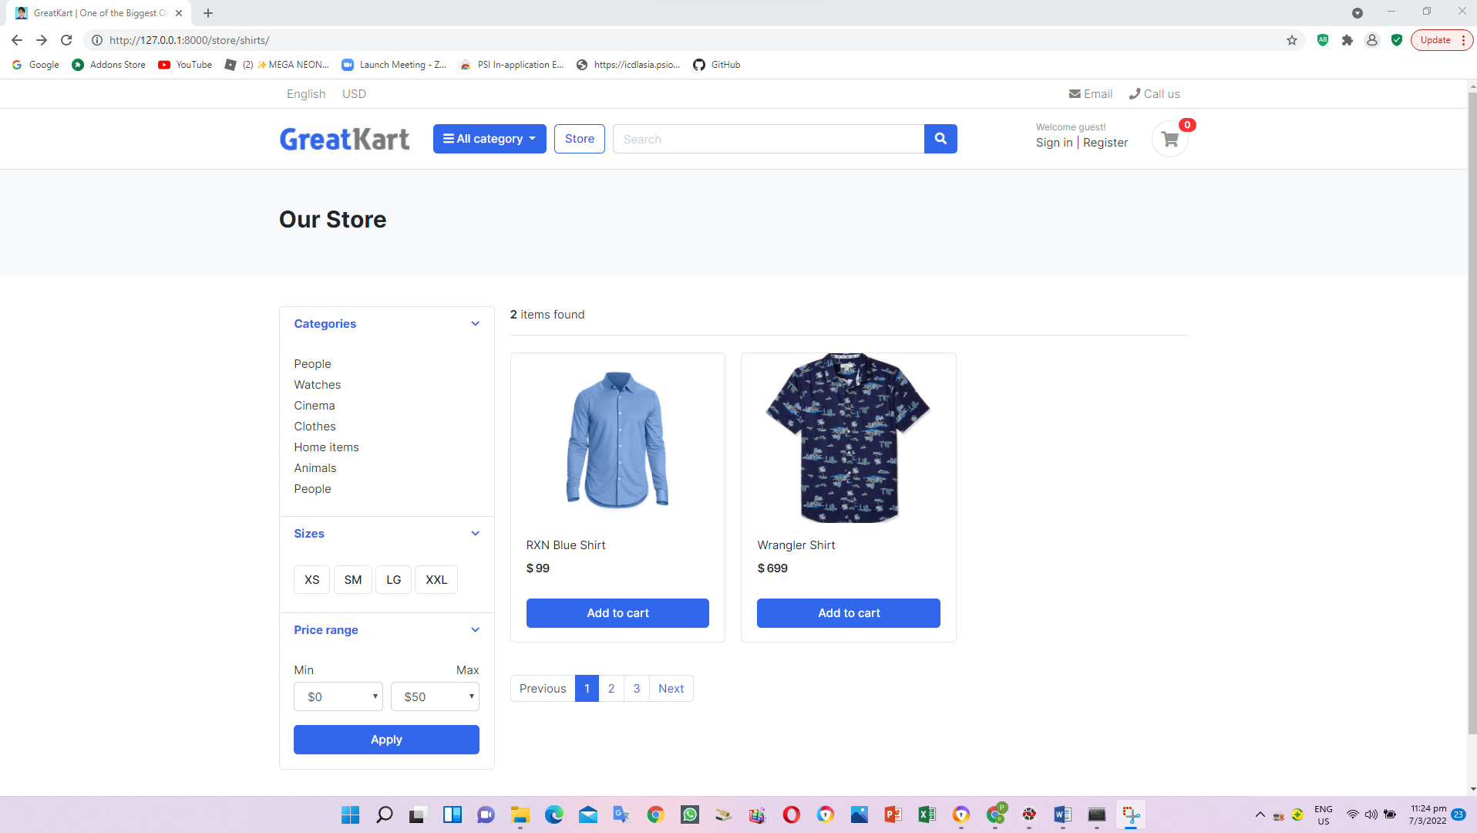

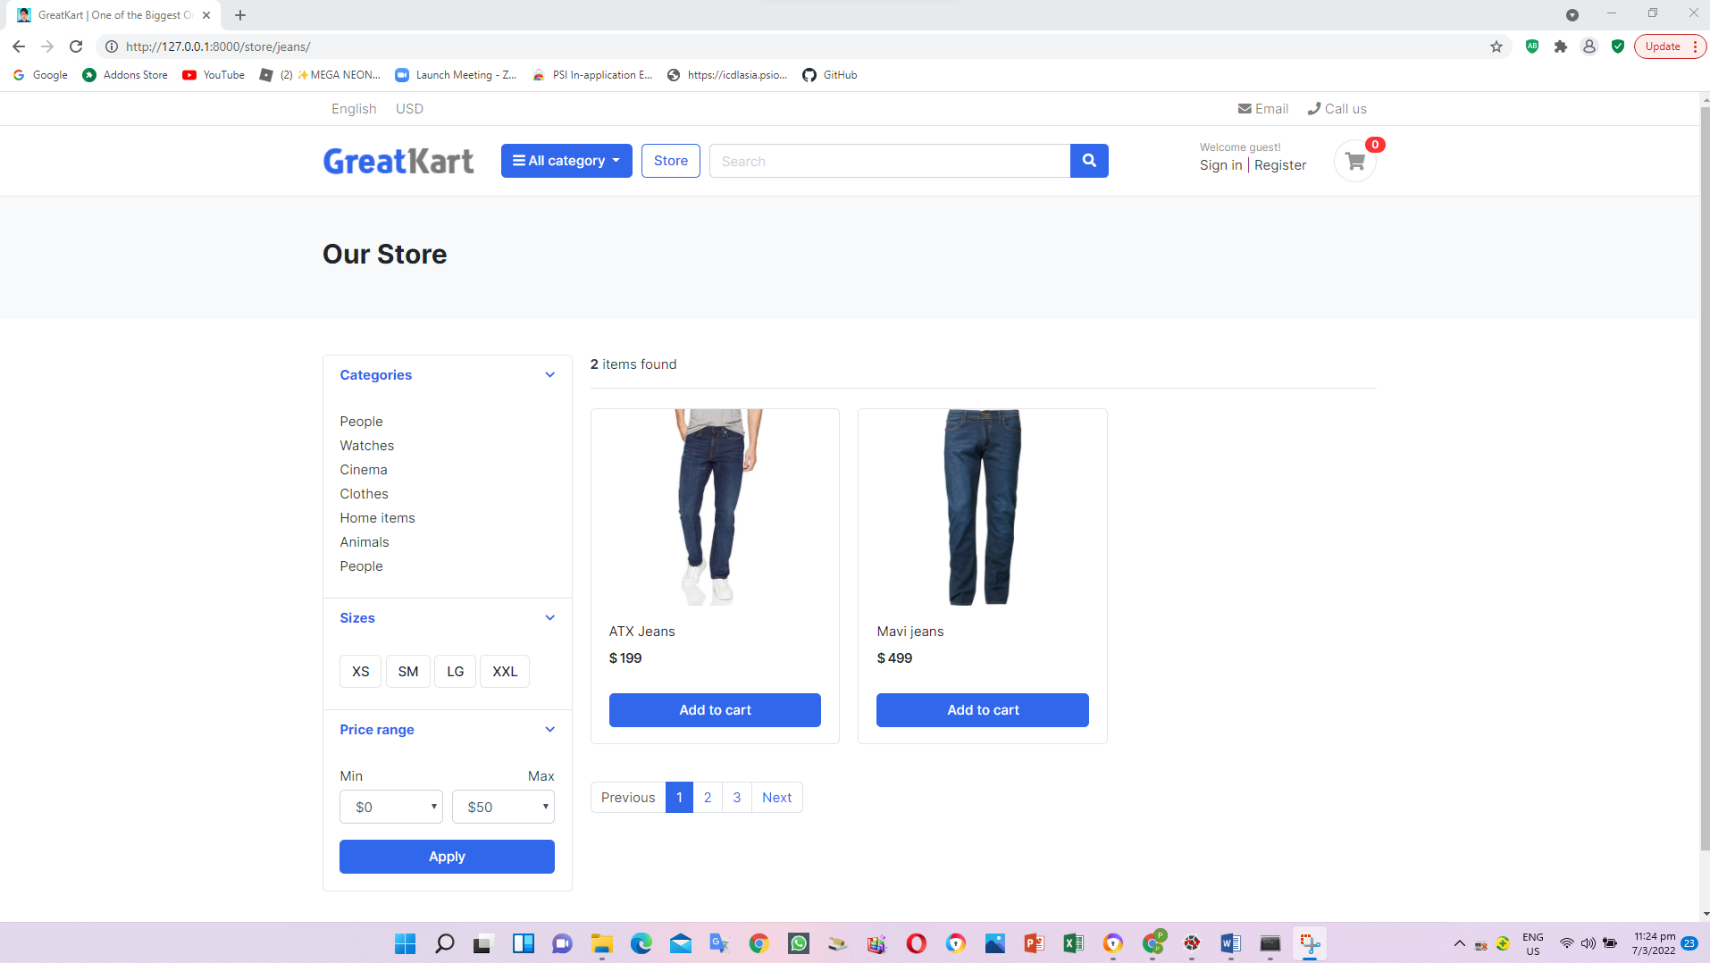

1. Create and add lines in the context_processors.py under category folder (Create linkage between category to web click)

from .models import Category

def menu_links(request):

links = Category.objects.all()

return dict(links=links)

1. Add line in the setting.py in the online folder

TEMPLATES = [

{

'BACKEND': 'django.template.backends.django.DjangoTemplates',

'DIRS': ['templates'],

'APP_DIRS': True,

'OPTIONS': {

'context_processors': [

'django.template.context_processors.debug',

'django.template.context_processors.request',

'django.contrib.auth.context_processors.auth',

'django.contrib.messages.context_processors.messages',

'category.context_processors.menu_links',

],

},

},

]

1. Edit the codes in the navbar.html under includes folder under templates folder

<i class="fa fa-bars"></i> All category

</button>

<div class="dropdown-menu">

{% for category in links %}

<a class="dropdown-item" href="{{ category.get_url }}">{{ category.category_name}}</a>

{% endfor%}

</div>

</div> <!-- category-wrap.// -->

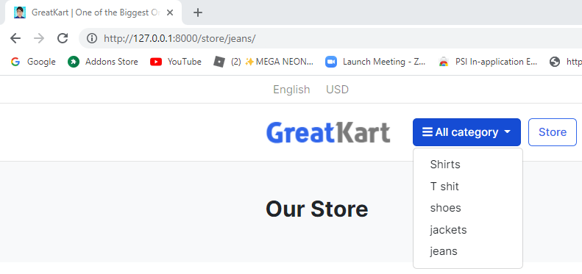

1. Adjust models.py under category folder

from django.db import models

from django.urls import reverse

# Create your models here.

class Category(models.Model):

category_name = models.CharField(max_length=50, unique = True)

slug = models.SlugField(max_length=100, unique=True)

description = models.TextField(max_length=255, blank=True)

cat_image = models.ImageField(upload_to='photos/categories', blank=True)

class Meta:

verbose_name = 'Category'

verbose_name_plural = 'Categories'

def get_url(self):

return reverse('products_by_category', args=[self.slug])

def __str__(self):

return self.category_name

1. Adjust the home.html under templates folder (remove the s)

{% block content %}

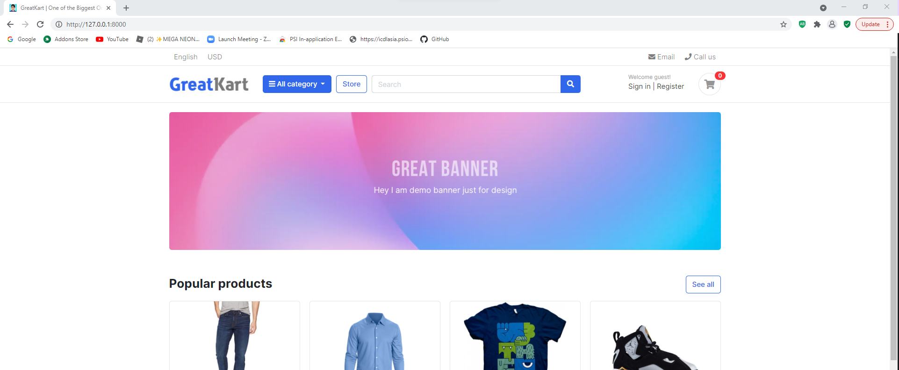

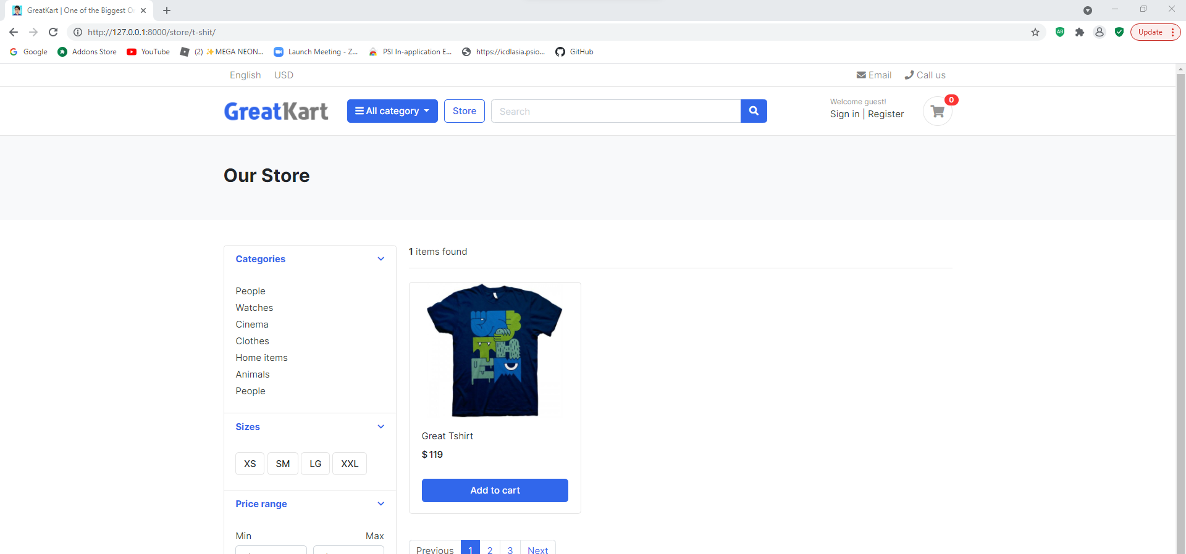

1. Adjust codes in the store.html under store folder under templates folder (display category in the store page)

<div class="card-body">

<ul class="list-menu">

<li><a href="{% url 'store' %}">All Products </a></li>

{% for category in links %}

<li><a href="{{ category.get_url }}">{{ category.category_name }} </a></li>

{% endfor %}

</ul>

</div> <!-- card-body.// -->

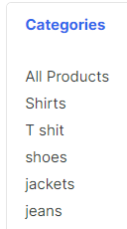

1. Adjust codes in the navbar.html under includes folder under templates folder

<div class="dropdown-menu">

<a class="dropdown-item" href="{% url 'store' %}">All Products</a>

{% for category in links %}

<a class="dropdown-item" href="{{ category.get_url }}">{{ category.category_name}}</a>

{% endfor %}

</div>

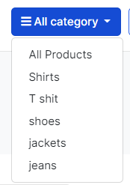

1. Add line in the urls.py in the store folder (implement product detail URL and design)

from django.urls import path

from . import views

urlpatterns = [

path('', views.store, name='store'),

path('<slug:category_slug>/', views.store, name='products_by_category'),

path('<slug:category_slug>/<slug:product_slug>/', views.product_detail, name='product_detail'),

]

1. Add lines in the views.py in the store folder

return render(request, 'store/store.html', context)

def product_detail(request,category_slug, product_slug):

return render(request, 'store/product_detail.html')

1. Create product_details.html in the store folder in the templates folder

<h2>Product Detail</h2>

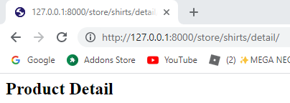

1. Replace the codes in the product_details.html in the store folder in the templates folder

{% extends 'base.html' %}

{% block content %}

{% endblock %}

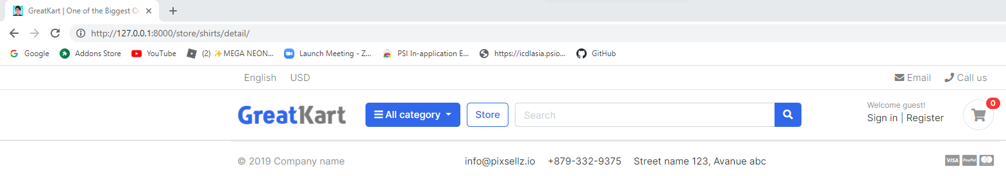

1. Copy the codes from product-detail.html from js folder from project sample folder to product_details.html in the store folder in the templates folder

Copy

<section class="section-content padding-y bg">

…

<!-- ========================= SECTION CONTENT END// ========================= -->

Paste

{% extends 'base.html' %}

{% block content %}

…

{% endblock %}

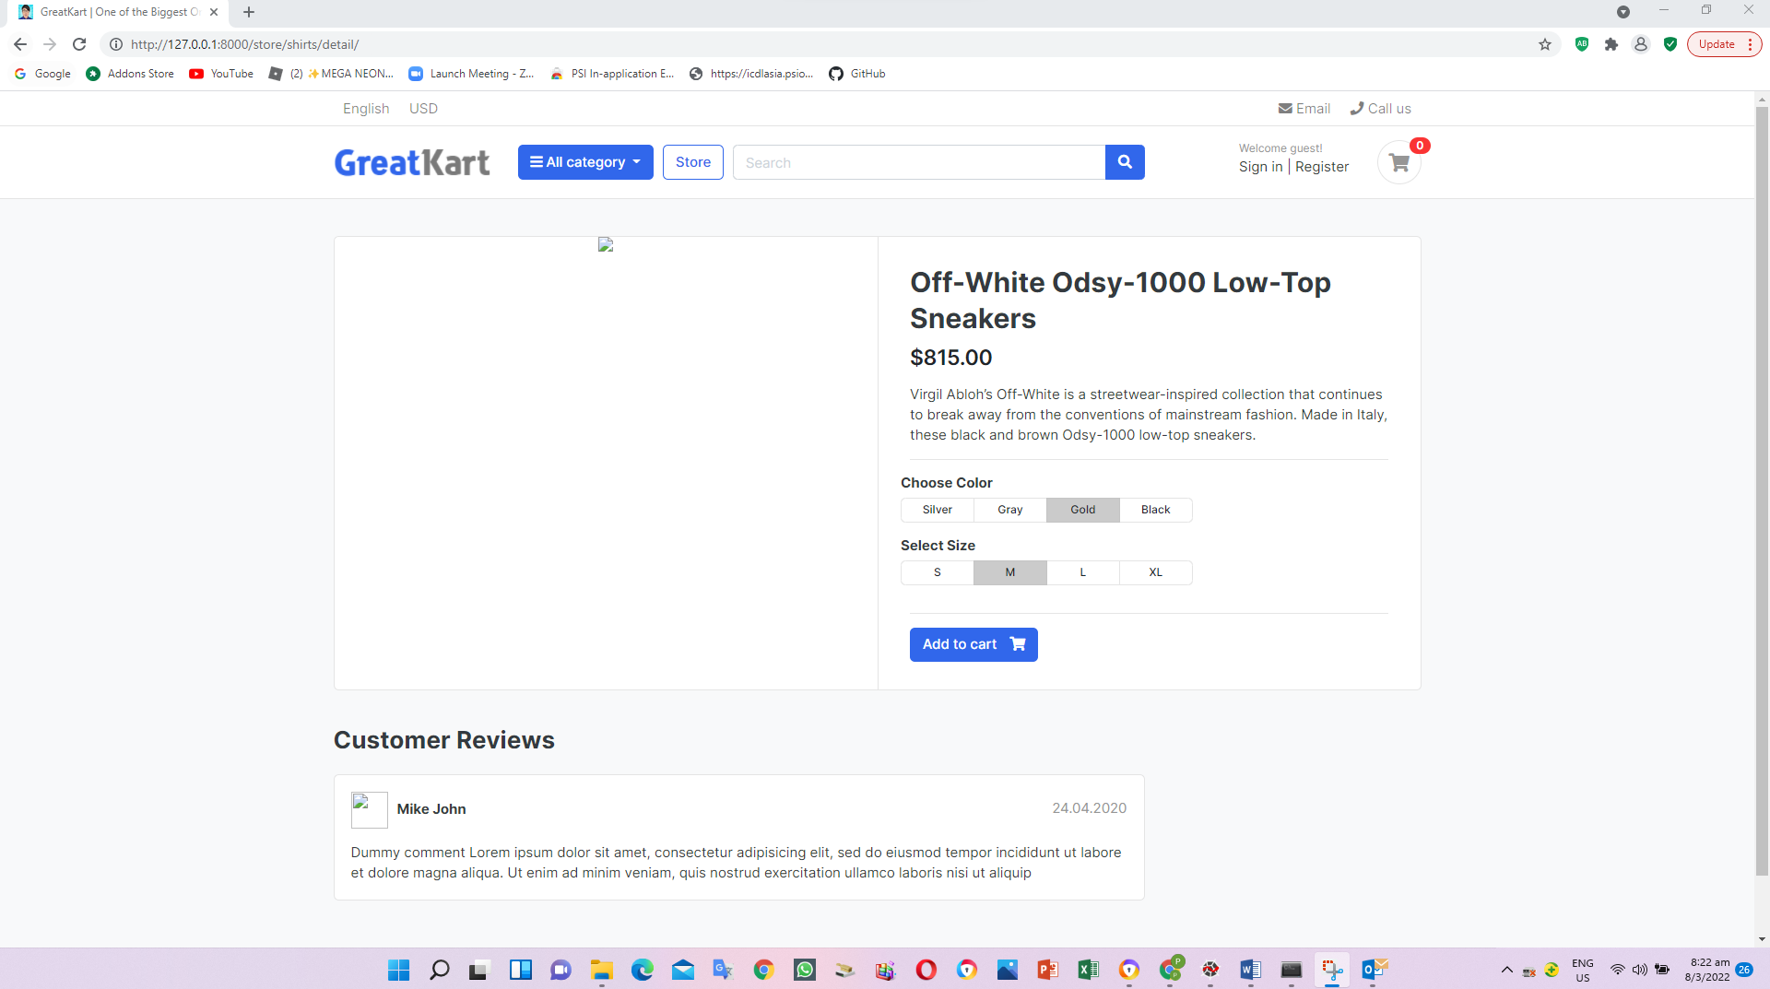

1. Adjust codes in the product_details.html in the store folder in the templates folder

{% extends 'base.html' %}

{% load static %}

{% block content %}

<section class="section-content padding-y bg">

<div class="container">

<!-- ============================ COMPONENT 1 ================================= -->

<div class="card">

<div class="row no-gutters">

<aside class="col-md-6">

<article class="gallery-wrap">

<div class="img-big-wrap">

<a href="#"><img src="{% static './images/items/12.jpg' %}"></a>

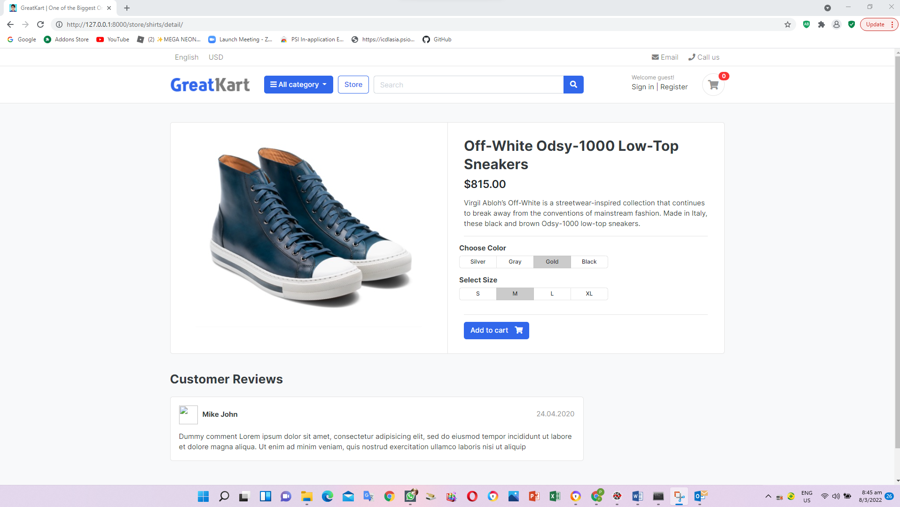

1. Adjust codes in the product_details.html in the store folder in the templates folder

<article class="box mb-3">

<div class="icontext w-100">

<img src="{% static './images/avatars/avatar1.jpg' %}" class="img-xs icon rounded-circle">

<div class="text">

<span class="date text-muted float-md-right">24.04.2020 </span>

<h6 class="mb-1">Mike John </h6>

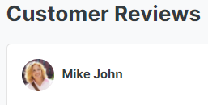

1. Adjust codes in the views.py in the store folder (Single Product View)

def product_detail(request,category_slug, product_slug):

try:

single_product = Product.objects.get(category__slug = category_slug, slug=product_slug)

except Exception as e:

raise e

context = {

'single_product': single_product,

}

return render(request, 'store/product_detail.html', context)

1. Adjust codes in the product_details.html in the store folder in the templates folder

<article class="content-body">

<h2 class="title">{{ single_product.product_name }}</h2>

<div class="mb-3">

<var class="price h4">$815.00</var>

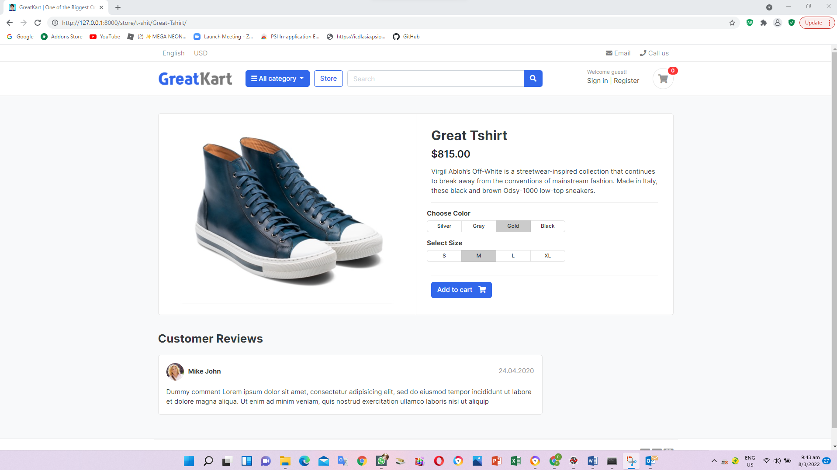

1. Adjust photo, price and description in the product_details.html in the store folder in the templates folder

<article class="gallery-wrap">

<div class="img-big-wrap">

<a href="#"><img src="{{ single_product.images.url }}"></a>

</div> <!-- img-big-wrap.// -->

</article> <!-- gallery-wrap .end// -->

</aside>

<main class="col-md-6 border-left">

<article class="content-body">

<h2 class="title">{{ single_product.product_name }}</h2>

<div class="mb-3">

<var class="price h4">$ {{ single_product.price }}</var>

</div>

<p>{{ single_product.description }}</p>

<hr>

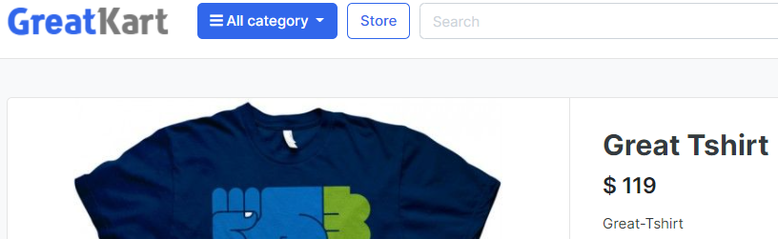



1. Adjust the line in the navbar.html under includes folder under templates folder (Fix Logo and store button)

Old

<a href="./store.html" class="btn btn-outline-primary">Store</a>

New

<a href="{% url 'store' %}" class="btn btn-outline-primary">Store</a>

Old

<a href="./" class="brand-wrap">

New

<a href="{% url 'home' %}" class="brand-wrap">

1. Adjust the line in the home.html under templates folder (Fix see all button)

Old

<a href="./store.html" class="btn btn-outline-primary float-right">See all</a>

New

<a href="{% url 'store' %}" class="btn btn-outline-primary float-right">See all</a>

1. Adjust store.html under store folder under templates folder (click photo and item tittle to see each item)

Old

<a href="./product-detail.html" class="title">{{ product.product_name }}</a>

New

<a href="{{ product.get_url }}" class="title">{{ product.product_name }}</a>

Old

<img src="{{ product.images.url }}">

New

<a href="{{ product.get_url }}"><img src="{{ product.images.url }}"></a>

User able to click the photo from our store page to individual page

1. User change the banker codes from home.html under templates folder (Change banner)

<img src={% static 'images/banners/cover.jpg' %} class="img-fluid rounded">

1. Product available in the product_details.html in the store folder in the templates folder

{% if single_product.stock <= 0 %}

<h5 class="text-danger">Out of Stock</h5>

{% else %}

<a href="./product-detail.html" class="btn btn-primary"> <span class="text">Add to cart</span> <i class="fas fa-shopping-cart"></i> </a>

{% endif %}

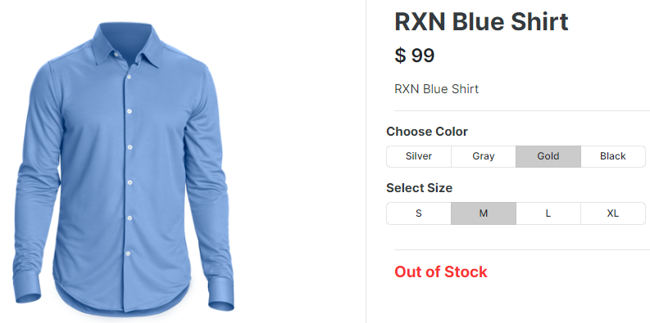

1. Log in GitHub and create a new repository and press Create repository

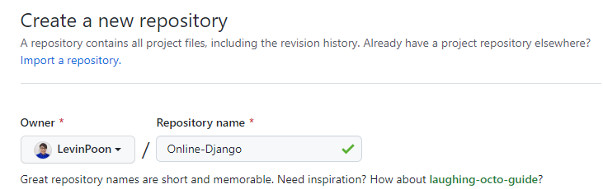

1. Enter command in the Anaconda Prompt (Anaconda3)

cd C:\Users\angel\OneDrive\Desktop\Python Django\env\Scripts

activate

cd C:\Users\angel\OneDrive\Desktop\Python Django

git init

1. Create an .gitignore file in online root folder (gitignore.io -> Django)

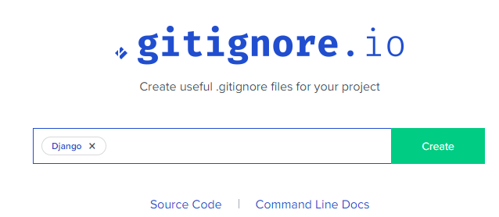

1. Copy and paste code from website to .gitignore file
2. Add codes to git repository

Git add –A

Git commit –m “this is my first commit”

git remote add origin https://github.com/LevinPoon/Online-Django.git

git branch -M main

git push -u origin main

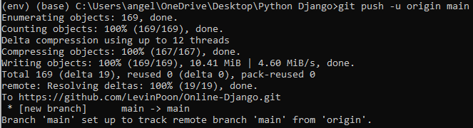

User please reload the page

Git status check any updates

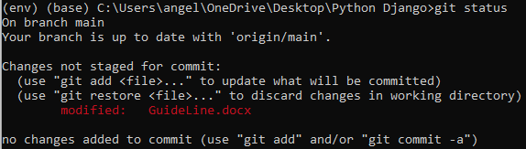

1. Enter CMD codes to create carts application folder

python manage.py startapp carts

1. Insert line in the setting.py under online folder

'store',

'carts',

]

1. Create urls.py in the carts folder

from django.urls import path

from . import views

urlpatterns = [

path('', views.cart, name='cart'),

]

1. Insert 1 line below store in the urls.py in the online folder

path('store/', include('store.urls')),

path('cart/', include('carts.urls')),

1. Edit views.py in the carts folder

from django.shortcuts import render

# Create your views here.

def cart(request):

return render(request, 'store/cart.html')

1. Create cart.html under store folder under templates folder

cart.html

cart

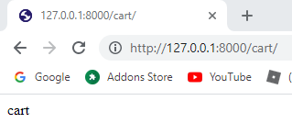

1. Adjust codes in cart.html under store folder under templates folder

{% extends 'base.html' %}

{% load static %}

{% block content %}

{% endblock %}

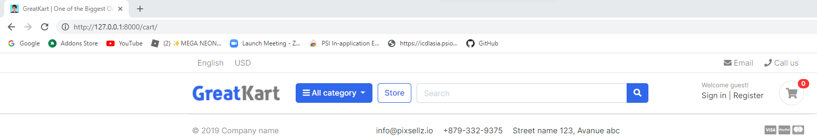

1. Copy session codes cart.html codes in project sample folder to cart.html under store folder under templates folder

<section class="section-content padding-y bg">

…

<!-- ========================= SECTION CONTENT END// ========================= -->

Paste in between

{% block content %}

…

{% endblock %}

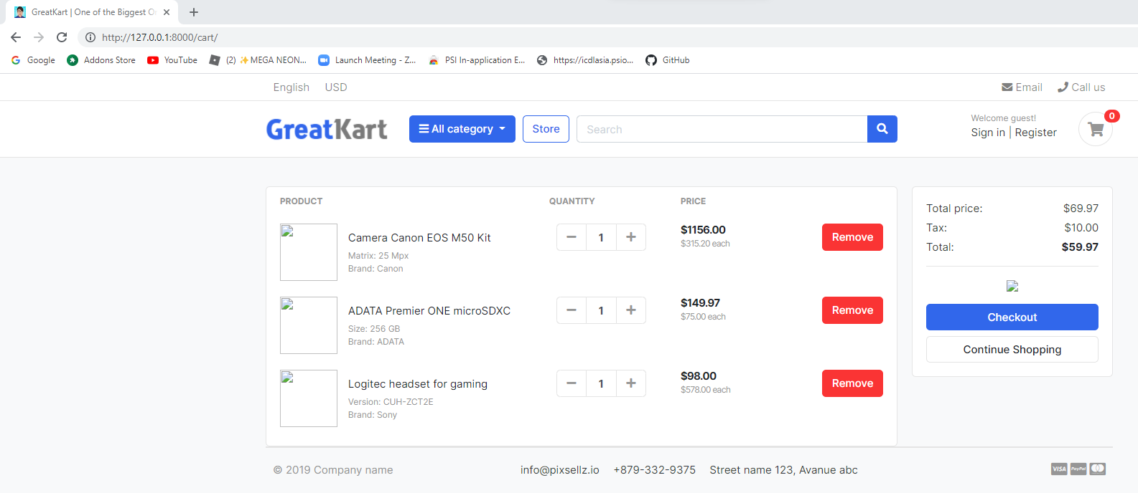

1. Edit the cart.html to display photo in the store folder in the templates folder (display item and visa logo)

Old

<div class="aside"><img src="./images/items/11.jpg" class="img-sm"></div>

New

<div class="aside"><img src="{% static './images/items/11.jpg' %}" class="img-sm"></div>

Old

<img src="./images/misc/payments.png" height="26">

New

<img src="{% static './images/misc/payments.png' %}" height="26">

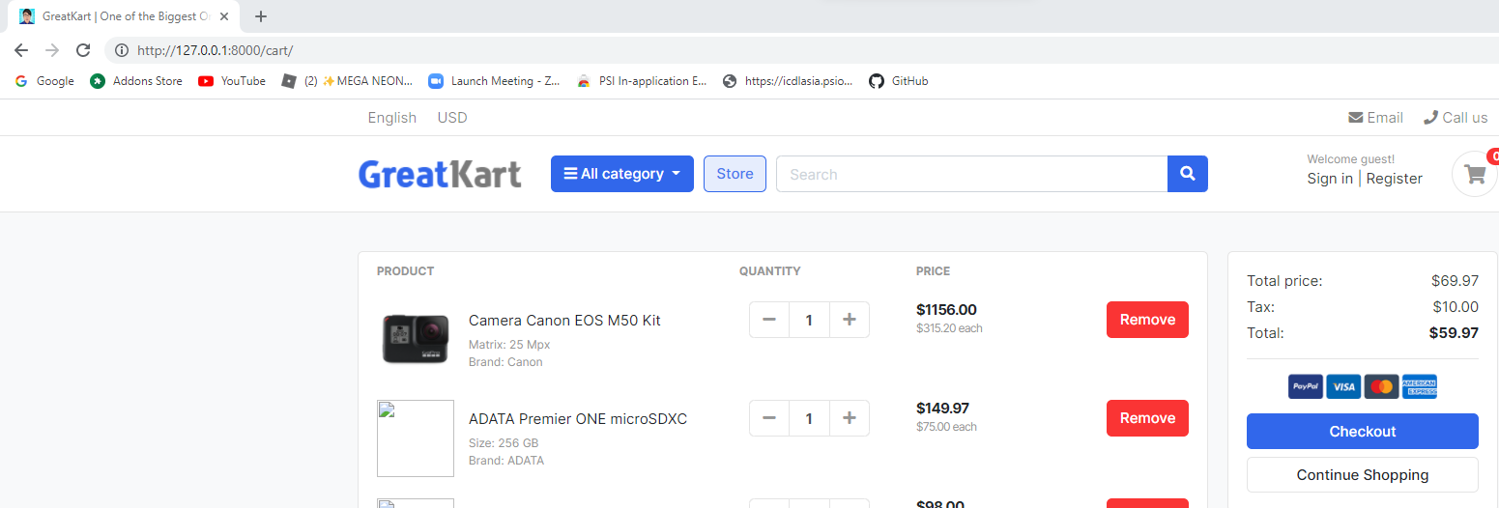

1. Delete 2nd tr to 3rd tr codes in the cart.html in the store folder in the templates folder

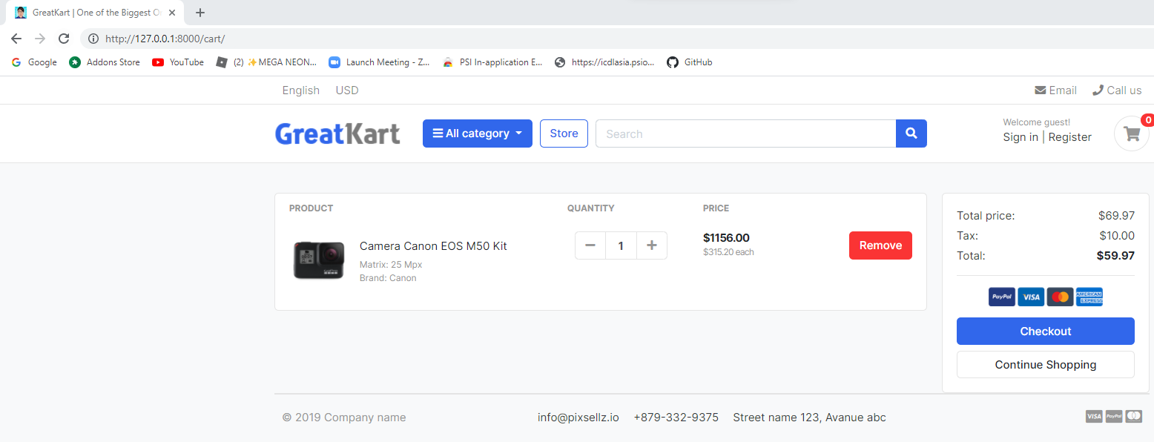

1. Add lines in models.py in the carts folder

from django.db import models

from store.models import Product

# Create your models here.

class Cart(models.Model):

cart_id = models.CharField(max_length=250, blank=True)

date_added = models.DateField(auto_now_add=True)

def __str__(self):

return self.cart_id

class CartItem(models.Model):

product = models.ForeignKey(Product, on_delete=models.CASCADE)

cart = models.ForeignKey(Cart, on_delete=models.CASCADE)

quantity = models.IntegerField()

is_active = models.BooleanField(default=True)

def __str__(self):

return self.product

1. Add lines in admin.py in the carts folder

from django.contrib import admin

from .models import Cart, CartItem

# Register your models here.

admin.site.register(Cart)

admin.site.register(CartItem)

1. Enter codes CMD to migrate in admin page

python manage.py makemigrations

python manage.py migrate

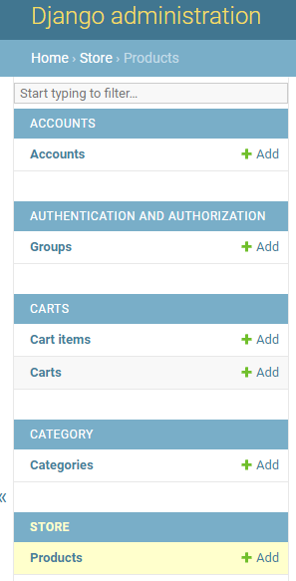

1. Add line to views.py under the carts folder (add item to cart from individual tab)

from django.shortcuts import render, redirect

from store.models import Product

from .models import Cart, CartItem

# Create your views here.

def _cart_id(request):

cart = request.session.session_key

if not cart:

cart = request.session.create()

return cart

def add_cart(request, product_id):

product = Product.objects.get(id=product_id) #get the product

try:

cart = Cart.objects.get(cart_id=_cart_id(request)) #get the cart using the cart_id present in the session

except Cart.DoesNotExist:

cart = Cart.objects.create(

cart_id = _cart_id(request)

)

cart.save()

try:

cart_item = CartItem.objects.get(product=product, cart=cart)

cart_item.quantity += 1 # cart_item.quantity = cart_item.quantity + 1

cart_item.save()

except CartItem.DoesNotExist:

cart_item = CartItem.objects.create(

product = product,

quantity = 1,

cart = cart,

)

cart_item.save()

return redirect('cart')

def cart(request):

return render(request, 'store/cart.html')

1. Add line to urls.py under the carts file

from django.urls import path

from . import views

urlpatterns = [

path('', views.cart, name='cart'),

path('add_cart/<int:product_id>/', views.add_cart, name='add_cart'),

]

1. Add lines in the product_detail.html in the store folder in the templates folder

Old

<a href="./product-detail.html" class="btn btn-primary"> <span class="text">Add to cart</span> <i class="fas fa-shopping-cart"></i> </a>

New

<a href="{% url 'add_cart' single_product.id %}" class="btn btn-primary"> <span class="text">Add to cart</span> <i class="fas fa-shopping-cart"></i> </a>

User able to add to cart by press “Add to cart” button

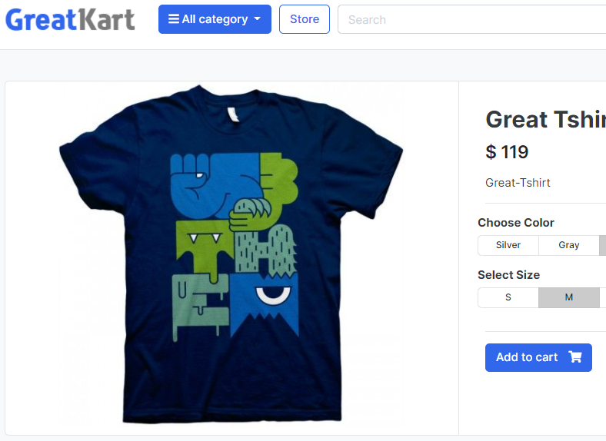 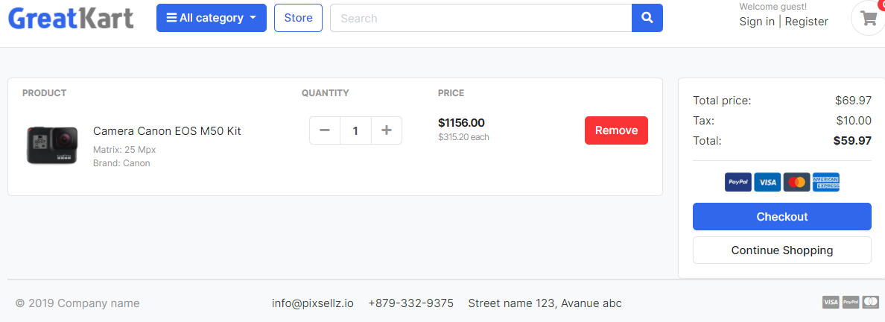

1. Adjust line in the view.py under carts folder (Insert new item to cart)

From Django.core.exceptions import ObjectDoesNotExist

&

def cart(request, total=0, quantity=0, cart_items=None):

try:

tax = 0

grand_total = 0

cart = Cart.objects.get(cart_id=_cart_id(request))

cart_items = CartItem.objects.filter(cart=cart, is_active=True)

for cart_item in cart_items:

total += (cart_item.product.price * cart_item.quantity)

quantity += cart_item.quantity

tax = (7 * total)/100

grand_total = total + tax

except ObjectDoesNotExist:

pass #just ignore

context = {

'total': total,

'quantity': quantity,

'cart_items': cart_items,

'tax': tax,

'grand_total': grand_total,

}

return render(request, 'store/cart.html', context)

1. Add for loop in front and end <tr> in the cart.html under store folder under templates folder

{% for cart_item in cart_items %}

<tr>

</tr>

{% endfor %}

1. Display cart item image in the cart.html under store folder under templates folder

Old

<div class="aside"><img src="{% static './images/items/11.jpg' %}" class="img-sm"></div>

New

<div class="aside"><img src="{{ cart_item.product.images.url }}" class="img-sm"></div>

1. Display cart item name in the cart.html under store folder under templates folder

Old

<a href="#" class="title text-dark">Camera Canon EOS M50 Kit</a>

New

<a href="#" class="title text-dark">{{ cart_item.product.product_name }}</a>1

1. Display no of cart item in the cart.html under store folder under templates folder

Old

<input type="text" class="form-control" value="1">

New

<input type="text" class="form-control" value="{{ cart_item.quantity }}">

1. Display total price of cart item in the cart.html under store folder under templates folder

Old

<var class="price">$1156.00</var>

<small class="text-muted"> $315.20 each </small>

New

<var class="price">$ {{ cart_item.sub_total }}</var>

<small class="text-muted"> $ {{ cart_item.product.price }} each </small>

1. Add function codes in the models.py under carts folder

class CartItem(models.Model):

product = models.ForeignKey(Product, on_delete=models.CASCADE)

cart = models.ForeignKey(Cart, on_delete=models.CASCADE)

quantity = models.IntegerField()

is_active = models.BooleanField(default=True)

def sub_total(self):

return self.product.price * self.quantity

def __str__(self):

return self.product

1. Adjust codes to increase item in cart.html under store folder under templates folder

Old

<button class="btn btn-light" type="button" id="button-minus"> <i class="fa fa-plus"></i> </button>

New

<a href="{% url 'add_cart' cart_item.product.id %}" class="btn btn-light" type="button" id="button-minus"> <i class="fa fa-plus"></i> </a>

1. Adjust codes to display total price in cart.html under store folder under templates folder

Old

<dd class="text-right">$69.97</dd>

<dd class="text-right"> $10.00</dd>

<dd class="text-right text-dark b"><strong>$59.97</strong></dd>

New

<dd class="text-right">$ {{ total }}</dd>

<dd class="text-right"> $ {{ tax }}</dd>

<dd class="text-right text-dark b"><strong>${{ grand_total }}</strong></dd>

1. Add lines in the view.py under the carts folder

from django.shortcuts import render, redirect, get_object_or_404

&

def remove_cart(request, product_id):

cart = Cart.objects.get(cart_id=_cart_id(request))

product = get_object_or_404(Product, id=product_id)

cart_item = CartItem.objects.get(product=product, cart=cart)

if cart_item.quantity > 1:

cart_item.quantity -= 1

cart_item.save()

else:

cart_item.delete()

return redirect('cart')

1. Add lines in the view.py under the carts folder

path('add_cart/<int:product_id>/', views.add_cart, name='add_cart'),

path('remove_cart/<int:product_id>/', views.remove_cart, name='remove_cart'),

1. Adjust codes to display total price in cart.html under store folder under templates folder (decrement & remove)

Old

<button class="btn btn-light" type="button" id="button-plus"> <i class="fa fa-minus"></i> </button>

New

<a href="{% url 'remove_cart' cart_item.product.id %}" class="btn btn-light" type="button" id="button-plus"> <i class="fa fa-minus"></i> </a>

1. Add lines in the view.py under the carts folder

def remove_cart_item(request, product_id):

cart = Cart.objects.get(cart_id=_cart_id(request))

product = get_object_or_404(Product, id=product_id)

cart_item = CartItem.objects.get(product=product, cart=cart)

cart_item.delete()

return redirect('cart')

1. Add lines in the view.py under the carts folder

path('remove_cart/<int:product_id>/', views.remove_cart, name='remove_cart'),

path('remove_cart_item/<int:product_id>/', views.remove_cart_item, name='remove_cart_item'),

1. Adjust codes to remove item in cart.html under store folder under templates folder

Old

<a href="" class="btn btn-danger"> Remove</a>

New

<a href="{% url 'remove_cart_item' cart_item.product.id %}" class="btn btn-danger"> Remove</a>

1. Add if else code in the cart.html under store folder under templates folder

<!-- ============================ COMPONENT 1 ================================= -->

{% if not cart_items %}

<h2 class="text-center" > Your Shopping Cart is Empty</h2>

<br>

<div class="text-center">

<a href="{% url 'store' %}" class="btn btn-primary">Continue Shopping</a>

</div>

<br>

{% else %}

<div class="row">

…

</div> <!-- row.// -->

{% endif %}

<!-- ============================ COMPONENT 1 END .// ================================= -->

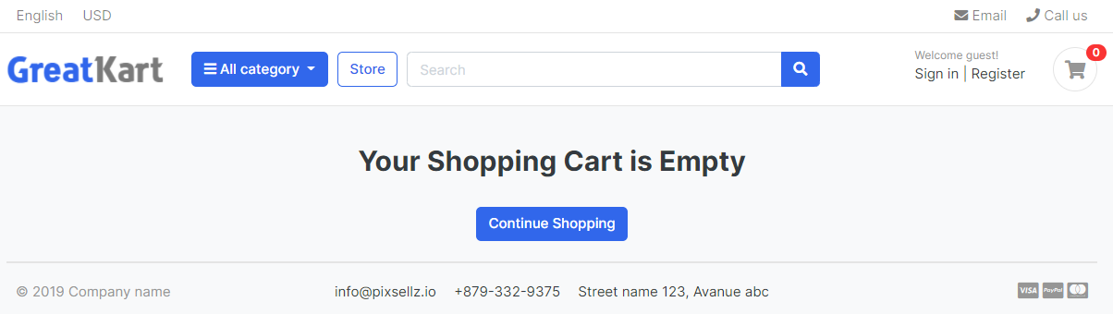

1. Adjust line to add to cart in the store page under store.html under store under templates

Old

<a href="#" class="btn btn-block btn-primary">Add to cart </a>

New

<a href="{% url 'add_cart' product.id %}" class="btn btn-block btn-primary">Add to cart </a>

1. Zoom into each item page from cart page under cart.html under store folder under templates folder

Old

<a href="#" class="title text-dark">{{ cart_item.product.product_name }}</a>

New

<a href="{{ cart_item.product.get_url }}" class="title text-dark">{{ cart_item.product.product_name }}</a>

1. Continue shopping under cart.html under store folder under templates folder

Old

<a href="./store.html" class="btn btn-light btn-block">Continue Shopping</a>

New

<a href="{% url 'store' %}" class="btn btn-light btn-block">Continue Shopping</a>

1. Display added to cart logo under cart.html under store folder under templates folder

from django.shortcuts import render, get_object_or_404

from .models import Product

from category.models import Category

from carts.models import CartItem

from carts.views import _cart_id

from django.http import HttpResponse

# Create your views here.

def store(request, category_slug=None):

categories = None

products = None

if category_slug != None:

categories = get_object_or_404(Category, slug=category_slug)

products = Product.objects.filter(category=categories, is_available=True)

product_count = products.count()

else:

products = Product.objects.all().filter(is_available=True)

product_count = products.count()

context = {

'products': products,

'product_count': product_count,

}

return render(request, 'store/store.html', context)

def product_detail(request, category_slug, product_slug):

try:

single_product = Product.objects.get(category__slug = category_slug, slug=product_slug)

in_cart = CartItem.objects.filter(cart__cart_id=_cart_id(request), product=single_product).exists()

return HttpResponse(in_cart)

exit()

except Exception as e:

raise e

context = {

'single_product': single_product,

'in_cart': in_cart,

}

return render(request, 'store/product_detail.html', context)

User able to see true or false after add to cart to match with existing cart status.

1. Add lines in the product_detail.html under store folder under templates folder

{% if single_product.stock <= 0 %}

<h5 class="text-danger">Outof Stock</h5>

{% else %}

{% if in_cart %}

<a href="#" class="btn btn-success"> <span class="text">Add to Cart</span> <i class="fas fa-check"></i> </a>

<a href="{% url 'cart' %}" class="btn btn-outline-primary"> <span class="text">View Cart</span> <i class="fas fa-eye"></i> </a>

{% else %}

<a href="{% url 'add_cart' single_product.id %}" class="btn btn-primary"> <span class="text">Add to Cart</span> <i class="fas fa-shopping-cart"></i> </a>

{% endif %}

{% endif %}

1. Remove code cart.html under store folder under templates folder

return HttpResponse(in_cart)

exit()

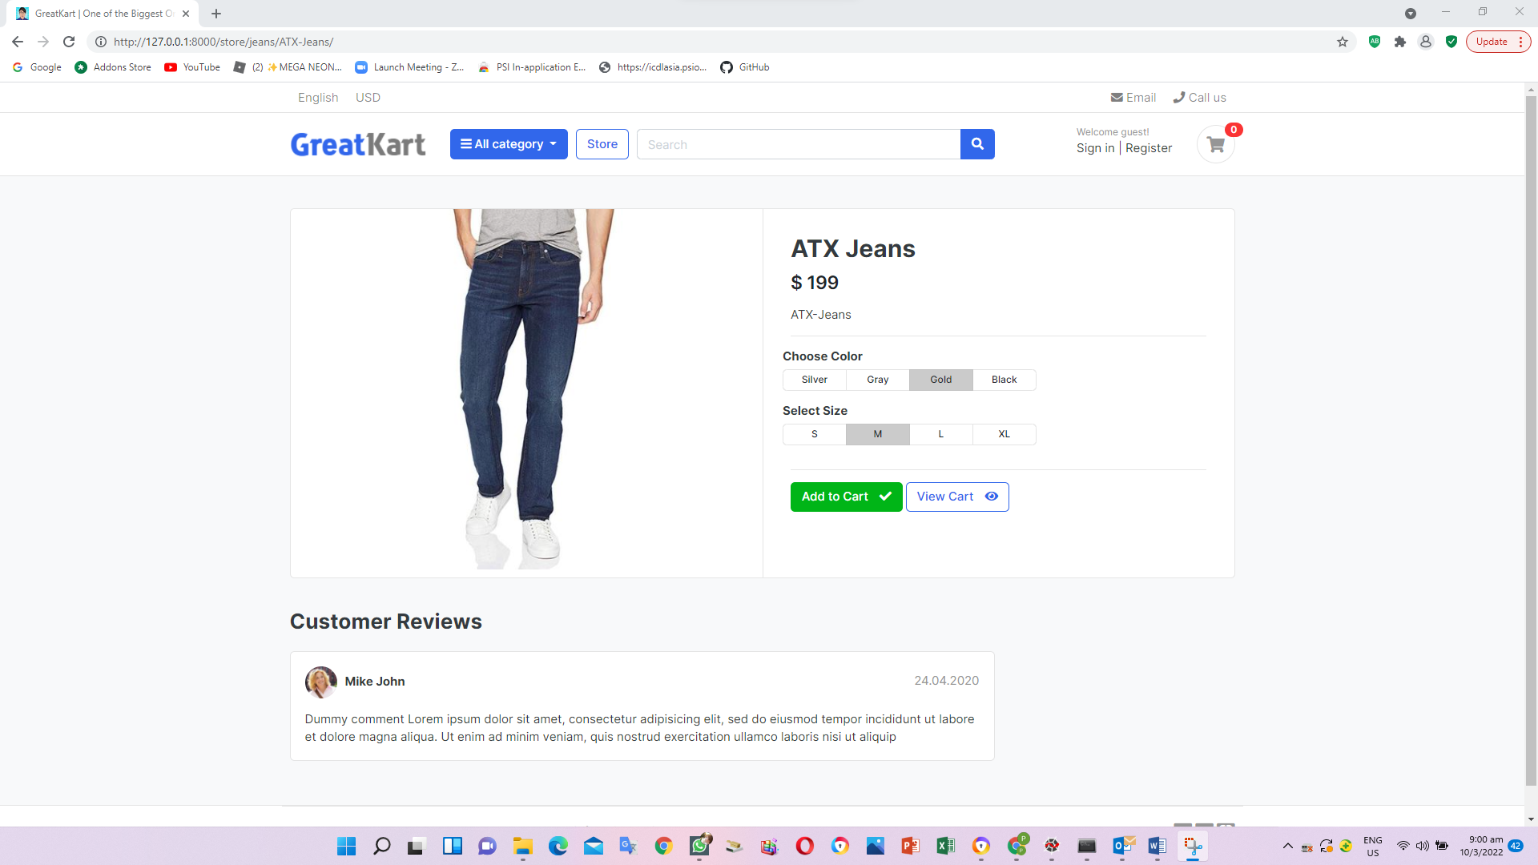

1. Create context_processors.py under carts folder (Linkage Cart Icon)

from .models import Cart, CartItem

from .views import _cart_id

def counter(request):

cart_count = 0

if 'admin' in request.path:

return {}

else:

try:

cart = Cart.objects.filter(cart_id=_cart_id(request))

cart_items = CartItem.objects.all().filter(cart=cart[:1])

for cart_item in cart_items:

cart_count += cart_item.quantity

except Cart.DoesNotExist:

cart_count = 0

return dict(cart_count=cart_count)

1. Add lines in settings.py under online folder

'category.context_processors.menu_links',

'carts.context_processors.counter',

1. Add line in the navbar.html under includes under templates folder

Old

a href="./cart.html" class="widget-header pl-3 ml-3">

<span class="badge badge-pill badge-danger notify">0</span>

New

<a href="{% url 'cart' %}" class="widget-header pl-3 ml-3">

<span class="badge badge-pill badge-danger notify">{{ cart_count }}</span>

1. Replace add to cart with view each item in the store.html under store folder under templates folder

Old

<a href="{% url 'add_cart' product.id %}" class="btn btn-block btn-primary">Add to cart </a>

New

<a href="{{ product.get_url }}" class="btn btn-block btn-primary">View Details </a>

1. Add lines in the view.py under store folder (view 6 items in the website)

from django.shortcuts import render, get_object_or_404

from .models import Product

from category.models import Category

from carts.models import CartItem

from carts.views import _cart_id

from django.http import HttpResponse

from django.core.paginator import EmptyPage, PageNotAnInteger, Paginator

# Create your views here.

def store(request, category_slug=None):

categories = None

products = None

if category_slug != None:

categories = get_object_or_404(Category, slug=category_slug)

products = Product.objects.filter(category=categories, is_available=True)

paginator = Paginator(products, 6)

page = request.GET.get('page')

paged_products = paginator.get_page(page)

product_count = products.count()

else:

products = Product.objects.all().filter(is_available=True).order_by('id')

paginator = Paginator(products, 6)

page = request.GET.get('page')

paged_products = paginator.get_page(page)

product_count = products.count()

context = {

'products': paged_products,

'product_count': product_count,

}

return render(request, 'store/store.html', context)

def product_detail(request, category_slug, product_slug):

try:

single_product = Product.objects.get(category__slug = category_slug, slug=product_slug)

in_cart = CartItem.objects.filter(cart__cart_id=_cart_id(request), product=single_product).exists()

except Exception as e:

raise e

context = {

'single_product': single_product,

'in_cart': in_cart,

}

return render(request, 'store/product_detail.html', context)

1. Edit codes in the store.html under store folder under templates folder display paginator correctly

Old

<nav class="mt-4" aria-label="Page navigation sample">

<ul class="pagination">

<li class="page-item disabled"><a class="page-link" href="#">Previous</a></li>

<li class="page-item active"><a class="page-link" href="#">1</a></li>

<li class="page-item"><a class="page-link" href="#">2</a></li>

<li class="page-item"><a class="page-link" href="#">3</a></li>

<li class="page-item"><a class="page-link" href="#">Next</a></li>

</ul>

</nav>

New

<nav class="mt-4" aria-label="Page navigation sample">

{% if products.has_other_pages %}

<ul class="pagination">

{% if products.has_previous %}

<li class="page-item"><a class="page-link" href="?page={{products.previous_page_number}}">Previous</a></li>

{% else %}

<li class="page-item disabled"><a class="page-link" href="#">Previous</a></li>

{% endif %}

{% for i in products.paginator.page_range %}

{% if products.number == i %}

<li class="page-item active"><a class="page-link" href="#">{{i}}</a></li>

{% else %}

<li class="page-item"><a class="page-link" href="?page={{i}}">{{i}}</a></li>

{% endif %}

{% endfor %}

{% if products.has_next %}

<li class="page-item"><a class="page-link" href="?page={{products.next_page_number}}">Next</a></li>

{% else %}

<li class="page-item disabled"><a class="page-link" href="#">Next</a></li>

{% endif %}

</ul>

{% endif %}

</nav>

1. Adjust lines in the urls.py under store folder (search function)

path('category/<slug:category_slug>/', views.store, name='products_by_category'),

path('category/<slug:category_slug>/<slug:product_slug>/', views.product_detail, name='product_detail'),

1. Add lines in the view.py under store folder (search function)

from django.http import HttpResponse

&

def search(request):

return HttpResponse('Search page')

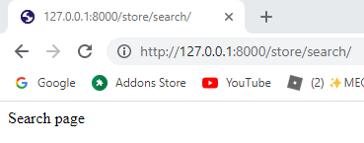

1. Replace the codes in the view.py under store folder (search function)

def search(request):

return render(request, 'store/store.html')

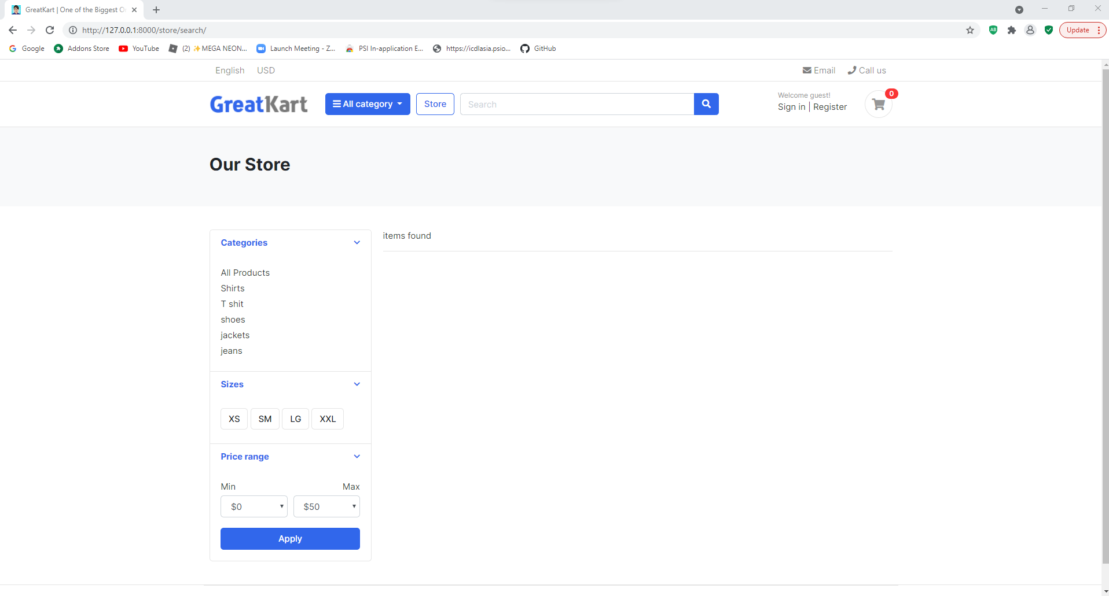

1. Edit navbar.html under includes folder under templates

Old

<form action="#" class="search">

<div class="input-group w-100">

<input type="text" class="form-control" style="width:60%;" placeholder="Search">

New

<form action="{% url 'search' %}" class="search" method='GET'>

<div class="input-group w-100">

<input type="text" class="form-control" style="width:60%;" placeholder="Search" name="keyword">

1. Edit codes in views.py under store folder

Old

def search(request):

return render(request, 'store/store.html')

New

from django.db.models import Q

&

def search(request):

if 'keyword' in request.GET:

keyword = request.GET['keyword']

if keyword:

products = Product.objects.order_by('-created_date').filter(Q(description__icontains=keyword) | Q(product_name__icontains=keyword))

product_count = products.count()

context = {

'products': products,

'product_count': product_count,

}

return render(request, 'store/store.html', context)

1. Edits store.html under store folder under templates folder

<!-- ========================= SECTION PAGETOP ========================= -->

<section class="section-pagetop bg">

<div class="container">

{% if 'search' in request.path %}

<h2 class="title-page">Search Result</h2>

{% else %}

<h2 class="title-page">Our Store</h2>

{% endif %}

</div> <!-- container // -->

</section>

<!-- ========================= SECTION INTRO END// ========================= -->

&

<div class="row">

{% if products %}

{% for product in products %}

<div class="col-md-4">

<figure class="card card-product-grid">

<div class="img-wrap">

<a href="{{ product.get_url }}"><img src="{{ product.images.url }}"></a>

</div> <!-- img-wrap.// -->

<figcaption class="info-wrap">

<div class="fix-height">

<a href="{{ product.get_url }}" class="title">{{ product.product_name }}</a>

<div class="price-wrap mt-2">

<span class="price">$ {{ product.price }}</span>

</div> <!-- price-wrap.// -->

</div>

<a href="{{ product.get_url }}" class="btn btn-block btn-primary">View Details </a>

</figcaption>

</figure>

</div> <!-- col.// -->

{% endfor %}

{% else %}

<div>

<h2> No result found. Please try again.</h2>

</div>

{% endif %}

</div> <!-- row end.// -->

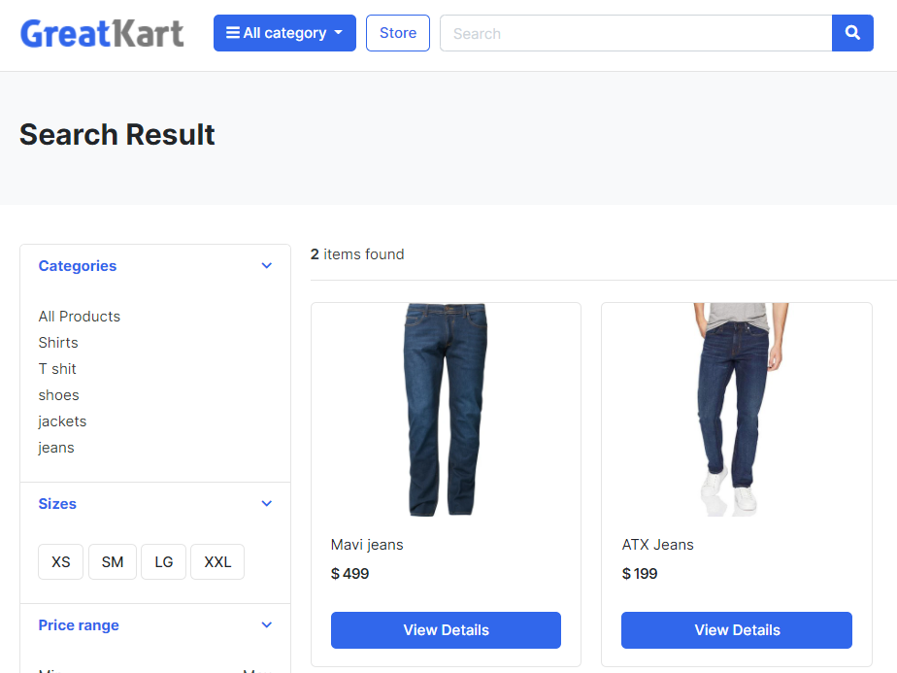

1. Edit the product_detail.html in store folder in templates folder (product variation color and size selection)

<form action="">

<article class="content-body">

…

</article> <!-- product-info-aside .// -->

</form>

1. Edit the product_detail.html under store folder under templates folder (product variation)

Old

<a href="{% url 'add_cart' single_product.id %}" class="btn btn-primary"> <span class="text">Add to Cart</span> <i class="fas fa-shopping-cart"></i> </a>

New

<button type="submit” class="btn btn-primary"> <span class="text">Add to Cart</span> <i class="fas fa-shopping-cart"></i> </button>

&

Old

<form action="">

New

<form action="{% url 'add_cart' single_product.id %}" method="GET">

1. Remove the lines in the product_detail.html under store folder under templates folder (color selection)

<div class="btn-group btn-group-sm btn-group-toggle" data-toggle="buttons">

<label class="btn btn-light">

<input type="radio" name="radio_color"> Silver

</label>

<label class="btn btn-light">

<input type="radio" name="radio_color" > Gray

</label>

<label class="btn btn-light active">

<input type="radio" name="radio_color checked"> Gold

</label>

<label class="btn btn-light">

<input type="radio" name="radio_color"> Black

</label>

</div>

1. Add the lines in the product_detail.html under store folder under templates folder (color selection)

<div class="item-option-select">

<h6>Choose Color</h6>

<select name ="color">

<option value="red">Red</option>

<option value="yellow">Yellow</option>

<option value="green">Green</option>

</select>

</div>

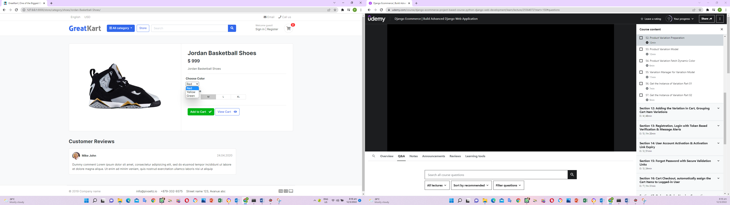

1. Remove the lines in the product_detail.html under store folder under templates folder (size selection)

<div class="btn-group btn-group-sm btn-group-toggle" data-toggle="buttons">

<label class="btn btn-light">

<input type="radio" name="radio_color"> S

</label>

<label class="btn btn-light active">

<input type="radio" name="radio_color" checked> M

</label>

<label class="btn btn-light">

<input type="radio" name="radio_color"> L

</label>

<label class="btn btn-light">

<input type="radio" name="radio_color"> XL

</label>

</div>

1. Add the lines in the product_detail.html under store folder under templates folder (size selection)

<div class="item-option-select">

<h6>Select Size</h6>

<select name ="size">

<option value="small">Small</option>

<option value="medium">Medium</option>

<option value="large">Large</option>

</select>

</div>

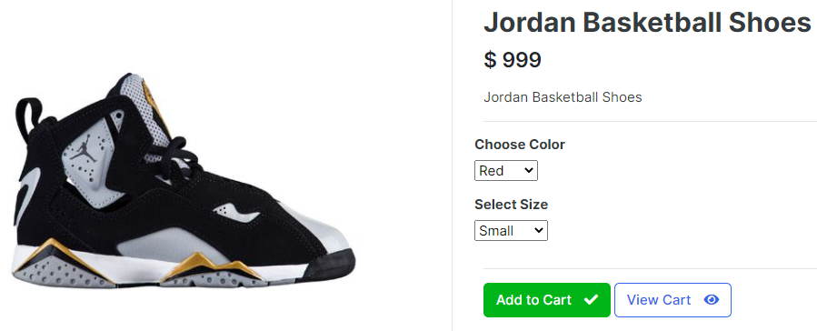

1. Replace the codes in the product_detail.html under store folder under templates folder

Old

<select name ="color">

<select name ="size">

New

<select name ="size" class="form-control">

<select name ="color" class="form-control">

1. Add lines in the views.py from carts folder

from django.http import HttpResponse

&

def add_cart(request, product_id):

color = request.GET['color']

size = request.GET['size']

return HttpResponse(color + ' ' + size)

exit()

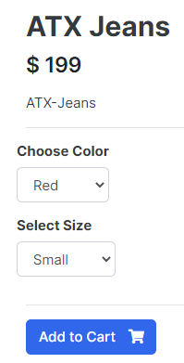 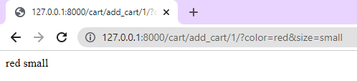

1. Add lines in the models.py in the store folder

def __str__(self):

return self.product_name

variation_category_choice = (

('color','color'),

('size','size'),

)

class Variation (models.Model):

product = models.ForeignKey(Product, on_delete=models.CASCADE)

variation_category = models.CharField(max_length=100, choices=variation_category_choice)

variation_value = models.CharField(max_length=100)

is_active = models.BooleanField(default=True)

created_date = models.DateTimeField(auto_now=True)

def __unicode__(self):

return self.product

1. Add lines in the admin.py in the store folder

from .models import Product, Variation

admin.site.register(Variation)

1. Migrate the changes thru CMD

python manage.py makemigrations

python manage.py migrate

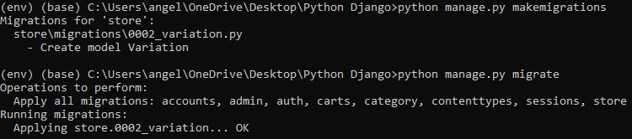

1. Log in admin page and ADD VARIATION in the Variations under STORE and press SAVE

Product: ATX Jeans

Variation category: color

Variation value: Red

Repeat the loop for Blue and Green

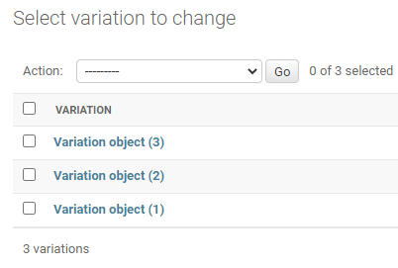

1. Add lines in the admin.py under store folder

class VariationAdmin(admin.ModelAdmin):

list_display =('product', 'variation_category', 'variation_value', 'is_active')

admin.site.register(Product, ProductAdmin)

admin.site.register(Variation, VariationAdmin)

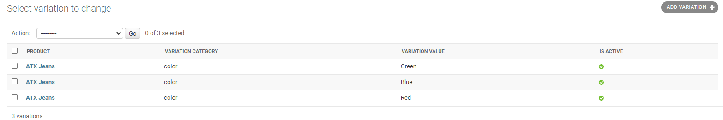

1. Add 1 line in the admin.py under store folder

list_display =('product', 'variation_category', 'variation_value', 'is_active')

list_editable = ('is_active',)

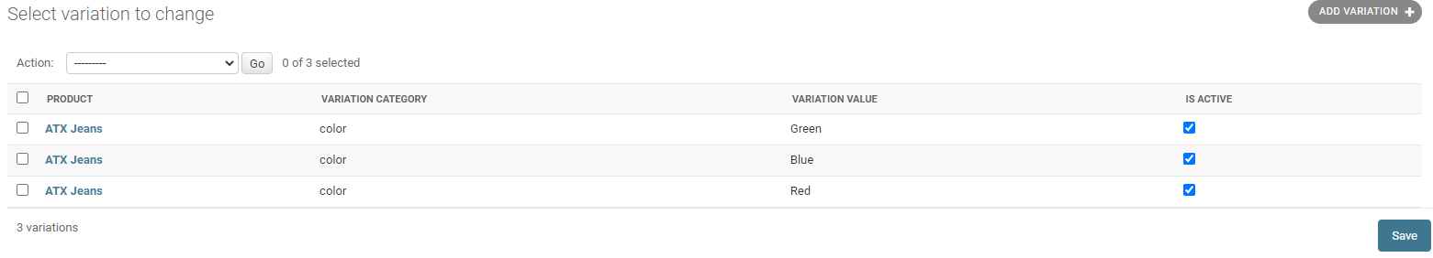

1. Add 1 line in the admin.py under store folder

list_editable = ('is_active',)

list_filter = ('product', 'variation_category', 'variation_value')

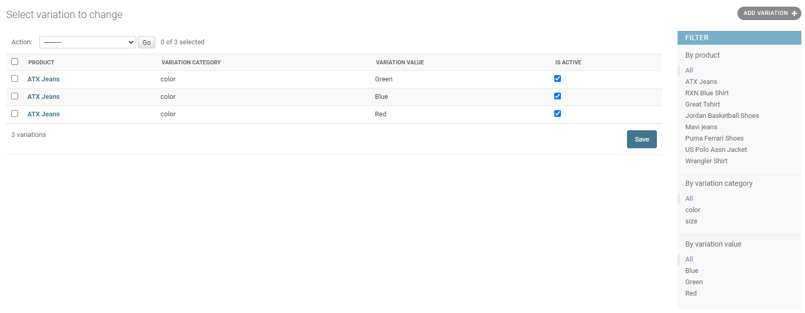

1. Edit lines in the product_detail.html under store folder in template folder

Old

<select name ="color" class="form-control">

<option value="red">Red</option>

<option value="yellow">Yellow</option>

<option value="green">Green</option>

</select>

New

<select name ="color" class="form-control">

{% for i in single_product.variation_set.all %}

<option value="{{ i.variation_value }}">{{ i.variation_value }}</option>

{% endfor %}

</select>

& edit and add line as follow

<select name ="color" class="form-control" required>

<option value ="" disabled selected>Choose Color</option>

1. Add lines in the models.py under store folder

class VariationManager(models.Manager):

def colors(self):

return super (VariationManager, self).filter(variation_category='color', is_active=True)

def sizes(self):

return super (VariationManager, self).filter(variation_category='size', is_active=True)

1. Edit line in the product_detail.html under store folder in template folder

Old

<div class="item-option-select">

<h6>Choose Color</h6>

<select name ="color" class="form-control" required>

<option value ="" disabled selected>Choose Color</option>

{% for i in single_product.variation_set.all %}

<option value="{{ i.variation_value }}">{{ i.variation_value }}</option>

{% endfor %}

</select>

</div>

</div> <!-- row.// -->

<div class="row">

<div class="item-option-select">

<h6>Select Size</h6>

<select name ="size" class="form-control">

<option value="small">Small</option>

<option value="medium">Medium</option>

<option value="large">Large</option>

</select>

</div>

New

<div class="item-option-select">

<h6>Choose Color</h6>

<select name ="color" class="form-control" required>

<option value ="" disabled selected>Choose Color</option>

{% for i in single_product.variation_set.colors %}

<option value="{{ i.variation_value | lower }}">{{ i.variation_value | capfirst }}</option>

{% endfor %}

</select>

</div>

</div> <!-- row.// -->

<div class="row">

<div class="item-option-select">

<h6>Select Size</h6>

<select name ="size" class="form-control">

{% for i in single_product.variation_set.sizes %}

<option value="{{ i.variation_value | lower }}">{{ i.variation_value | capfirst }}</option>

{% endfor %}

</select>

</div>

1. Insert 1 line in the models.py in the store folder

objects = VariationManager()

def __str__(self):

return self.variation_value

1. Edit line in the product_detail.html under store folder in template folder

<select name ="size" class="form-control" required>

<option value ="" disabled selected>Choose Size</option>

1. Add size variation in admin page as follow

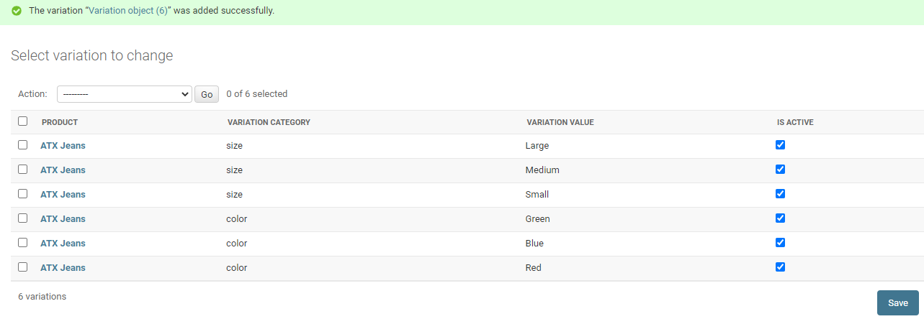

1. Edit codes in the product_detail.html under store folder in template folder

Old

<form action="{% url 'add_cart' single_product.id %}" method="GET">

New

<form action="{% url 'add_cart' single_product.id %}" method="POST">

{% csrf_token %}

1. Edit codes in the views.py under carts folder

Old

def add_cart(request, product_id):

color = request.GET['color']

size = request.GET['size']

return HttpResponse(color + ' ' + size)

exit()

New

def add_cart(request, product_id):

if request.method == 'POST':

color = request.POST['color']

size = request.POST['size']

1. Replace codes in the views.py under carts folder

Old

if request.method == 'POST':

color = request.POST['color']

size = request.POST['size']

New

from store.models import Product, Variation

&

def add_cart(request, product_id):

product = Product.objects.get(id=product_id) #get the product

product_variation = []

if request.method == 'POST':

for item in request.POST:

key = item

value = request.POST[key]

try:

variation = Variation.objects.get(product=product, variation_category__iexact=key, variation_value__iexact=value)

product_variation.append(variation)

except:

pass

1. Add line in the models.py under carts folder

from store.models import Product, Variation

&

variations = models.ManyToManyField(Variation, blank=True)

&

def __unicode__(self):

return self.product

1. Migrate the changes thru CMD

python manage.py makemigrations

python manage.py migrate

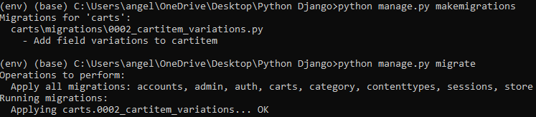

1. Edit admin.py under carts folder

from django.contrib import admin

from .models import Cart, CartItem

# Register your models here.

class CartAdmin(admin.ModelAdmin):

list_display = ('cart_id' , 'date_added')

class CartItemAdmin(admin.ModelAdmin):

list_display = ('product' , 'cart' , 'quantity','is_active')

admin.site.register(Cart)

admin.site.register(CartItem, CartItemAdmin)

1. Add comments and codes in the view.py under carts folder

#product variation codes

product = Product.objects.get(id=product_id) #get the product

&

#cart codes

try:

cart = Cart.objects.get(cart_id=_cart_id(request)) #get the cart using the cart_id present in the session

&

#cart item codes

try:

cart_item = CartItem.objects.get(product=product, cart=cart)

&

cart_item = CartItem.objects.get(product=product, cart=cart)

if len(product_variation) > 0:

for item in product_variation:

cart_item.variations.add(item)

cart_item.quantity += 1 # cart_item.quantity = cart_item.quantity + 1

&

cart = cart,

)

if len(product_variation) > 0:

for item in product_variation:

cart_item.variations.add(item)

cart_item.save()

return redirect('cart')

1. Edit the lines in product_detail.html under store folder in template folder

Old

{% if single_product.stock <= 0 %}

<h5 class="text-danger">Out of Stock</h5>

{% else %}

{% if in_cart %}

<a href="#" class="btn btn-success"> <span class="text">Add to Cart</span> <i class="fas fa-check"></i> </a>

<a href="{% url 'cart' %}" class="btn btn-outline-primary"> <span class="text">View Cart</span> <i class="fas fa-eye"></i> </a>

{% else %}

<button type="submit" class="btn btn-primary"> <span class="text">Add to Cart</span> <i class="fas fa-shopping-cart"></i> </button>

{% endif %}

{% endif %}

New

{% if single_product.stock <= 0 %}

<h5 class="text-danger">Out of Stock</h5>

{% else %}

<button type="submit" class="btn btn-primary"> <span class="text">Add to Cart</span> <i class="fas fa-shopping-cart"></i> </button>

{% endif %}

1. Edit views.py under carts folder

if len(product_variation) > 0:

cart_item.variations.clear()

for item in product_variation:

cart_item.variations.add(item)

cart_item.quantity += 1 # cart_item.quantity = cart_item.quantity + 1

cart_item.save()

except CartItem.DoesNotExist:

cart_item = CartItem.objects.create(

product = product,

quantity = 1,

cart = cart,

)

if len(product_variation) > 0:

cart_item.variations.clear()

for item in product_variation:

1. Edit cart.html under store folder under templates folder

Old

<p class="text-muted small">Matrix: 25 Mpx <br> Brand: Canon</p>

New

<p class="text-muted small">

{% if cart_item.variations.all %}

{% for item in cart_item.variations.all %}

{{ item.variation_category | capfirst }} : {{ item.variation_value | capfirst }} <br>

{% endfor %}

{% endif %}

</p>

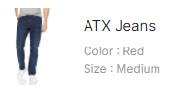

1. Edit views.py under carts folder

Old

#cart item codes

try:

cart_item = CartItem.objects.get(product=product, cart=cart)

New

#cart item codes

try:

cart_item = CartItem.objects.create(product=product, quantity=1, cart=cart)

if len(product_variation) > 0:

cart_item.variations.clear()

for item in product_variation:

cart_item.variations.add(item)

#cart_item.quantity += 1 # cart_item.quantity = cart_item.quantity + 1

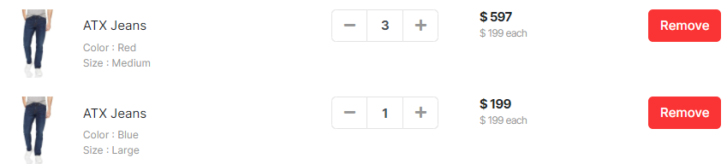

1. Edit codes in views.py under carts folder

#cart item codes

is_cart_item_exists = CartItem.objects.filter(product=product, cart=cart).exists()

if is_cart_item_exists:

cart_item = CartItem.objects.filter(product=product, cart=cart)

# existing_variation -> database

# current variation -> product_variation

# item_id -> database

ex_var_list = []

id = []

for item in cart_item:

existing_variation = item.variations.all()

ex_var_list.append(list(existing_variation))

id.append(item.id)

print(ex_var_list)

if product_variation in ex_var_list:

# increase the cart item quantity

index = ex_var_list.index(product_variation)

item_id = id[index]

item = CartItem.objects.get(product=product, id=item_id)

item.quantity += 1

item.save()

else:

item = CartItem.objects.create(product=product, quantity=1, cart=cart)

if len(product_variation) > 0:

item.variations.clear()

item.variations.add(*product_variation)

item.save()

else:

cart_item = CartItem.objects.create(

product = product,

quantity = 1,

cart = cart,

)

if len(product_variation) > 0:

cart_item.variations.clear()

cart_item.variations.add(*product_variation)

cart_item.save()

return redirect('cart')

The - + remove button not working.

1. Edit codes in the cart.html in the store folder under the templates folder

<div class="input-group-append">

<form action="{% url 'add_cart' cart_item.product.id %}" method="POST">

{% csrf_token %}

{% for item in cart_item.variations.all %}

<input type="hidden" name="{{ item.variation_category | lower }}" value="{{ item.variation_value | capfirst }}">

{% endfor %}

<button class="btn btn-light" type="submit" id="button-minus"> <i class="fa fa-plus"></i> </button>

</form>

</div>

User able to add item no in the cart page

1. Edit views.py in the carts folder

def remove_cart(request, product_id, cart_item_id):

1. Edit codes in the cart.html in the store folder under the templates folder

<a href="{% url 'remove_cart' cart_item.product.id cart_item.id %}" class="btn btn-light" type="button" id="button-plus"> <i class="fa fa-minus"></i> </a>

1. Edit codes in the urls.py under carts folder

path('remove_cart/<int:product_id>/<int:cart_item_id>/', views.remove_cart, name='remove_cart'),

1. Edit views.py in the carts folder

def remove_cart(request, product_id, cart_item_id):

cart = Cart.objects.get(cart_id=_cart_id(request))

product = get_object_or_404(Product, id=product_id)

try:

cart_item = CartItem.objects.get(product=product, cart=cart, id=cart_item_id)

if cart_item.quantity > 1:

cart_item.quantity -= 1

cart_item.save()

else:

cart_item.delete()

except:

pass

return redirect('cart')

User able to decrease the no of item in the cart page

1. Edit codes in the cart.html in the store folder under the templates folder

<a href="{% url 'remove_cart_item' cart_item.product.id cart_item.id %}" class="btn btn-danger"> Remove</a>

1. Edit codes in the urls.py under carts folder

path('remove_cart_item/<int:product_id>/<int:cart_item_id>/', views.remove_cart_item, name='remove_cart_item'),

1. Edit views.py in the carts folder

def remove_cart_item(request, product_id, cart_item_id):

cart = Cart.objects.get(cart_id=_cart_id(request))

product = get_object_or_404(Product, id=product_id)

cart_item = CartItem.objects.get(product=product, cart=cart, id=cart_item_id)

cart_item.delete()

return redirect('cart')

user able to remove item in the cart page

1. Edit code in the cart.html in the store folder under the templates folder

<a href="{% url 'remove_cart_item' cart_item.product.id cart_item.id %}" onclick="return confirm('Are you sure you want to delete this item?')" class="btn btn-danger"> Remove</a>

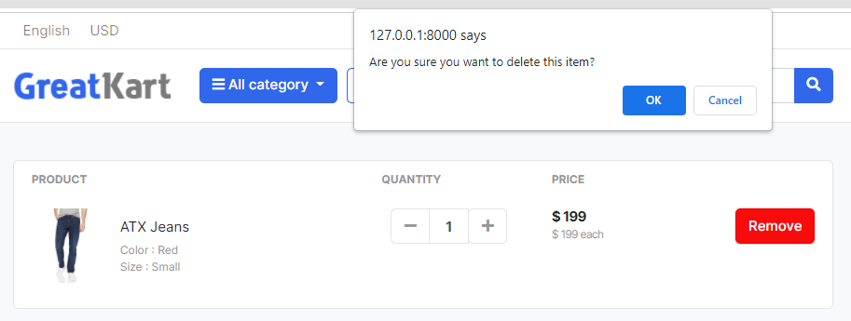

1. Push Code to GitHub on CMD

git status

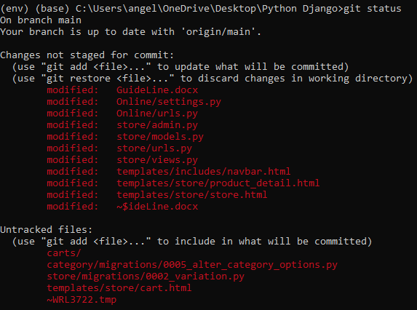

git add –A

git commit -m "store and carts functionality"

git push origin main

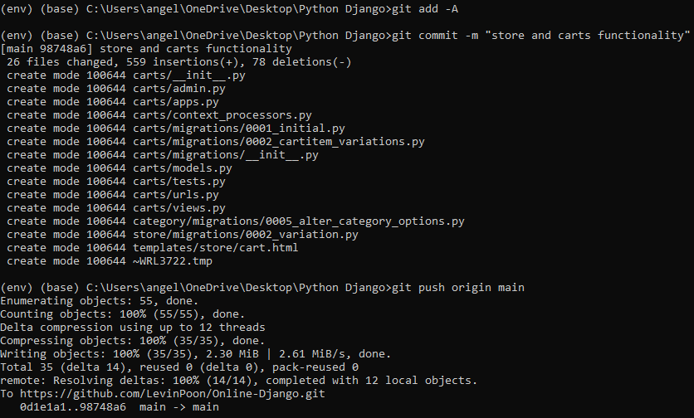

1. Create urls.py in the accounts folder and add lines

from django.urls import path

from . import views

urlpatterns = [

path('register/', views.register, name='register'),

path('login/', views.login, name='login'),

path('logout/', views.logout, name='logout'),

]

1. Add line in the urls.py in the online folder

path('cart/', include('carts.urls')),

path('accounts/', include('accounts.urls')),

1. Add lines in the views.py under accounts folder

from django.shortcuts import render

def register(request):

return render(request, 'accounts/register.html')

def login(request):

return render(request, 'accounts/login.html')

def logout(request):

return

1. Create accounts folder in the templates folder
2. Create and add lines in register.html under accounts folder under templates folder

{% extends 'base.html' %}

{% block content %}

{% endblock %}

1. Create login.html under accounts folder under templates folder

{% extends 'base.html' %}

{% block content %}

{% endblock %}

1. Edit codes in navbar.html under includes folder under templates folder (Register page)

Old

<a href="./signin.html">Sign in</a> <span class="dark-transp"> | </span>

<a href="./register.html"> Register</a>

New

<a href="{% url 'login' %}">Sign in</a> <span class="dark-transp"> | </span>

<a href="{% url 'register' %}"> Register</a>

1. Copy the codes from register.html under sample project folder to register.html under accounts folder under templates folder

Copy

<!-- ========================= SECTION CONTENT ========================= -->

…

<!-- ========================= SECTION CONTENT END// ========================= -->

Paste between

{% block content %}

…

{% endblock %}

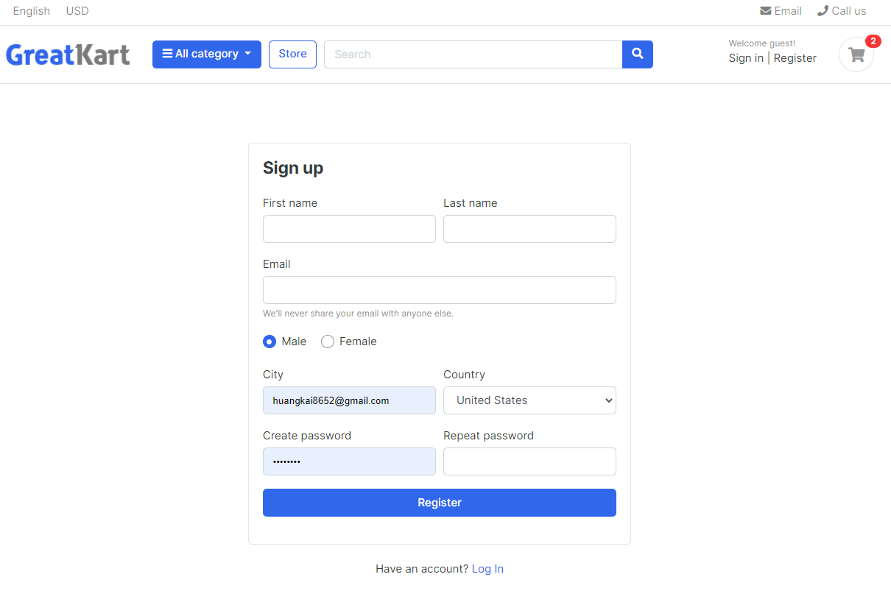

1. 1
2. Create and add lines in the forms.py under accounts folder

from django import forms

from .models import Account

class RegistrationForm (forms.ModelForm):

class Meta:

model = Account

fields = ['first_name','last_name','phone_number','email','password']

1. Add line in the views.py under accounts folder

from django shortcuts import render.

from .forms import RegistrationForm

def register(request):

form = RegistrationForm()

context = {

'form': form,

}

return render(request, 'accounts/register.html',context)

def login(request):

return render(request, 'accounts/login.html')

def logout(request):

return

1. Add line in the register.html under accounts folder under templates folder

<header class="mb-4"><h4 class="card-title">Sign up</h4></header>

<form action="{% url 'register’ %}" method="POST">

{% csrf_token %}

{{ form.as_p }}

<div class="form-row">

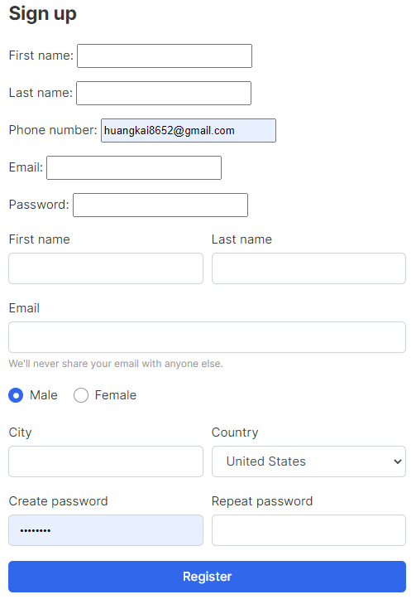

1. Edit line in the register.html under accounts folder under templates folder

Remove this line

{{ form.as_p }}

Remove these line

<div class="form-group">

<label class="custom-control custom-radio custom-control-inline">

<input class="custom-control-input" checked="" type="radio" name="gender" value="option1">

<span class="custom-control-label"> Male </span>

</label>

<label class="custom-control custom-radio custom-control-inline">

<input class="custom-control-input" type="radio" name="gender" value="option2">

<span class="custom-control-label"> Female </span>

</label>

</div> <!-- form-group end.// -->

Old

<label>First name</label>

<input type="text" class="form-control" placeholder="">

&

<label>Last name</label>

<input type="text" class="form-control" placeholder="">

New

<label>First name</label>

{{ form.first_name }}

&

<label>Last name</label>

{{ form.last_name }}

Old

<label>City</label>

<input type="text" class="form-control">

New

<label>Email Address</label>

{{ form.email }}

Remove the email codes

<div class="form-group">

<label>Email</label>

<input type="email" class="form-control" placeholder="">

<small class="form-text text-muted">We'll never share your email with anyone else.</small>

</div> <!-- form-group end.// -->

&

<select id="inputState" class="form-control">

<option> Choose...</option>

<option>Uzbekistan</option>

<option>Russia</option>

<option selected="">United States</option>

<option>India</option>

<option>Afganistan</option>

</select>

Old

<label>Country</label>

New

<label>Phone Number</label>

{{ form.phone_number }}

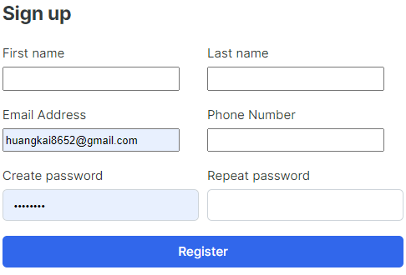

1. Edit forms.py in the accounts

from django import forms

from .models import Account

class RegistrationForm (forms.ModelForm):

password = forms.CharField(widget=forms.PasswordInput(attrs={

'placeholder':'Enter Password',

}))

class Meta:

model = Account

fields = ['first_name','last_name','phone_number','email','password']

1. Edit line in the register.html under accounts folder under templates folder

Old

<label> Create password</label>

<input class="form-control" type="password">

New

<label>Create password</label>

{{ form.password }}

1. Edit forms.py in the accounts

}))

confirm_password = forms.CharField(widget=forms.PasswordInput(attrs={

'placeholder':'Confirm Password'

}))

class Meta:

1. Edit line in the register.html under accounts folder under templates folder

Old

<label>Repeat password</label>

<input class="form-control" type="password">

New

<label>Repeat password</label>

{{ form.confirm_password }}

1. Edit forms.py in the accounts

'placeholder':'Enter Password',

'class':'form-control',

}))

confirm_password = forms.CharField(widget=forms.PasswordInput(attrs={

'placeholder':'Confirm Password'

}))

class Meta:

model = Account

fields = ['first_name','last_name','phone_number','email','password']

def __init__ (self, *args, **kwargs):

super (RegistrationForm, self).__init__(*args, **kwargs)

for field in self.fields:

self.fields[field].widget.attrs['class'] = 'form-control'

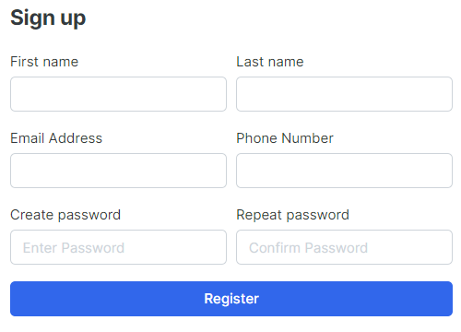

1. Edit forms.py in the accounts

def __init__ (self, *args, **kwargs):

super (RegistrationForm, self).__init__(*args, **kwargs)

self.fields['first_name'].widget.attrs['placeholder'] = 'Enter First Name'

self.fields['last_name'].widget.attrs['placeholder'] = 'Enter Last Name'

self.fields['phone_number'].widget.attrs['placeholder'] = 'Enter Phone Number'

self.fields['email'].widget.attrs['placeholder'] = 'Enter Email Address'

for field in self.fields:

self.fields[field].widget.attrs['class'] = 'form-control'

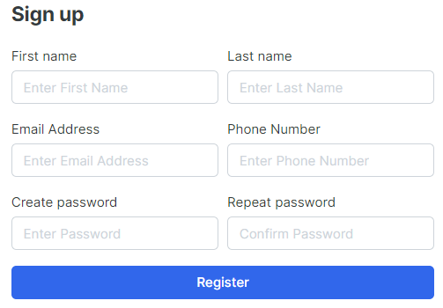

1. Edit codes in the views.py under accounts folder

from django.shortcuts import render

from .forms import RegistrationForm

from .models import Account

def register(request):

if request.method == 'POST':

form = RegistrationForm(request.POST)

if form.is_valid():

first_name = form.cleaned_data['first_name']

last_name = form.cleaned_data['last_name']

phone_number = form.cleaned_data['phone_number']

email = form.cleaned_data['email']

password = form.cleaned_data['password']

username = email.split("@")[0]

user = Account.objects.create_user(first_name=first_name,last_name=last_name, email=email, username=username, password=password)

user.phone_number = phone_number

user.save()

else:

form = RegistrationForm()

context = {

'form': form,

}

return render(request, 'accounts/register.html',context)

def login(request):

return render(request, 'accounts/login.html')

def logout(request):

return

User register a new user

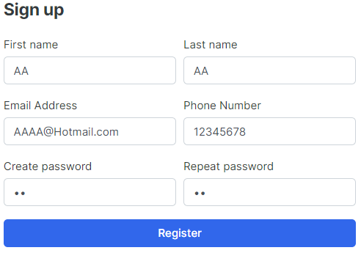



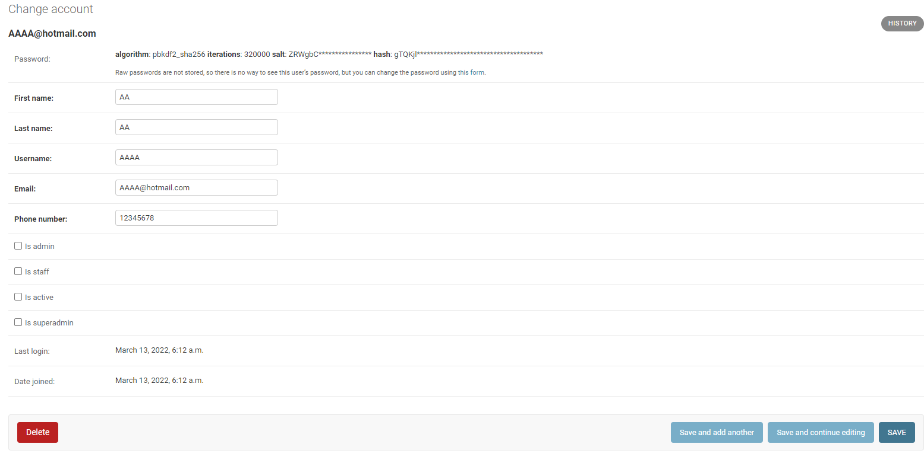

1. Edit codes in the forms.py under accounts folder

from django import forms

from .models import Account

class RegistrationForm (forms.ModelForm):

password = forms.CharField(widget=forms.PasswordInput(attrs={

'placeholder':'Enter Password',

'class':'form-control',

}))

confirm_password = forms.CharField(widget=forms.PasswordInput(attrs={

'placeholder':'Confirm Password'

}))

class Meta:

model = Account

fields = ['first_name','last_name','phone_number','email','password']

def clean(self):

cleaned_data = super(RegistrationForm, self).clean()

password = cleaned_data.get('password')

confirm_password = cleaned_data.get('confirm_password')

if password != confirm_password:

raise forms.ValidationError(

"Password does not match!"

)

def __init__ (self, *args, **kwargs):

super (RegistrationForm, self).__init__(*args, **kwargs)

self.fields['first_name'].widget.attrs['placeholder'] = 'Enter First Name'

self.fields['last_name'].widget.attrs['placeholder'] = 'Enter Last Name'

self.fields['phone_number'].widget.attrs['placeholder'] = 'Enter Phone Number'

self.fields['email'].widget.attrs['placeholder'] = 'Enter Email Address'

for field in self.fields:

self.fields[field].widget.attrs['class'] = 'form-control'

1. Edit line in the register.html under accounts folder under templates folder

</div> <!-- form-group// -->

{{ form.errors }}

{{ form.non_field_errors }}

</form>

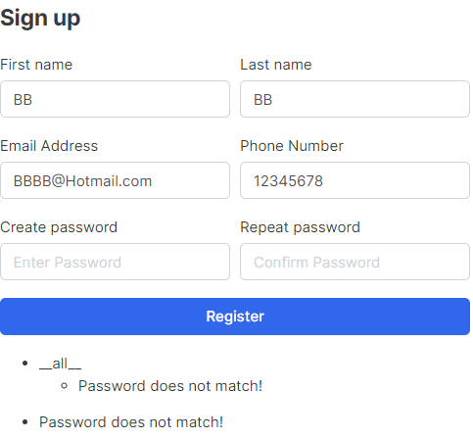

1. Edit code in the register.html under accounts folder under templates folder

</div> <!-- form-group// -->

{{ form.email.errors }}

{{ form.non_field_errors }}

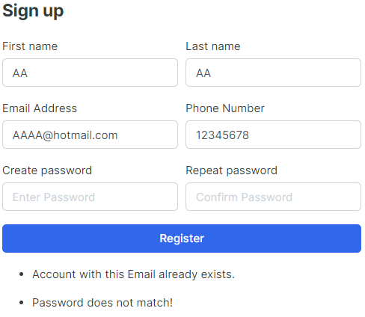

1. Add lines in the settings.py under the online folder

DEFAULT_AUTO_FIELD = 'django.db.models.BigAutoField'

from django.contrib.messages import constants as messages

MESSAGE_TAGS = {

messages.ERROR: 'danger',

}

1. Create and add lines alerts.html in the includes folder in the templates folder

{% if messages %}

<ul class="messages">

{% for message in messages %}

<li{% if message.tags %} class="{{ message.tags }}" {% endif %}>

{% if message.level == DEFAULT_MESSAGE_LEVELS>ERROR %} IMportant: {% endif %}

{{ message }}

</li>

{% endfor %}

</ul>

{% endif %}

1. Edit code in the register.html under accounts folder under templates folder

Old

<article class="card-body">

<header class="mb-4"><h4 class="card-title">Sign up</h4></header>

New

<article class="card-body">

{% include 'includes/alerts.html' %}

<header class="mb-4"><h4 class="card-title">Sign up</h4></header>

1. Edit codes in the views.py under accounts folder

from django.shortcuts import render, redirect

from .forms import RegistrationForm

from .models import Account

from django.contrib import messages

&

user.save()

messages.success(request, 'Registration successful.')

return redirect('register')

1. Edit lines alerts.html in the includes folder in the templates folder

{% if messages %}

{% for message in messages %}

<div id="message" class="container">

<div {% if message.tags %} class="alert alert-{{ message.tags }}" {% endif %} role="alert">

<button type="button" class="close" data-dismiss="alert"><span aria-hidden="true">&times;</span></button>

{% if message.level == DEFAULT_MESSAGE_LEVELS.ERROR %} Important: {% endif %}

{{ message }}

</div>

</div>

{% endfor %}

{% endif %}

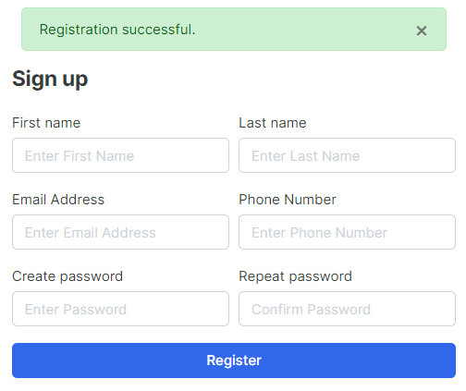

1. Add 3 lines in the after last lines in script.js in the JS folder in the static folder under online folder

setTimeout(function(){

$('#message').fadeOut('slow')

},4000)

Registration successful message will auto disappear in 4 seconds

1. Copy the codes from signin.html under sample project folder to login.html under accounts folder under templates folder (login page)

Copy

<!-- ========================= SECTION CONTENT ========================= -->

…

<!-- ========================= SECTION CONTENT END// ========================= -->

Paste

{% block content %}

<!-- ========================= SECTION CONTENT ========================= -->

<section class="section-conten padding-y" style="min-height:84vh">

<!-- ============================ COMPONENT LOGIN ================================= -->

<div class="card mx-auto" style="max-width: 380px; margin-top:100px;">

<div class="card-body">

<h4 class="card-title mb-4">Sign in</h4>

<form>

<div class="form-group">

<input type="email" class="form-control" placeholder="Email Address" >

</div> <!-- form-group// -->

<div class="form-group">

<input type="password" class="form-control" placeholder="Password" >

</div> <!-- form-group// -->

<div class="form-group">

<a href="#" class="float-right">Forgot password?</a>

</div> <!-- form-group form-check .// -->

<div class="form-group">

<button type="submit" class="btn btn-primary btn-block"> Login </button>

</div> <!-- form-group// -->

</form>

</div> <!-- card-body.// -->

</div> <!-- card .// -->

<p class="text-center mt-4">Don't have account? <a href="{% url 'register' %}">Sign up</a></p>

<br><br>

<!-- ============================ COMPONENT LOGIN END.// ================================= -->

</section>

<!-- ========================= SECTION CONTENT END// ========================= -->

{% endblock %}

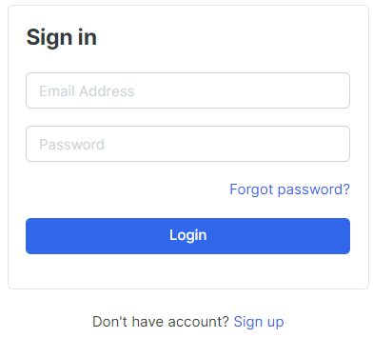

1. Edit codes in the register.html under accounts folder under templates holder

Old

<p class="text-center mt-4">Have an account? <a href="">Log In</a></p>

New

<p class="text-center mt-4">Have an account? <a href="{% url ‘login’ %}">Log In</a></p>

1. Edit codes in login.html in the accounts folder in the templates folder

Old

<h4 class="card-title mb-4">Sign in</h4>

<form>

<div class="form-group">

&

<input type="email" class="form-control" placeholder="Email Address" >

&

<input type="password" class="form-control" placeholder="Password" >

New

<form action="{% url 'login' %}" method="POST">

{% csrf_token %}

<div class="form-group">

&

<input type="email" class="form-control" placeholder="Email Address" name=”email”>

&

<input type="password" class="form-control" placeholder="Password" name=”password”>

1. Edit views.py under accounts folder

Old

def login(request):

return render(request, 'accounts/login.html')

New

from django.contrib import messages, auth

&

def login(request):

if request.method == 'POST':

email = request.POST['email']

password = request.POST['password']

user = auth.authenticate(email=email, password=password)

if user is not None:

auth.login(request, user)

# message.success(request, 'You are now logged in.')

return redirect('home')

else:

messages.error(request, 'Invalid login credentials')

return redirect(‘login’)

return render(request, 'accounts/login.html')

1. Add lines in the login.html under accounts folder under templates folder

<h4 class="card-title mb-4">Sign in</h4>

{% include 'includes/alerts.html' %}

<form action="{% url 'login' %}" method="POST">

1. Edit code in alerts.html in the includes folder templates folder

Old

{% if message.level == DEFAULT_MESSAGE_LEVELS.ERROR %} Important: {% endif %}

New

{% if message.level == DEFAULT_MESSAGE_LEVELS.ERROR %} Error: {% endif %}

1. Edit navbar.html under includes folder in the templates folder

Old

<div class="d-flex justify-content-end mb-3 mb-lg-0">

<div class="widget-header">

&

</div>

<a href="{% url 'cart' %}" class="widget-header pl-3 ml-3">

New

<div class="d-flex justify-content-end mb-3 mb-lg-0">

{% if user.id is None %}

<div class="widget-header">

&

</div>

{% else %}

<div class="widget-header">

<small class="title text-muted">Welcome {{user.first_name}}!</small>

<div>

<a href="#">Dashbaord</a> <span class="dark-transp"> | </span>

<a href="{% url 'logout' %}"> Logout</a>

</div>

</div>

{% endif %}

<a href="{% url 'cart' %}" class="widget-header pl-3 ml-3">

1. Add and Edit views.py under accounts (log out button)

Add lines

from django.contrib.auth.decorators import login_required

&

Replace logout codes

@login_required(login_url = 'login')

def logout(request):

auth.logout(request)

messages.success(request, "You are logged out.")

return redirect('login')

1. Add and replace lines in the views.py in the account folder (Activation link with token for email verification upon user register)

Add

#Verification email

from django.contrib.sites.shortcuts import get_current_site

from django.template.loader import render_to_string

from django.utils.http import urlsafe_base64_encode, urlsafe_base64_decode

from django.utils.encoding import force_bytes

from django.contrib.auth.tokens import default_token_generator

from django.core.mail import EmailMessage

Old

user.save()

messages.success(request, 'Registration successful.')

return redirect('register')

else:

New

user.save()

#user activation

current_site = get_current_site(request)

mail_subject = 'Please activate your account'

message = render_to_string('accounts/account_verification_email.html', {

'user': user,

'domain': current_site,

'uid': urlsafe_base64_encode(force_bytes(user.pk)),

'token': default_token_generator.make_token(user),

})

to_email = email

send_email = EmailMessage(mail_subject, message, to=[to_email])

send_email.send()

messages.success(request, 'Registration successful.')

1. Create and add lines in account_verification_email.html in the accounts folder in the templates folder

{% autoescape off %}

Hi {{user.first_name}},

Please click on below link to confirm your registration.

http://{{domain}}{% url 'activate' uidb64=uid token=token %}

if your think it's not you, please ignore this email.

{% endautoescape %}

1. Edit codes settings.py in the online folder

#SMTP configuration GMAIL

EMAIL_HOST = 'smtp.gmail.com'

EMAIL_PORT = 587

EMAIL_HOST_USER = 'onlinedjango1314@gmail.com'

EMAIL_HOST_PASSWORD = '!q2w3e4R'

EMAIL_USE_TLS = True

1. Create Gmail account

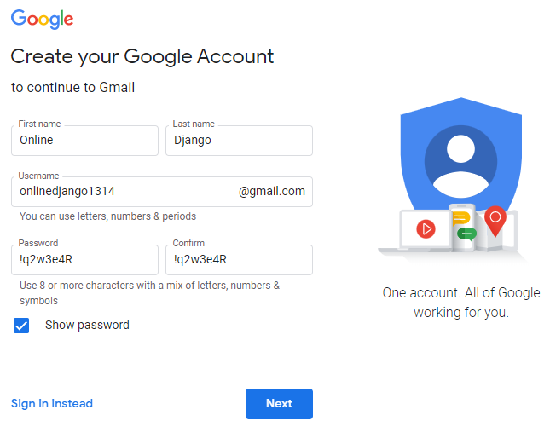

1. Add lines in the last row in the views.py in the accounts folder

def activate(request, uidb64, token):

try:

uid = urlsafe_base64_decode(uidb64).decode()

user = Account._default_manager.get(pk=uid)

except(TypeError, ValueError, OverflowError, Account.DoesNotExist):

user = None

if user is not None and default_token_generator.check_token(user, token):

user.is_active = True

user.save()

messages.success(request, 'Congratulations! Your account is activated.')

return redirect('login')

else:

messages.error(request,'Invalid activation link')

return redirect('register')

1. Edit urls.py in the accounts folder

path('logout/', views.logout, name='logout'),

path('activate/<uidb64>/<token>/', views.activate, name='activate'),

]

1. Edits lines views.py in the accounts folder

send_email.send()

#messages.success(request, 'Registration successful.')

return redirect('/accounts/login/?command=verification&email='+email)

else:

1. Edit lines in the login.html in the accounts folder and templates folder

{% extends 'base.html' %}

{% block content %}

<!-- ========================= SECTION CONTENT ========================= -->

<section class="section-conten padding-y" style="min-height:84vh">

<!-- ============================ COMPONENT LOGIN ================================= -->

{% if reuqest.GET.command == 'verification' %}

<div class="container mx-auto alert alett-info text-center" role="alert" style="max-width: 1024px; margin-top:100px;">

Thank you for reistering with us. We have sent you a verification email to your email [{{request.GET.email }}]

<br><br>

Already verified? <a href="{% url 'login’ %}">Login</a>

</div>

{% else %}

<div class="card mx-auto" style="max-width: 380px; margin-top:100px;">

<div class="card-body">

<h4 class="card-title mb-4">Sign in</h4>

{% include 'includes/alerts.html' %}

<form action="{% url 'login' %}" method="POST">

{% csrf_token %}

<div class="form-group">

<input type="email" class="form-control" placeholder="Email Address" name="email">

</div> <!-- form-group// -->

<div class="form-group">

<input type="password" class="form-control" placeholder="Password" name="password">

</div> <!-- form-group// -->

<div class="form-group">

<a href="#" class="float-right">Forgot password?</a>

</div> <!-- form-group form-check .// -->

<div class="form-group">

<button type="submit" class="btn btn-primary btn-block"> Login </button>

</div> <!-- form-group// -->

</form>

</div> <!-- card-body.// -->

</div> <!-- card .// -->

<p class="text-center mt-4">Don't have account? <a href="{% url 'register' %}">Sign up</a></p>

<br><br>

<!-- ============================ COMPONENT LOGIN END.// ================================= -->

{% endif %}

</section>

<!-- ========================= SECTION CONTENT END// ========================= -->

{% endblock %}

Password: 11

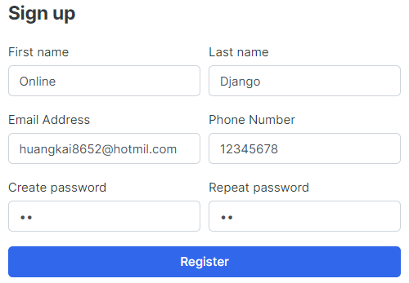

User click link and able to log in with new register email

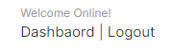

1. Add urls.py under accounts folder (dashboard button)

path('logout/', views.logout, name='logout'),

path('dashboard/', views.dashboard, name='dashboard'),

path('activate/<uidb64>/<token>/', views.activate, name='activate'),

1. Edit lines in the navbar.html in the includes folder in the templates folder

Old

<a href="#">Dashbaord</a> <span class="dark-transp"> | </span>

New

<a href="{% url ‘dashboard’ %}">Dashbaord</a> <span class="dark-transp"> | </span>

1. Add lines below the last row in the views.py in the accounts folder

@login_required(login_url = 'login')

def dashboard(request):

return render(request, 'accounts/dashboard.html')

1. Create and add lines in the dashboard.html under accounts folder under templates folder

{% extends 'base.html' %}

{% block content %}

{% endblock %}

1. Copy dashboard.html content from project sample folder to dashboard.html in the accounts folder in the templates folder

Copy

<!-- ========================= SECTION CONTENT ========================= -->

…

…

<!-- ========================= SECTION CONTENT END// ========================= -->

Paste

{% block content %}

…

{% endblock %}

1. Edit views.py under accounts folder

Old

return redirect('home')

else:

New

return redirect('dashboard')

else:

&

Old

auth.login(request, user)

#message.success(request, 'You are now logged in.')

return redirect('dashboard')

New

auth.login(request, user)

messages.success(request, 'You are now logged in.')

return redirect('dashboard')

1. Add lines in the dashboard.html under accounts folder under templates folder

<section class="section-conten padding-y bg">

{% include 'includes/alerts.html' %}

<div class="container">

1. Edit codes in the dashboard.html under accounts folder under templates folder

Old

<a class="btn btn-light btn-block" href="#"> <i class="fa fa-power-off"></i> <span class="text">Log out</span> </a>

New

<a class="btn btn-light btn-block" href="{% url 'logout' %}"> <i class="fa fa-power-off"></i> <span class="text">Log out</span> </a>

1. Add line in the urls.py in the accounts folder

path('dashboard/', views.dashboard, name='dashboard'),

path('', views.dashboard, name='dashboard'),

path('activate/<uidb64>/<token>/', views.activate, name='activate'),

1. Add line in the urls.py in the accounts folder (forget password)

path('activate/<uidb64>/<token>/', views.activate, name='activate'),

path('forgotPassword/',views.forgotPassword, name='forgotPassword'),

]

1. Add lines in the views.py in the accounts folder

def forgotPassword(request):

return render(request, 'accounts/forgotPassword.html')

1. Create forgetPasword.html in the accounts folder in the templates folder

{% extends 'base.html' %}

{% block content %}

<!-- ========================= SECTION CONTENT ========================= -->

<section class="section-conten padding-y" style="min-height:84vh">

<!-- ============================ COMPONENT LOGIN ================================= -->

<div class="card mx-auto" style="max-width: 600px; margin-top:100px;">

<div class="card-body">

<h4 class="card-title mb-4">Forgot Password</h4>

{% include 'includes/alerts.html' %}

<form action="{% url 'forgotPassword' %}" method="POST">

{% csrf_token %}

<div class="form-group">

<input type="email" class="form-control" placeholder="Email Address" name="email">

</div> <!-- form-group// -->

<div class="form-group">

<a href="{% url 'login' %}" class="float-right">Got Password? Login</a>

</div> <!-- form-group form-check .// -->

<div class="form-group">

<button type="submit" class="btn btn-primary btn-block"> Submit </button>

</div> <!-- form-group// -->

</form>

</div> <!-- card-body.// -->

</div> <!-- card .// -->

<p class="text-center mt-4">Don't have account? <a href="{% url 'register' %}">Sign up</a></p>

<br><br>

<!-- ============================ COMPONENT LOGIN END.// ================================= -->

</section>

<!-- ========================= SECTION CONTENT END// ========================= -->

{% endblock %}

1. Edits lines in the views.py in the accounts folder

from django.http import HttpResponse

&

def forgotPassword(request):

if request.method == 'POST':

email = request.POST['email']

if Account.objects.filter(email=email).exists():

user = Account.objects.get(email__exact=email)

# Reset password email

current_site = get_current_site(request)

mail_subject = 'Reset Your Password'

message = render_to_string('accounts/reset_password_email.html', {

'user': user,

'domain': current_site,

'uid': urlsafe_base64_encode(force_bytes(user.pk)),

'token': default_token_generator.make_token(user),

})

to_email = email

send_email = EmailMessage(mail_subject, message, to=[to_email])

send_email.send()

messages.success(request,'Please reset email has been sent to your email address.')

return redirect('login')

else:

messages.error(request,'Account does not exist!')

return redirect('forgotPassword')

return render(request, 'accounts/forgotPassword.html')

def resetpassword_validate(request):

return HttpResponse('ok')

1. Create reset_password_email.html in the accounts folder in the templates folder

{% autoescape off %}

Hi {{user.first_name}},

Please click on below link to confirm your registration.

http://{{domain}}{% url 'resetpassword_validate' uidb64=uid token=token %}

if your think it's not you, please ignore this email.

{% endautoescape %}

1. Edits urls.py in the accounts folder

path('forgotPassword/', views.forgotPassword, name='forgotPassword'),

path('resetpassword_validate/<uidb64>/<token>/', views.resetpassword_validate, name='resetpassword_validate'),

path('resetPassword/', views.resetPassword, name='resetPassword'),

]

1. Add lines in the views.py in the accounts folder

def resetpassword_validate(request, uidb64, token):

try:

uid = urlsafe_base64_decode(uidb64).decode()

user = Account._default_manager.get(pk=uid)

except(TypeError, ValueError, OverflowError, Account.DoesNotExist):

user = None

if user is not None and default_token_generator.check_token(user, token):

request.session['uid'] = uid

messages.success(request, 'Please reset your password')

return redirect('resetPassword')

else:

messages.error(request,'This link has been expired!')

return redirect('login')

def resetPassword(request):

return render(request, 'accounts/resetPassword .html')

1. Create resetPassword.html in the accounts folder in the templates folder

{% extends 'base.html' %}

{% block content %}

<!-- ========================= SECTION CONTENT ========================= -->

<section class="section-conten padding-y" style="min-height:84vh">

<!-- ============================ COMPONENT LOGIN ================================= -->

<div class="card mx-auto" style="max-width: 380px; margin-top:100px;">

<div class="card-body">

<h4 class="card-title mb-4">Reset Password</h4>

{% include 'includes/alerts.html' %}

<form action="{% url 'resetPassword' %}" method="POST">

{% csrf_token %}

<div class="form-group">

<input type="password" class="form-control" placeholder="Create Password" name="password">

</div> <!-- form-group// -->

<div class="form-group">

<input type="password" class="form-control" placeholder="confirm Password" name="Confirm_password">

</div> <!-- form-group// -->

<div class="form-group">

<button type="submit" class="btn btn-primary btn-block"> Reset </button>

</div> <!-- form-group// -->

</form>

</div> <!-- card-body.// -->

</div> <!-- card .// -->

<p class="text-center mt-4">Don't have account? <a href="{% url 'register' %}">Sign up</a></p>

<br><br>

<!-- ============================ COMPONENT LOGIN END.// ================================= -->

</section>

<!-- ========================= SECTION CONTENT END// ========================= -->

{% endblock %}

1. Edits views.py in the account folder

def resetPassword(request):

if request.method == 'POST':

password = request.POST['password']

confirm_password = request.POST['confirm_password']

if password == confirm_password:

uid = request.session.get('uid')

user = Account.objects.get(pk=uid)

user.set_password(password)

user.save()

messages.success(request, 'Password reset successful')

return redirect('login')

else:

messages.error(request, 'Password do not match!')

return redirect('resetPassword')

else:

return render(request, 'accounts/resetPassword.html')

1. Edit codes in the login.html in the accounts folder in the templates folder

Old

<a href="#" class="float-right">Forgot password?</a>

New

<a href="{% url 'forgotPassword' %}" class="float-right">Forgot password?</a>

1. Push to github thru CMD

Git status

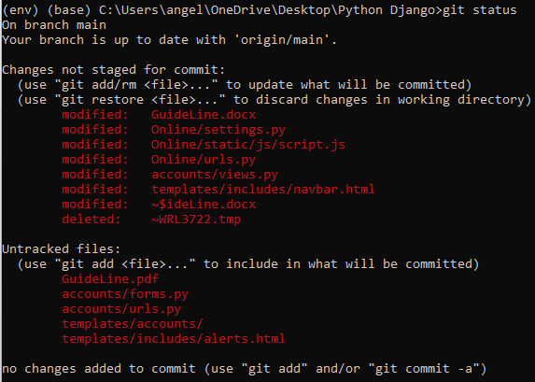

Git add –A

Git commit –m “Django authentication”

git push origin main

1. Add lines codes in the urls.py in the carts folder (check out page design)

path('checkout/', views.checkout, name='checkout'),

]

1. Add line in the views.py in the carts folder

return render(request, 'store/cart.html', context)

def checkout(request):

return render(request, 'store/checkout.html')

1. Create checkout.html in the store folder in the templates folder

<h2>check out</h2>

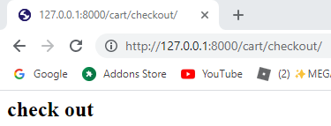

1. Copy codes from cart.html and paste and remove some codes into checkout.html in the store folder in the templates folder

{% extends 'base.html' %}

{% load static %}

{% block content %}

<section class="section-content padding-y bg">

<div class="container">

<!-- ============================ COMPONENT 1 ================================= -->

<div class="row">

<aside class="col-lg-9">

<div class="card">

<table class="table table-borderless table-shopping-cart">

<thead class="text-muted">

<tr class="small text-uppercase">

<th scope="col">Product</th>

<th scope="col" width="120">Quantity</th>

<th scope="col" width="120">Price</th>

<th scope="col" class="text-right" width="200"> </th>

</tr>

</thead>

<tbody>

{% for cart_item in cart_items %}

<tr>

<td>

<figure class="itemside align-items-center">

<div class="aside"><img src="{{ cart_item.product.images.url }}" class="img-sm"></div>

<figcaption class="info">

<a href="{{ cart_item.product.get_url }}" class="title text-dark">{{ cart_item.product.product_name }}</a>

<p class="text-muted small">

{% if cart_item.variations.all %}

{% for item in cart_item.variations.all %}

{{ item.variation_category | capfirst }} : {{ item.variation_value | capfirst }} <br>

{% endfor %}

{% endif %}

</p>

</figcaption>

</figure>

</td>

<td>

<!-- col.// -->

<div class="col">

<div class="input-group input-spinner">

<div class="input-group-prepend">

<a href="{% url 'remove_cart' cart_item.product.id cart_item.id %}" class="btn btn-light" type="button" id="button-plus"> <i class="fa fa-minus"></i> </a>

</div>

<input type="text" class="form-control" value="{{ cart_item.quantity }}">

<div class="input-group-append">

<form action="{% url 'add_cart' cart_item.product.id %}" method="POST">

{% csrf_token %}

{% for item in cart_item.variations.all %}

<input type="hidden" name="{{ item.variation_category | lower }}" value="{{ item.variation_value | capfirst }}">

{% endfor %}

<button class="btn btn-light" type="submit" id="button-minus"> <i class="fa fa-plus"></i> </button>

</form>

</div>

</div> <!-- input-group.// -->

</div> <!-- col.// -->

</td>

<td>

<div class="price-wrap">

<var class="price">$ {{ cart_item.sub_total }}</var>

<small class="text-muted"> $ {{ cart_item.product.price }} each </small>

</div> <!-- price-wrap .// -->

</td>

<td class="text-right">

<a href="{% url 'remove_cart_item' cart_item.product.id cart_item.id %}" onclick="return confirm('Are you sure you want to delete this item?')" class="btn btn-danger"> Remove</a>

</td>

</tr>

{% endfor %}

</tbody>

</table>

</div> <!-- card.// -->

</aside> <!-- col.// -->

<aside class="col-lg-3">

<div class="card">

<div class="card-body">

<dl class="dlist-align">

<dt>Total price:</dt>

<dd class="text-right">$ {{ total }}</dd>

</dl>

<dl class="dlist-align">

<dt>Tax:</dt>

<dd class="text-right"> $ {{ tax }}</dd>

</dl>

<dl class="dlist-align">

<dt>Total:</dt>

<dd class="text-right text-dark b"><strong>${{ grand_total }}</strong></dd>

</dl>

<hr>

<p class="text-center mb-3">

<img src="{% static './images/misc/payments.png' %}" height="26">

</p>

<a href="./place-order.html" class="btn btn-primary btn-block"> Checkout </a>

<a href="{% url 'store' %}" class="btn btn-light btn-block">Continue Shopping</a>

</div> <!-- card-body.// -->

</div> <!-- card.// -->

</aside> <!-- col.// -->

</div> <!-- row.// -->

<!-- ============================ COMPONENT 1 END .// ================================= -->

{% endblock %}

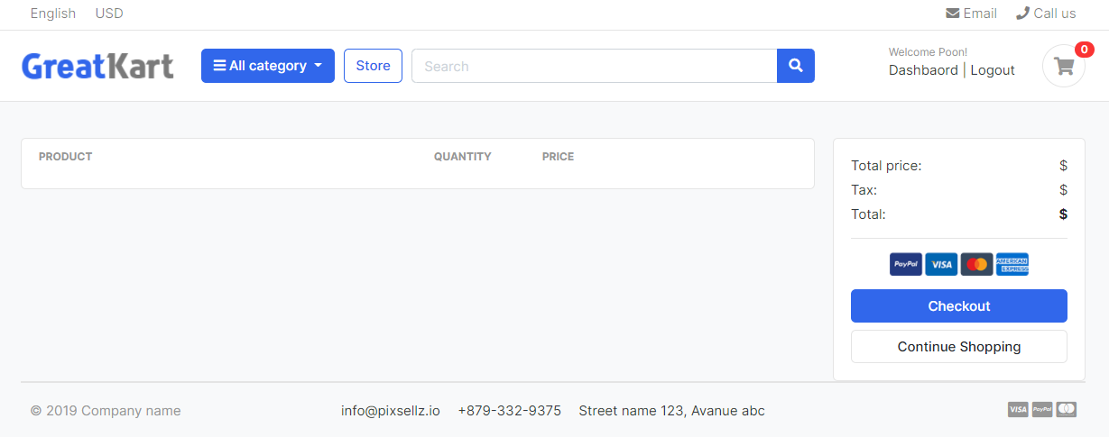

1. Edit codes in the checkout.html in the store folder in the templates folder

{% extends 'base.html' %}

{% load static %}

{% block content %}

<section class="section-content padding-y bg">

<div class="container">

<!-- ============================ COMPONENT 1 ================================= -->

<div class="row">

<aside class="col-lg-6">

<div class="card">

<div class="card-body">

<h4 class="card-title mb-4">Billing Address</h4>

<form action="">

<div class="form-row">

<div class="col form-group">

<label for="">First Name</label>

<input type="text" name="first_name" class="form-control" required>

</div>

<div class="col form-group">

<label for="">Last Name</label>

<input type="text" name="last_name" class="form-control" required>

</div>

</div>

<div class="form-row">

<div class="col form-group">

<label for="">Email</label>

<input type="text" name="email" class="form-control" required>

</div>

<div class="col form-group">

<label for="">Phone Number</label>

<input type="text" name="phone" class="form-control" required>

</div>

</div>

<div class="form-row">

<div class="col form-group">

<label for="">Address Line 1</label>

<input type="text" name="address_line_1" class="form-control" required>

</div>

<div class="col form-group">

<label for="">Address Line 2</label>

<input type="text" name="address_line_2" class="form-control" >

</div>

</div>

<div class="form-row">

<div class="col form-group">

<label for="">City</label>

<input type="text" name="city" class="form-control" required>

</div>

<div class="col form-group">

<label for="">State</label>

<input type="text" name="state" class="form-control" required>

</div>

<div class="col form-group">

<label for="">Country</label>

<input type="text" name="country" class="form-control" required>

</div>

</div>

<div class="form-row">

<div class="col form-group">

<label for="">Order Note</label>

<textarea name="order_note" ros="2" class="form-control"></textarea>

</div>

</div>

</form>

</div> <!-- card.// -->

</aside> <!-- col.// -->

<aside class="col-lg-6">

<div class="card">

<div class="card-body">

<table class="table table-borderless table-shopping-cart">

<thead class="text-muted">

<tr class="small text-uppercase">

<th scope="col">Product</th>

<th scope="col" width="120">Quantity</th>

<th scope="col" width="120">Price</th>

<th scope="col" class="text-right" width="200"> </th>

</tr>

</thead>

<tbody>

{% for cart_item in cart_items %}

<tr>

<td>

<figure class="itemside align-items-center">

<div class="aside"><img src="{{ cart_item.product.images.url }}" class="img-sm"></div>

<figcaption class="info">

<a href="{{ cart_item.product.get_url }}" class="title text-dark">{{ cart_item.product.product_name }}</a>

<p class="text-muted small">

{% if cart_item.variations.all %}

{% for item in cart_item.variations.all %}

{{ item.variation_category | capfirst }} : {{ item.variation_value | capfirst }} <br>

{% endfor %}

{% endif %}

</p>

</figcaption>

</figure>

</td>

<td>

<!-- col.// -->

<div class="col">

<div class="input-group input-spinner">

<div class="input-group-prepend">

<a href="{% url 'remove_cart' cart_item.product.id cart_item.id %}" class="btn btn-light" type="button" id="button-plus"> <i class="fa fa-minus"></i> </a>

</div>

<input type="text" class="form-control" value="{{ cart_item.quantity }}">

<div class="input-group-append">

<form action="{% url 'add_cart' cart_item.product.id %}" method="POST">

{% csrf_token %}

{% for item in cart_item.variations.all %}

<input type="hidden" name="{{ item.variation_category | lower }}" value="{{ item.variation_value | capfirst }}">

{% endfor %}

<button class="btn btn-light" type="submit" id="button-minus"> <i class="fa fa-plus"></i> </button>

</form>

</div>

</div> <!-- input-group.// -->

</div> <!-- col.// -->

</td>

<td>

<div class="price-wrap">

<var class="price">$ {{ cart_item.sub_total }}</var>

<small class="text-muted"> $ {{ cart_item.product.price }} each </small>

</div> <!-- price-wrap .// -->

</td>

<td class="text-right">

<a href="{% url 'remove_cart_item' cart_item.product.id cart_item.id %}" onclick="return confirm('Are you sure you want to delete this item?')" class="btn btn-danger"> Remove</a>

</td>

</tr>

{% endfor %}

</tbody>

</table>

<a href="./place-order.html" class="btn btn-primary btn-block"> Place Order </a>

<a href="{% url 'store' %}" class="btn btn-light btn-block">Continue Shopping</a>

</div> <!-- card-body.// -->

</div> <!-- card.// -->

</aside> <!-- col.// -->

</div> <!-- row.// -->

<!-- ============================ COMPONENT 1 END .// ================================= -->

{% endblock %}

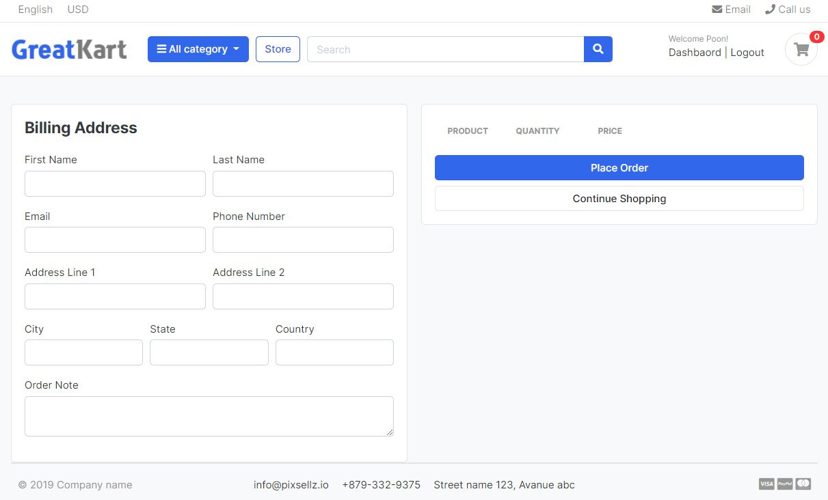

1. Edit codes in the views.py in the carts folder

def checkout(request, total=0, quantity=0, cart_items=None):

try:

tax = 0

grand_total = 0

cart = Cart.objects.get(cart_id=_cart_id(request))

cart_items = CartItem.objects.filter(cart=cart, is_active=True)

for cart_item in cart_items:

total += (cart_item.product.price * cart_item.quantity)

quantity += cart_item.quantity

tax = (7 * total)/100

grand_total = total + tax

except ObjectDoesNotExist:

pass #just ignore

context = {

'total': total,

'quantity': quantity,

'cart_items': cart_items,

'tax': tax,

'grand_total': grand_total,

}

return render(request, 'store/checkout.html', context)

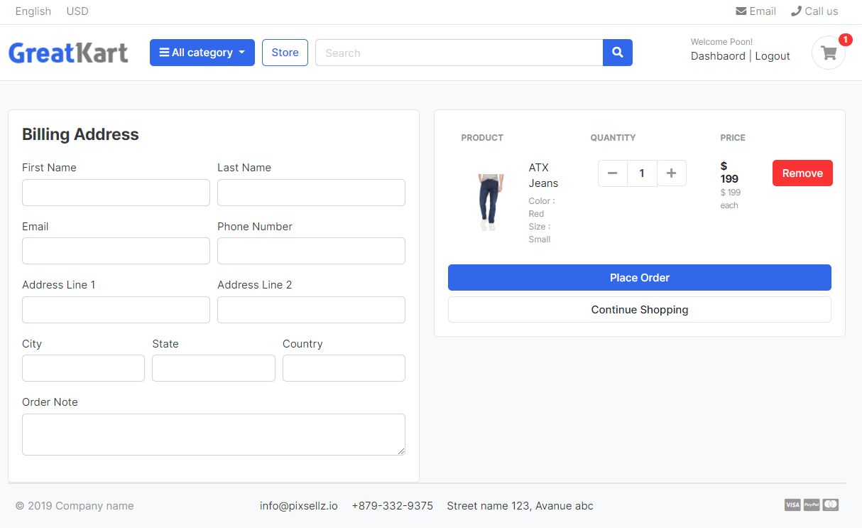

1. Remove remove button codes in the checkout.html in the store folder in the templates folder

<td class="text-right">

<a href="{% url 'remove_cart_item' cart_item.product.id cart_item.id %}" onclick="return confirm('Are you sure you want to delete this item?')" class="btn btn-danger"> Remove</a>

</td>

1. Remove + - button in the checkout.html in the store folder in the templates folder

<div class="col">

<div class="input-group input-spinner">

<div class="input-group-prepend">

<a href="{% url 'remove_cart' cart_item.product.id cart_item.id %}" class="btn btn-light" type="button" id="button-plus"> <i class="fa fa-minus"></i> </a>

</div>

<input type="text" class="form-control" value="{{ cart_item.quantity }}">

<div class="input-group-append">

<form action="{% url 'add_cart' cart_item.product.id %}" method="POST">

{% csrf_token %}

{% for item in cart_item.variations.all %}

<input type="hidden" name="{{ item.variation_category | lower }}" value="{{ item.variation_value | capfirst }}">

{% endfor %}

<button class="btn btn-light" type="submit" id="button-minus"> <i class="fa fa-plus"></i> </button>

</form>

</div>

</div> <!-- input-group.// -->

</div> <!-- col.// -->

& add line

<td>

<!-- col.// -->

<label for="">{{cart_item.}}</label>

</td>

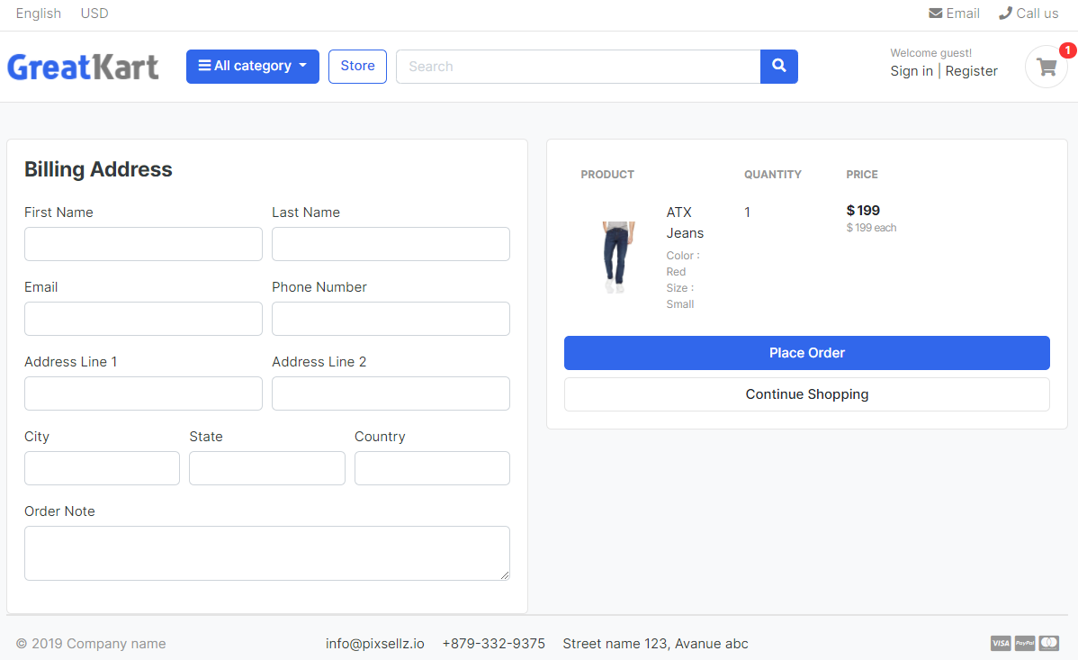

1. Remove line in the checkout.html in the store folder in the templates folder

<th scope="col" width="120">Price</th>

<th scope="col" class="text-right" width="200"> </th>

</tr>

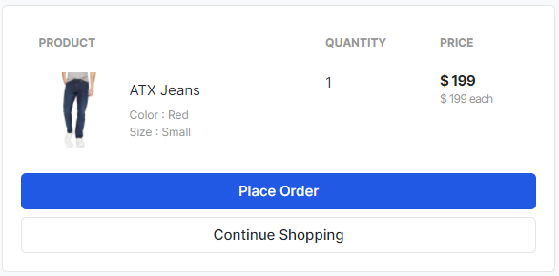

1. Replace codes in the cart.html in the store folder in the templates folder (link the checkout button in the cart page)

Old

<a href="./place-order.html" class="btn btn-primary btn-block"> Checkout </a>

<a href="{% url 'store' %}" class="btn btn-light btn-block">Continue Shopping</a>

New

<a href="{% url 'checkout' %}" class="btn btn-primary btn-block"> Checkout </a>

<a href="{% url 'store' %}" class="btn btn-light btn-block">Continue Shopping</a>

1. Add lines in the views.py in the carts folder

from django.contrib.auth.decorators import login_required

&

@login_required(login_url='login')

def checkout(request, total=0, quantity=0, cart_items=None):

User will force to log in when they press checkout button

1. Add codes in the checkout.html in the store folder in the templates folder

Old

<h4 class="card-title mb-4">Billing Address</h4>

<form action="">

New

<h4 class="card-title mb-4">Billing Address</h4>

<form action="" method="POST">

{% csrf_token %}

Cut the </form> from

<textarea name="Order_note" ros="2" class="form-control"></textarea>

</div>

</div>

</form>

To

<a href="{% url 'store' %}" class="btn btn-light btn-block">Continue Shopping</a>

</form>

</div> <!-- card-body.// -->

Old

<a href="./place-order.html" class="btn btn-primary btn-block"> Place Order </a>

New

<button type="submit" name="submit" class="btn btn-primary btn-block"> Place Order </button>

1. Add lines in the models.py in the carts folder to link cart items with with log in accounts (sessionid from web)

from accounts.models import Account

&

class CartItem(models.Model):

user = models.ForeignKey(Account, on_delete=models.CASCADE, null=True)

product = models.ForeignKey(Product, on_delete=models.CASCADE)

1. Migration X2 codes

python manage.py makemigrations

python manage.py migrate

1. Add lines of codes in the views.py in the accounts folder

from carts.views import _cart_id

from carts.models import Cart, CartItem

&

def login(request):

if request.method == 'POST':

email = request.POST['email']

password = request.POST['password']

user = auth.authenticate(email=email, password=password)

if user is not None:

try:

cart = Cart.objects.get(cart_id=_cart_id(request))

is_cart_item_exists = CartItem.objects.filter(cart=cart).exists()

if is_cart_item_exists:

cart_item = CartItem.objects.filter(cart=cart)

for item in cart_item:

item.user = user

item.save()

except:

pass

auth.login(request, user)

messages.success(request, 'You are now logged in.')

return redirect('dashboard')

else:

messages.error(request, 'Invalid login credentials')

return redirect('login')

return render(request, 'accounts/login.html')

1. Add lines in the context_processors.py in the carts folder (fix shopping cart 0 problem)

from .models import Cart, CartItem

from .views import _cart_id

def counter(request):

cart_count = 0

if 'admin' in request.path:

return {}

else:

try:

cart = Cart.objects.filter(cart_id=_cart_id(request))

if request.user.is_authenticated:

cart_items = CartItem.objects.all().filter(user=request.user)

else:

cart_items = CartItem.objects.all().filter(cart=cart[:1])

for cart_item in cart_items:

cart_count += cart_item.quantity

except Cart.DoesNotExist:

cart_count = 0

return dict(cart_count=cart_count)

1. Add lines in the views.py in the carts folder

def cart(request, total=0, quantity=0, cart_items=None):

try:

tax = 0

grand_total = 0

if request.user.is_authenticated:

cart_items = CartItem.objects.filter(user=request.user, is_active=True)

else:

cart = Cart.objects.get(cart_id=_cart_id(request))

cart_items = CartItem.objects.filter(cart=cart, is_active=True)

for cart_item in cart_items:

total += (cart_item.product.price * cart_item.quantity)

quantity += cart_item.quantity

tax = (7 * total)/100

grand_total = total + tax

except ObjectDoesNotExist:

pass #just ignore

context = {

'total': total,

'quantity': quantity,

'cart_items': cart_items,

'tax': tax,

'grand_total': grand_total,

}

return render(request, 'store/cart.html', context)

1. Edits views.py in the carts folder (+ button)

def add_cart(request, product_id):

current_user = request.user

#product variation codes

product = Product.objects.get(id=product_id) #get the product

#if the user is authenticated

if current_user.is_authenticated:

product_variation = []

if request.method == 'POST':

for item in request.POST:

key = item

value = request.POST[key]

try:

variation = Variation.objects.get(product=product, variation_category__iexact=key, variation_value__iexact=value)

product_variation.append(variation)

except:

pass

#cart item codes

is_cart_item_exists = CartItem.objects.filter(product=product, user = current_user).exists()

if is_cart_item_exists:

cart_item = CartItem.objects.filter(product=product, user = current_user)

ex_var_list = []

id = []

for item in cart_item:

existing_variation = item.variations.all()

ex_var_list.append(list(existing_variation))

id.append(item.id)

if product_variation in ex_var_list:

# increase the cart item quantity

index = ex_var_list.index(product_variation)

item_id = id[index]

item = CartItem.objects.get(product=product, id=item_id)

item.quantity += 1

item.save()

else:

item = CartItem.objects.create(product=product, quantity=1, user = current_user)

if len(product_variation) > 0:

item.variations.clear()

item.variations.add(*product_variation)

item.save()

else:

cart_item = CartItem.objects.create(

product = product,

quantity = 1,

user = current_user,

)

if len(product_variation) > 0:

cart_item.variations.clear()

cart_item.variations.add(*product_variation)

cart_item.save()

return redirect('cart')

#if the user is not authenticated

else:

product_variation = []

if request.method == 'POST':

for item in request.POST:

key = item

value = request.POST[key]

try:

variation = Variation.objects.get(product=product, variation_category__iexact=key, variation_value__iexact=value)

product_variation.append(variation)

except:

pass

#cart codes

try:

cart = Cart.objects.get(cart_id=_cart_id(request)) #get the cart using the cart_id present in the session

except Cart.DoesNotExist:

cart = Cart.objects.create(

cart_id = _cart_id(request)

)

cart.save()

#cart item codes

is_cart_item_exists = CartItem.objects.filter(product=product, cart=cart).exists()

if is_cart_item_exists:

cart_item = CartItem.objects.filter(product=product, cart=cart)

# existing_variation -> database

# current variation -> product_variation

# item_id -> database

ex_var_list = []

id = []

for item in cart_item:

existing_variation = item.variations.all()

ex_var_list.append(list(existing_variation))

id.append(item.id)

print(ex_var_list)

if product_variation in ex_var_list:

# increase the cart item quantity

index = ex_var_list.index(product_variation)

item_id = id[index]

item = CartItem.objects.get(product=product, id=item_id)

item.quantity += 1

item.save()

else:

item = CartItem.objects.create(product=product, quantity=1, cart=cart)

if len(product_variation) > 0:

item.variations.clear()

item.variations.add(*product_variation)

item.save()

else:

cart_item = CartItem.objects.create(

product = product,

quantity = 1,

cart = cart,

)

if len(product_variation) > 0:

cart_item.variations.clear()

cart_item.variations.add(*product_variation)

cart_item.save()

return redirect('cart')

1. Edits views.py in the accounts folder

def login(request):

if request.method == 'POST':

email = request.POST['email']

password = request.POST['password']

user = auth.authenticate(email=email, password=password)

if user is not None:

try:

cart = Cart.objects.get(cart_id=_cart_id(request))

is_cart_item_exists = CartItem.objects.filter(cart=cart).exists()

if is_cart_item_exists:

cart_item = CartItem.objects.filter(cart=cart)

# getting the product variations by cart id

product_variation=[]

for item in cart_item:

variation = item.variations.all()

product_variation.append(list(variation))

#get the cart items from the user to access his product variations

cart_item = CartItem.objects.filter(user=user)

ex_var_list = []

id=[]

for item in cart_item:

existing_variation = item.variations.all()

ex_var_list.append(list(existing_variation))

id.append(item.id)

#product_variation = [1,2,3,4,6]

#ex_var_list = [4,6,3,5]

for pr in product_variation:

if pr in ex_var_list:

index = ex_var_list.index(pr)

item_id = id[index]

item = CartItem.objects.get(id=item_id)

item.quantity += 1

item.user = user

item.save()

else:

cart_item = CartItem.objects.filter(cart=cart)

for item in cart_item:

item.user = user

item.save()

except:

pass

auth.login(request, user)

messages.success(request, 'You are now logged in.')

return redirect('dashboard')

else:

messages.error(request, 'Invalid login credentials')

return redirect('login')

return render(request, 'accounts/login.html')

User able to add cart item without account and log in account add cart same item.

1. Add line to views.py in the carts folder (fix the reduce button)

def remove_cart(request, product_id, cart_item_id):

#reduce item button

product = get_object_or_404(Product, id=product_id)

try:

if request.user.is_authenticated:

cart_item = CartItem.objects.get(product=product, user=request.user, id=cart_item_id)

else:

cart = Cart.objects.get(cart_id=_cart_id(request))

cart_item = CartItem.objects.get(product=product, cart=cart, id=cart_item_id)

if cart_item.quantity > 1:

cart_item.quantity -= 1

cart_item.save()

else:

cart_item.delete()

except:

pass

return redirect('cart')

1. Add line to views.py in the carts folder (fix the remove button)

def remove_cart_item(request, product_id, cart_item_id):

product = get_object_or_404(Product, id=product_id)

if request.user.is_authenticated:

cart_item = CartItem.objects.get(product=product, user=request.user, id=cart_item_id)

else:

cart = Cart.objects.get(cart_id=_cart_id(request))

cart_item = CartItem.objects.get(product=product, cart=cart, id=cart_item_id)

cart_item.delete()

return redirect('cart')

1. Install requests package to bring user to shopping cart once log in with cart item

pip install requests

python manage.py runserver

1. Add lines in the views.py in the accounts folder

import requests

&

cart_item = CartItem.objects.filter(cart=cart)

for item in cart_item:

item.user = user

item.save()

except:

pass

auth.login(request, user)

messages.success(request, 'You are now logged in.')

url = request.META.get('HTTP_REFERER')

try:

query = requests.utils.urlparse(url).query

params = dict(x.split('=') for x in query.split('&'))

if 'next' in params:

nextPage = params['next']

return redirect(nextPage)

except:

return redirect('dashboard')

else:

messages.error(request, 'Invalid login credentials')

return redirect('login')

return render(request, 'accounts/login.html')

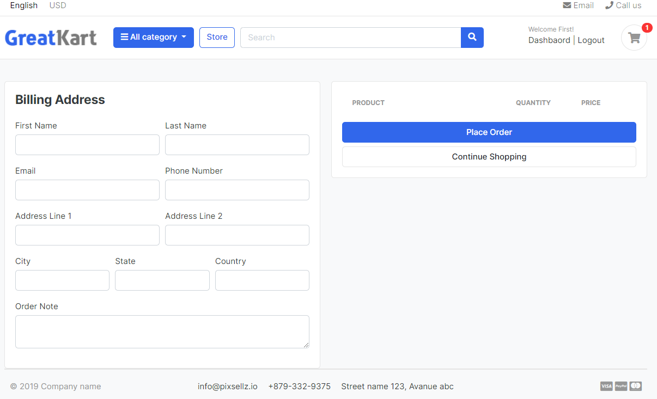

1. Edit views.py in the carts folder

Old

grand_total = 0

cart = Cart.objects.get(cart_id=_cart_id(request))

cart_items = CartItem.objects.filter(cart=cart, is_active=True)

for cart_item in cart_items:

New

grand_total = 0

if request.user.is_authenticated:

cart_items = CartItem.objects.filter(user=request.user, is_active=True)

else:

cart = Cart.objects.get(cart_id=_cart_id(request))

cart_items = CartItem.objects.filter(cart=cart, is_active=True)

for cart_item in cart_items:

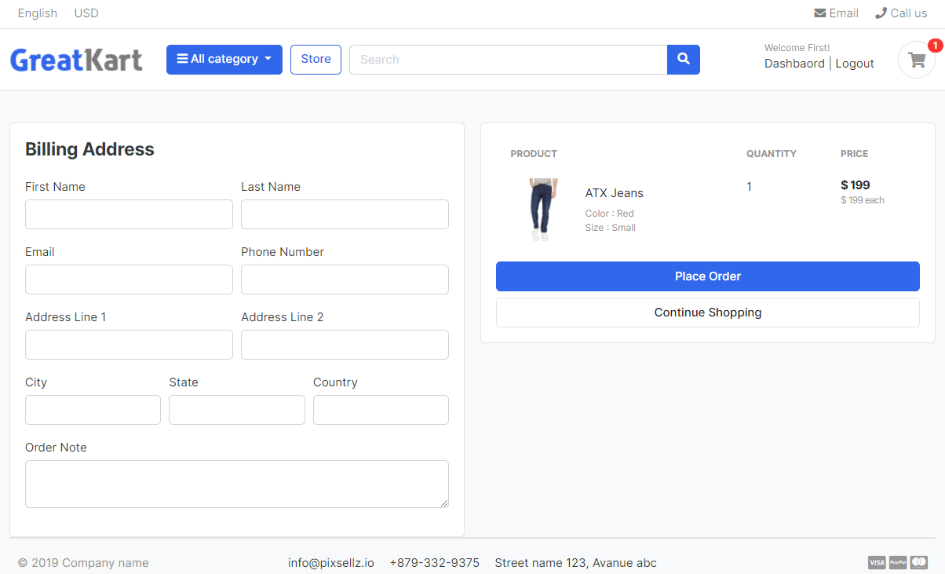

1. Add comments in the CMD in git

git status

git add –A

git commit -m "handles cart and checkout page for the logges in user"

git push origin main

User loaded the files to github

1. User create orders folder in the online folder

python manage.py startapp orders

1. Add line in the settings.py in the online folder

'carts',

'orders',

]

1. Add codes in the models.py in orders folder

from django.db import models

from accounts.models import Account

from store.models import Product, Variation

# Create your models here.

class Payment(models.Model):

user = models.ForeignKey(Account, on_delete = models.CASCADE)

payment_id = models.CharField(max_length=100)

payment_method = models.CharField(max_length=100)

amount_paid = models.CharField(max_length=100)

status = models.CharField(max_length=100)

created_at = models.DateTimeField(auto_now_add=True)

def __str__(self):

return self.payment_id

class Order(models.Model):

STATUS = (

('New','New'),

('Accepted','Accepted'),

('Completed','Completed'),

('Cancelled','Cancelled'),

)

user = models.ForeignKey(Account, on_delete=models.SET_NULL, null=True)

payment = models.ForeignKey(Payment, on_delete=models.SET_NULL, blank=True, null=True)

order_number = models.CharField(max_length=20)

first_name = models.CharField(max_length=50)

last_name = models.CharField(max_length=50)

phone = models.CharField(max_length=15)

email = models.EmailField(max_length=50)

address_line_1 = models.CharField(max_length=50)

address_line_2 = models.CharField(max_length=50, blank=True)

country = models.CharField(max_length=50)

state = models.CharField(max_length=50)

city = models.CharField(max_length=50)

order_note = models.CharField(max_length=100, blank=True)

order_total = models.FloatField()

tax = models.FloatField()

status = models.CharField(max_length=10, choices=STATUS, default='New')

ip = models.CharField(blank=True, max_length=20)

is_ordered = models.BooleanField(default=False)

created_at = models.DateTimeField(auto_now_add=True)

updated_at = models.DateTimeField(auto_now=True)

def __str__(self):

return self.user.first_name

class OrderProduct(models.Model):

order = models.ForeignKey(Order, on_delete=models.CASCADE)

payment = models.ForeignKey(Payment, on_delete=models.SET_NULL, blank=True, null=True)

user = models.ForeignKey(Account, on_delete=models.CASCADE)

product = models.ForeignKey(Product, on_delete=models.CASCADE)

variations = models.ManyToManyField(Variation, blank=True)

quantity = models.IntegerField()

product_price = models.FloatField()

ordered = models.BooleanField(default=False)

created_at = models.DateTimeField(auto_now_add=True)

updated_at = models.DateTimeField(auto_now=True)

def __str__(self):

return self.product.product_name

1. Makemigrations

python manage.py makemigrations

python manage.py migrate

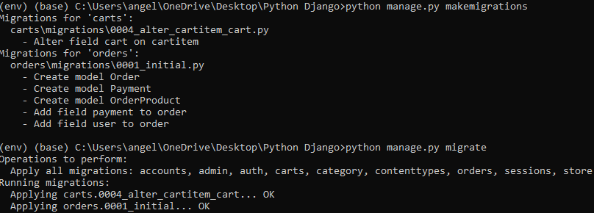

1. Add lines in the admin.py register the 3 models in the models.py in the orders folder

from django.contrib import admin

from .models import Payment, Order, OrderProduct

# Register your models here.

admin.site.register(Payment)

admin.site.register(Order)

admin.site.register(OrderProduct)

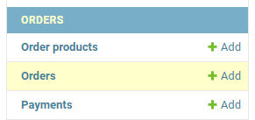

1. Add lines in the urls.py in the online folder

path('accounts/', include('accounts.urls')),

#order

path('orders/', include('orders.urls')),

] + static(settings.MEDIA_URL, document_root=settings.MEDIA_ROOT)

1. Create urls.py in the orders folder

Copy urls.py in the store folder to urls.py in the orders folder

from django.urls import path

from . import views

urlpatterns = [

path('', views.store, name='store'),

path('category/<slug:category_slug>/', views.store, name='products_by_category'),

path('category/<slug:category_slug>/<slug:product_slug>/', views.product_detail, name='product_detail'),

path('search/', views.search, name='search'),

]

1. Edit codes in the urls.py in the orders folder

from django.urls import path

from . import views

urlpatterns = [

path('place_order/', views.place_order, name='place_order'),

]

1. Edits codes in the views.py in the order folder

from django.shortcuts import render

from django.http import HttpResponse

# Create your views here.

def place_order(request):

return HttpResponse('ok')

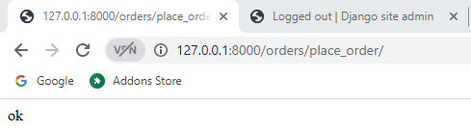

1. Add lines in the views.py in the order folder

from django.shortcuts import render

from django.http import HttpResponse

from carts.models import CartItem

# Create your views here.

def place_order(request):

#return HttpResponse('ok')

current_user = request.user

#If the cart count is less than or equal to 0, then redirect back to shop

cart_items = CartItem.objects.filter(user=current_user)

cart_count = cart_items.count()

if cart_count <= 0:

return redirect('store')

if request.method == 'POST':

form = OrderForm(request.POST)

1. Create and add lines in the forms.py in the order folders

from django import forms

from .models import Order

class OrderForm(forms.ModelForm):

class Meta:

model = Order

fields = ['first_name','last_name','phone','email','address_line_1','address_line_2','country','state','city','order_note']

1. Edit checkout.html in the store folder in the templates folder

Old

<h4 class="card-title mb-4">Billing Address</h4>

<form action="" method="POST">

New

<h4 class="card-title mb-4">Billing Address</h4>

<form action="{% url 'place_order' %}" method="POST">

1. Edits models.py in the oders folder

Old

def __str__(self):

return self.user.first_name

New

def __str__(self):

return self.first_name

1. Add views.py in the orders folder

from django.shortcuts import render, redirect

#from django.http import HttpResponse

from carts.models import CartItem

from .forms import OrderForm

import datetime

from .models import Order

# Create your views here.

def place_order(request, total=0, quantity=0,):

#return HttpResponse('ok')

current_user = request.user

#If the cart count is less than or equal to 0, then redirect back to shop

cart_items = CartItem.objects.filter(user=current_user)

cart_count = cart_items.count()

if cart_count <= 0:

return redirect('store')

grand_total = 0

tax = 0

for cart_item in cart_items:

total += (cart_item.product.price * cart_item.quantity)

quantity += cart_item.quantity

tax = (7 * total)/100

grand_total = total + tax

if request.method == 'POST':

form = OrderForm(request.POST)

if form.is_valid():

# Store all the billing information inside Order table

data = Order()

data.user = current_user

data.first_name = form.cleaned_data['first_name']

data.last_name = form.cleaned_data['last_name']

data.phone = form.cleaned_data['phone']

data.email = form.cleaned_data['email']

data.address_line_1 = form.cleaned_data['address_line_1']

data.address_line_2 = form.cleaned_data['address_line_2']

data.country = form.cleaned_data['country']

data.state = form.cleaned_data['state']

data.city = form.cleaned_data['city']

data.order_note = form.cleaned_data['order_note']

data.order_total = grand_total

data.tax = tax

data.ip = request.META.get('REMOTE_ADDR')

data.save()

# Generate order number

yr = int(datetime.date.today().strftime('%Y'))

dt = int(datetime.date.today().strftime('%d'))

mt = int(datetime.date.today().strftime('%m'))

d = datetime.date(yr,mt,dt)

current_date = d.strftime("%Y%m%d") #20210305

order_number = current_date + str(data.id)

data.order_number = order_number

data.save()

return redirect('checkout')

else:

return redirect('checkout')

1. Edit codes models.py in the orders folder

updated_at = models.DateTimeField(auto_now=True)

def __str__(self):

return self.first_name

class OrderProduct(models.Model):

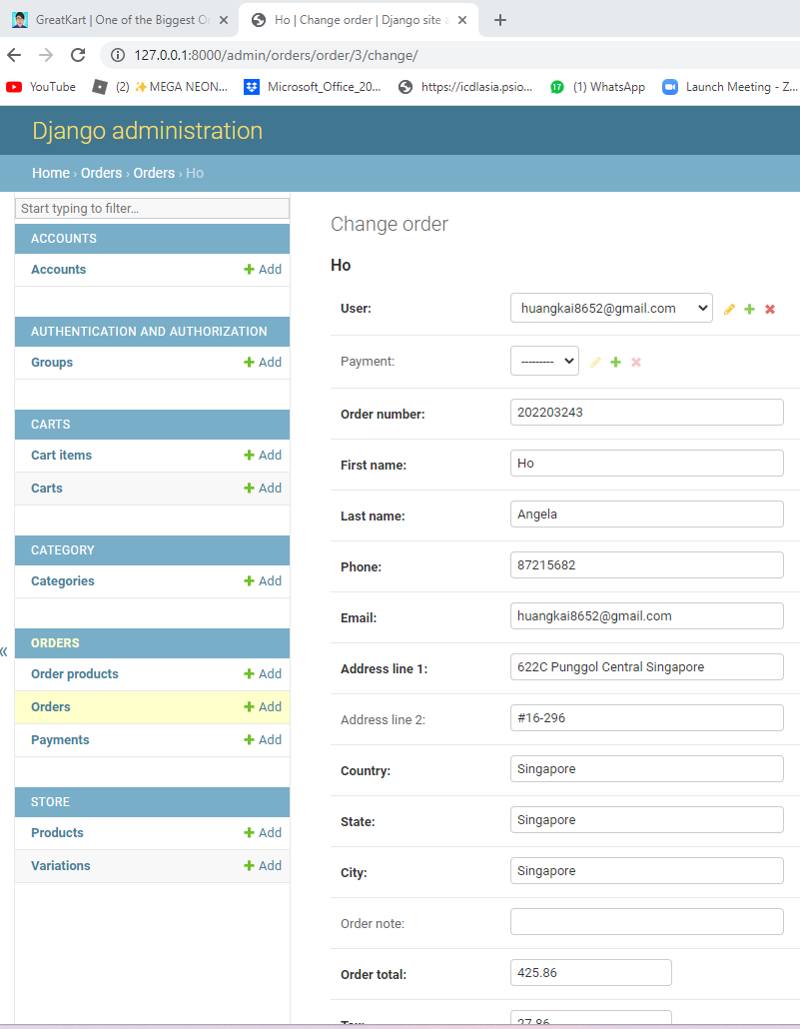

1. Add lines codes in the urls.py in the orders folder(Payments)

from django.urls import path

from . import views

urlpatterns = [

path('place_order/', views.place_order, name='place_order'),

path('payments/',views.payments,name='payments'),

]

1. Add lines codes in the views.py in the orders folder

from .models import Order

def payments(request):

return render(request, 'orders/payments.html')

# Create your views here.

def place_order(request, total=0, quantity=0,):

1. Create payments.html in the orders folder in the templates folder

{% extends 'base.html' %}

{% load static %}

{% block content %}

<section class="section-content padding-y bg">

<div class="container">

<!-- ============================ COMPONENT 1 ================================= -->

<div class="row">

<aside class="col-lg-8">

<div class="card">

<h5 class="card-header">Billing Address</h5>

<div class="card-body">

<p class="card-text">Word</p>

</div>

</div>

<div class="card">

<h5 class="card-header">Payment Method</h5>

<div class="card-body">

<p class="card-text">Word</p>

</div>

</div>

<div class="card">

<h5 class="card-header">Review Products</h5>

<div class="card-body">

<p class="card-text">Word</p>

</div>

</div> <!-- card.// -->

</aside> <!-- col.// -->

<aside class="col-lg-4">

<div class="card">

<div class="card-body">

<dl class="dlist-align">

<dt>Total price:</dt>

<dd class="text-right">$ {{ total }}</dd>

</dl>

<dl class="dlist-align">

<dt>Tax:</dt>

<dd class="text-right"> $ {{ tax }}</dd>

</dl>

<dl class="dlist-align">

<dt>Total:</dt>

<dd class="text-right text-dark b"><strong>${{ grand_total }}</strong></dd>

</dl>

<hr>

<p class="text-center mb-3">

<img src="{% static './images/misc/payments.png' %}" height="26">

</p>

<a href="{% url 'checkout' %}" class="btn btn-primary btn-block"> Make Payment </a>

</div> <!-- card-body.// -->

</div> <!-- card.// -->

</aside> <!-- col.// -->

</div> <!-- row.// -->

<!-- ============================ COMPONENT 1 END .// ================================= -->

{% endblock %}

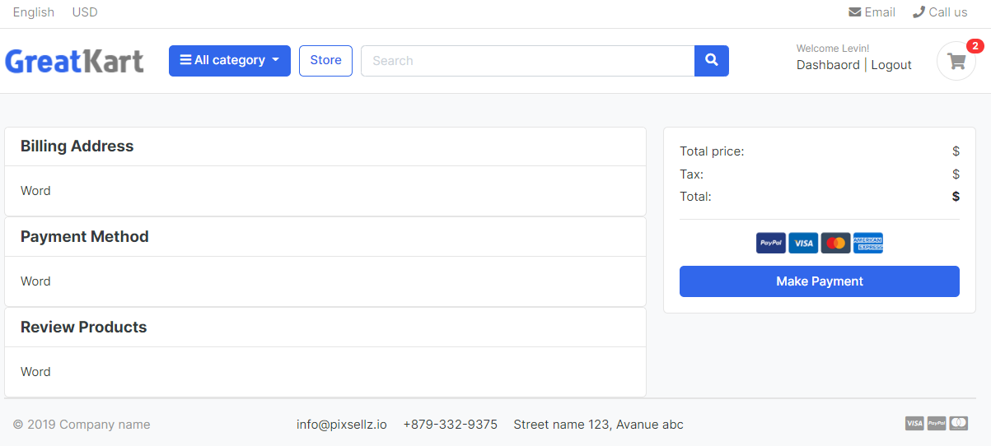

1. Add lines in the views.py in the orders folder

data.save()

order = Order.objects.get(user=current_user, is_ordered=False, order_number=order_number)

context = {

'order': order,

'cart_items': cart_items,

'total': total,

'tax': tax,

'grand_total': grand_total,

}

return redirect('checkout')

1. Edits the payments.html in the order folder in the templates folder

<h5 class="card-header">Billing Address</h5>

<div class="card-body">

<p class="card-text">{{order.first_name}}</p>

</div>

1. Edit views.py in the orders folder

return render(request, 'orders/payments.html', context)

#return redirect('checkout')

else:

return redirect('checkout')

1. Edit models.py in the orders folders

updated_at = models.DateTimeField(auto_now=True)

def full_name(self):

return f'{self.first_name} {self.last_name}'

def full_address(self):

return f'{self.address_line_1} {self.address_line_2}'

def __str__(self):

return self.first_name

1. Edits payments.html in the orders folder

<div class="card-body">

<p class="card-text">{{order.full_name}}</p>

<p class="card-text">{{order.full_address}}</p>

</div>

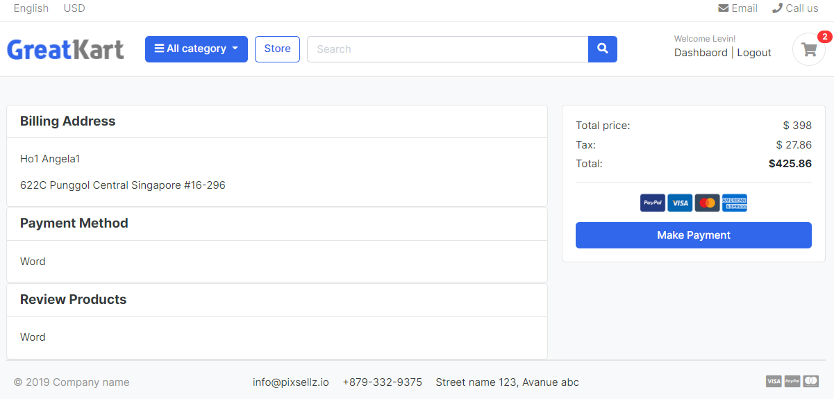

1. Edit codes in the payments.html in the orders folder

<div class="card-body">

<p class="card-text mb-0">{{order.full_name}}</p>

<p class="card-text mb-0">{{order.full_address}}</p>

<p class="card-text mb-0">{{order.city}},{{order.state}}</p>

<p class="card-text mb-0">{{order.country}}</p>

</div>

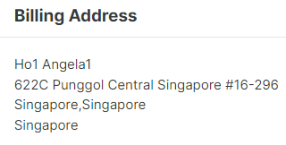

1. Final codes in the payments.html in the orders folder

{% extends 'base.html' %}

{% load static %}

{% block content %}

<section class="section-content padding-y bg">

<div class="container">

<!-- ============================ COMPONENT 1 ================================= -->

<h4 class="text-center mb-10">Review Your Order and Make Payment</h4>

<div class="row">

<aside class="col-lg-8">

<div class="card">

<h5 class="card-header">Billing Address</h5>

<div class="card-body">

<p class="card-text mb-0">{{order.full_name}}</p>

<p class="card-text mb-0">{{order.full_address}}</p>

<p class="card-text mb-0">{{order.city}},{{order.state}}</p>

<p class="card-text mb-0">{{order.country}}</p>

<p class="card-text mb-0">{{order.email}}</p>

<p class="card-text mb-0">{{order.phone}}</p>

{% if order.order_note %}

<b>Order Note: </b> {{order.order_note}}

{% endif %}

</div>

</div>

<div class="card">

<h5 class="card-header">Payment Method</h5>

<div class="card-body">

<p class="card-text">PayPal</p>

</div>

</div>

<div class="card">

<h5 class="card-header">Review Products</h5>

<div class="card-body">

<table class="table table-borderless table-shopping-cart">

<thead class="text-muted">

<tr class="small text-uppercase">

<th scope="col">Product</th>

<th scope="col" width="120">Quantity</th>

<th scope="col" width="120">Price</th>

</tr>

</thead>

<tbody>

{% for cart_item in cart_items %}

<tr>

<td>

<figure class="itemside align-items-center">

<div class="aside"><img src="{{ cart_item.product.images.url }}" class="img-sm"></div>

<figcaption class="info">

<a href="{{ cart_item.product.get_url }}" class="title text-dark">{{ cart_item.product.product_name }}</a>

<p class="text-muted small">

{% if cart_item.variations.all %}

{% for item in cart_item.variations.all %}

{{ item.variation_category | capfirst }} : {{ item.variation_value | capfirst }} <br>

{% endfor %}

{% endif %}

</p>

</figcaption>

</figure>

</td>

<td>

<!-- col.// -->

<label for="">{{cart_item.quantity}}</label>

</td>

<td>

<div class="price-wrap">

<var class="price">$ {{ cart_item.sub_total }}</var>

<small class="text-muted"> $ {{ cart_item.product.price }} each </small>

</div> <!-- price-wrap .// -->

</td>

</tr>

{% endfor %}

</tbody>

</table>

</div>

</div> <!-- card.// -->

</aside> <!-- col.// -->

<aside class="col-lg-4">

<div class="card">

<div class="card-body">

<dl class="dlist-align">

<dt>Total price:</dt>

<dd class="text-right">$ {{ total }}</dd>

</dl>

<dl class="dlist-align">

<dt>Tax:</dt>

<dd class="text-right"> $ {{ tax }}</dd>

</dl>

<dl class="dlist-align">

<dt>Total:</dt>

<dd class="text-right text-dark b"><strong>${{ grand_total }}</strong></dd>

</dl>

<hr>

<p class="text-center mb-3">

<img src="{% static './images/misc/payments.png' %}" height="26">

</p>

<a href="{% url 'checkout' %}" class="btn btn-primary btn-block"> Make Payment </a>

</div> <!-- card-body.// -->

</div> <!-- card.// -->

</aside> <!-- col.// -->

</div> <!-- row.// -->

<!-- ============================ COMPONENT 1 END .// ================================= -->

{% endblock %}

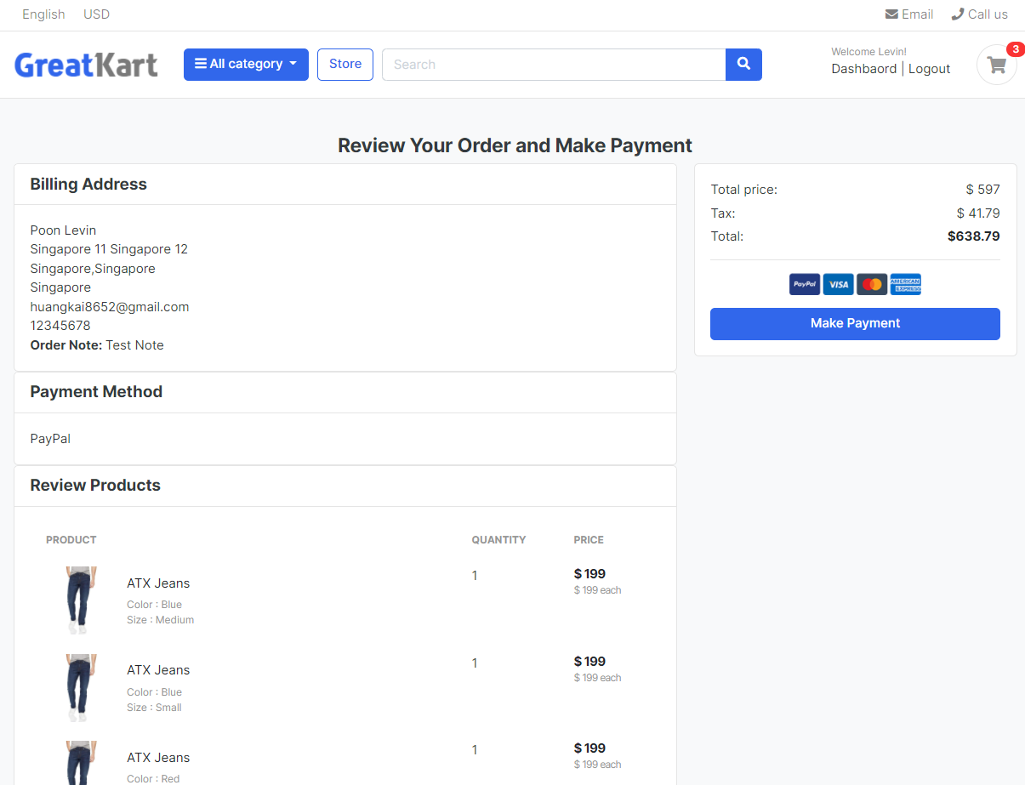

1. Create an business paypal account
2. Log in <https://developer.paypal.com/home>

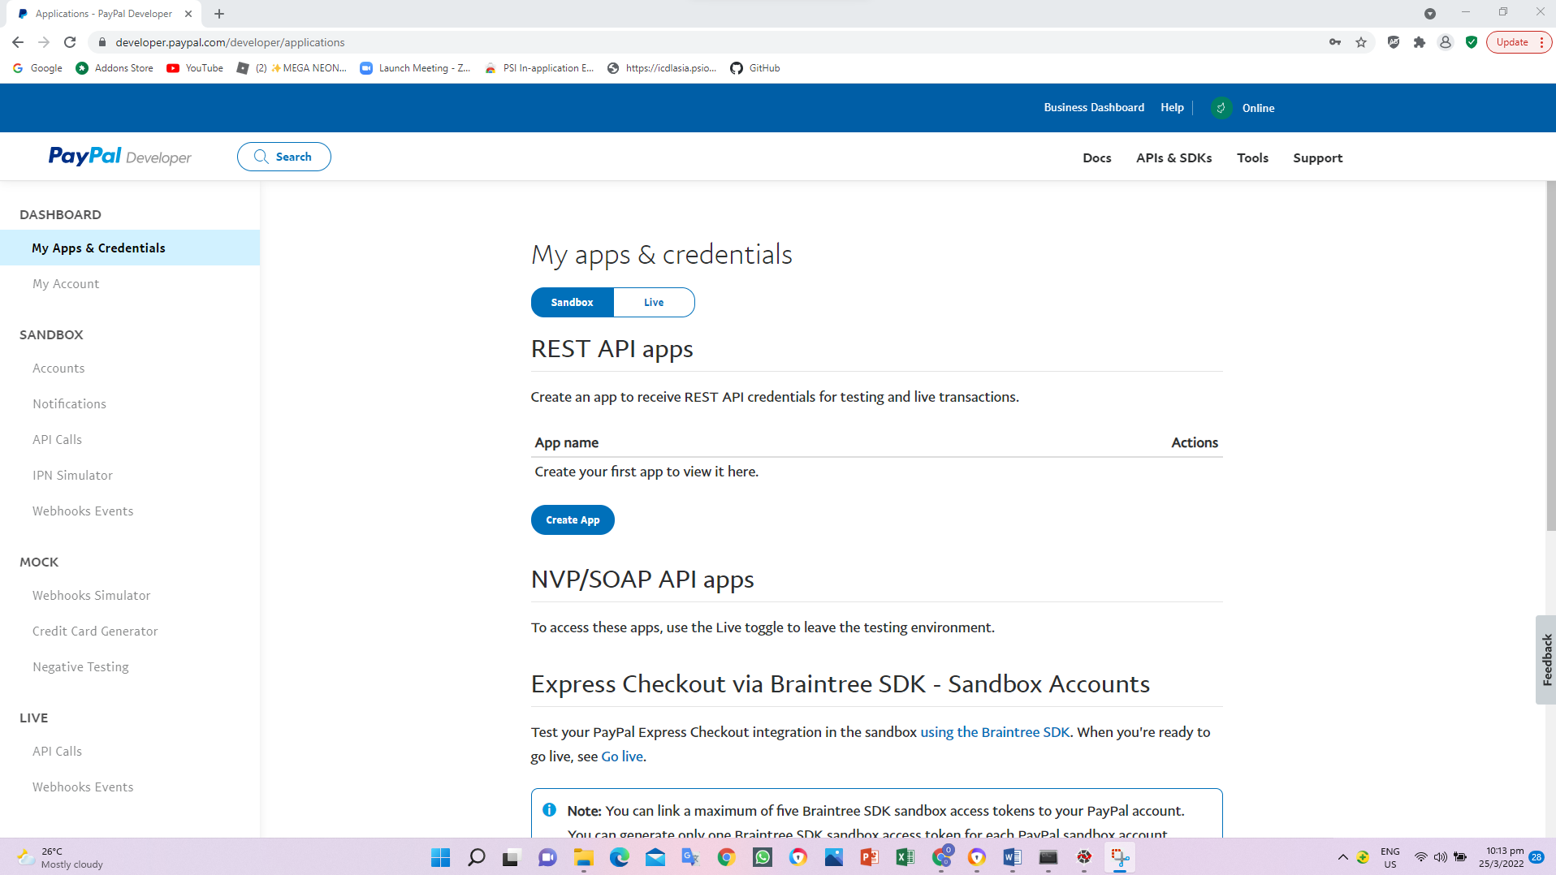

1. Click Accounts under SANDBOX
2. Create 2 account in the paypal

Personal (Buyer Account) to send money

huangkai8652@hotmail.com

!q2w3e4R

Poon

Levin

100000

Visa

Click Create account

Business (Merchant Account) to receive money

huangkai8652@gmail.com

!q2w3e4R

Poon

Levin

100000

Visa

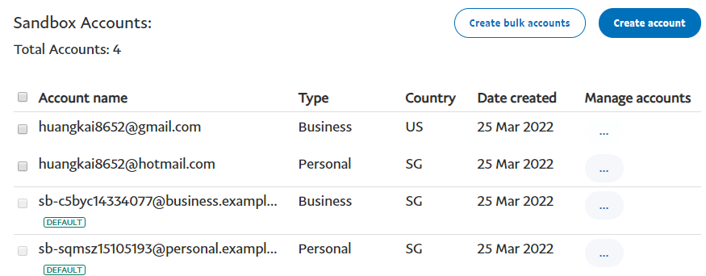

1. Click My Apps & Credentials under DASHBOARD
2. Click Create App

Online Django

Create App

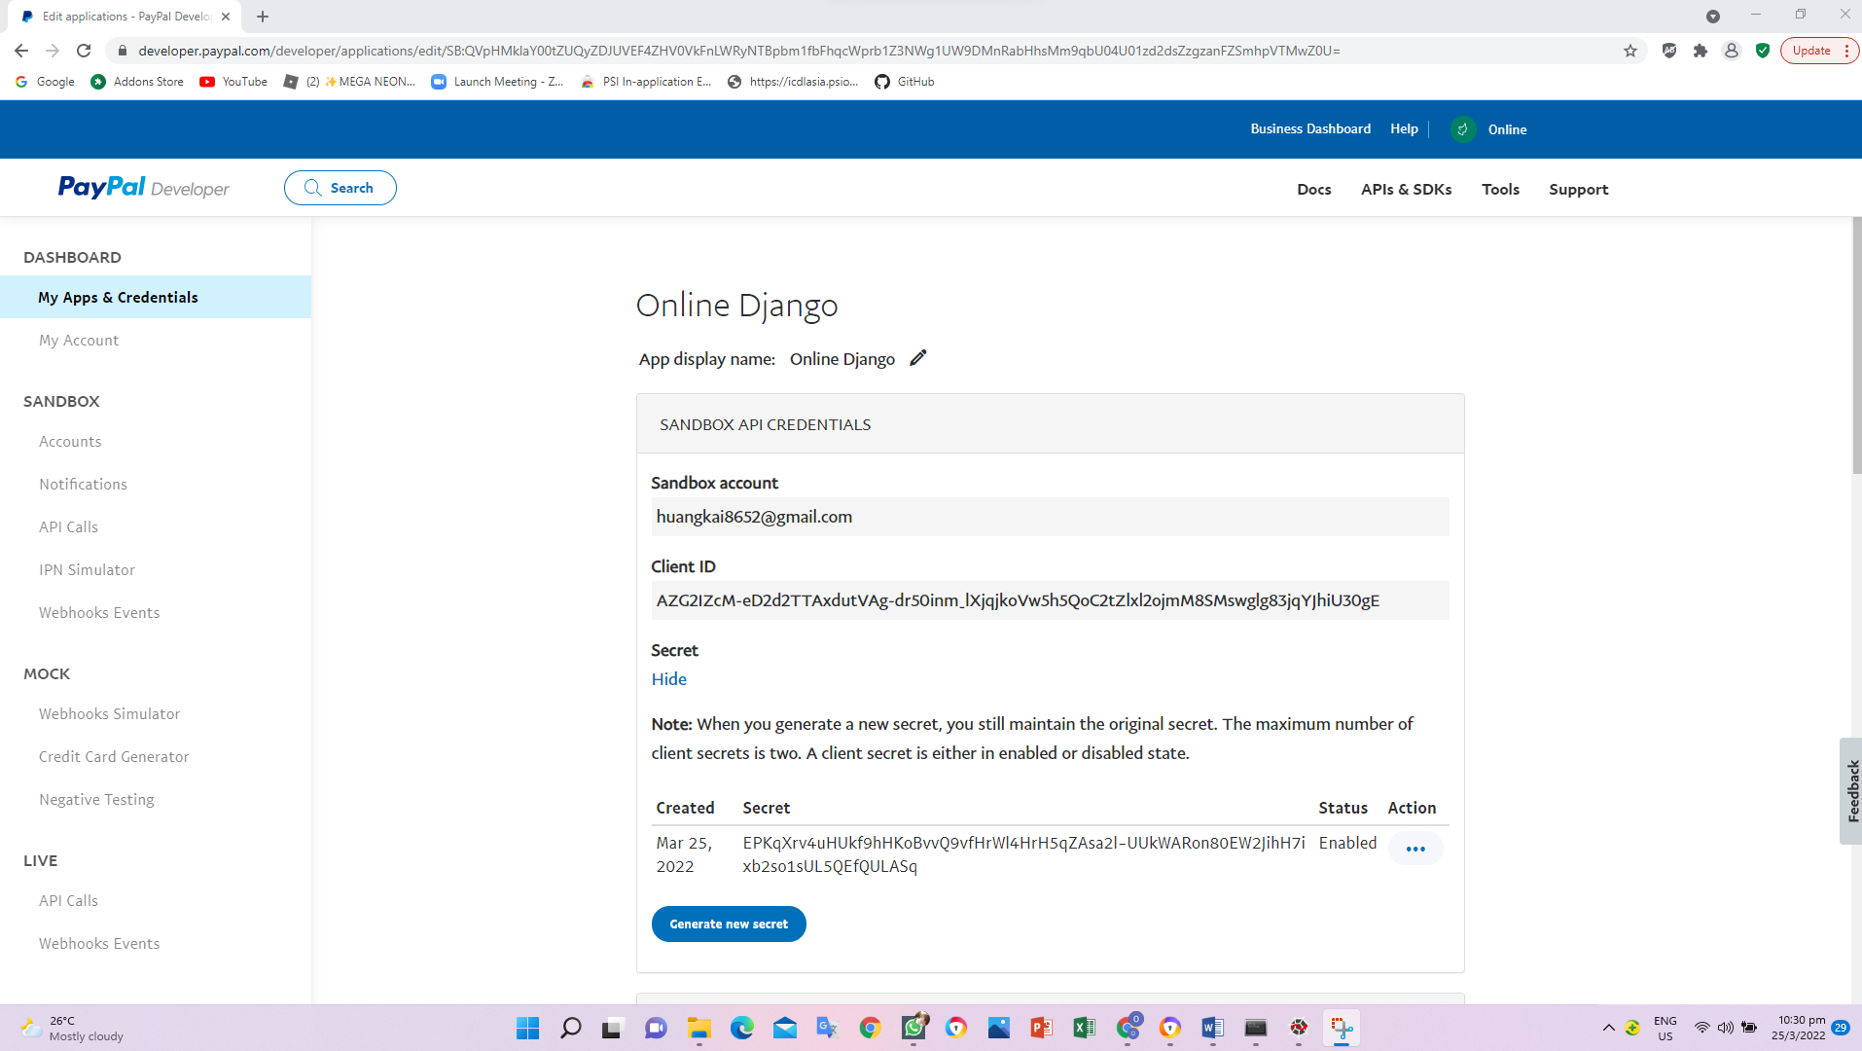

1. Replace codes in the payments.html in the orders folder in the templates folder

Old

<a href="{% url 'checkout' %}" class="btn btn-primary btn-block"> Make Payment </a>

New

<div id="paypal-button-container">

</div>

1. Insert code in the base.html in the store folder in the templates folder

<script src={% static 'js/script.js' %} type="text/javascript"></script>

<script src="https://www.paypal.com/sdk/js?client-id=sb&currency=USD"></script>

<script type="text/javascript">

1. Add codes in the payments.html in the orders folder in the templates folder

</div> <!-- row.// -->

<!-- ============================ COMPONENT 1 END .// ================================= -->

<script>

// Render the PayPal button into #paypal-button-container

paypal.Buttons({

// Set up the transaction

createOrder: function(data, actions) {

return actions.order.create({

purchase_units: [{

amount: {

value: '88.44'

}

}]

});

},

// Finalize the transaction

onApprove: function(data, actions) {

return actions.order.capture().then(function(details) {

// Show a success message to the buyer

console.log(details);

alert('Transaction completed by ' + details.payer.name.given_name + '!');

});

}

}).render('#paypal-button-container');

</script>

{% endblock %}

1. Add codes in the payments.html in the orders folder in the templates folder

paypal.Buttons({

style:{

color: 'blue',

shape: 'rect',

label: 'pay',

height: 40

},

// Set up the transaction

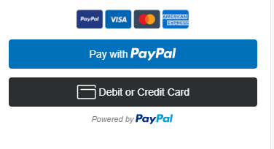

1. Log in paypal developer and click My Apps & Credentials under DASHBOARD (Client Credentials)
2. Click Online Django
3. Copy Client ID

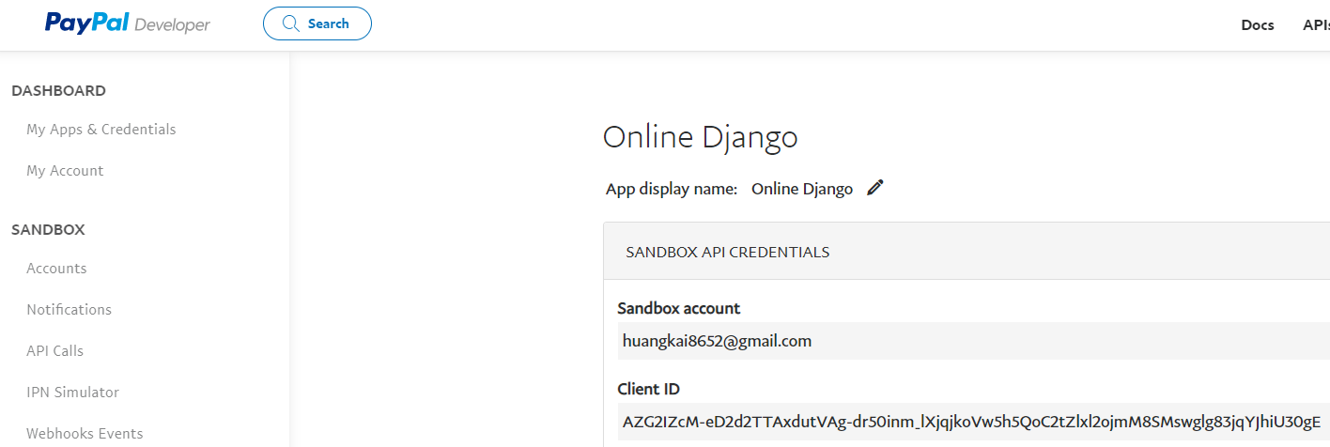

1. Replace the base.html in the templates folder

Old

<script src="https://www.paypal.com/sdk/js?client-id=sb&currency=USD"></script>

New

<script src="https://www.paypal.com/sdk/js?client-id=AZG2IZcM-eD2d2TTAxdutVAg-dr50inm_lXjqjkoVw5h5QoC2tZlxl2ojmM8SMswglg83jqYJhiU30gE&currency=SGD"></script>

1. Log in https://sandbox.paypal.com/ personal account created early

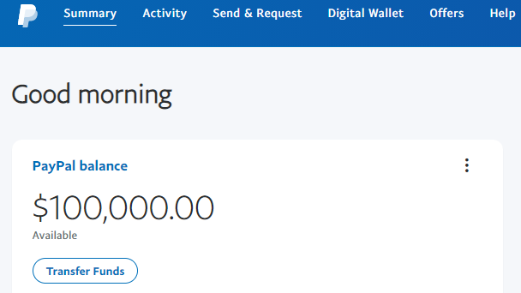

1. Log in https://sandbox.paypal.com/ business account created early

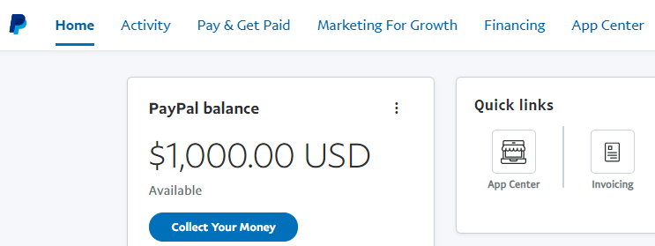

1. Edit the amount in the payments.html in the store folder in the templates folder

<script>

var amount = {{ grand_total }}

// Render the PayPal button into #paypal-button-container

paypal.Buttons({

style:{

color: 'blue',

shape: 'rect',

label: 'pay',

height: 40

},

// Set up the transaction

createOrder: function(data, actions) {

return actions.order.create({

purchase_units: [{

amount: {

value: amount,

}

}]

});

},

// Finalize the transaction

onApprove: function(data, actions) {

return actions.order.capture().then(function(details) {

// Show a success message to the buyer

console.log(details);

alert('Transaction completed by ' + details.payer.name.given_name + '!');

});

}

}).render('#paypal-button-container');

</script>

1. Test the payment if personal to business account

Log in peronal account

View the payment amount in as website amount

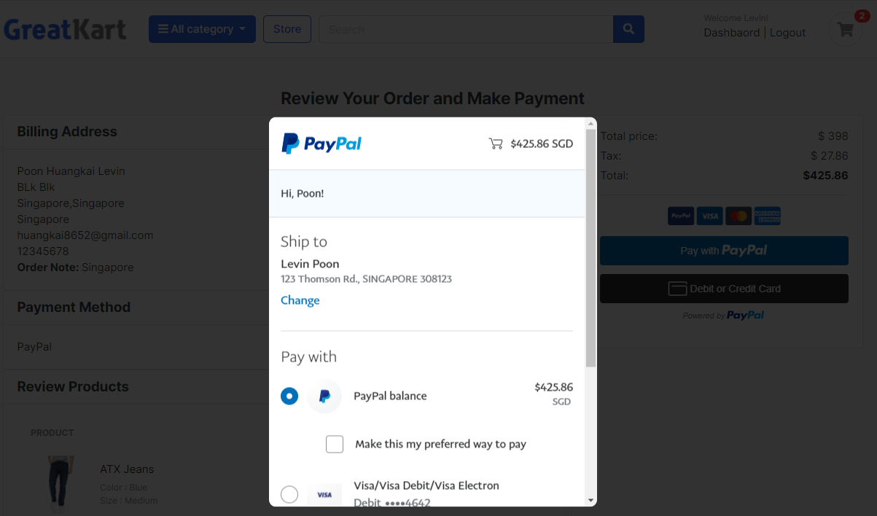

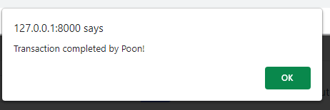

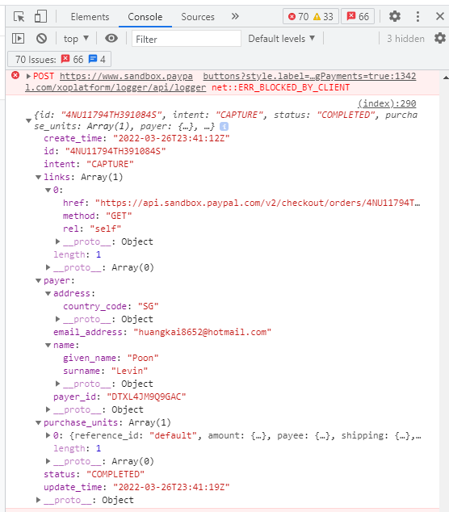

User able to view transctions thru personal and buseiness account.

1. Edit payments.html in the payments.html in the orders folder in the templates folder (capture the details in the admin page)

<script>

function getCookie(name) {

let cookieValue = null;

if (document.cookie && document.cookie !== '') {

const cookies = document.cookie.split(';');

for (let i = 0; i < cookies.length; i++) {

const cookie = cookies[i].trim();

// Does this cookie string begin with the name we want?

if (cookie.substring(0, name.length + 1) === (name + '=')) {

cookieValue = decodeURIComponent(cookie.substring(name.length + 1));

break;

}

}

}

return cookieValue;

}

var amount = {{ grand_total }}

var url = {% url 'payments' %}

var csrftoken = getCookie('csrftoken')

var orderID = {{order.order_number}}

// Render the PayPal button into #paypal-button-container

paypal.Buttons({

style:{

color: 'blue',

shape: 'rect',

label: 'pay',

height: 40

},

// Set up the transaction

createOrder: function(data, actions) {

return actions.order.create({

purchase_units: [{

amount: {

value: amount,

}

}]

});

},

// Finalize the transaction

onApprove: function(data, actions) {

return actions.order.capture().then(function(details) {

// Show a success message to the buyer

console.log(details);

function SendData(){

fetch(url, {

method = "POST",

header: {

"Content-type": "application/json",

"X-CSRFToken": csrftoken,

}

boby: JSON.stringify({

orderID: orderID,

transID: details.id,

payment_method: payment_method,

status: details.status,

})

})

//.then(response => response.json())

//.then(data => console.log(data));

}

});

}

}).render('#paypal-button-container');

</script>

1. Edit codes in the views.py in the orders folder

from .models import Order

import json

def payments(request):

body = json.loads(request.body)

print(body)

return render(request, 'orders/payments.html')

1. Edit codes in the payments.html in the store folder in the templates folder

<script>

function getCookie(name) {

let cookieValue = null;

if (document.cookie && document.cookie !== '') {

const cookies = document.cookie.split(';');

for (let i = 0; i < cookies.length; i++) {

const cookie = cookies[i].trim();

// Does this cookie string begin with the name we want?

if (cookie.substring(0, name.length + 1) === (name + '=')) {

cookieValue = decodeURIComponent(cookie.substring(name.length + 1));

break;

}

}

}

return cookieValue;

}

var amount = "{{ grand_total }}"

var url = "{% url 'payments' %}"

var csrftoken = getCookie('csrftoken')

var orderID = "{{order.order_number}}"

var payment_method = 'Paypal'

// Render the PayPal button into #paypal-button-container

paypal.Buttons({

style:{

color: 'blue',

shape: 'rect',

label: 'pay',

height: 40

},

// Set up the transaction

createOrder: function(data, actions) {

return actions.order.create({

purchase_units: [{

amount: {

value: amount,

}

}]

});

},

// Finalize the transaction

onApprove: function(data, actions) {

return actions.order.capture().then(function(details) {

// Show a success message to the buyer

console.log(details);

SendData();

function SendData(){

fetch(url, {

method : "POST",

headers : {

"Content-type": "application/json",

"X-CSRFToken": csrftoken,

},

body: JSON.stringify({

orderID: orderID,

transID: details.id,

payment_method: payment_method,

status: details.status,

}),

})

//.then(response => response.json())

//.then(data => console.log(data));

}

});

}

}).render('#paypal-button-container');

</script>

User make payment console and CMD display transaction details

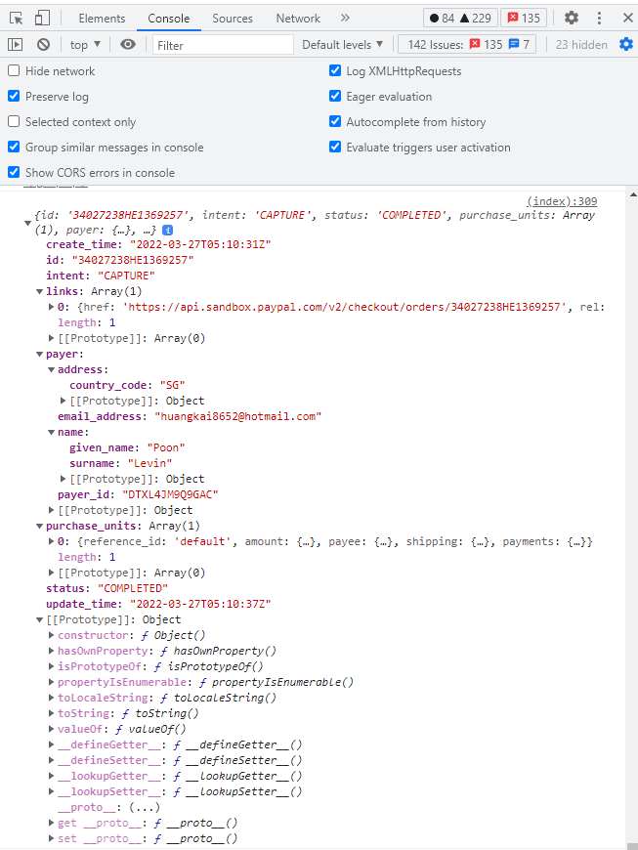



1. Add lines in the views.py in the order folder (store transactions details in the payment details)

from .models import Order, Payment

import json

def payments(request):

body = json.loads(request.body)

order = Order.objects.get(user=request.user, is_ordered=False, order_number=body['orderID'])

#store transaction details inside Payment model

payment = Payment(

user = request.user,

payment_id = body['transID'],

payment_method = body['payment_method'],

amount_paid = order.order_total,

status = body['status'],

)

payment.save()

order.payment = payment

order.is_ordered = True

order.save()

return render(request, 'orders/payments.html')

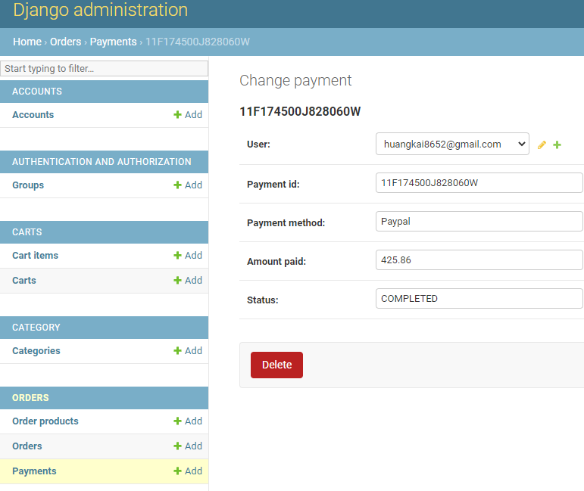

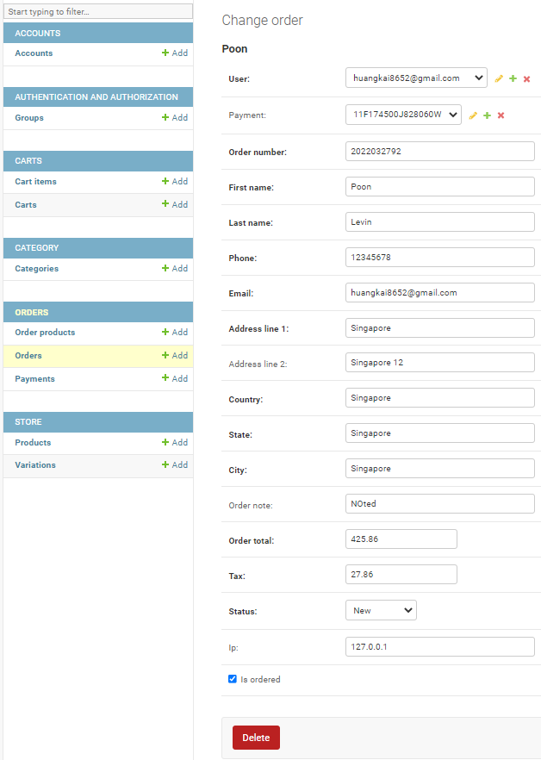

1. Add codes in the views.py in the orders folder

order.save()

#move the cart items to Order Product table

#reduce the quantity of the sold products

#Clear cart

#send order received email to customer

#send order number and transaction id back to sendData method via JsonResponse

return render(request, 'orders/payments.html')

1. Add codes in the admins.py in the orders folder

from django.contrib import admin

from .models import Payment, Order, OrderProduct

# Register your models here.

class OrderAdmin(admin.ModelAdmin):

list_display = ['order_number', 'full_name', 'phone', 'email', 'city', 'order_total', 'tax', 'status', 'is_ordered', 'created_at']

list_filter = ['status', 'is_ordered']

search_fields = ['order_number', 'first_name', 'last_name', 'phone', 'email']

list_per_page = 20

admin.site.register(Payment)

admin.site.register(Order, OrderAdmin)

admin.site.register(OrderProduct)

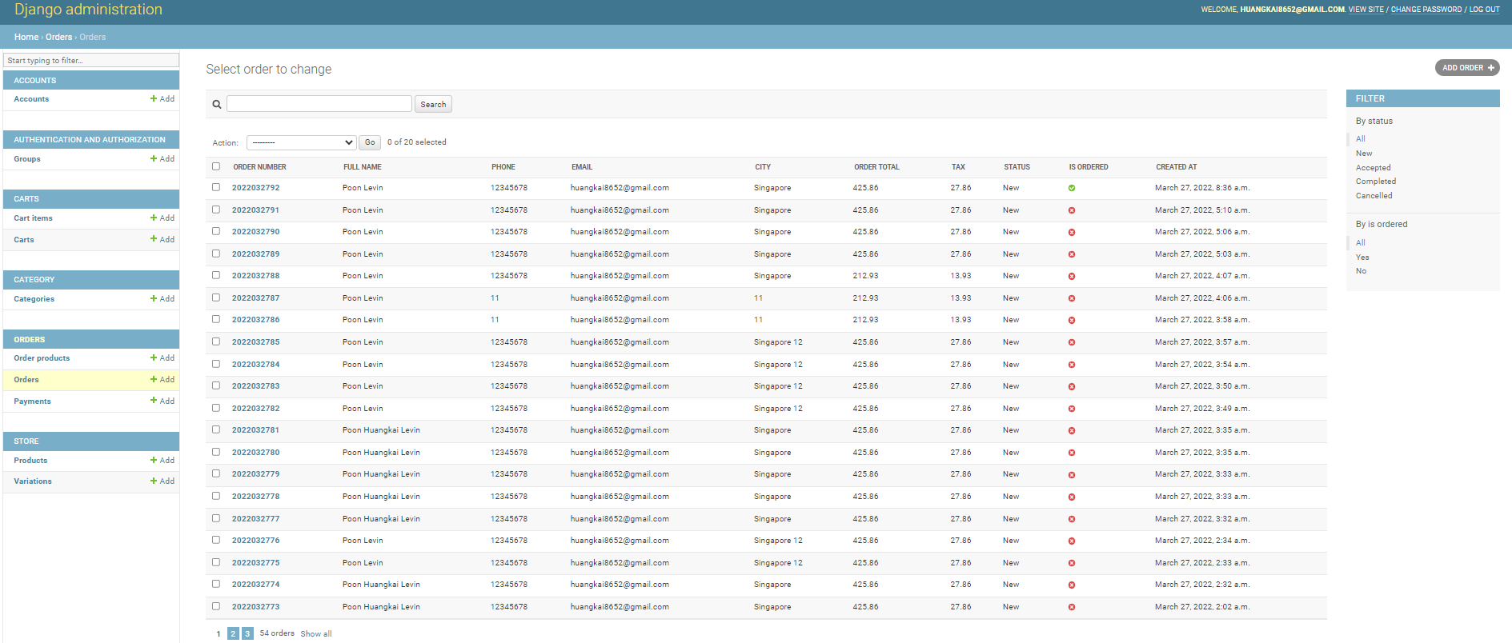

1. 1
2. 1
3. 1
4. Add codes in the views.py in the orders folder

from .models import Order, Payment, OrderProduct

import json

def payments(request):

body = json.loads(request.body)

order = Order.objects.get(user=request.user, is_ordered=False, order_number=body['orderID'])

#store transaction details inside Payment model

payment = Payment(

user = request.user,

payment_id = body['transID'],

payment_method = body['payment_method'],

amount_paid = order.order_total,

status = body['status'],

)

payment.save()

order.payment = payment

order.is_ordered = True

order.save()

#move the cart items to Order Product table

cart_items = CartItem.objects.filter(user=request.user)

for item in cart_items:

orderproduct = OrderProduct()

orderproduct.order_id = order.id

orderproduct.payment = payment

orderproduct.user_id = request.user.id

orderproduct.product_id = item.product_id

orderproduct.quantity = item.quantity

orderproduct.product_price = item.product.price

orderproduct.ordered = True

orderproduct.save()

#reduce the quantity of the sold products

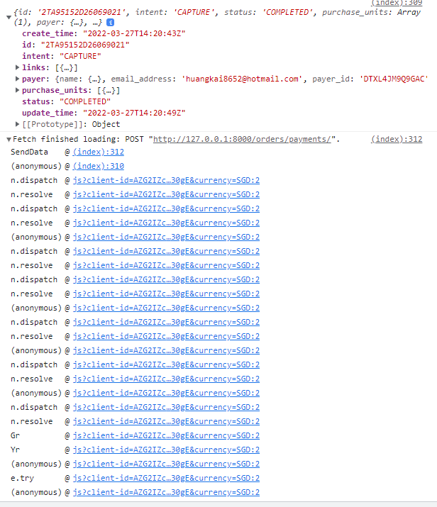

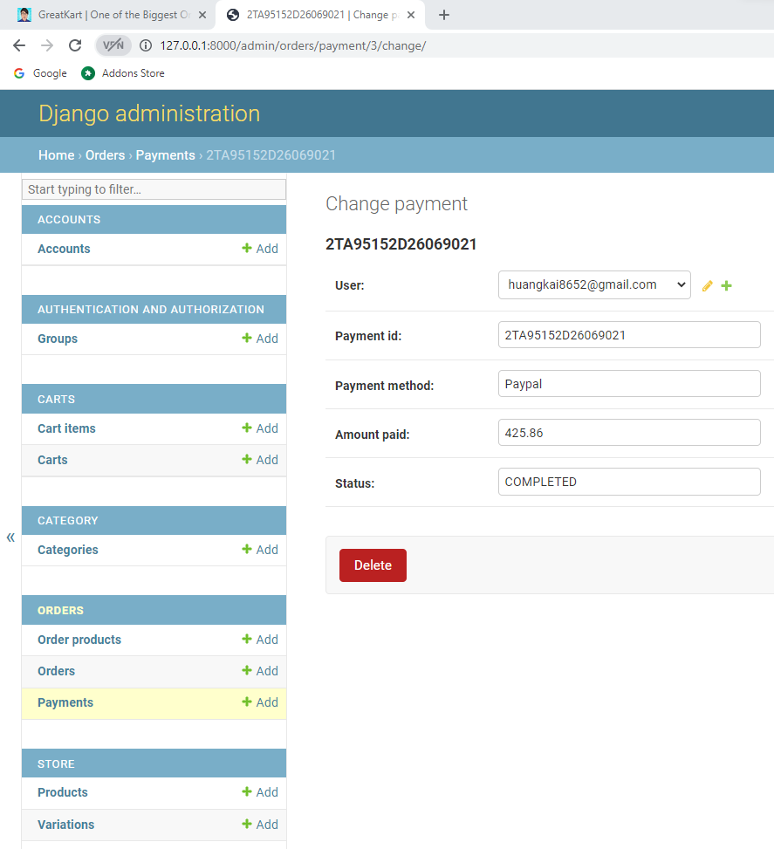 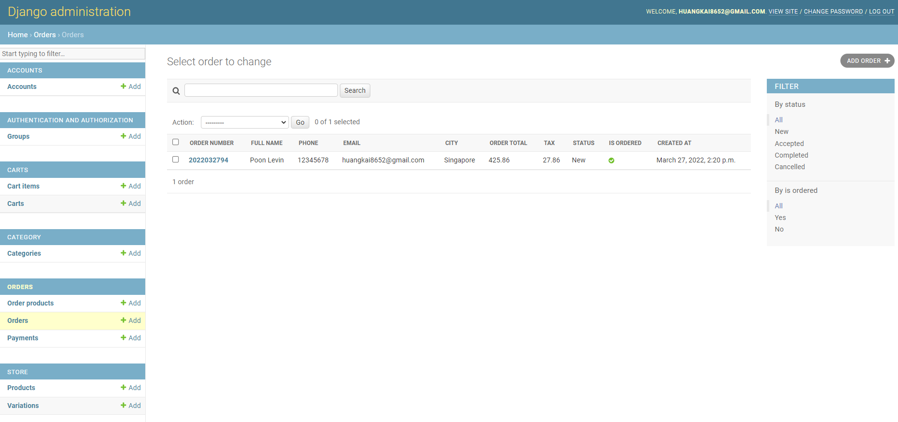

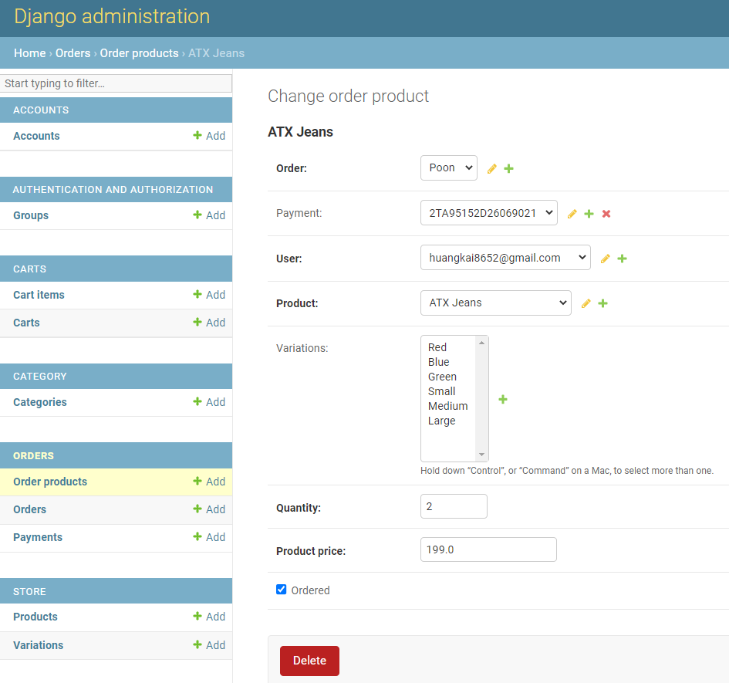

1. Add lines in the admin.py in the orders folder

from .models import Payment, Order, OrderProduct

class OrderProductInline(admin.TabularInline):

model = OrderProduct

readonly_fields = ('payment', 'user', 'product', 'quantity', 'product_price', 'ordered')

extra = 0

# Register your models here.

class OrderAdmin(admin.ModelAdmin):

list_display = ['order_number', 'full_name', 'phone', 'email', 'city', 'order_total', 'tax', 'status', 'is_ordered', 'created_at']

list_filter = ['status', 'is_ordered']

search_fields = ['order_number', 'first_name', 'last_name', 'phone', 'email']

list_per_page = 20

inlines = [OrderProductInline]

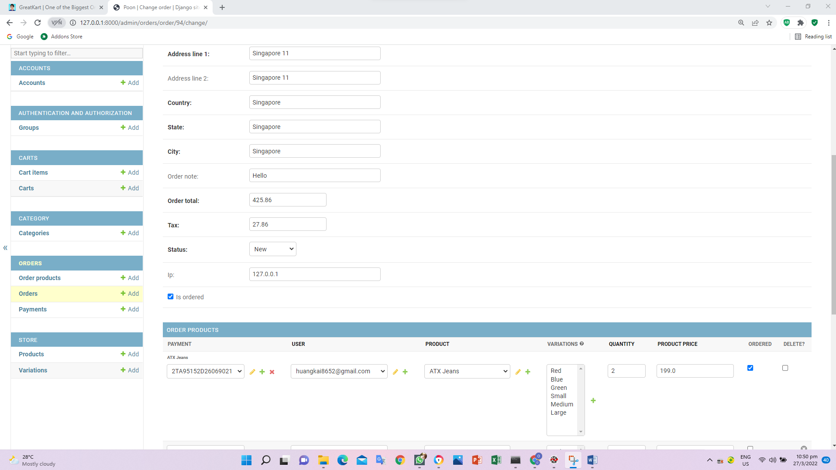

1. Add lines in the views.py in the orders

orderproduct.save()

cart_item = CartItem.objects.get(id=item.id)

product_variation = cart_item.variations.all()

orderproduct = OrderProduct.objects.get(id=orderproduct.id)

orderproduct.variations.set(product_variation)

orderproduct.save()

#reduce the quantity of the sold products

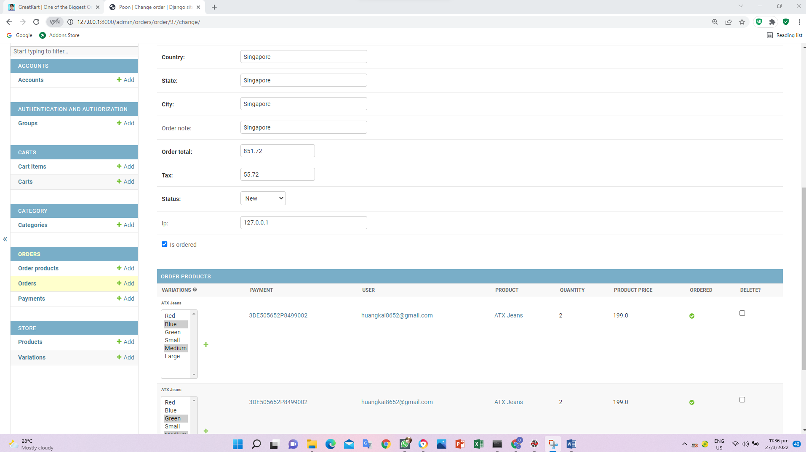

1. Add lines in the views.py in the orders

import json

from store.models import Product

from django.core.mail import EmailMessage

from django.template.loader import render_to_string

&

orderproduct.save()

# Reduce the quantity of the sold products

product = Product.objects.get(id=item.product_id)

product.stock -= item.quantity

product.save()

# Clear cart

CartItem.objects.filter(user=request.user).delete()

# Send order recieved email to customer

mail_subject = 'Thank you for your order!'

message = render_to_string('orders/order_recieved_email.html', {

'user': request.user,

'order': order,

})

to_email = request.user.email

send_email = EmailMessage(mail_subject, message, to=[to_email])

send_email.send()

#Clear cart

#send order received email to customer

#send order number and transaction id back to sendData method via JsonResponse

return render(request, 'orders/payments.html')

1. Create order_received_email.html in the orders folder in the templates folder

{% autoescape off %}

Hi {{user.first_name}},

YOUR ORDER HAS BEEN RECIEVED

Order Number: {{order.order_number}}

{% endautoescape %}

User able to received email confirmation after payment confirmed.

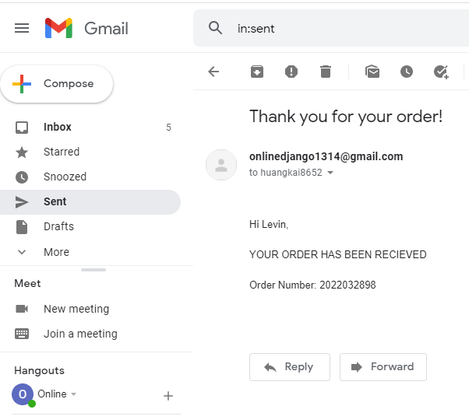

1. Add lines in the urls.py in the orders folder

path('payments/', views.payments, name='payments'),

path('order_complete/', views.order_complete, name='order_complete'),

]

1. Create order_complete.html in the orders folder in the templates folder

<h2>Order complete</h2>

1. Add lines views.py in the orders folder

else:

return redirect('checkout')

def order_complete(request):

return render(request, 'orders/order_completed.html')

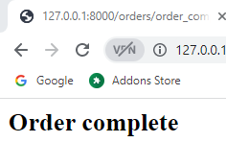

1. Add lines order_complete.html in the orders folder in the templates folder

{% extends 'base.html' %}

{% load static %}

{% block content %}

<div class="container" style="margin-top: 50px;">

<center><i class="fas fa-check-circle" style="font-size: 72px;margin-bottom: 20px;color: #28A745;"></i></center>

<h2 class="text-center">Payment Successful</h2>

<br>

<div class="text-center">

<a href="{% url 'store' %}" class="btn btn-success">Shop more</a>

</div>

</div>

<div class="container" style="margin: 0 auto;width: 50%;padding: 50px;background: #f1f1f1;margin-top: 50px;margin-bottom: 50px;">

<div class="row invoice row-printable">

<div class="col-md-12">

<!-- col-lg-12 start here -->

<div class="panel panel-default plain" id="dash_0">

<!-- Start .panel -->

<div class="panel-body p30">

<div class="row">

<!-- Start .row -->

<div class="col-lg-6">

<!-- col-lg-6 start here -->

<div class="invoice-logo"><img src="/images/logo.png" alt="Invoice logo" style="max-height: 40px;"></div>

</div>

<!-- col-lg-6 end here -->

<div class="col-lg-6">

<!-- col-lg-6 start here -->

<div class="invoice-from">

<ul class="list-unstyled text-right">

<li><strong>Invoiced To</strong></li>

<li>Jakob Smith</li>

<li>Roupark 37</li>

<li>New York, NY, 2014</li>

<li>USA</li>

</ul>

</div>

</div>

<!-- col-lg-6 end here -->

<div class="col-lg-12">

<!-- col-lg-12 start here -->

<div class="invoice-details mt25">

<div class="well">

<ul class="list-unstyled mb0">

<li><strong>Order</strong> #</li>

<li><strong>Transaction</strong> #</li>

<li><strong>Order Date:</strong> Monday, October 10th, 2015</li>

<li><strong>Status:</strong> PAID</li>

</ul>

</div>

</div>

<div class="invoice-items">

<div class="table-responsive" style="overflow: hidden; outline: none;" tabindex="0">

<table class="table table-bordered">

<thead>

<tr>

<th class="per70 text-center">Description</th>

<th class="per5 text-center">Qty</th>

<th class="per25 text-center">Total</th>

</tr>

</thead>

<tbody>

<tr>

<td>1024MB Cloud 2.0 Server - elisium.dynamic.com (12/04/2014 - 01/03/2015)</td>

<td class="text-center">1</td>

<td class="text-center">$25.00 USD</td>

</tr>

<tr>

<td>Logo design</td>

<td class="text-center">1</td>

<td class="text-center">$200.00 USD</td>

</tr>

<tr>

<td>Backup - 1024MB Cloud 2.0 Server - elisium.dynamic.com</td>

<td class="text-center">12</td>

<td class="text-center">$12.00 USD</td>

</tr>

</tbody>

<tfoot>

<tr>

<th colspan="2" class="text-right">Sub Total:</th>

<th class="text-center">$237.00 USD</th>

</tr>

<tr>

<th colspan="2" class="text-right">Tax:</th>

<th class="text-center">$47.40 USD</th>

</tr>

<tr>

<th colspan="2" class="text-right">Grand Total:</th>

<th class="text-center">$284.4.40 USD</th>

</tr>

</tfoot>

</table>

</div>

</div>

<div class="invoice-footer mt25">

<p class="text-center">Thank you for shopping with us!</p>

</div>

</div>

<!-- col-lg-12 end here -->

</div>

<!-- End .row -->

</div>

</div>

<!-- End .panel -->

</div>

<!-- col-lg-12 end here -->

</div>

</div>

{% endblock %} 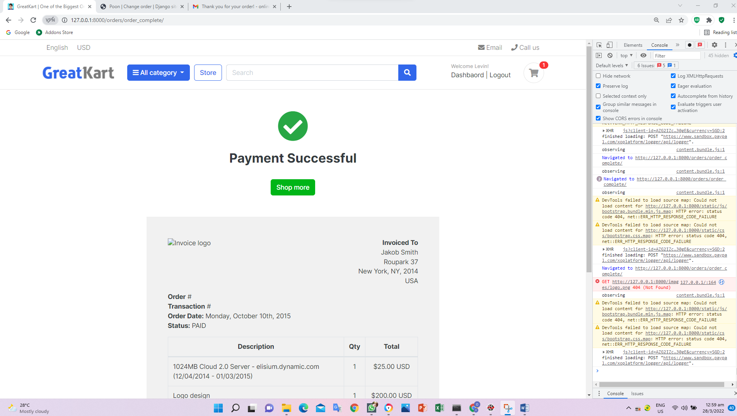

1. Replace codes in the order_complete.html in the orders folder in the templates folder

Old

<div class="invoice-logo"><img src="/images/logo.png" alt="Invoice logo" style="max-height: 40px;"></div>

New

<div class="invoice-logo"><img src="{% static '/images/logo.png' %}" alt="Invoice logo" style="max-height: 40px;"></div>

1. Edit address address as follow

http://127.0.0.1:8000/orders/order_complete



1. Add lines codes in the views.py in the order folder

from django.http import HttpResponse, JsonResponse

&

send_email = EmailMessage(mail_subject, message, to=[to_email])

send_email.send()

#send order received email to customer

data = {

'order_number' : order.order_number,

'transID': payment.payment_id,

}

return JsonResponse(data)

1. Replace codes in payments.html in the orders folder in the templates folder

Old

})

//.then(response => response.json())

//.then(data => console.log(data));

}

New

})

.then((response) => response.json())

.then((data) => {

console.log('Success: ',data);

console.log('Transaction Completed.');

});

}

User make payment and application display success with data and transaction completed wordings

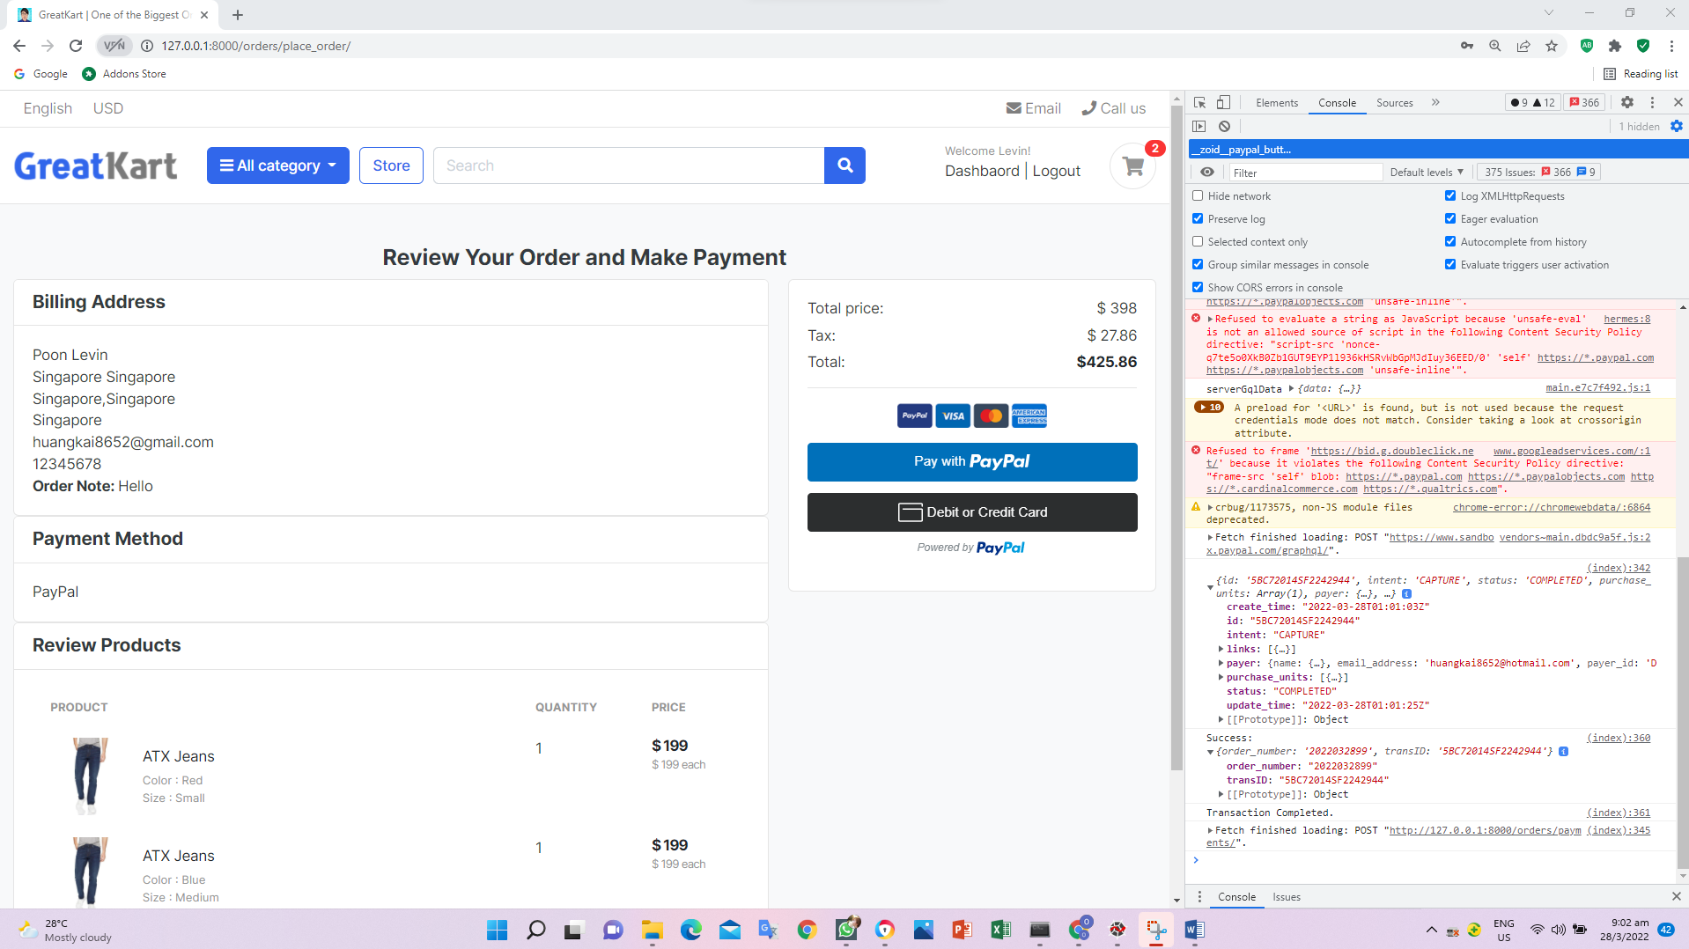

1. Add lines of codes in the payments.html in the orders folder in the templates folder (redirect to payment page)

var payment_method = 'Paypal'

var redirect_url = "{% url 'order_complete' %}"

// Render the PayPal button into #paypal-button-container

&

Old

console.log('Success: ',data);

console.log('Transaction Completed.');

New

//console.log('Success: ',data);

//console.log('Transaction Completed.');

window.location.href = redirect_url + '?order_number='+data.order_number+'&payment_id='+data.transID;

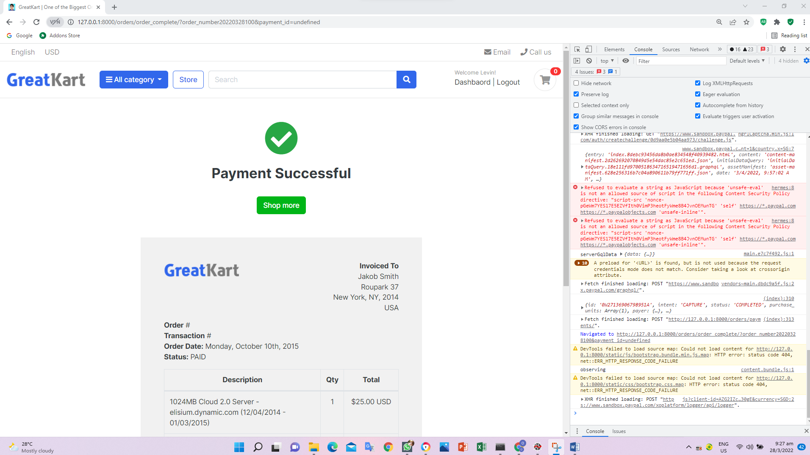

1. Add codes in the order_completed.html in the online folder

<!-- col-lg-6 end here -->

<div class="col-lg-6">

<!-- col-lg-6 start here -->

<div class="invoice-from">

<ul class="list-unstyled text-right">

<li><strong>Invoiced To</strong></li>

<li>{{order.full_name}}</li>

<li>{{order.full_address}}</li>

<li>{{order.city}},{{order.state}}</li>

<li>{{order.country}}</li>

</ul>

</div>

</div>

&

<ul class="list-unstyled mb0">

<li><strong>Order</strong> #{{order_number}}</li>

<li><strong>Transaction</strong> {{transID}}</li>

<li><strong>Order Date:</strong> {{order.created_at}}</li>

<li><strong>Status:</strong> {{payment.status}}</li>

</ul>

</div>

</div>

<div class="invoice-items">

& remove last 2 <tr>

<tr>

<td>Logo design</td>

<td class="text-center">1</td>

<td class="text-center">$200.00 USD</td>

</tr>

<tr>

<td>Backup - 1024MB Cloud 2.0 Server - elisium.dynamic.com</td>

<td class="text-center">12</td>

<td class="text-center">$12.00 USD</td>

</tr>

&

<tbody>

{% for item in ordered_products %}

<tr>

<td>{{item.product.product_name}}</td>

<td class="text-center">{{item.quantity}}</td>

<td class="text-center">${{item.product_price}} SGD</td>

</tr>

{% endfor %}

</tbody>

</tbody>

<tfoot>

<tr>

<th colspan="2" class="text-right">Sub Total:</th>

<th class="text-center">${{subtotal}} SGD</th>

</tr>

<tr>

<th colspan="2" class="text-right">Tax:</th>

<th class="text-center">${{order.tax}} SGD</th>

</tr>

<tr>

<th colspan="2" class="text-right">Grand Total:</th>

<th class="text-center">${{order.order_total}} SGD</th>

1. Add codes in views.py in the order folder (display information on the invoice)

def order_complete(request):

order_number = request.GET.get('order_number')

transID = request.GET.get('payment_id')

try:

order = Order.objects.get(order_number=order_number, is_ordered=True)

ordered_products = OrderProduct.objects.filter(order_id=order.id)

subtotal = 0

for i in ordered_products:

subtotal += i.product_price * i.quantity

payment = Payment.objects.get(payment_id=transID)

context = {

'order': order,

'ordered_products': ordered_products,

'order_number': order.order_number,

'transID': payment.payment_id,

'payment': payment,

'subtotal': subtotal,

}

return render(request, 'orders/order_complete.html', context)

except (Payment.DoesNotExist, Order.DoesNotExist):

return redirect('home')

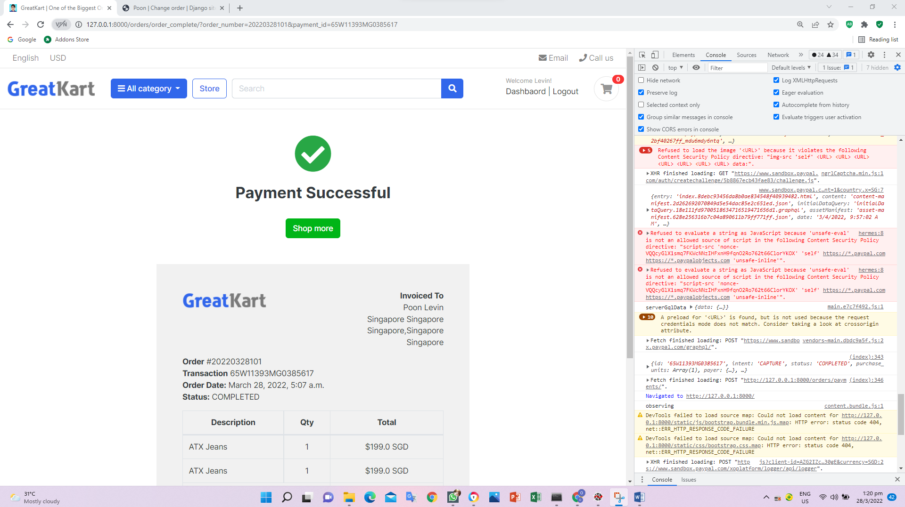

1. Add lines in the order_complete.html in the orders folder in the templates folder

<th class="per70 text-center">Products</th>

<th class="per5 text-center">Qty</th>

<th class="per25 text-center">Total</th>

</tr>

</thead>

<tbody>

{% for item in ordered_products %}

<tr>

<td>{{item.product.product_name}}

<p class="text-muted small">

{% if cart_item.variations.all %}

{% for item in cart_item.variations.all %}

{{ item.variation_category | capfirst }} : {{ item.variation_value | capfirst }} <br>

{% endfor %}

{% endif %}

</p>

</td>

<td class="text-center">{{item.quantity}}</td>

<td class="text-center">${{item.product_price}} SGD</td>

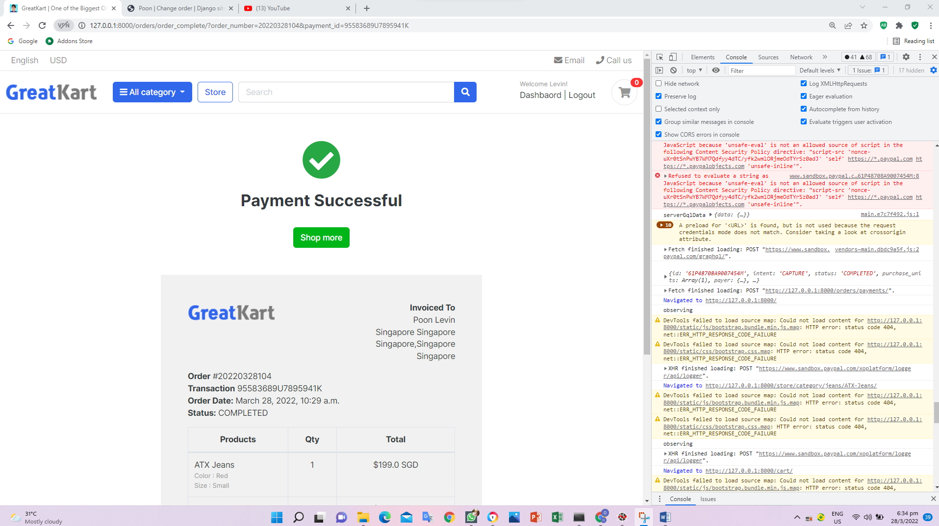

1. Push to github

git status

git add –A

git commit -m "product order and payments"

git push origin main

1. Add codes in the models.py in the store folder (review and rating model)

from accounts.models import Account

&

class ReviewRating(models.Model):

product = models.ForeignKey(Product, on_delete=models.CASCADE)

user = models.ForeignKey(Account, on_delete=models.CASCADE)

subject = models.CharField(max_length=100, blank=True)

review = models.TextField(max_length=500, blank=True)

rating = models.FloatField()

ip = models.CharField(max_length=20, blank=True)

status = models.BooleanField(default=True)

created_at = models.DateTimeField(auto_now_add=True)

updated_at = models.DateTimeField(auto_now=True)

def __str__(self):

return self.subject

1. Migrations thru CMD

python manage.py makemigrations

python manage.py migrate

1. Add codes in the admin.py in the store folder

from django.contrib import admin

from .models import Product, Variation, ReviewRating

# Register your models here.

class ProductAdmin(admin.ModelAdmin):

list_display = ('product_name','price','stock','category','modified_date','is_available')

prepopluated_fields = {'slug': ('product_name',)}

class VariationAdmin(admin.ModelAdmin):

list_display =('product', 'variation_category', 'variation_value', 'is_active')

list_editable = ('is_active',)

list_filter = ('product', 'variation_category', 'variation_value')

admin.site.register(Product, ProductAdmin)

admin.site.register(Variation, VariationAdmin)

admin.site.register(ReviewRating)

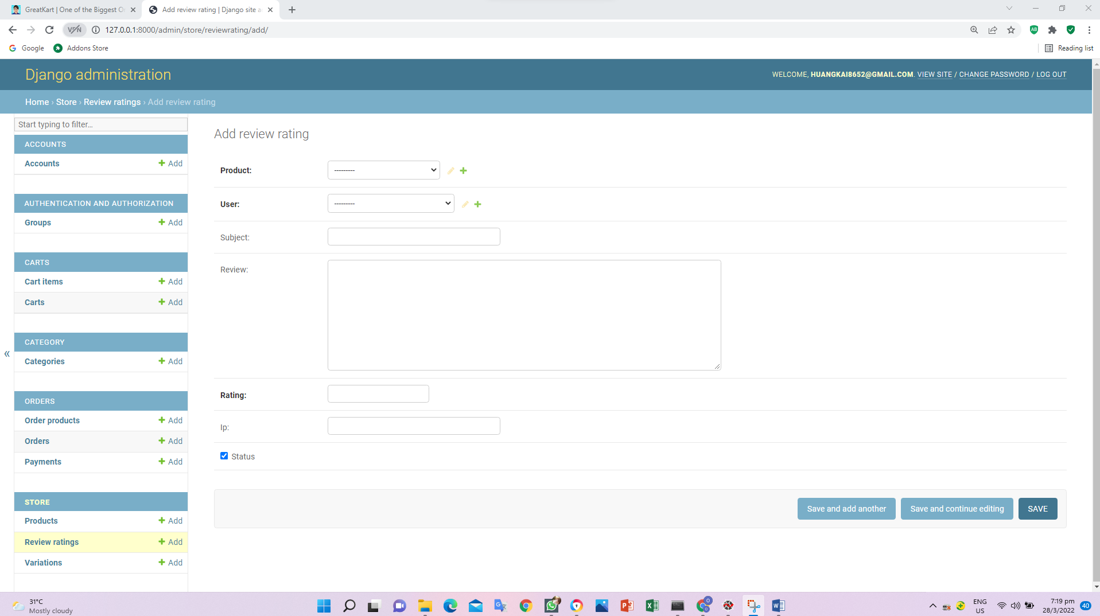

1. Create forms.py in the store folder

from django import forms

from .models import ReviewRating

class ReviewForm(forms.ModelForm):

class Meta:

model = ReviewRating

fields = ['subject', 'review', 'rating']

1. Add codes in the product_details.html in the store folder in the templates folder (customer review input)

</header>

<form action="" method="POST">

{% csrf_token %}

<h5>Write Your Review</h5>

<div>

Review Title:

<input type="text" class="form-control" name="subject">

<br>

Review:

<textarea name="review" rows="4" class="form-control"></textarea>

<br>

<input type="submit" value="Submit Review" Class="btn btn-primary">

</div>

</form>

<br>

<article class="box mb-3">

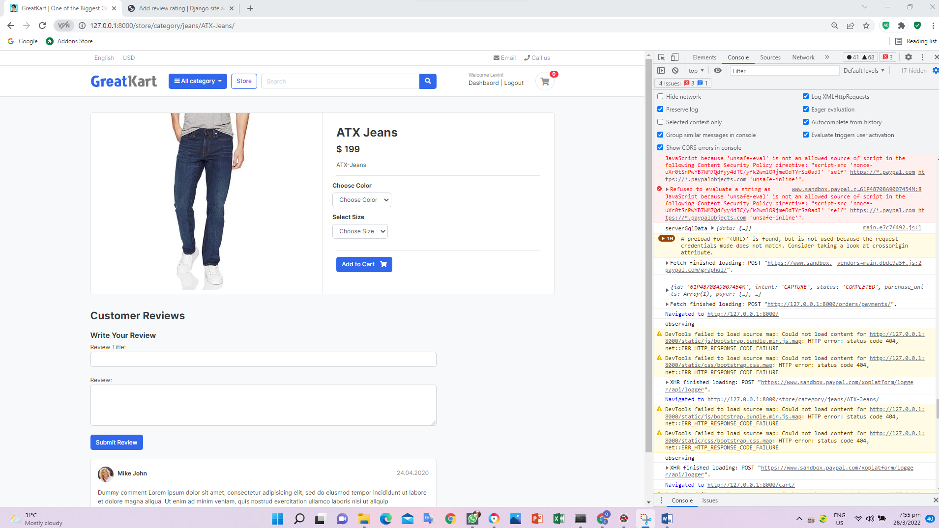

1. Add codes in the product_details.html in the store folder in the templates folder (customer review input)

<h5>Write Your Review</h5>

<div>

<label>How do you rate this product?</label>

<br>

<div class="rate">

<input type="radio" name="rating" id="rating10" value="5" required /><label for="rating10" title="5"></label>

<input type="radio" name="rating" id="rating9" value="4.5" required /><label for="rating9" title="4.5" class="half"></label>

<input type="radio" name="rating" id="rating8" value="4" required /><label for="rating8" title="4"></label>

<input type="radio" name="rating" id="rating7" value="3.5" required /><label for="rating7" title="3.5" class="half"></label>

<input type="radio" name="rating" id="rating6" value="3" required /><label for="rating6" title="3"></label>

<input type="radio" name="rating" id="rating5" value="2.5" required /><label for="rating5" title="2.5" class="half"></label>

<input type="radio" name="rating" id="rating4" value="2" required /><label for="rating4" title="2"></label>

<input type="radio" name="rating" id="rating3" value="1.5" required /><label for="rating3" title="1.5" class="half"></label>

<input type="radio" name="rating" id="rating2" value="1" required /><label for="rating2" title="1"></label>

<input type="radio" name="rating" id="rating1" value="0.5" required /><label for="rating1" title="0.5" class="half"></label>

</div>

<br>

Review Title:

<input type="text" class="form-control" name="subject">

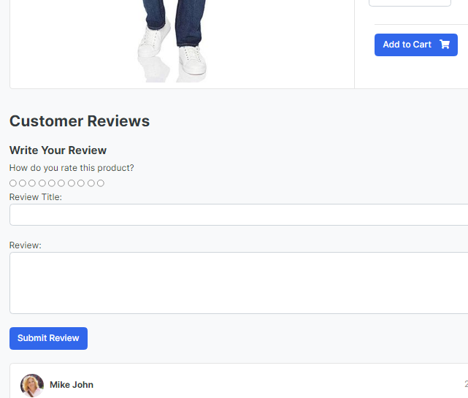

1. Add base.html in the templates folder

<link href={% static 'css/responsive.css' %} rel="stylesheet" media="only screen and (max-width: 1200px)" />

<link href={% static 'css/custom.css' %} rel="stylesheet" type="text/css"/>

<link rel="stylesheet" href="https://cdnjs.cloudflare.com/ajax/libs/font-awesome/4.7.0/css/font-awesome.min.css">

<!-- custom javascript -->

1. Create custom.css in the css folder in the static folder in the online folder

/* Hide Radio button */

.rate > input{

display: none;

}

.rate{

display: inline-block;;

border: 0;

}

.rate > label{

float: right;

}

/* Showing the stars */

.rate > label:before{

display: inline-block;

font-size: 1.1rem;

font-family: FontAwesome;

content: "\f005";

margin:0;

padding:0.3rem .2rem;

cursor: pointer;

}

/* Half star */

.rate .half:before{

content: "\f089";

position: absolute;

padding-right: 0;

}

/* Click and hover */

input:checked ~ label, label:hover ~ label{

color: #ffb503;

}

/* hover hightlight */

input:checked + label:hover, input:checked ~ label:hover,input:checked ~ label:hover ~ label,

label:hover ~ input:checked ~ label{

color: #cc9000;

}

.rating-star i{

color: #ffb503 !important;

}

ul.thumb{

margin:0 auto;

padding: 0;

float: left;

}

ul.thumb li{

list-style: none;

margin: 10px;

}

ul.thumb li img{

width: 80px;

height: 80px;

border: 1px solid grey;

}

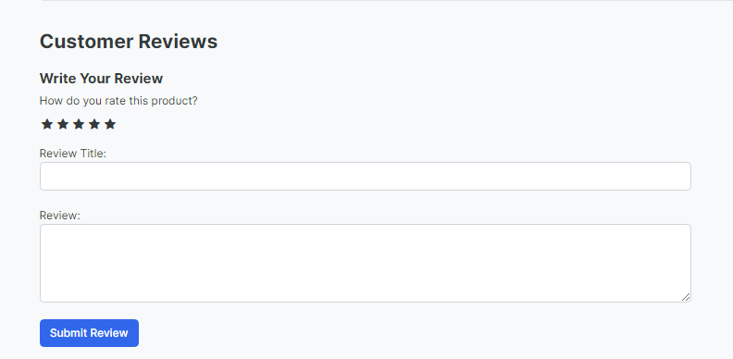

1. Add codes in the urls.py in the store folder

path('search/', views.search, name='search'),

path('submit_review/<int:product_id>/', views.submit_review, name='submit_review'),

]

1. Add codes in the product_details.html in the order folder

<form action="{% url 'submit_review' single_product.id %}" method="POST">

1. Replace codes in the products_detail.html in the store folder in the templates folder

<input type="radio" name="rating" id="rating1" value="0.5" required /><label for="rating1" title="0.5" class="half"></label>

</div>

<br>

Review Title:

<input type="text" class="form-control" name="subject">

<br>

Review:

<textarea name="review" rows="4" class="form-control"></textarea>

<br>

{% if user.is_authenticated %}

<input type="submit" value="Submit Review" class="btn btn-primary">

{% else %}

<p>You must be logged in to post a review. <span><a href="{% url 'login' %}">Login now</a></span></p>

{% endif %}

</div>

{% include 'includes/alerts.html' %}

</form>

<br>

<header class="section-heading">

<h3>Customer Reviews </h3>

</header>

<article class="box mb-3">

<div class="icontext w-100">

<img src="{% static './images/avatars/avatar1.jpg' %}" class="img-xs icon rounded-circle">

1. Add codes in the views.py in the store folder

from django.shortcuts import render, get_object_or_404, redirect

from .models import Product, ReviewRating

from .forms import ReviewForm

from django.contrib import messages

&

def submit_review(request, product_id):

url = request.META.get('HTTP_REFERER')

if request.method == 'POST':

try:

reviews = ReviewRating.objects.get(user__id=request.user.id, product__id=product_id)

form = ReviewForm(request.POST, instance=reviews)

form.save()

messages.success(request, 'Thank you! Your review has been updated.')

return redirect(url)

except ReviewRating.DoesNotExist:

form = ReviewForm(request.POST)

if form.is_valid():

data = ReviewRating()

data.subject = form.cleaned_data['subject']

data.rating = form.cleaned_data['rating']

data.review = form.cleaned_data['review']

data.ip = request.META.get('REMOTE_ADDR')

data.product_id = product_id

data.user_id = request.user.id

data.save()

messages.success(request, 'Thank you! Your review has been submitted.')

return redirect(url)

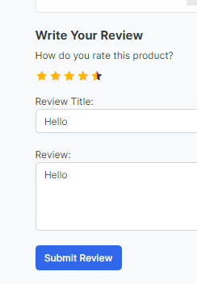 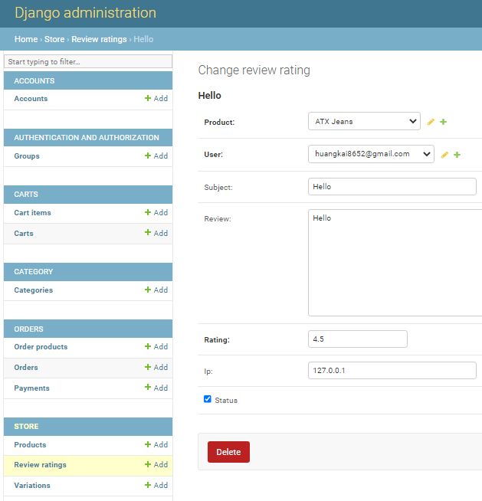

1. Add lines in the views.py in the store folder

from orders.models import OrderProduct

&

except Exception as e:

raise e

try:

orderproduct = OrderProduct.objects.filter(user=request.user, product_id=single_product.id).exists()

except OrderProduct.DoesNotExist:

orderproduct = None

context = {

'single_product': single_product,

'in_cart': in_cart,

'orderproduct': orderproduct,

1. Add codes in the products_detail.html in the store folder in the templates folder

<br>

{% if user.is_authenticated %}

{% if orderproduct %}

<input type="submit" value="Submit Review" class="btn btn-primary">

{% else %}

<p>You must purchase this product to post a review.</p>

{% endif %}

{% else %}

<p>You must be logged in to post a review. <span><a href="{% url 'login' %}">Login now</a></span></p>

{% endif %}

</div>

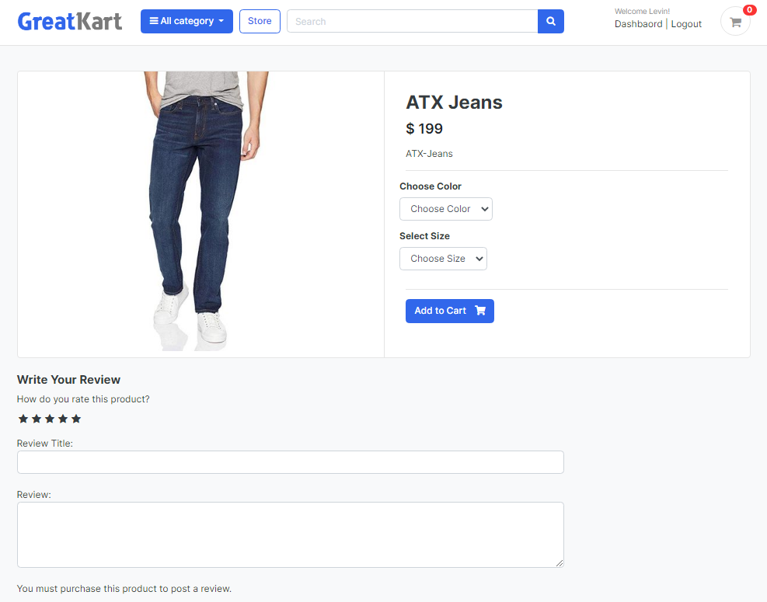

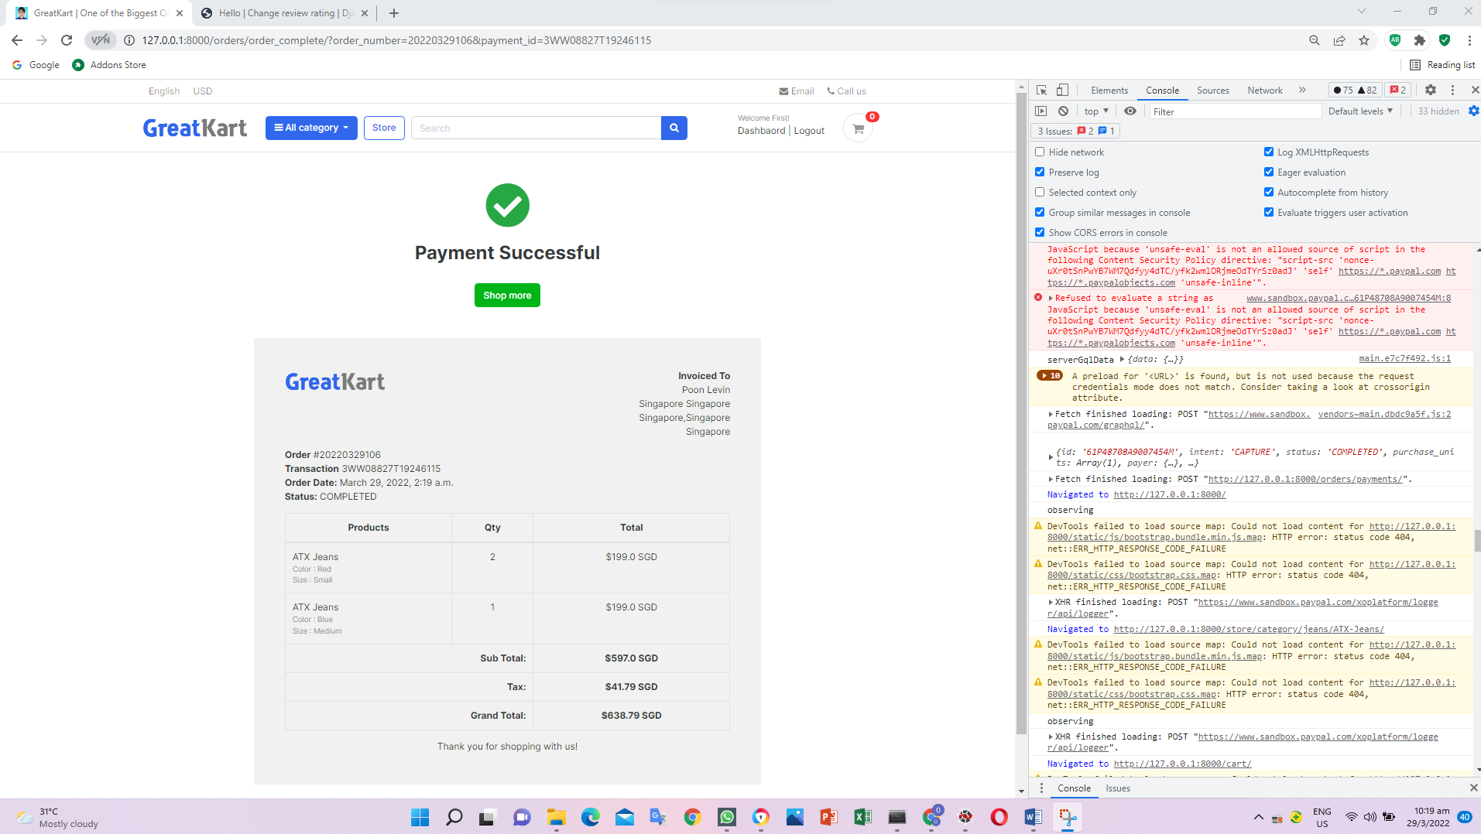

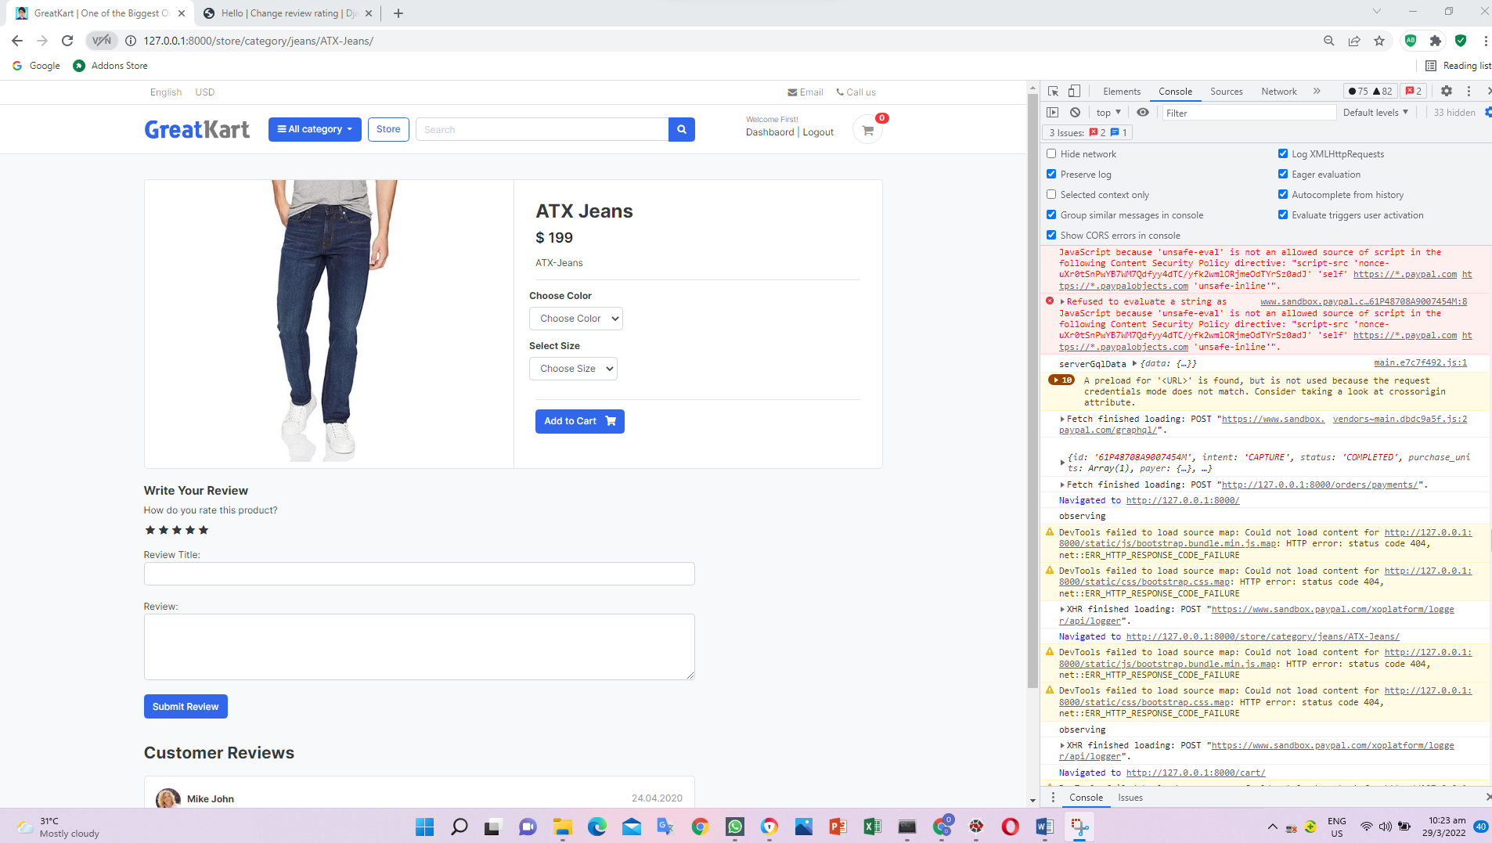

1. Add codes in the views.py in the order folder

orderproduct = None

#get the review

reviews = ReviewRating.objects.filter(product_id=single_product.id, status=True)

context = {

'single_product': single_product,

'in_cart': in_cart,

'orderproduct': orderproduct,

'reviews': reviews,

}

1. Add codes in the products_detail.html in the store folder in the templates folder

{% include 'includes/alerts.html' %}

</form>

<br>

<header class="section-heading">

<h3>Customer Reviews </h3>

</header>

{% for review in reviews %}

<article class="box mb-3">

<div class="icontext w-100">

<div class="text">

<span class="date text-muted float-md-right">{{review.updated_at}} </span>

<h6 class="mb-1">{{review.user.full_name}} </h6>

<!--{{review.rating}}-->

<div class = "rating-star">

<span>

<i class="fa fa-star{% if review.rating == 0.5 %}-half-o{% elif review.rating < 1 %}-o {% endif %}" aria-hidden="true"></i>

<i class="fa fa-star{% if review.rating == 1.5 %}-half-o{% elif review.rating < 2 %}-o {% endif %}" aria-hidden="true"></i>

<i class="fa fa-star{% if review.rating == 2.5 %}-half-o{% elif review.rating < 3 %}-o {% endif %}" aria-hidden="true"></i>

<i class="fa fa-star{% if review.rating == 3.5 %}-half-o{% elif review.rating < 4 %}-o {% endif %}" aria-hidden="true"></i>

<i class="fa fa-star{% if review.rating == 4.5 %}-half-o{% elif review.rating < 5 %}-o {% endif %}" aria-hidden="true"></i>

<span>{{single_product.countReview}} reviews</span>

</span>

</div>

</div>

</div> <!-- icontext.// -->

<div class="mt-3">

<h6>{{review.subject}}</h6>

<p>

{{review.review}}

</p>

</div>

</article>

{% endfor %}

</div> <!-- col.// -->

</div> <!-- row.// -->

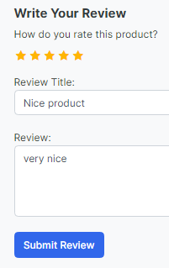 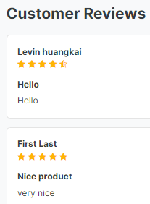

User able to leave comments in the comments box

1. Add codes in the models.py in the store folder

from django.db.models import Avg, Count

&

def __str__(self):

return self.product_name

def averageReview(self):

reviews = ReviewRating.objects.filter(product=self, status=True).aggregate(average=Avg('rating'))

avg = 0

if reviews['average'] is not None:

avg = float(reviews['average'])

return avg

def countReview(self):

reviews = ReviewRating.objects.filter(product=self, status=True).aggregate(count=Count('id'))

count = 0

if reviews['count'] is not None:

count = int(reviews['count'])

return count

class VariationManager(models.Manager):

1. Add codes in the products_detail.html in the store folder in the templates folder

<header class="section-heading">

<h3>Customer Reviews </h3><span>Average Review:</span>

{{single_product.averageReview}}

</header>

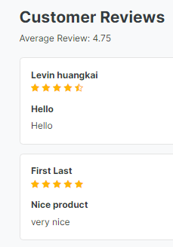 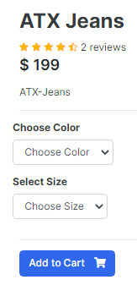

&

{% extends 'base.html' %}

{% load static %}

{% block content %}

<section class="section-content padding-y bg">

<div class="container">

<!-- ============================ COMPONENT 1 ================================= -->

<div class="card">

<div class="row no-gutters">

<aside class="col-md-6">

<article class="gallery-wrap">

<div class="img-big-wrap">

<a href="#"><img src="{{ single_product.images.url }}"></a>

</div> <!-- img-big-wrap.// -->

</article> <!-- gallery-wrap .end// -->

</aside>

<main class="col-md-6 border-left">

<form action="{% url 'add_cart' single_product.id %}" method="POST">

{% csrf_token %}

<article class="content-body">

<h2 class="title">{{ single_product.product_name }}</h2>

<div class="rating-star">

<span>

<i class="fa fa-star{% if single_product.averageReview < 0.5 %}-o{% elif single_product.averageReview >= 0.5 and single_product.averageReview < 1 %}-half-o {% endif %}" aria-hidden="true"></i>

<i class="fa fa-star{% if single_product.averageReview < 1.5 %}-o{% elif single_product.averageReview >= 1.5 and single_product.averageReview < 2 %}-half-o {% endif %}" aria-hidden="true"></i>

<i class="fa fa-star{% if single_product.averageReview < 2.5 %}-o{% elif single_product.averageReview >= 2.5 and single_product.averageReview < 3 %}-half-o {% endif %}" aria-hidden="true"></i>

<i class="fa fa-star{% if single_product.averageReview < 3.5 %}-o{% elif single_product.averageReview >= 3.5 and single_product.averageReview < 4 %}-half-o {% endif %}" aria-hidden="true"></i>

<i class="fa fa-star{% if single_product.averageReview < 4.5 %}-o{% elif single_product.averageReview >= 4.5 and single_product.averageReview < 5 %}-half-o {% endif %}" aria-hidden="true"></i>

<span>{{single_product.countReview}} reviews</span>

</span>

</div>

<div class="mb-3">

<var class="price h4">$ {{ single_product.price }}</var>

</div>

<p>{{ single_product.description }}</p>

<hr>

<div class="row">

<div class="item-option-select">

<h6>Choose Color</h6>

<select name ="color" class="form-control" required>

<option value ="" disabled selected>Choose Color</option>

{% for i in single_product.variation_set.colors %}

<option value="{{ i.variation_value | lower }}">{{ i.variation_value | capfirst }}</option>

{% endfor %}

</select>

</div>

</div> <!-- row.// -->

<div class="row">

<div class="item-option-select">

<h6>Select Size</h6>

<select name ="size" class="form-control" required>

<option value ="" disabled selected>Choose Size</option>

{% for i in single_product.variation_set.sizes %}

<option value="{{ i.variation_value | lower }}">{{ i.variation_value | capfirst }}</option>

{% endfor %}

</select>

</div>

</div> <!-- row.// -->

<hr>

{% if single_product.stock <= 0 %}

<h5 class="text-danger">Out of Stock</h5>

{% else %}

<button type="submit" class="btn btn-primary"> <span class="text">Add to Cart</span> <i class="fas fa-shopping-cart"></i> </button>

{% endif %}

</article> <!-- product-info-aside .// -->

</form>

</main> <!-- col.// -->

</div> <!-- row.// -->

</div> <!-- card.// -->

<!-- ============================ COMPONENT 1 END .// ================================= -->

<br>

<div class="row">

<div class="col-md-9">

<form action="{% url 'submit_review' single_product.id %}" method="POST">

{% csrf_token %}

<h5>Write Your Review</h5>

<div>

<label>How do you rate this product?</label>

<br>

<div class="rate">

<input type="radio" name="rating" id="rating10" value="5" required /><label for="rating10" title="5"></label>

<input type="radio" name="rating" id="rating9" value="4.5" required /><label for="rating9" title="4.5" class="half"></label>

<input type="radio" name="rating" id="rating8" value="4" required /><label for="rating8" title="4"></label>

<input type="radio" name="rating" id="rating7" value="3.5" required /><label for="rating7" title="3.5" class="half"></label>

<input type="radio" name="rating" id="rating6" value="3" required /><label for="rating6" title="3"></label>

<input type="radio" name="rating" id="rating5" value="2.5" required /><label for="rating5" title="2.5" class="half"></label>

<input type="radio" name="rating" id="rating4" value="2" required /><label for="rating4" title="2"></label>

<input type="radio" name="rating" id="rating3" value="1.5" required /><label for="rating3" title="1.5" class="half"></label>

<input type="radio" name="rating" id="rating2" value="1" required /><label for="rating2" title="1"></label>

<input type="radio" name="rating" id="rating1" value="0.5" required /><label for="rating1" title="0.5" class="half"></label>

</div>

<br>

Review Title:

<input type="text" class="form-control" name="subject">

<br>

Review:

<textarea name="review" rows="4" class="form-control"></textarea>

<br>

{% if user.is_authenticated %}

{% if orderproduct %}

<input type="submit" value="Submit Review" class="btn btn-primary">

{% else %}

<p>You must purchase this product to post a review.</p>

{% endif %}

{% else %}

<p>You must be logged in to post a review. <span><a href="{% url 'login' %}">Login now</a></span></p>

{% endif %}

</div>

{% include 'includes/alerts.html' %}

</form>

<br>

<header class="section-heading">

<h3>Customer Reviews </h3><span>Average Review:</span> <br>

{{single_product.averageReview}}

<div class="rating-star">

<span>

<i class="fa fa-star{% if single_product.averageReview < 0.5 %}-o{% elif single_product.averageReview >= 0.5 and single_product.averageReview < 1 %}-half-o {% endif %}" aria-hidden="true"></i>

<i class="fa fa-star{% if single_product.averageReview < 1.5 %}-o{% elif single_product.averageReview >= 1.5 and single_product.averageReview < 2 %}-half-o {% endif %}" aria-hidden="true"></i>

<i class="fa fa-star{% if single_product.averageReview < 2.5 %}-o{% elif single_product.averageReview >= 2.5 and single_product.averageReview < 3 %}-half-o {% endif %}" aria-hidden="true"></i>

<i class="fa fa-star{% if single_product.averageReview < 3.5 %}-o{% elif single_product.averageReview >= 3.5 and single_product.averageReview < 4 %}-half-o {% endif %}" aria-hidden="true"></i>

<i class="fa fa-star{% if single_product.averageReview < 4.5 %}-o{% elif single_product.averageReview >= 4.5 and single_product.averageReview < 5 %}-half-o {% endif %}" aria-hidden="true"></i>

<span>{{single_product.countReview}} reviews</span>

</span>

</div>

</header>

{% for review in reviews %}

<article class="box mb-3">

<div class="icontext w-100">

<div class="text">

<span class="date text-muted float-md-right">{{review.updated_at}} </span>

<h6 class="mb-1">{{review.user.full_name}} </h6>

<!--{{review.rating}}-->

<div class = "rating-star">

<span>

<i class="fa fa-star{% if review.rating == 0.5 %}-half-o{% elif review.rating < 1 %}-o {% endif %}" aria-hidden="true"></i>

<i class="fa fa-star{% if review.rating == 1.5 %}-half-o{% elif review.rating < 2 %}-o {% endif %}" aria-hidden="true"></i>

<i class="fa fa-star{% if review.rating == 2.5 %}-half-o{% elif review.rating < 3 %}-o {% endif %}" aria-hidden="true"></i>

<i class="fa fa-star{% if review.rating == 3.5 %}-half-o{% elif review.rating < 4 %}-o {% endif %}" aria-hidden="true"></i>

<i class="fa fa-star{% if review.rating == 4.5 %}-half-o{% elif review.rating < 5 %}-o {% endif %}" aria-hidden="true"></i>

</span>

</div>

</div>

</div> <!-- icontext.// -->

<div class="mt-3">

<h6>{{review.subject}}</h6>

<p>

{{review.review}}

</p>

</div>

</article>

{% endfor %}

</div> <!-- col.// -->

</div> <!-- row.// -->

</div> <!-- container .// -->

</section>

<!-- ========================= SECTION CONTENT END// ========================= -->

{% endblock %}

1. Edit codes in the views.py in the store folder (AnonymousUser fixed)

except Exception as e:

raise e

if request.user.is_authenticated:

try:

orderproduct = OrderProduct.objects.filter(user=request.user, product_id=single_product.id).exists()

except OrderProduct.DoesNotExist:

orderproduct = None

else:

orderproduct = None

#get the review

reviews = ReviewRating.objects.filter(product_id=single_product.id, status=True)

1. Push to github

git status

git add –A

git commit -m "review and rating system"

git push origin main

1. Create dashboard_sidebar.html in the includes folder in the templates folder (payment dashboard)
2. Cut the codes from dashboard.html in the accounts folder in the templates folder into dashboard_sidebar.html in the includes folder in the templates folder

<aside class="col-md-3">

<!-- SIDEBAR -->

<ul class="list-group">

<a class="list-group-item active" href="#"> My order history </a>

<a class="list-group-item" href="#"> Transactions </a>

<a class="list-group-item" href="#"> Return and refunds </a>

<a class="list-group-item" href="#">Settings </a>

<a class="list-group-item" href="#"> My Selling Items </a>

<a class="list-group-item" href="#"> Received orders </a>

</ul>

<br>

<a class="btn btn-light btn-block" href="{% url 'logout' %}"> <i class="fa fa-power-off"></i> <span class="text">Log out</span> </a>

<!-- SIDEBAR .//END -->

</aside>

&

<div class="row">

{% include 'includes/dashboard_sidebar.html' %}

<main class="col-md-9">

1. Replace codes in the dashboard_sidebar.html in the includes folder in the templates folder

<aside class="col-md-3">

<!-- SIDEBAR -->

<ul class="list-group">

<a class="list-group-item active" href="#"> Dashboard </a>

<a class="list-group-item" href="#"> My Orders </a>

<a class="list-group-item" href="#"> Edit Profile </a>

<a class="list-group-item" href="#"> Change Password </a>

</ul>

<br>

<a class="btn btn-light btn-block" href="{% url 'logout' %}"> <i class="fa fa-power-off"></i> <span class="text">Log out</span> </a>

<!-- SIDEBAR .//END -->

</aside>

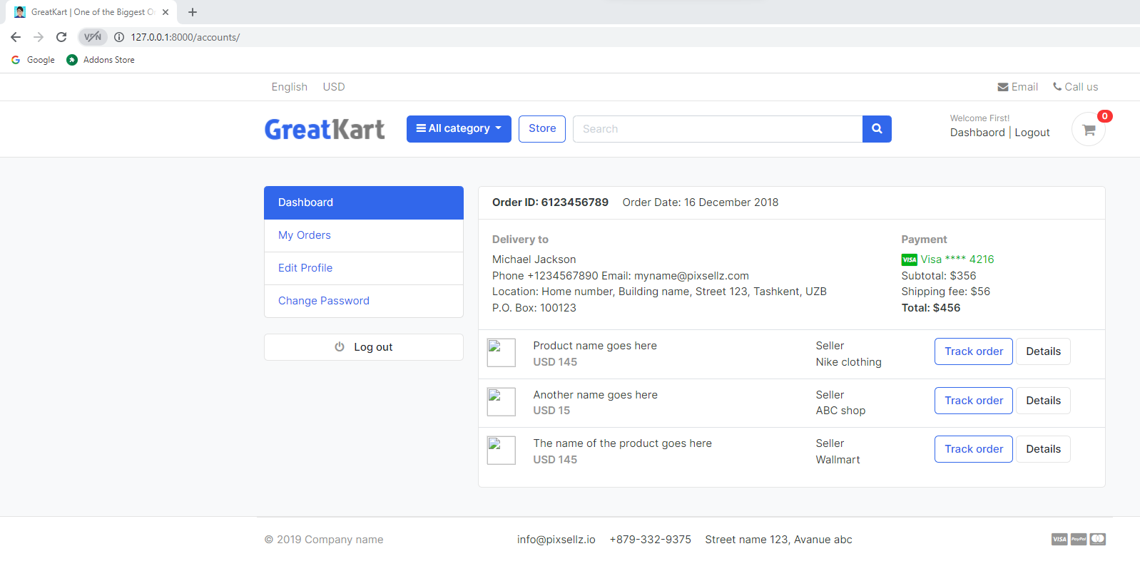

1. Replace codes in the dashboard_sidebar.html in the includes folder in the templates folder

Old

<strong class="d-inline-block mr-3">Order ID: 6123456789</strong>

<span>Order Date: 16 December 2018</span>

New

<strong class="d-inline-block mr-3">Logged in as:</strong>

<span>{{user.full_name}}</span>

1. Delete table codes in the dashboard_sidebar.html in the includes folder in the templates folder

<div class="table-responsive">

<table class="table table-hover">

<tr>

<td width="65">

<img src="../images/items/1.jpg" class="img-xs border">

</td>

<td>

<p class="title mb-0">Product name goes here </p>

<var class="price text-muted">USD 145</var>

</td>

<td> Seller <br> Nike clothing </td>

<td width="250"> <a href="#" class="btn btn-outline-primary">Track order</a> <a href="#" class="btn btn-light"> Details </a> </td>

</tr>

<tr>

<td>

<img src="../images/items/2.jpg" class="img-xs border">

</td>

<td>

<p class="title mb-0">Another name goes here </p>

<var class="price text-muted">USD 15</var>

</td>

<td> Seller <br> ABC shop </td>

<td> <a href="#" class="btn btn-outline-primary">Track order</a> <a href="#" class="btn btn-light"> Details </a> </td>

</tr>

<tr>

<td>

<img src="../images/items/3.jpg" class="img-xs border">

</td>

<td>

<p class="title mb-0">The name of the product goes here </p>

<var class="price text-muted">USD 145</var>

</td>

<td> Seller <br> Wallmart </td>

<td> <a href="#" class="btn btn-outline-primary">Track order</a> <a href="#" class="btn btn-light"> Details </a> </td>

</tr>

</table>

</div> <!-- table-responsive .end// -->

&

<div class="col-md-8">

<h6 class="text-muted">Delivery to</h6>

<p>Michael Jackson <br>

Phone +1234567890 Email: myname@pixsellz.com <br>

Location: Home number, Building name, Street 123, Tashkent, UZB <br>

P.O. Box: 100123

</p>

</div>

&

<div class="col-md-4">

<h6 class="text-muted">Payment</h6>

<span class="text-success">

<i class="fab fa-lg fa-cc-visa"></i>

Visa **** 4216

</span>

<p>Subtotal: $356 <br>

Shipping fee: $56 <br>

<span class="b">Total: $456 </span>

</p>

</div>

1. Add codes in the dashboard_sidebar.html in the includes folder in the templates folder

<div class="row">

<div class="col-md-6">

<div class="card" style="text-align:center;">

<div class="card-body">

<h5 class="card-title">Total Orders</h5>

<h4>100</h4>

<a href="">View Orders</a>

</div>

</div>

</div>

<div class="col-md-6">

<div class="card" style="text-align:center;">

<div class="card-body">

<img src="https://www.w3schools.com/howto/img_avatar.png" alt="User Profile Picture" width="50" height="50" style="border-radius:50%;">

<p class="mb-0">{{user.email}}</p>

<p>{{user.phone_number}}</p>

</div>

</div>

</div>

</div> <!-- row.// -->

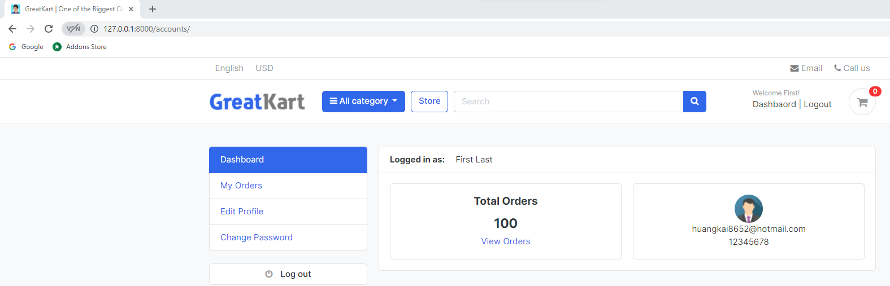

1. Add codes in the views.py in the accounts folder

from orders.models import Order

&

@login_required(login_url = 'login')

def dashboard(request):

orders = Order.objects.order_by('-created_at').filter(user_id=request.user.id, is_ordered=True)

orders_count = orders.count()

context = {

'orders_count': orders_count,

}

return render(request, 'accounts/dashboard.html', context)

1. Replace codes in the dashboard_sidebar.html in the includes folder in the templates folder

<h5 class="card-title">Total Orders</h5>

<h4>{{orders_count}}</h4>

<a href="">View Orders</a>

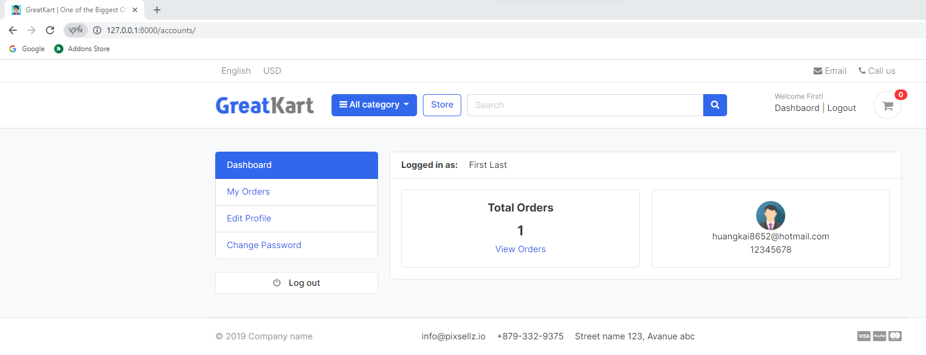

1. Add codes in the urls.py in the accounts folder

path('resetPassword/', views.resetPassword, name='resetPassword'),

path('my_orders/', views.my_orders, name='my_orders'),

]

1. Add codes in the last line in the views.py in the accounts folder

def my_orders(request):

return render(request, 'accounts/my_orders.html')

1. Create my_orders.html in the accounts folder in the templates folder and copy codes from dashboard.html from accounts folder in the templates folder

{% extends 'base.html' %}

{% block content %}

<!-- ========================= SECTION CONTENT ========================= -->

<section class="section-conten padding-y bg">

{% include 'includes/alerts.html' %}

<div class="container">

<div class="row">

{% include 'includes/dashboard_sidebar.html' %}

<main class="col-md-9">

<article class="card">

<header class="card-header">

<strong class="d-inline-block mr-3">Logged in as:</strong>

<span>{{user.full_name}}</span>

</header>

<div class="card-body">

<div class="row">

<div class="col-md-6">

<div class="card" style="text-align:center;">

<div class="card-body">

<h5 class="card-title">Total Orders</h5>

<h4>{{orders_count}}</h4>

<a href="">View Orders</a>

</div>

</div>

</div>

<div class="col-md-6">

<div class="card" style="text-align:center;">

<div class="card-body">

<img src="https://www.w3schools.com/howto/img_avatar.png" alt="User Profile Picture" width="50" height="50" style="border-radius:50%;">

<p class="mb-0">{{user.email}}</p>

<p>{{user.phone_number}}</p>

</div>

</div>

</div>

</div> <!-- row.// -->

</div> <!-- card-body .// -->

</article> <!-- order-group.// -->

</main>

</div> <!-- row.// -->

</div>

</section>

<!-- ========================= SECTION CONTENT END// ========================= -->

{% endblock %}

1. Remove the codes in the my_orders.html in the accounts folder in the templates folder

{% extends 'base.html' %}

{% block content %}

<!-- ========================= SECTION CONTENT ========================= -->

<section class="section-conten padding-y bg">

{% include 'includes/alerts.html' %}

<div class="container">

<div class="row">

{% include 'includes/dashboard_sidebar.html' %}

<main class="col-md-9">

<article class="card">

<header class="card-header">

<strong class="d-inline-block mr-3">Your order history:</strong>

</header>

<div class="card-body">

<div class="row">

<div class="col-md-12">

</div>

</div> <!-- row.// -->

</div> <!-- card-body .// -->

</article> <!-- order-group.// -->

</main>

</div> <!-- row.// -->

</div>

</section>

<!-- ========================= SECTION CONTENT END// ========================= -->

{% endblock %}

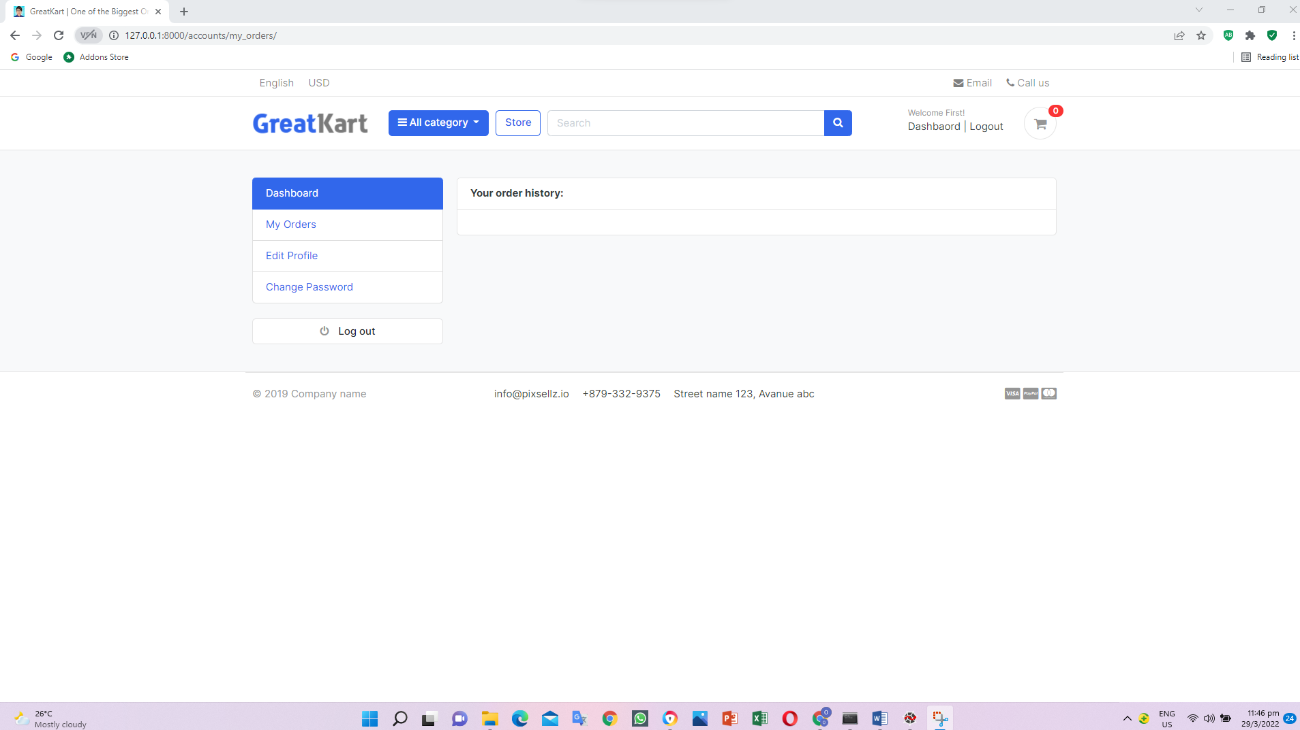

1. Edits codes in the views.py in the accounts folder

@login_required(login_url='login')

def my_orders(request):

orders = Order.objects.filter(user=request.user, is_ordered=True).order_by('-created_at')

context = {

'orders': orders,

}

return render(request, 'accounts/my_orders.html', context)

1. Add codes in the my_orders.html in the accounts folder in the templates folder

{% extends 'base.html' %}

{% block content %}

<!-- ========================= SECTION CONTENT ========================= -->

<section class="section-conten padding-y bg">

{% include 'includes/alerts.html' %}

<div class="container">

<div class="row">

{% include 'includes/dashboard_sidebar.html' %}

<main class="col-md-9">

<article class="card">

<header class="card-header">

<strong class="d-inline-block mr-3">Your order history:</strong>

</header>

<div class="card-body">

<div class="row">

<div class="col-md-12">

<table class="table table-hover">

<thead>

<tr>

<th scope="col">Order #</th>

<th scope="col">Billing Name</th>

<th scope="col">Phone</th>

<th scope="col">Order Total</th>

<th scope="col">Date</th>

</tr>

</thead>

<tbody>

{% for order in orders %}

<tr>

<th scope="row">{{order.order_number}}</a></th>

<td>{{order.full_name}}</td>

<td>{{order.phone}}</td>

<td>${{order.order_total}}</td>

<td>{{order.created_at}}</td>

</tr>

{% endfor %}

</tbody>

</table>

</div>

</div> <!-- row.// -->

</div> <!-- card-body .// -->

</article> <!-- order-group.// -->

</main>

</div> <!-- row.// -->

</div>

</section>

<!-- ========================= SECTION CONTENT END// ========================= -->

{% endblock %}

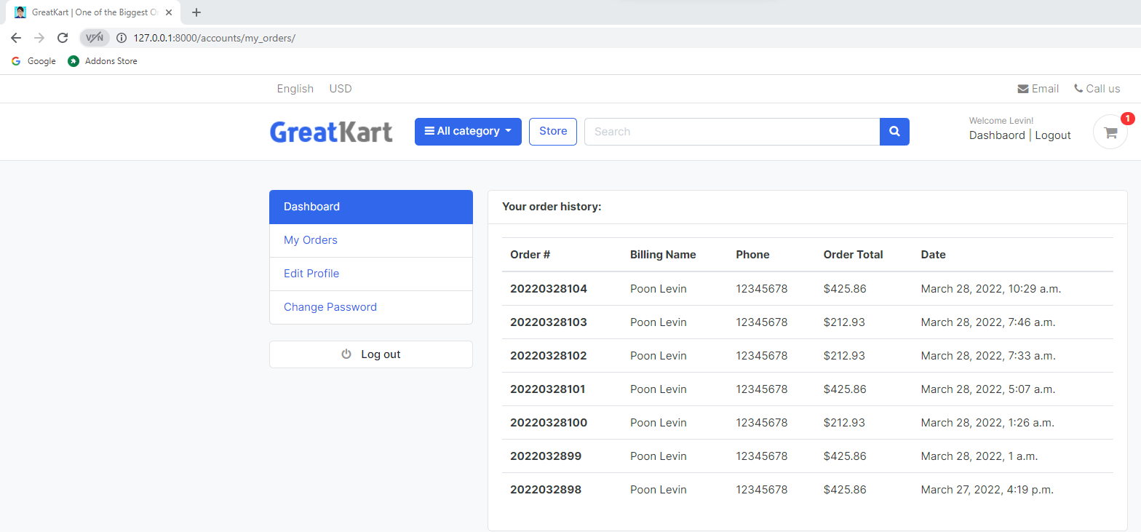

1. Replace codes in the dashboard_sidebar.html in the includes folder in the templates folder

<ul class="list-group">

<a class="list-group-item {% if '/accounts/' == request.path %}active{% endif %}" href="{% url 'dashboard' %}"> Dashboard </a>

<a class="list-group-item {% if '/my_orders/' in request.path %}active{% endif %}" href="{% url 'my_orders' %}"> My Orders </a>

<a class="list-group-item" href="#"> Edit Profile </a>

User able to click Dashboard and My Orders

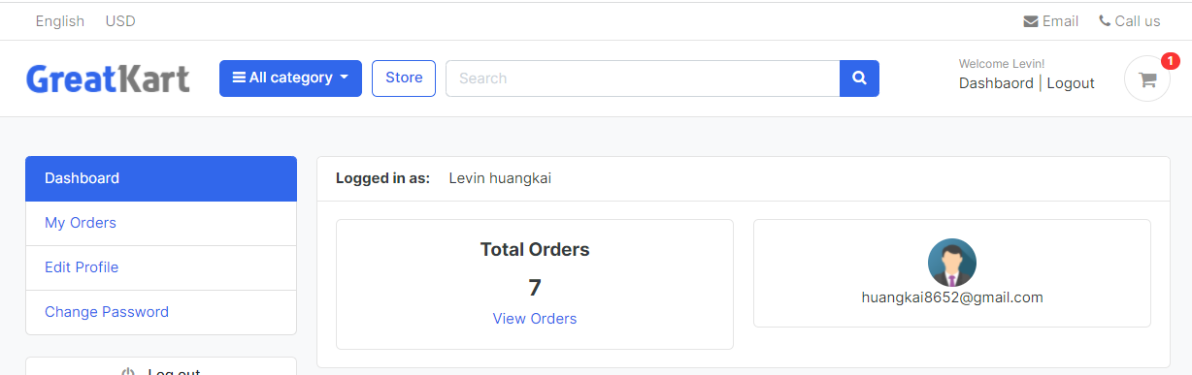

1. Add codes in the last part in the models.py in the accounts folder

class UserProfile(models.Model):

user = models.OneToOneField(Account, on_delete=models.CASCADE)

address_line_1 = models.CharField(blank=True, max_length=100)

address_line_2 = models.CharField(blank=True, max_length=100)

profile_picture = models.ImageField(blank=True, upload_to='userprofile')

city = models.CharField(blank=True, max_length=20)

state = models.CharField(blank=True, max_length=20)

country = models.CharField(blank=True, max_length=20)

def __str__(self):

return self.user.first_name

def full_address(self):

return f'{self.address_line_1} {self.address_line_2}'

1. Add lines in the admin.py in the accounts folder

from .models import Account, UserProfile

from django.utils.html import format_html

&

class UserProfileAdmin(admin.ModelAdmin):

def thumbnail(self, object):

return format_html('<img src="{}" width="30" style="border-radius:50%;">'.format(object.profile_picture.url))

thumbnail.short_description = 'Profile Picture'

list_display = ('thumbnail', 'user', 'city', 'state', 'country')

admin.site.register(Account, AccountAdmin)

admin.site.register(UserProfile, UserProfileAdmin)

1. Python make migration

python manage.py makemigrations

python manage.py migrate

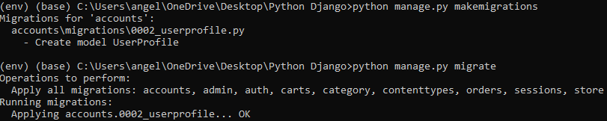

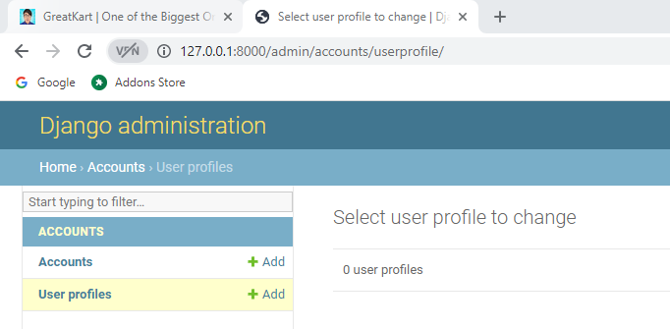

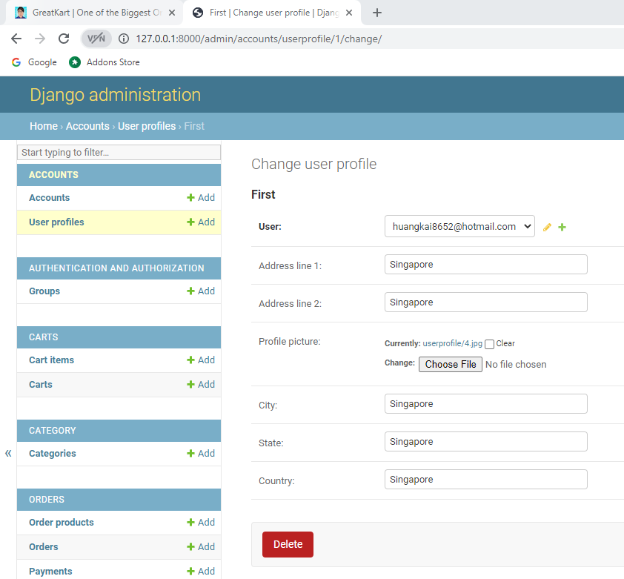

1. Add lines of codes in the urls.py in the accounts folder

path('my_orders/', views.my_orders, name='my_orders'),

path('edit_profile/', views.edit_profile, name='edit_profile'),

]

1. Add lines in the last row in the views.py in the accounts folder

def edit_profile(request):

return render(request, 'accounts/edit_profile.html')

1. Create edit_profile.html in the accounts folder in the templates folder
2. Copy my orders.html codes in the edit_profile.html in the accounts folder in the templates folder

{% extends 'base.html' %}

{% block content %}

<!-- ========================= SECTION CONTENT ========================= -->

<section class="section-conten padding-y bg">

{% include 'includes/alerts.html' %}

<div class="container">

<div class="row">

{% include 'includes/dashboard_sidebar.html' %}

<main class="col-md-9">

<article class="card">

<header class="card-header">

<strong class="d-inline-block mr-3">Edit your profile</strong>

</header>

<div class="card-body">

<div class="row">

<div class="col-md-12">

<table class="table table-hover">

<thead>

<tr>

<th scope="col">Order #</th>

<th scope="col">Billing Name</th>

<th scope="col">Phone</th>

<th scope="col">Order Total</th>

<th scope="col">Date</th>

</tr>

</thead>

<tbody>

{% for order in orders %}

<tr>

<th scope="row">{{order.order_number}}</a></th>

<td>{{order.full_name}}</td>

<td>{{order.phone}}</td>

<td>${{order.order_total}}</td>

<td>{{order.created_at}}</td>

</tr>

{% endfor %}

</tbody>

</table>

</div>

</div> <!-- row.// -->

</div> <!-- card-body .// -->

</article> <!-- order-group.// -->

</main>

</div> <!-- row.// -->

</div>

</section>

<!-- ========================= SECTION CONTENT END// ========================= -->

{% endblock %}

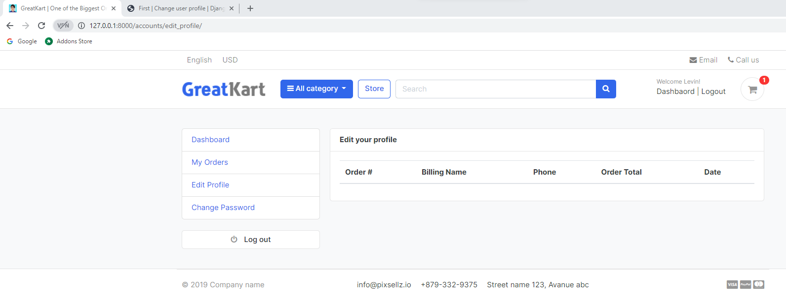

1. Edits codes in the edit_profile.html in the accounts folder in the templates folder

{% extends 'base.html' %}

{% block content %}

<!-- ========================= SECTION CONTENT ========================= -->

<section class="section-conten padding-y bg">

{% include 'includes/alerts.html' %}

<div class="container">

<div class="row">

{% include 'includes/dashboard_sidebar.html' %}

<main class="col-md-9">

<article class="card">

<header class="card-header">

<strong class="d-inline-block mr-3">Edit your profile</strong>

</header>

<div class="card-body">

<div class="row">

<div class="col-md-12">

</div>

</div> <!-- row.// -->

</div> <!-- card-body .// -->

</article> <!-- order-group.// -->

</main>

</div> <!-- row.// -->

</div>

</section>

<!-- ========================= SECTION CONTENT END// ========================= -->

{% endblock %}

1. Edit codes in the dashboard_sidebar.html in the includes folder in the templates folder

<a class="list-group-item {% if '/my_orders/' in request.path %}active{% endif %}" href="{% url 'my_orders' %}"> My Orders </a>

<a class="list-group-item {% if '/edit_profile/' in request.path %}active{% endif %}" href="{% url 'edit_profile' %}"> Edit Profile </a>

<a class="list-group-item" href="#"> Change Password </a>

User able to click Dashboard, My Orders and Edit Profile button under the Dashbaord button

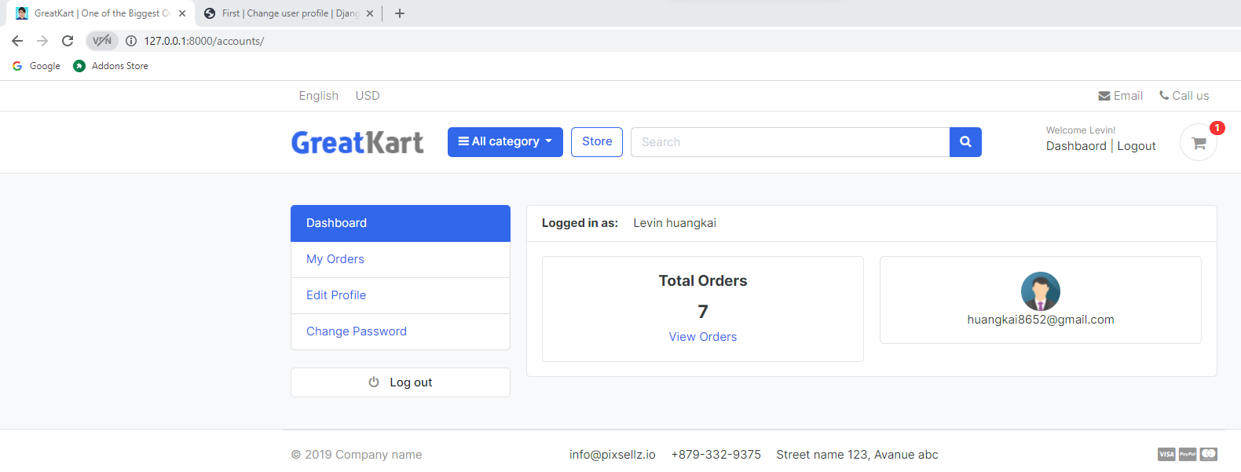

1. Edit codes in the edit_profile.html in the accounts folder in the templates folder

{% extends 'base.html' %}

{% block content %}

<!-- ========================= SECTION CONTENT ========================= -->

<section class="section-conten padding-y bg">

{% include 'includes/alerts.html' %}

<div class="container">

<div class="row">

{% include 'includes/dashboard_sidebar.html' %}

<main class="col-md-9">

<article class="card">

<header class="card-header">

<strong class="d-inline-block mr-3">Edit your profile</strong>

</header>

<div class="card-body">

<div class="row">

<div class="col-md-12">

<form action="{% url 'edit_profile' %}" method="POST" enctype="multipart/form-data">

{% csrf_token %}

<div class="form-row">

<div class="form-group col-md-6">

<label>First Name</label>

{{user_form.first_name}}

</div>

<div class="form-group col-md-6">

<label>Last Name</label>

{{user_form.last_name}}

</div>

</div>

<div class="form-row">

<div class="form-group col-md-6">

<label>Phone Number</label>

{{user_form.phone_number}}

</div>

<div class="form-group col-md-6">

<label>Profile Picture</label>

{{profile_form.profile_picture}}

</div>

</div>

<div class="form-group">

<label>Address Line 1</label>

{{profile_form.address_line_1}}

</div>

<div class="form-group">

<label>Address Line 2</label>

{{profile_form.address_line_2}}

</div>

<div class="form-row">

<div class="form-group col-md-4">

<label>City</label>

{{profile_form.city}}

</div>

<div class="form-group col-md-4">

<label>State</label>

{{profile_form.state}}

</div>

<div class="form-group col-md-4">

<label>Country</label>

{{profile_form.country}}

</div>

</div>

<input type="submit" value="Save" class="btn btn-primary">

</form>

</div>

</div> <!-- row.// -->

</div> <!-- card-body .// -->

</article> <!-- order-group.// -->

</main>

</div> <!-- row.// -->

</div>

</section>

<!-- ========================= SECTION CONTENT END// ========================= -->

{% endblock %}

1. Add lines of code in the forms.py in the accounts folder

from .models import Account, UserProfile

&

class UserProfileForm(forms.ModelForm):

profile_picture = forms.ImageField(required=False, error_messages = {'invalid':("Image files only")}, widget=forms.FileInput)

class Meta:

model = UserProfile

fields = ('address_line_1', 'address_line_2', 'city', 'state', 'country', 'profile_picture')

def __init__(self, *args, **kwargs):

super(UserProfileForm, self).__init__(*args, **kwargs)

for field in self.fields:

self.fields[field].widget.attrs['class'] = 'form-control'

1. Add codes in the views.py in the accounts folder

from django.shortcuts import render, redirect, get_object_or_404

from .forms import RegistrationForm, Userform, UserProfileForm

from .models import Account, UserProfile

1. Add lines in the forms.py in the accounts folder

class UserForm(forms.ModelForm):

class Meta:

model = Account

fields = ('first_name', 'last_name', 'phone_number')

def __init__(self, *args, **kwargs):

super(UserForm, self).__init__(*args, **kwargs)

for field in self.fields:

self.fields[field].widget.attrs['class'] = 'form-control'

1. Edit codes in the edit_profile.html in the accounts folder in the templates folder

<div class="card-body">

<div class="text-right">

<img src="{{userprofile.profile_picture.url}}" alt="Profile Picture" width="100" style="border-radus:50;">

</div>

<div class="row">

<div class="col-md-12">

<form action="{% url 'edit_profile' %}" method="POST" enctype="multipart/form-data">

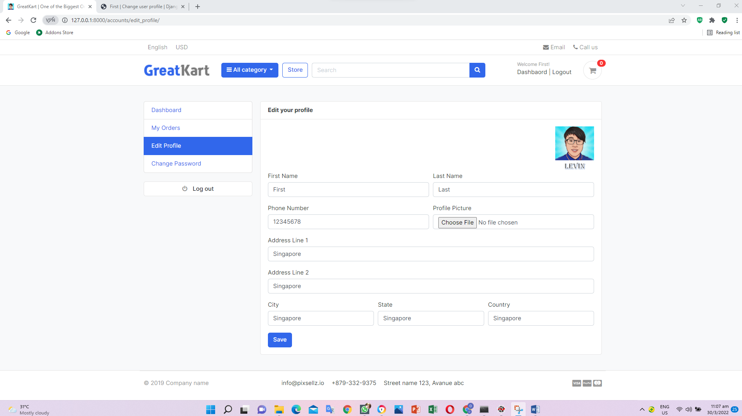

1. Add lines in the views.py in the account folder

user.save()

#Create User Profile

profile = UserProfile()

profile.user_id = user.id

profile.profile_picture = 'default/default-user.png'

profile.save()

#user activation

current_site = get_current_site(request)

1. Create default folder and images folder in the media folder

User able to edit user profile

1. Add lines in the urls.py in the accounts folder (Change Password)

path('my_orders/', views.my_orders, name='my_orders'),

path('edit_profile/', views.edit_profile, name='edit_profile'),

path('change_password/', views.change_password, name='change_password'),

]

1. Add lines in the dashboard_sidebar.html in the includes folder in the templates folder

<a class="list-group-item {% if '/edit_profile/' in request.path %}active{% endif %}" href="{% url 'edit_profile' %}"> Edit Profile </a>

<a class="list-group-item {% if '/change_password/' in request.path %}active{% endif %}" href="{% url 'change_password' %}"> Change Password </a>

</ul>

1. Add lines views.py in the accounts folder

def change_password(request):

return render(request, 'accounts/change_password.html')

1. Copy edit_profile.html into change_password.html in the account folder in the templates folder

{% extends 'base.html' %}

{% block content %}

<!-- ========================= SECTION CONTENT ========================= -->

<section class="section-conten padding-y bg">

{% include 'includes/alerts.html' %}

<div class="container">

<div class="row">

{% include 'includes/dashboard_sidebar.html' %}

<main class="col-md-9">

<article class="card">

<header class="card-header">

<strong class="d-inline-block mr-3">Change Your Password</strong>

</header>

<div class="card-body">

<div class="row">

<div class="col-md-12">

<form action="{% url 'change_password' %}" method="POST">

{% csrf_token %}

<div class="form-group">

<label>Current Password</label>

<input type="password" name="current_password" placeholder="Current Password" class="form-control" required>

</div>

<div class="form-group">

<label>Create new password</label>

<input type="password" name="new_password" placeholder="Create New Password" class="form-control" required>

</div>

<div class="form-group">

<label>Confirm new password</label>

<input type="password" name="confirm_password" placeholder="Confirm New Password" class="form-control" required>

</div>

<input type="submit" value="Save" class="btn btn-primary">

</form>

</div>

</div> <!-- row.// -->

</div> <!-- card-body .// -->

</article> <!-- order-group.// -->

</main>

</div> <!-- row.// -->

</div>

</section>

<!-- ========================= SECTION CONTENT END// ========================= -->

{% endblock %}

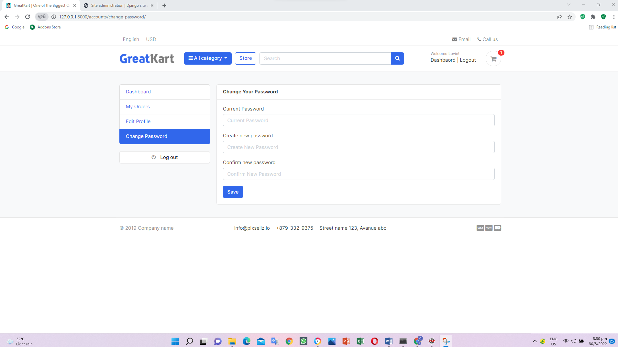

1. Add line of codes in the views.py in the account folder

from orders.models import Order, OrderProduct

&

@login_required(login_url='login')

def order_detail(request, order_id):

return render(request, 'accounts/order_detail.html')

1. Add lines views.py in the accounts folder(Order Detail Page)

path('change_password/', views.change_password, name='change_password'),

path('order_detail/<int:order_id>/', views.order_detail, name='order_detail'),

]

1. Copy order_complete.html from orders folder in the templates folder to Order_detail.html in the accounts folder in the templates folder

{% extends 'base.html' %}

{% load static %}

{% block content %}

<div class="container" style="margin: 0 auto;width: 50%;padding: 50px;background: #f1f1f1;margin-top: 50px;margin-bottom: 50px;">

<div class="row invoice row-printable">

<div class="col-md-12">

<!-- col-lg-12 start here -->

<div class="panel panel-default plain" id="dash_0">

<!-- Start .panel -->

<div class="panel-body p30">

<div class="row">

<!-- Start .row -->

<div class="col-lg-6">

<!-- col-lg-6 start here -->

<div class="invoice-logo"><img src="{% static '/images/logo.png' %}" alt="Invoice logo" style="max-height: 40px;"></div>

</div>

<!-- col-lg-6 end here -->

<div class="col-lg-6">

<!-- col-lg-6 start here -->

<div class="invoice-from">

<ul class="list-unstyled text-right">

<li><strong>Invoiced To</strong></li>

<li>{{order.full_name}}</li>

<li>{{order.full_address}}</li>

<li>{{order.city}},{{order.state}}</li>

<li>{{order.country}}</li>

</ul>

</div>

</div>

<!-- col-lg-6 end here -->

<div class="col-lg-12">

<!-- col-lg-12 start here -->

<div class="invoice-details mt25">

<div class="well">

<ul class="list-unstyled mb0">

<li><strong>Order</strong> #{{order_number}}</li>

<li><strong>Transaction</strong> {{transID}}</li>

<li><strong>Order Date:</strong> {{order.created_at}}</li>

<li><strong>Status:</strong> {{payment.status}}</li>

</ul>

</div>

</div>

<div class="invoice-items">

<div class="table-responsive" style="overflow: hidden; outline: none;" tabindex="0">

<table class="table table-bordered">

<thead>

<tr>

<th class="per70 text-center">Products</th>

<th class="per5 text-center">Qty</th>

<th class="per25 text-center">Total</th>

</tr>

</thead>

<tbody>

{% for item in ordered_products %}

<tr>

<td>{{item.product.product_name}}

<p class="text-muted small">

{% if item.variations.all %}

{% for i in item.variations.all %}

{{ i.variation_category | capfirst }} : {{ i.variation_value | capfirst }} <br>

{% endfor %}

{% endif %}

</p>

</td>

<td class="text-center">{{item.quantity}}</td>

<td class="text-center">${{item.product_price}} SGD</td>

</tr>

{% endfor %}

</tbody>

<tfoot>

<tr>

<th colspan="2" class="text-right">Sub Total:</th>

<th class="text-center">${{subtotal}} SGD</th>

</tr>

<tr>

<th colspan="2" class="text-right">Tax:</th>

<th class="text-center">${{order.tax}} SGD</th>

</tr>

<tr>

<th colspan="2" class="text-right">Grand Total:</th>

<th class="text-center">${{order.order_total}} SGD</th>

</tr>

</tfoot>

</table>

</div>

</div>

<div class="invoice-footer mt25">

<p class="text-center">Thank you for shopping with us!</p>

</div>

</div>

<!-- col-lg-12 end here -->

</div>

<!-- End .row -->

</div>

</div>

<!-- End .panel -->

</div>

<!-- col-lg-12 end here -->

</div>

</div>

{% endblock %}

1. Add line of codes in the views.py in the account folder

from django.shortcuts import render, redirect, get_object_or_404

from .forms import RegistrationForm, UserForm, UserProfileForm

from .models import Account, UserProfile

from django.contrib import messages, auth

from django.contrib.auth.decorators import login_required

#Verification email

from django.contrib.sites.shortcuts import get_current_site

from django.template.loader import render_to_string

from django.utils.http import urlsafe_base64_encode, urlsafe_base64_decode

from django.utils.encoding import force_bytes

from django.contrib.auth.tokens import default_token_generator

from django.core.mail import EmailMessage

from carts.views import _cart_id

from carts.models import Cart, CartItem

import requests

from orders.models import Order, OrderProduct

from django.http import HttpResponse

def register(request):

if request.method == 'POST':

form = RegistrationForm(request.POST)

if form.is_valid():

first_name = form.cleaned_data['first_name']

last_name = form.cleaned_data['last_name']

phone_number = form.cleaned_data['phone_number']

email = form.cleaned_data['email']

password = form.cleaned_data['password']

username = email.split("@")[0]

user = Account.objects.create_user(first_name=first_name,last_name=last_name, email=email, username=username, password=password)

user.phone_number = phone_number

user.save()

#Create User Profile

profile = UserProfile()

profile.user_id = user.id

profile.profile_picture = 'default/default-user.png'

profile.save()

#user activation

current_site = get_current_site(request)

mail_subject = 'Please activate your account'

message = render_to_string('accounts/account_verification_email.html', {

'user': user,

'domain': current_site,

'uid': urlsafe_base64_encode(force_bytes(user.pk)),

'token': default_token_generator.make_token(user),

})

to_email = email

send_email = EmailMessage(mail_subject, message, to=[to_email])

send_email.send()

#messages.success(request, 'Registration successful.')

return redirect('/accounts/login/?command=verification&email='+email)

else:

form = RegistrationForm()

context = {

'form': form,

}

return render(request, 'accounts/register.html',context)

def login(request):

if request.method == 'POST':

email = request.POST['email']

password = request.POST['password']

user = auth.authenticate(email=email, password=password)

if user is not None:

try:

cart = Cart.objects.get(cart_id=_cart_id(request))

is_cart_item_exists = CartItem.objects.filter(cart=cart).exists()

if is_cart_item_exists:

cart_item = CartItem.objects.filter(cart=cart)

# getting the product variations by cart id

product_variation=[]

for item in cart_item:

variation = item.variations.all()

product_variation.append(list(variation))

#get the cart items from the user to access his product variations

cart_item = CartItem.objects.filter(user=user)

ex_var_list = []

id = []

for item in cart_item:

existing_variation = item.variations.all()

ex_var_list.append(list(existing_variation))

id.append(item.id)

#product_variation = [1,2,3,4,6]

#ex_var_list = [4,6,3,5]

for pr in product_variation:

if pr in ex_var_list:

index = ex_var_list.index(pr)

item_id = id[index]

item = CartItem.objects.get(id=item_id)

item.quantity += 1

item.user = user

item.save()

else:

cart_item = CartItem.objects.filter(cart=cart)

for item in cart_item:

item.user = user

item.save()

except:

pass

auth.login(request, user)

messages.success(request, 'You are now logged in.')

url = request.META.get('HTTP_REFERER')

try:

query = requests.utils.urlparse(url).query

params = dict(x.split('=') for x in query.split('&'))

if 'next' in params:

nextPage = params['next']

return redirect(nextPage)

except:

return redirect('dashboard')

else:

messages.error(request, 'Invalid login credentials')

return redirect('login')

return render(request, 'accounts/login.html')

@login_required(login_url = 'login')

def logout(request):

auth.logout(request)

messages.success(request, "You are logged out.")

return redirect('login')

def activate(request, uidb64, token):

try:

uid = urlsafe_base64_decode(uidb64).decode()

user = Account._default_manager.get(pk=uid)

except(TypeError, ValueError, OverflowError, Account.DoesNotExist):

user = None

if user is not None and default_token_generator.check_token(user, token):

user.is_active = True

user.save()

messages.success(request, 'Congratulations! Your account is activated.')

return redirect('login')

else:

messages.error(request,'Invalid activation link')

return redirect('register')

@login_required(login_url = 'login')

def dashboard(request):

orders = Order.objects.order_by('-created_at').filter(user_id=request.user.id, is_ordered=True)

orders_count = orders.count()

context = {

'orders_count': orders_count,

}

return render(request, 'accounts/dashboard.html', context)

def forgotPassword(request):

if request.method == 'POST':

email = request.POST['email']

if Account.objects.filter(email=email).exists():

user = Account.objects.get(email__exact=email)

# Reset password email

current_site = get_current_site(request)

mail_subject = 'Reset Your Password'

message = render_to_string('accounts/reset_password_email.html', {

'user': user,

'domain': current_site,

'uid': urlsafe_base64_encode(force_bytes(user.pk)),

'token': default_token_generator.make_token(user),

})

to_email = email

send_email = EmailMessage(mail_subject, message, to=[to_email])

send_email.send()

messages.success(request,'Please reset email has been sent to your email address.')

return redirect('login')

else:

messages.error(request,'Account does not exist!')

return redirect('forgotPassword')

return render(request, 'accounts/forgotPassword.html')

def resetpassword_validate(request, uidb64, token):

try:

uid = urlsafe_base64_decode(uidb64).decode()

user = Account._default_manager.get(pk=uid)

except(TypeError, ValueError, OverflowError, Account.DoesNotExist):

user = None

if user is not None and default_token_generator.check_token(user, token):

request.session['uid'] = uid

messages.success(request, 'Please reset your password')

return redirect('resetPassword')

else:

messages.error(request,'This link has been expired!')

return redirect('login')

def resetPassword(request):

if request.method == 'POST':

password = request.POST['password']

confirm_password = request.POST['confirm_password']

if password == confirm_password:

uid = request.session.get('uid')

user = Account.objects.get(pk=uid)

user.set_password(password)

user.save()

messages.success(request, 'Password reset successful')

return redirect('login')

else:

messages.error(request, 'Password do not match!')

return redirect('resetPassword')

else:

return render(request, 'accounts/resetPassword.html')

@login_required(login_url='login')

def my_orders(request):

orders = Order.objects.filter(user=request.user, is_ordered=True).order_by('-created_at')

context = {

'orders': orders,

}

return render(request, 'accounts/my_orders.html', context)

@login_required(login_url='login')

def edit_profile(request):

userprofile = get_object_or_404(UserProfile, user=request.user)

if request.method == 'POST':

user_form = UserForm(request.POST, instance=request.user)

profile_form = UserProfileForm(request.POST, request.FILES, instance=userprofile)

if user_form.is_valid() and profile_form.is_valid():

user_form.save()

profile_form.save()

messages.success(request, 'Your profile has been updated.')

return redirect('edit_profile')

else:

user_form = UserForm(instance=request.user)

profile_form = UserProfileForm(instance=userprofile)

context = {

'user_form': user_form,

'profile_form': profile_form,

'userprofile': userprofile,

}

return render(request, 'accounts/edit_profile.html', context)

@login_required(login_url='login')

def change_password(request):

if request.method == 'POST':

current_password = request.POST['current_password']

new_password = request.POST['new_password']

confirm_password = request.POST['confirm_password']

user = Account.objects.get(username__exact=request.user.username)

if new_password == confirm_password:

success = user.check_password(current_password)

if success:

user.set_password(new_password)

user.save()

# auth.logout(request)

messages.success(request, 'Password updated successfully.')

return redirect('change_password')

else:

messages.error(request, 'Please enter valid current password')

return redirect('change_password')

else:

messages.error(request, 'Password does not match!')

return redirect('change_password')

return render(request, 'accounts/change_password.html')

@login_required(login_url='login')

def order_detail(request, order_id):

order_detail = OrderProduct.objects.filter(order__order_number=order_id)

order = Order.objects.get(order_number=order_id)

subtotal = 0

for i in order_detail:

subtotal += i.product_price * i.quantity

context = {

'order_detail': order_detail,

'order': order,

'subtotal': subtotal,

}

return render(request, 'accounts/order_detail.html', context)

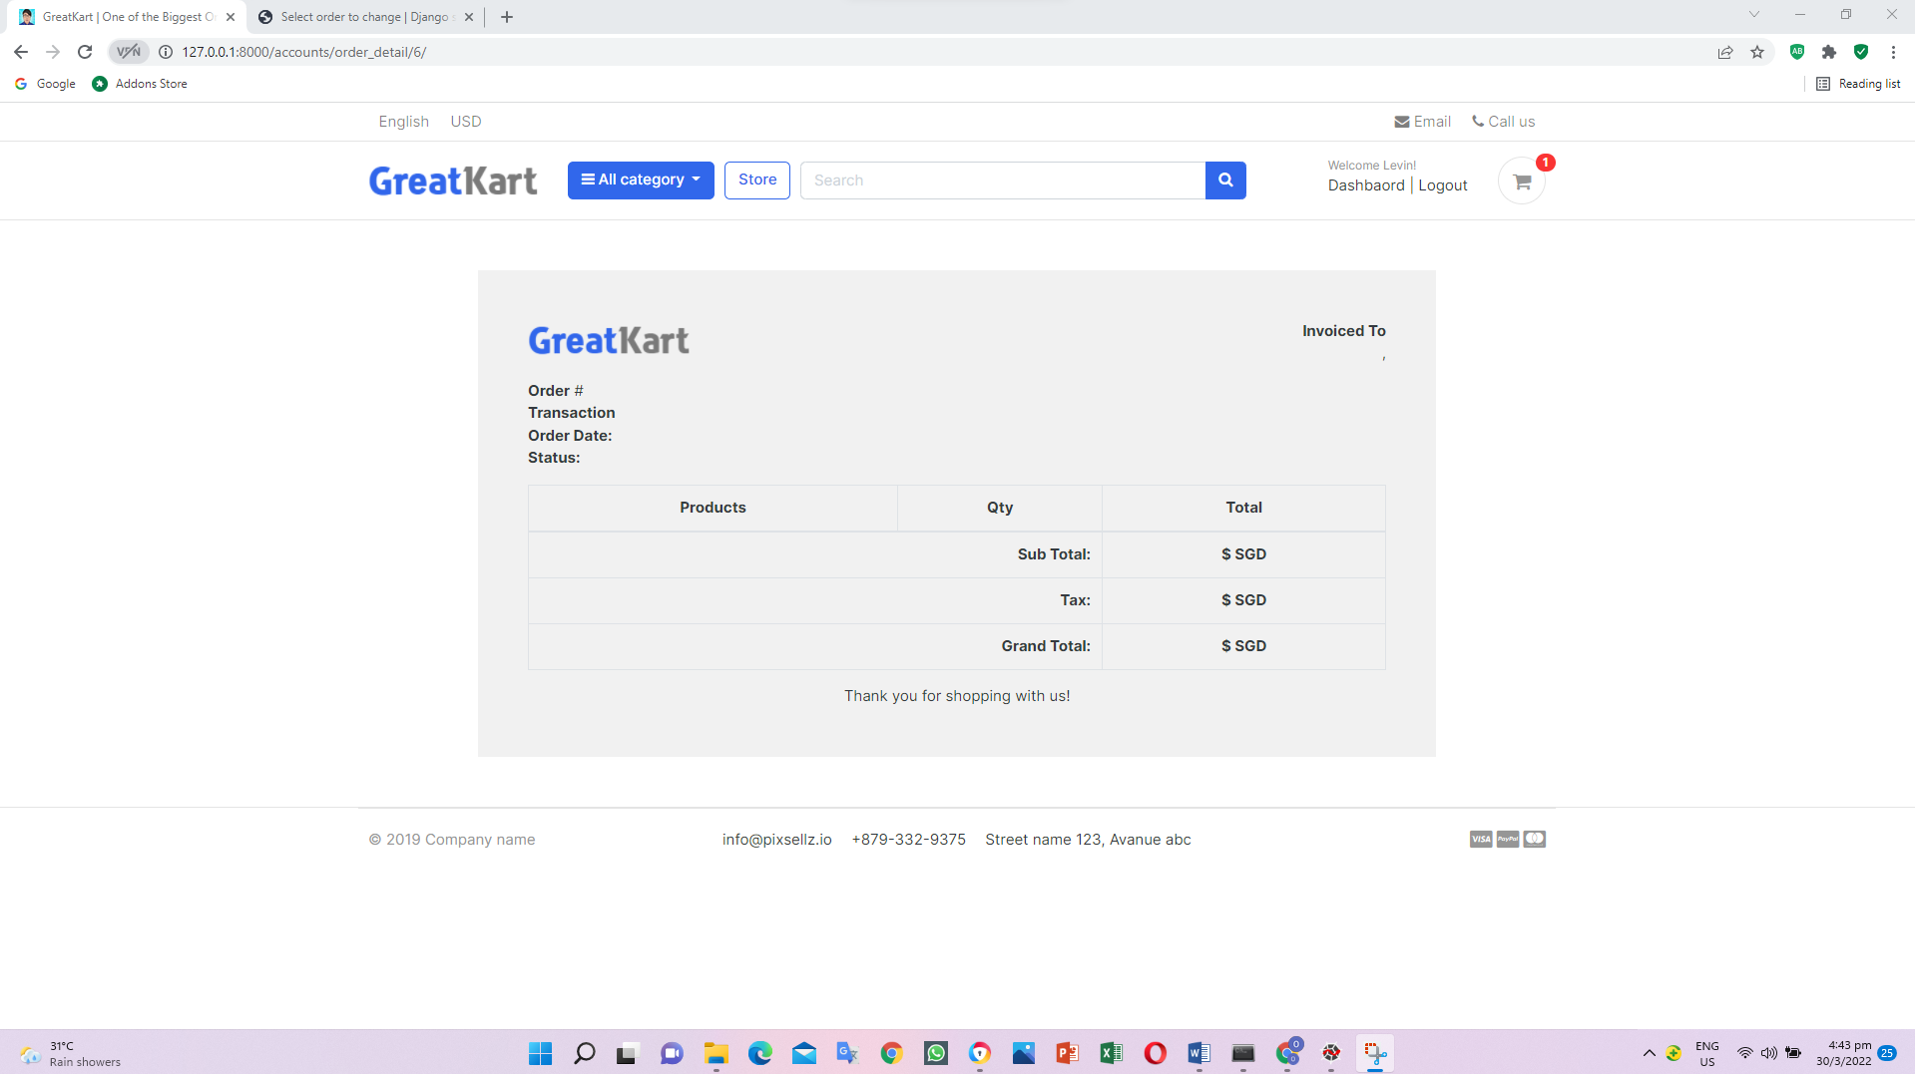

1. Edit codes in the views.py in the accounts folder

@login_required(login_url='login')

def order_detail(request, order_id):

order_detail = OrderProduct.objects.filter(order__order_number=order_id)

order = Order.objects.get(order_number=order_id)

subtotal = 0

for i in order_detail:

subtotal += i.product_price * i.quantity

context = {

'order_detail': order_detail,

'order': order,

'subtotal': subtotal,

}

return render(request, 'accounts/order_detail.html', context)

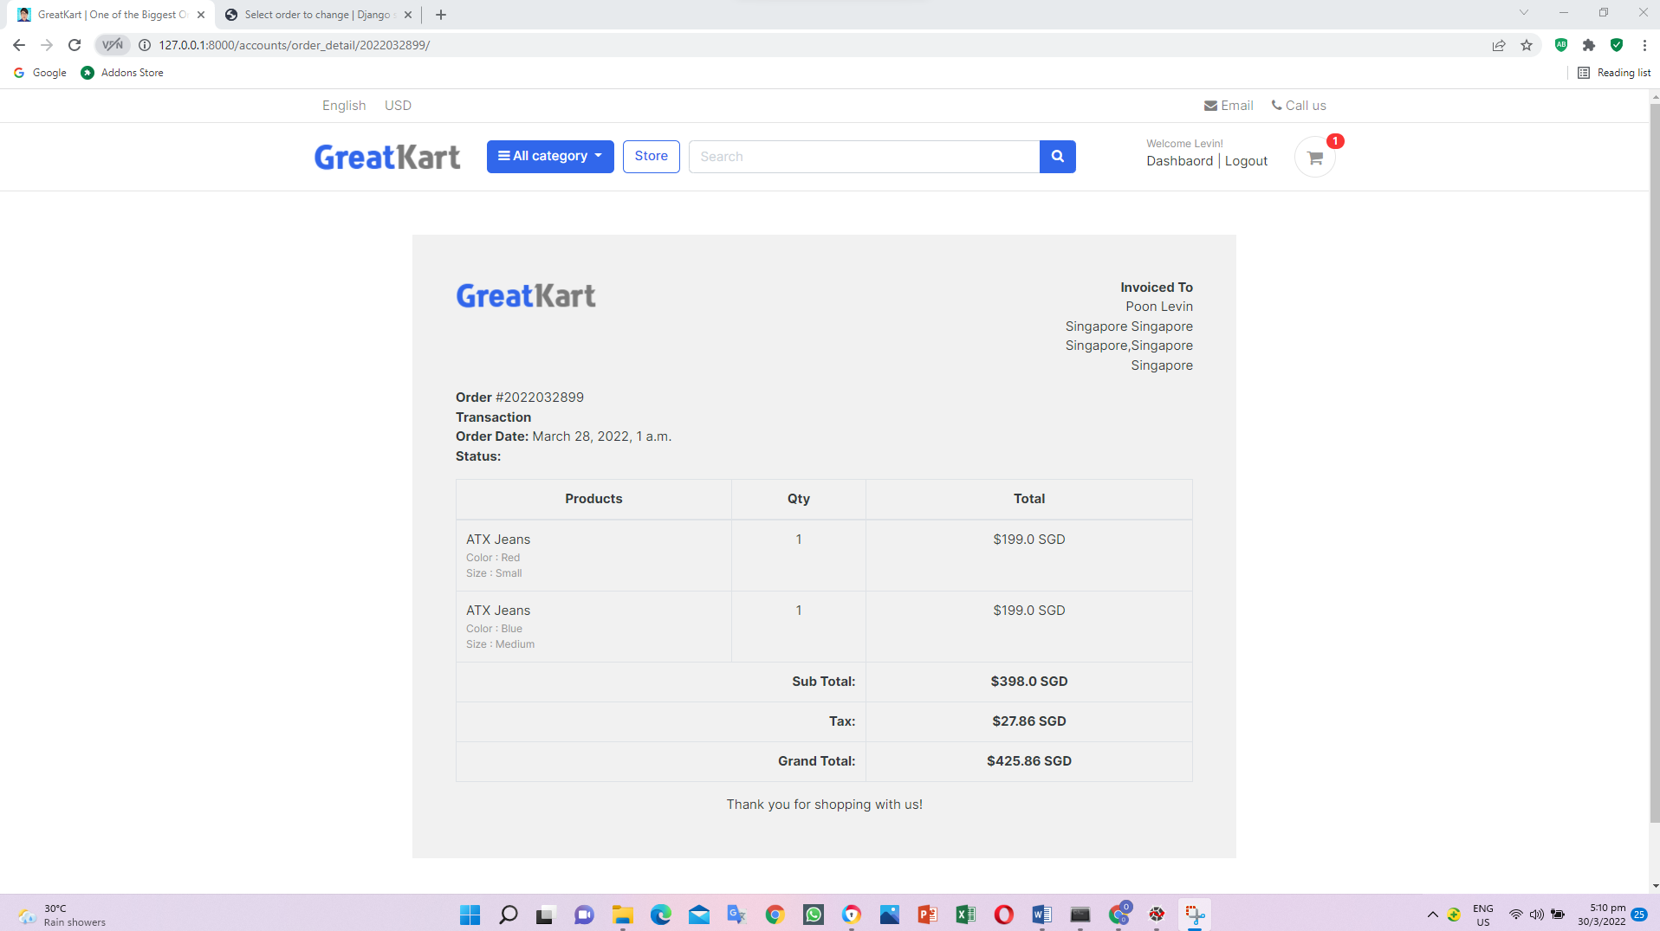

1. Replace my_orders.html in the accounts folder in the templates folder

<th scope="row"><a href="{% url 'order_detail' order.order_number %}">{{order.order_number}}</a></th>

1. Add lines in the order_detail.html in the accounts folder in the templates folder

{% extends 'base.html' %}

{% load static %}

{% block content %}

<div class="container" style="margin: 0 auto;width: 50%;padding: 50px;background: #f1f1f1;margin-top: 50px;margin-bottom: 50px;">

<div class="row invoice row-printable">

<div class="col-md-12">

<!-- col-lg-12 start here -->

<div class="panel panel-default plain" id="dash_0">

<!-- Start .panel -->

<div class="panel-body p30">

<div class="row">

<!-- Start .row -->

<div class="col-lg-6">

<!-- col-lg-6 start here -->

<div class="invoice-logo"><img src="{% static '/images/logo.png' %}" alt="Invoice logo" style="max-height: 40px;"></div>

</div>

<!-- col-lg-6 end here -->

<div class="col-lg-6">

<!-- col-lg-6 start here -->

<div class="invoice-from">

<ul class="list-unstyled text-right">

<li><strong>Invoiced To</strong></li>

<li>{{order.full_name}}</li>

<li>{{order.full_address}}</li>

<li>{{order.city}},{{order.state}}</li>

<li>{{order.country}}</li>

</ul>

</div>

</div>

<!-- col-lg-6 end here -->

<div class="col-lg-12">

<!-- col-lg-12 start here -->

<div class="invoice-details mt25">

<div class="well">

<ul class="list-unstyled mb0">

<li><strong>Order</strong> #{{order.order_number}}</li>

<li><strong>Transaction</strong> {{order.payment.payment_id}}</li>

<li><strong>Order Date:</strong> {{order.created_at}}</li>

<li><strong>Status:</strong> {{order.payment.status}}</li>

</ul>

</div>

</div>

<div class="invoice-items">

<div class="table-responsive" style="overflow: hidden; outline: none;" tabindex="0">

<table class="table table-bordered">

<thead>

<tr>

<th class="per70 text-center">Products</th>

<th class="per5 text-center">Qty</th>

<th class="per25 text-center">Total</th>

</tr>

</thead>

<tbody>

{% for item in order_detail %}

<tr>

<td>{{item.product.product_name}}

<p class="text-muted small">

{% if item.variations.all %}

{% for i in item.variations.all %}

{{ i.variation_category | capfirst }} : {{ i.variation_value | capfirst }} <br>

{% endfor %}

{% endif %}

</p>

</td>

<td class="text-center">{{item.quantity}}</td>

<td class="text-center">${{item.product_price}} SGD</td>

</tr>

{% endfor %}

</tbody>

<tfoot>

<tr>

<th colspan="2" class="text-right">Sub Total:</th>

<th class="text-center">${{subtotal}} SGD</th>

</tr>

<tr>

<th colspan="2" class="text-right">Tax:</th>

<th class="text-center">${{order.tax}} SGD</th>

</tr>

<tr>

<th colspan="2" class="text-right">Grand Total:</th>

<th class="text-center">${{order.order_total}} SGD</th>

</tr>

</tfoot>

</table>

</div>

</div>

<div class="invoice-footer mt25">

<p class="text-center">Thank you for shopping with us!</p>

</div>

</div>

<!-- col-lg-12 end here -->

</div>

<!-- End .row -->

</div>

</div>

<!-- End .panel -->

</div>

<!-- col-lg-12 end here -->

</div>

</div>

{% endblock %}

1. Replace codes in the dashboard.html in the accounts folder in the templates folder

<a href="{% url 'my_orders' %}">View Orders</a>

<img src="{{userprofile.profile_picture.url}}" alt="User Profile Picture" width="50" height="50" style="border-radius:50%;">

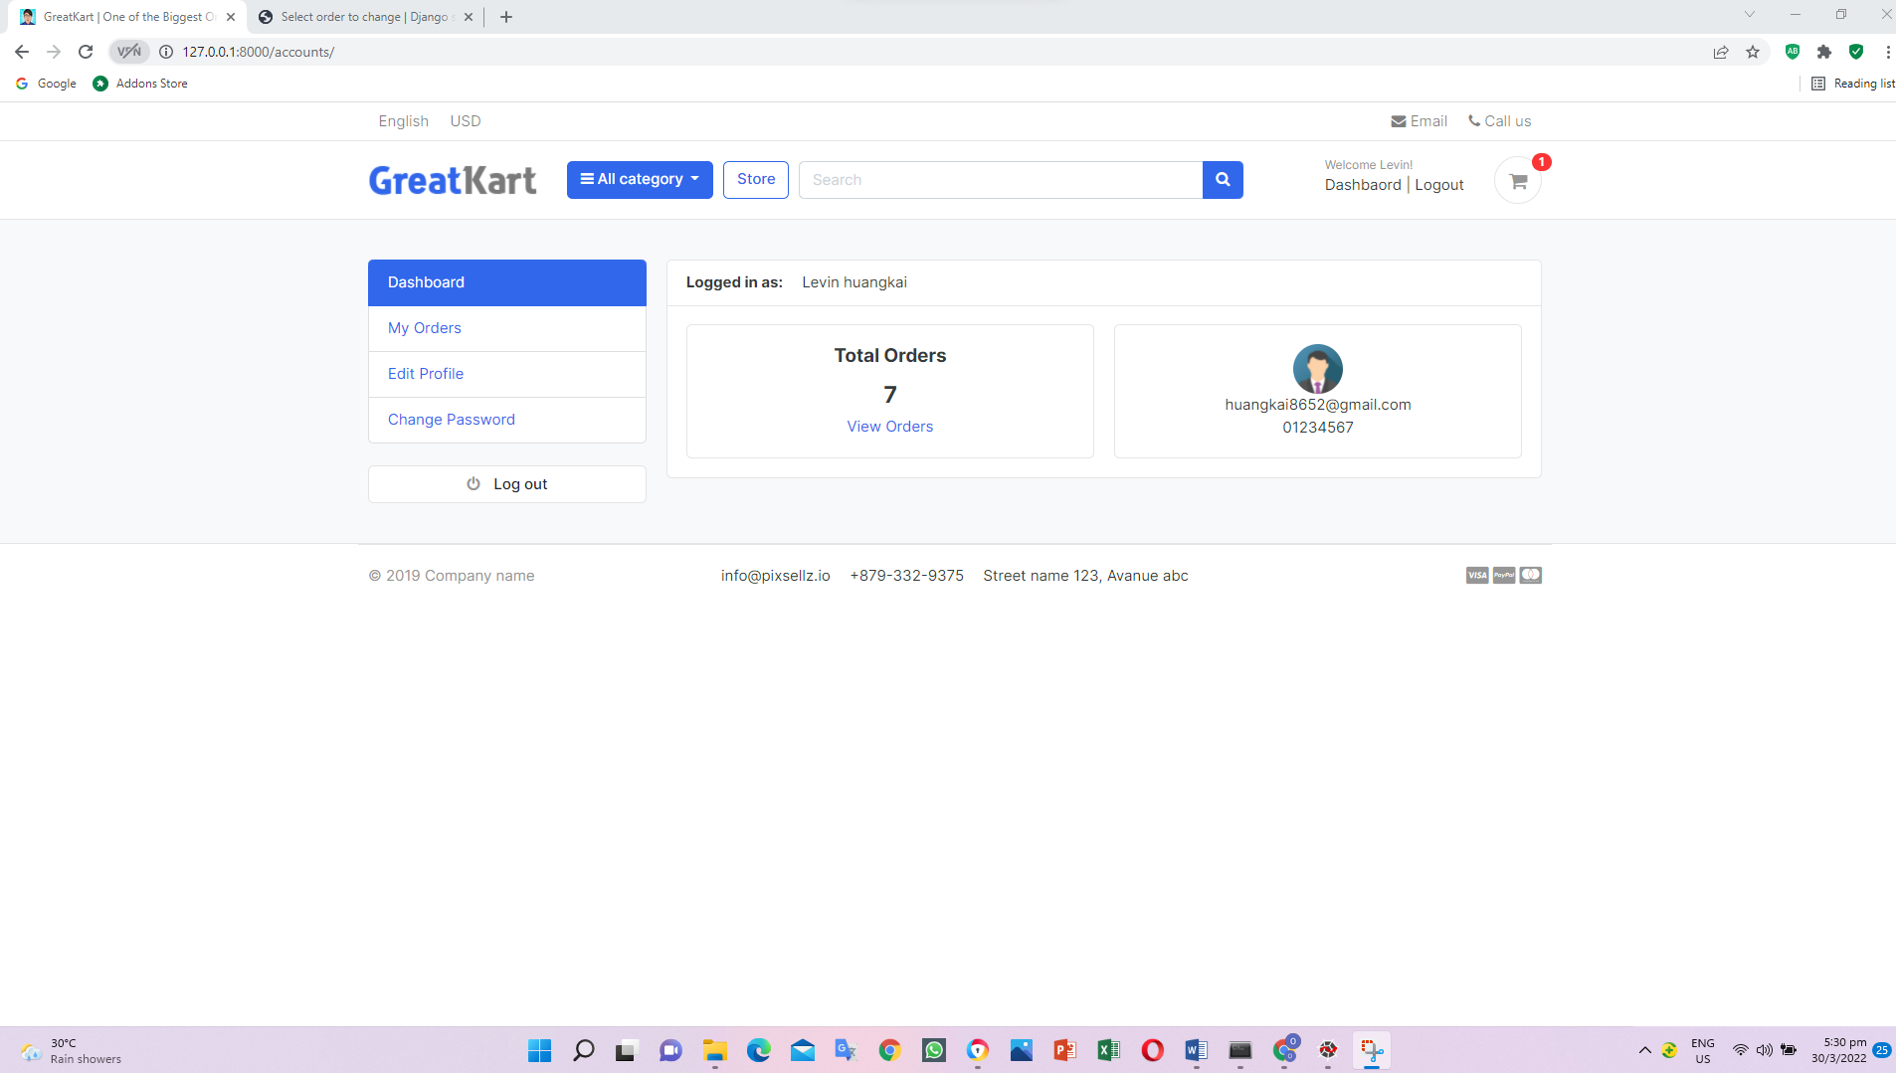

User able to click view order from dashboard

1. Add views.py in the accounts folder

@login_required(login_url = 'login')

def dashboard(request):

orders = Order.objects.order_by('-created_at').filter(user_id=request.user.id, is_ordered=True)

orders_count = orders.count()

userprofile = UserProfile.objects.get(user_id=request.user.id)

context = {

'orders_count': orders_count,

'userprofile' : userprofile,

}

return render(request, 'accounts/dashboard.html', context)

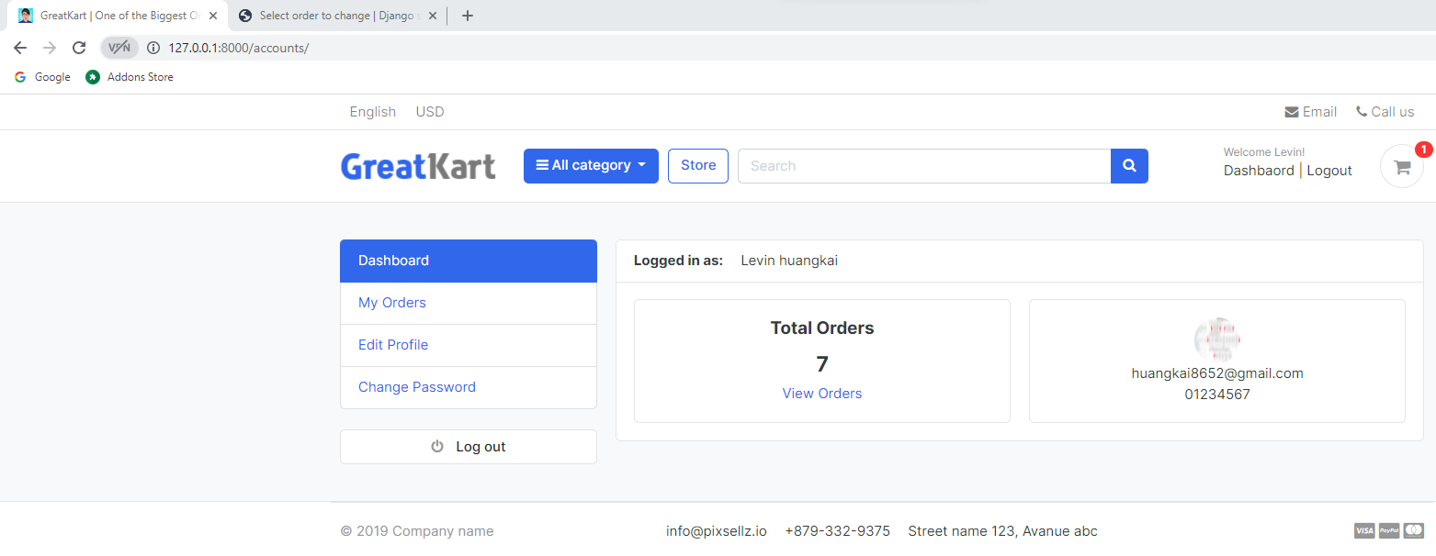

1. Add codes in the last row in the models.py in the store folder

class ProductGallery(models.Model):

product = models.ForeignKey(Product, default=None, on_delete=models.CASCADE)

image = models.ImageField(upload_to='store/products', max_length=255)

def __str__(self):

return self.product.product_name

class Meta:

verbose_name = 'productgallery'

verbose_name_plural = 'product gallery'

1. Make migrations

python manage.py makemigrations

python manage.py migrate

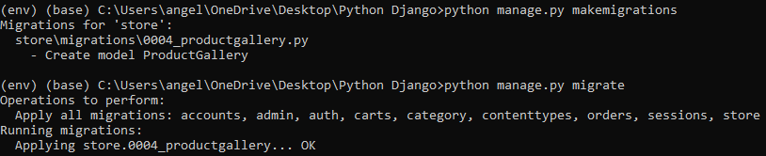

1. Add codes in the admin.py in the store folder

from .models import Product, Variation, ReviewRating, ProductGallery

&

admin.site.register(ProductGallery)

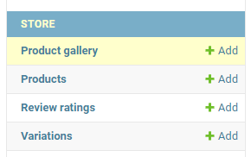

1. Add codes in the admin.py in the store folder

# Register your models here.

class ProductGalleryInline(admin.TabularInline):

model = ProductGallery

extra = 1

class ProductAdmin(admin.ModelAdmin):

list_display = ('product_name','price','stock','category','modified_date','is_available')

prepopluated_fields = {'slug': ('product_name',)}

inlines = [ProductGalleryInline]

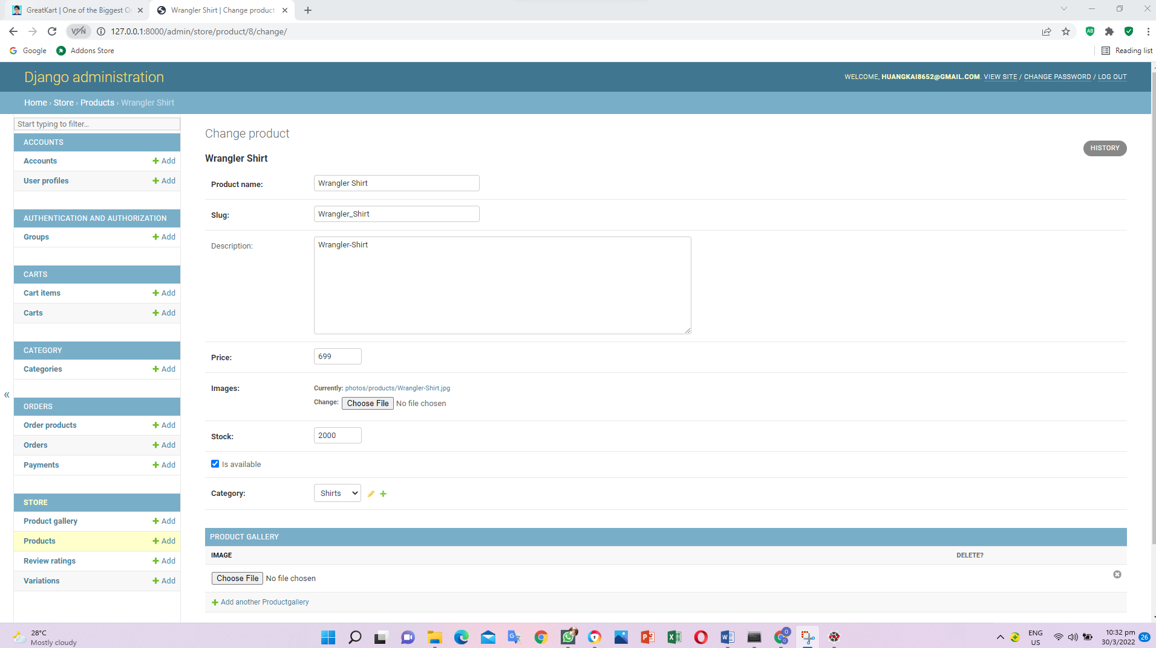

1. Install python package

Pip install Django-admin-thumbnails

1. Add codes in the admin.py in the store folder

# Register your models here.

import admin_thumbnails

@admin_thumbnails.thumbnail('image')

class ProductGalleryInline(admin.TabularInline):

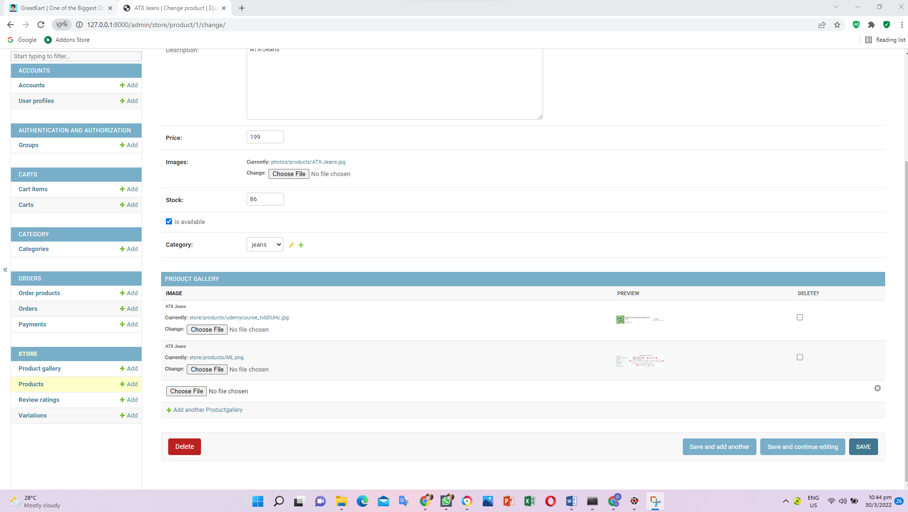

1. Add codes in the product_details.html in the store folder in the templates folder

</div> <!-- img-big-wrap.// -->

</article> <!-- gallery-wrap .end// -->

<ul class="thumb">

<li>

{% for i in product_gallery %}

<a href="{{i.image.url}}" target="mainImage"><img src="{{i.image.url}}" alt="Product Image"></a>

{% endfor %}

</li>

</ul>

</aside>

<main class="col-md-6 border-left">

1. Add codes in the views.py in the store folder

from .models import Product, ReviewRating, ProductGallery

&

#get the review

reviews = ReviewRating.objects.filter(product_id=single_product.id, status=True)

#get the product gallery

product_gallery = ProductGallery.objects.filter(product_id=single_product.id)

context = {

'single_product': single_product,

'in_cart': in_cart,

'orderproduct': orderproduct,

'reviews': reviews,

'product_gallery': product_gallery,

}

return render(request, 'store/product_detail.html', context)

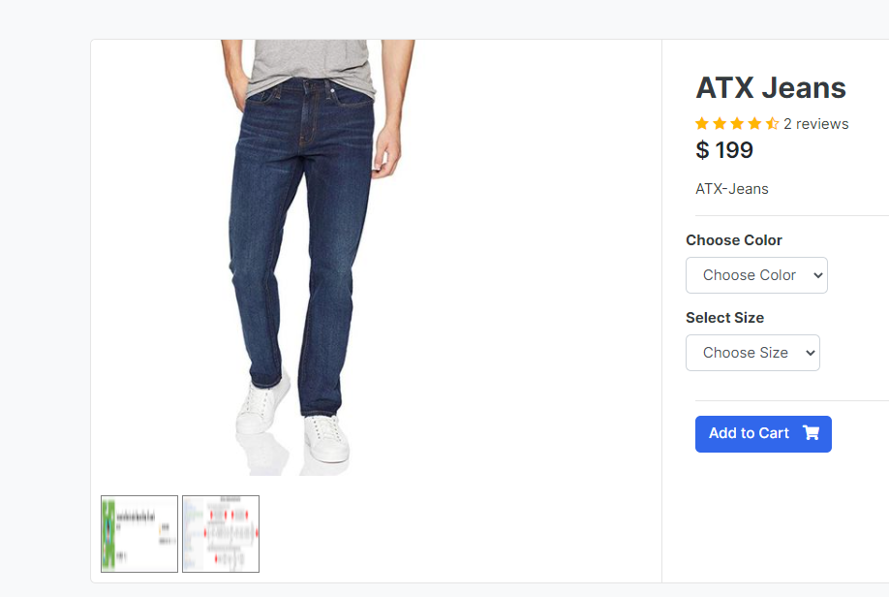

1. Python collectstatic thru CMD

python manage.py collectstatic

1. Add lines of codes in the foorer.html in the includes folder in the templates folder (write javascript to display photos in the big box)

</footer>

<!-- ========================= FOOTER END // ========================= -->

<script src="https://ajax.googleapis.com/ajax/libs/jquery/3.5.1/jquery.min.js"></script>

<script>

$(document).ready(function(){

$('.thumb a').click(function(e){

e.preventDefault();

$('.mainImage img').attr('src', $(this).attr("href"));

})

})

</script>

</body>

</html>

1. Add codes in the product_details.html in the store folder in the templates folder

<div class="img-big-wrap mainImage">

<center>

<img src="{{ single_product.images.url }}">

</center>

</div> <!-- img-big-wrap.// -->

</article> <!-- gallery-wrap .end// -->

<ul class="thumb">

<li>

<a href="{{single_product.images.url}}" target="mainImage"><img src="{{single_product.images.url}}" alt="Product Image"></a>

{% for i in product_gallery %}

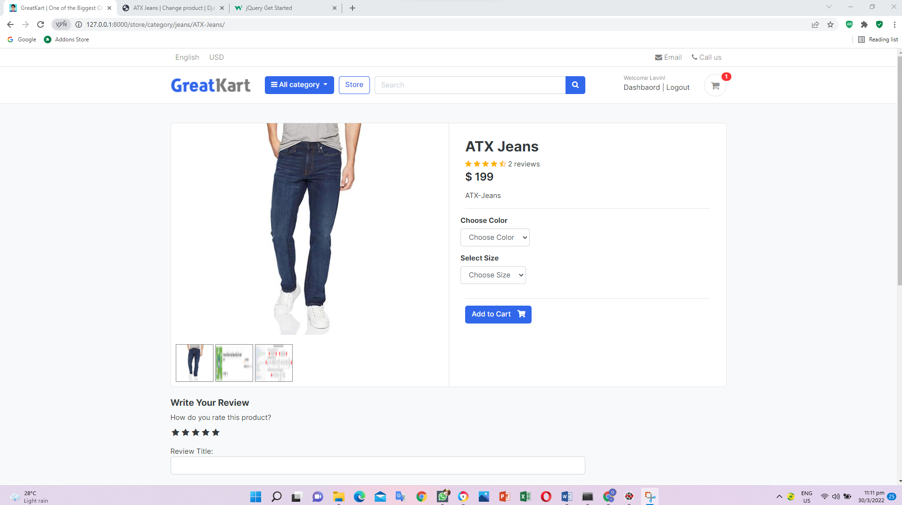

1. Add lines of codes in the views.py in the online folder

#from django.http import HttpResponse

from django.shortcuts import render

from store.models import Product, ReviewRating

def home(request):

#return HttpResponse('homepage')

products = Product.objects.all().filter(is_available=True).order_by('created_date')

#get the review

for product in products:

reviews = ReviewRating.objects.filter(product_id=product.id, status=True)

context = {

'products': products,

'reviews': reviews,

}

return render(request, 'home.html', context)

1. Add codes in the home.html in the templates folder

<div class="price mt-1">$ {{ product.price }}</div> <!-- price-wrap.// -->

<div class="rating-star">

<span>

<i class="fa fa-star{% if product.averageReview < 0.5 %}-o{% elif product.averageReview >= 0.5 and product.averageReview < 1 %}-half-o {% endif %}" aria-hidden="true"></i>

<i class="fa fa-star{% if product.averageReview < 1.5 %}-o{% elif product.averageReview >= 1.5 and product.averageReview < 2 %}-half-o {% endif %}" aria-hidden="true"></i>

<i class="fa fa-star{% if product.averageReview < 2.5 %}-o{% elif product.averageReview >= 2.5 and product.averageReview < 3 %}-half-o {% endif %}" aria-hidden="true"></i>

<i class="fa fa-star{% if product.averageReview < 3.5 %}-o{% elif product.averageReview >= 3.5 and product.averageReview < 4 %}-half-o {% endif %}" aria-hidden="true"></i>

<i class="fa fa-star{% if product.averageReview < 4.5 %}-o{% elif product.averageReview >= 4.5 and product.averageReview < 5 %}-half-o {% endif %}" aria-hidden="true"></i>

</span>

</div>

</figcaption>

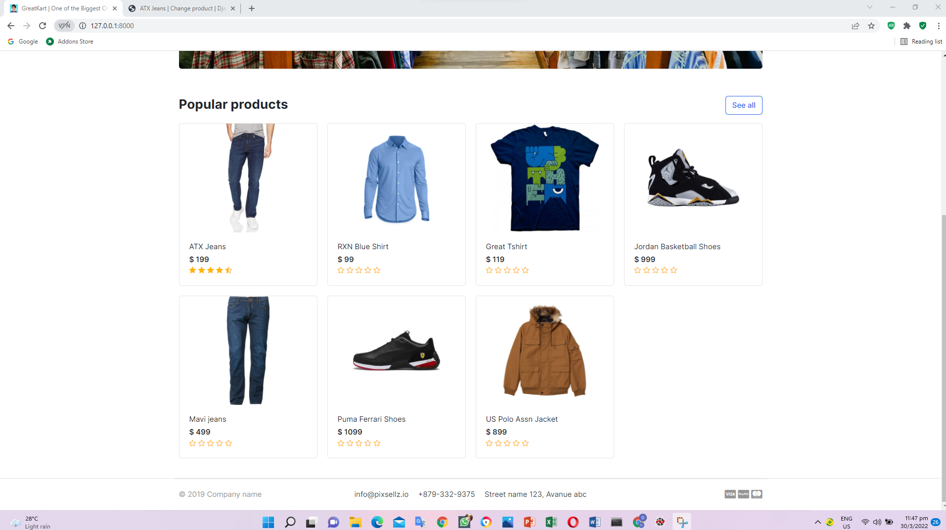

1. Python stall decouple thru CMD (Store Your Website’s Sensitive Information Securely)

Pip install python-decouple

1. Add codes in the settings.py in the online folder

from pathlib import Path

from decouple import config

&

# SECURITY WARNING: keep the secret key used in production secret!

SECRET_KEY = config('SECRET_KEY')

&

DEBUG = config('DEBUG', default=True, cast=bool)

&

#SMTP configuration GMAIL

EMAIL_HOST = config('EMAIL_HOST')

EMAIL_PORT = config('EMAIL_PORT', cast=int)

EMAIL_HOST_USER = config('EMAIL_HOST_USER')

EMAIL_HOST_PASSWORD = config('EMAIL_HOST_PASSWORD')

EMAIL_USE_TLS = config('EMAIL_USE_TLS', cast=bool)

1. Create and add codes in the .env in the root folder

SECRET_KEY=django-insecure-b41*8*kqw-jff+)htfj!c!%zpvu96cj@r@uvl2eo3qs4aa$%-q

DEBUG=True

EMAIL_HOST=smtp.gmail.com

EMAIL_PORT=587

EMAIL_HOST_USER=onlinedjango1314@gmail.com

EMAIL_HOST_PASSWORD=!q2w3e4R

EMAIL_USE_TLS=True

1. Add lines in the .gitignore in the root folder

# Environments

.env

.venv

1. Create and add codes in the .env-sample in the root folder

SECRET_KEY=

DEBUG=

EMAIL_HOST=

EMAIL_PORT=

EMAIL_HOST_USER=

EMAIL_HOST_PASSWORD=

EMAIL_USE_TLS=

1. Replace codes in the urls.py in the online folder (change admin address)

Old

path('admin/', admin.site.urls),

New

path('seeseelooklook/', admin.site.urls),

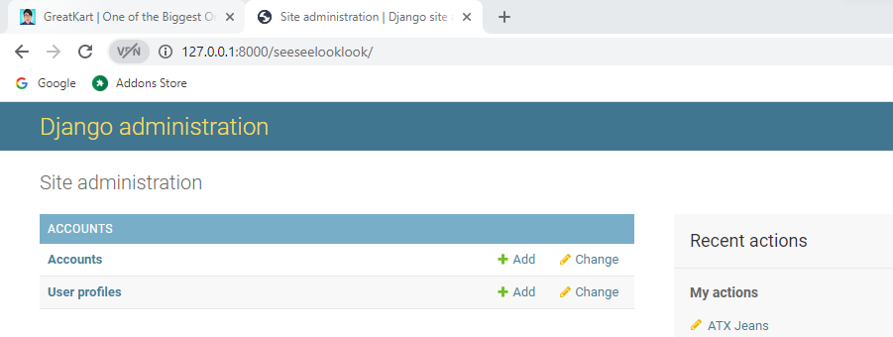

1. Install honeypot in the python thru CMD (Create a fake login page and track the IP address)

pip install Django-admin-honeypot

1. Add codes in the settings.py in the online folder

'orders',

'admin_honeypot',

]

1. Add codes in the urls.py in the online folder

urlpatterns = [

path('admin/', include('admin_honeypot.urls', namespace='admin_honeypot')),

path('seeseelooklook/', admin.site.urls),

1. Migrations thru CMD
2. python manage.py makemigrations
3. downgrade python Django from version 4 to version 3

pip install django==3.2.12

1. python manage.py migrate

python manage.py makemigrations

python manage.py migrate

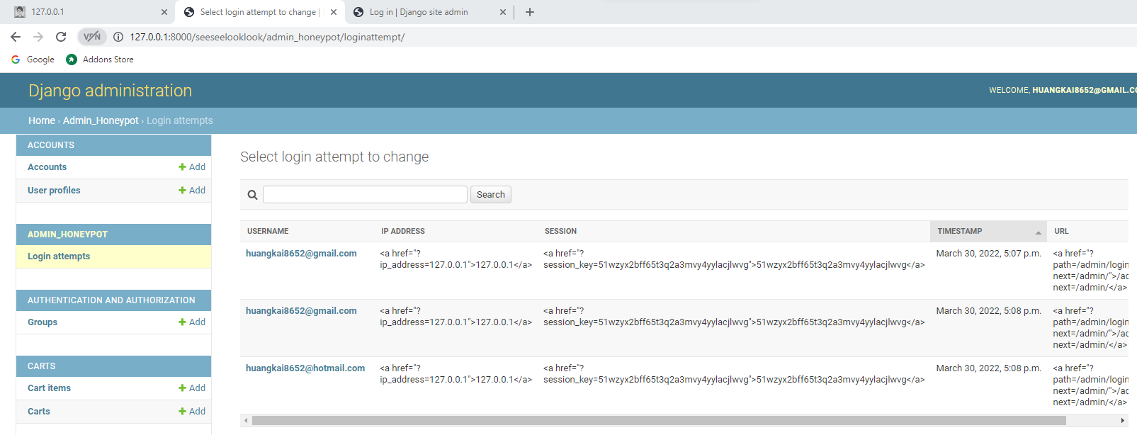

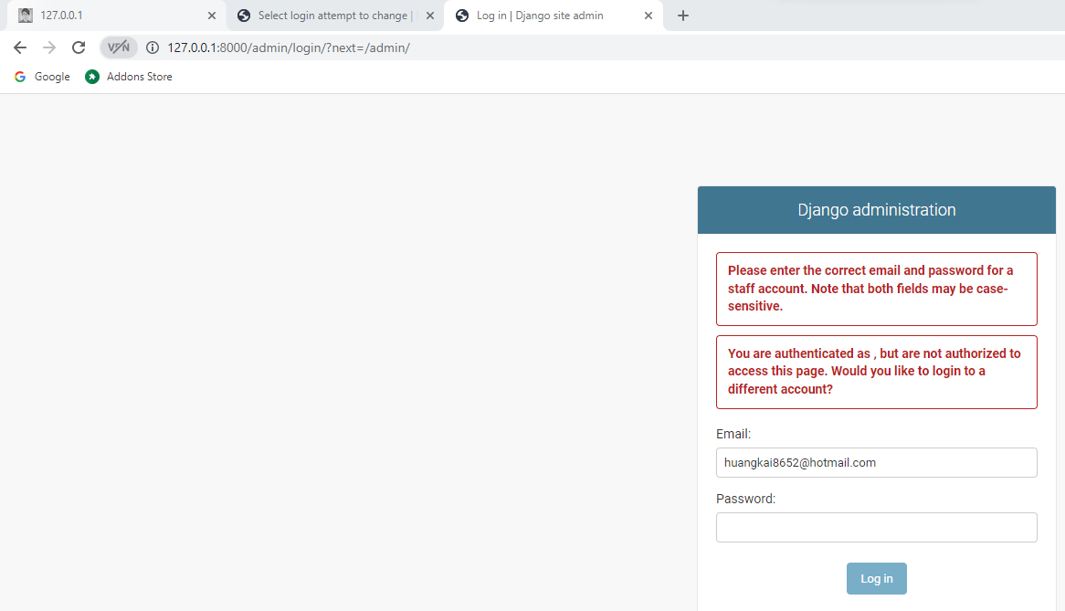

1. Python install session time out (Automatically logout after Inactivity)

pip install django-session-timeout

1. Add lines codes in the settings.py in the online

'django.contrib.sessions.middleware.SessionMiddleware',

'django_session_timeout.middleware.SessionTimeoutMiddleware',

'django.middleware.common.CommonMiddleware',

&

]

SESSION_EXPIRE_SECONDS = 300 # 5 mins

SESSION_EXPIRE_AFTER_LAST_ACTIVITY = True

SESSION_TIMEOUT_REDIRECT = 'accounts/login'

ROOT_URLCONF = 'Online.urls'

1. Use db.sqlite3 for developer server and PostgreSQL for production server
2. Log in aws.amazon.com

Click Create an AWS Account

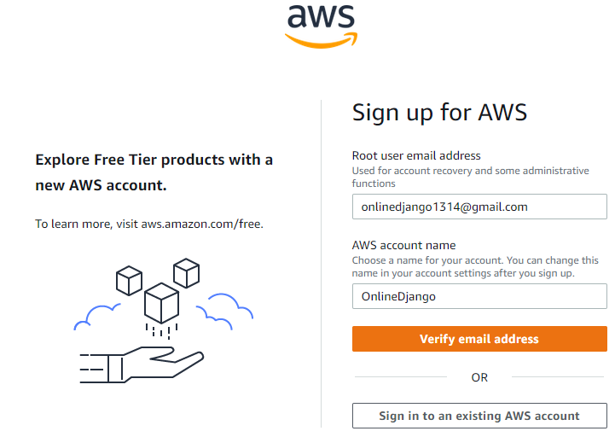

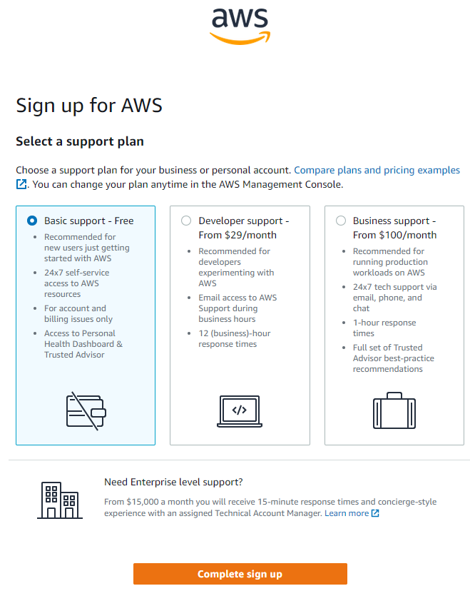



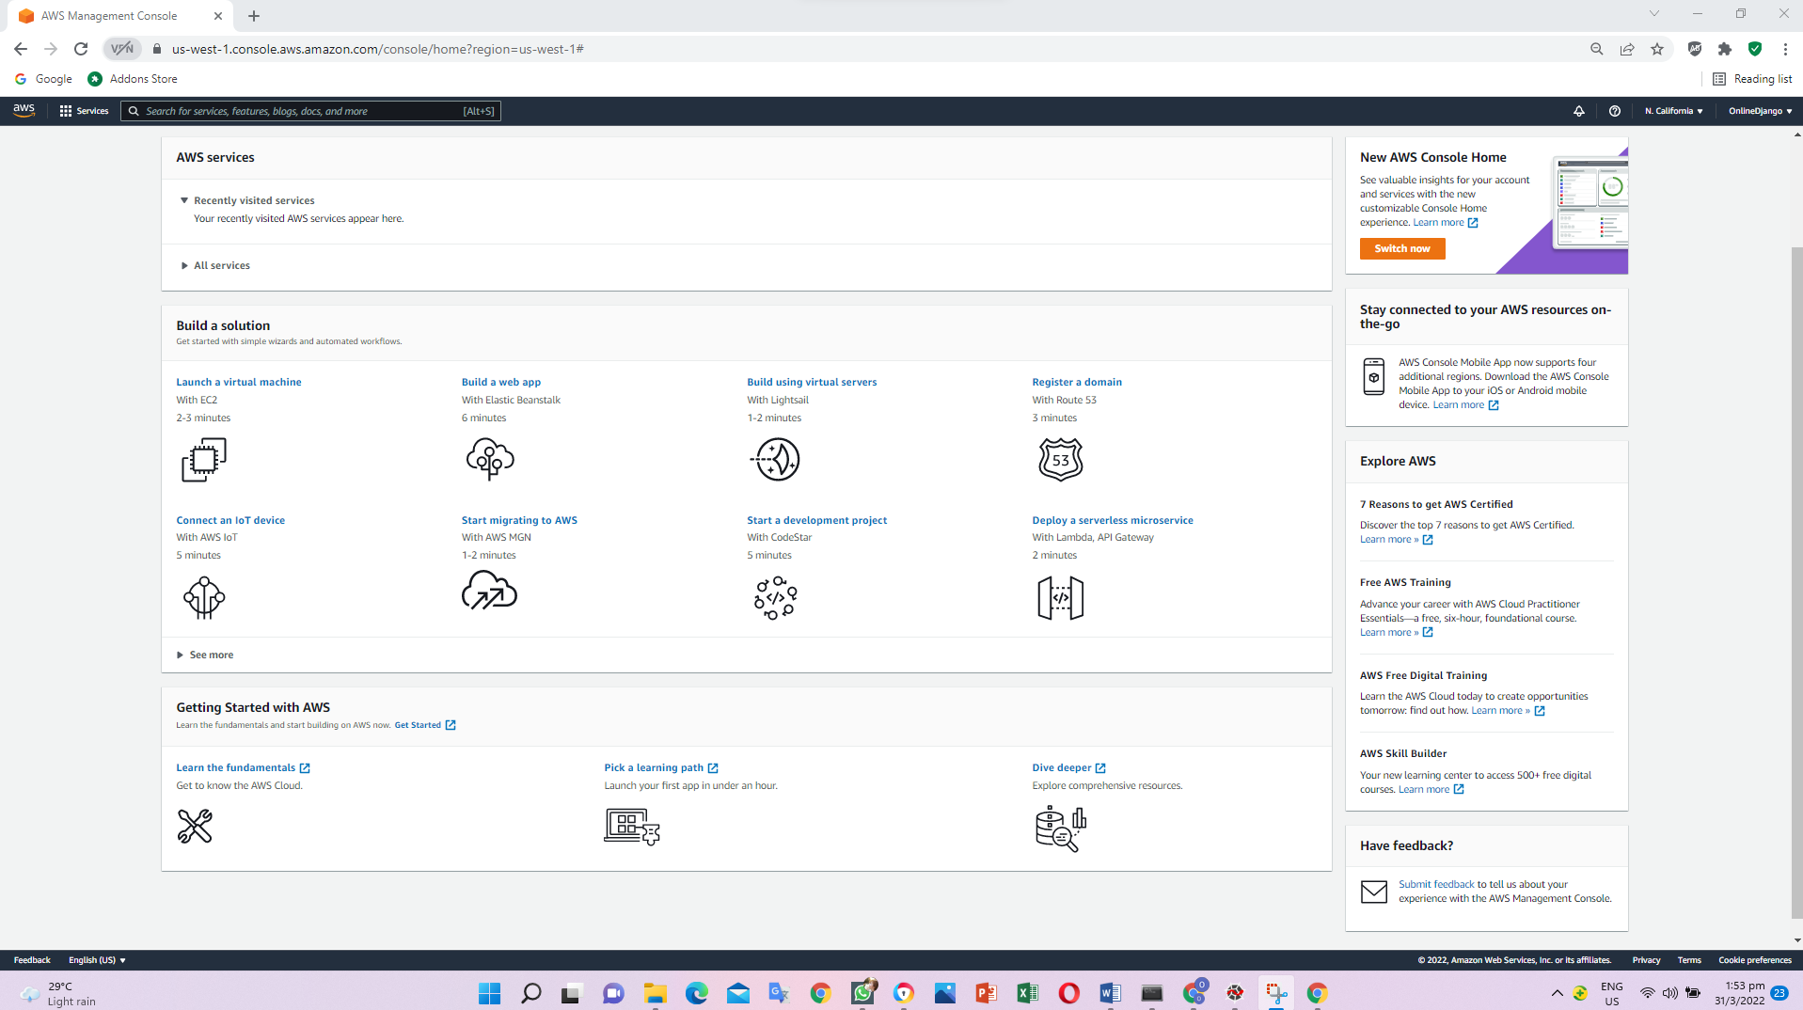

1. Check python version

python --version

1. Check pip version

pip --version

1. Deactivate from env to base mode

deactivate

1. Python install awsebcli

pip install awsebcli

eb –version

cd C:\Users\angel\OneDrive\Desktop\Python Django\env\Scripts

activate



cd ..

cd ..

pip freeze > requirments.txt

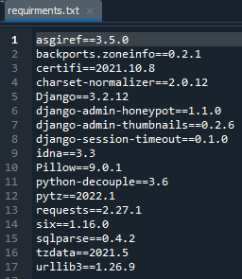

1. Create .ebextensions file in the online folder



1. Create Django.config in the .ebextensions folder in the root folder

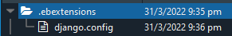

option_settings:

aws:elasticbeanstalk:container:python:

WSGIPath: greatkart/wsgi.py

1. Copy words in the wsgi.py file in the root folder

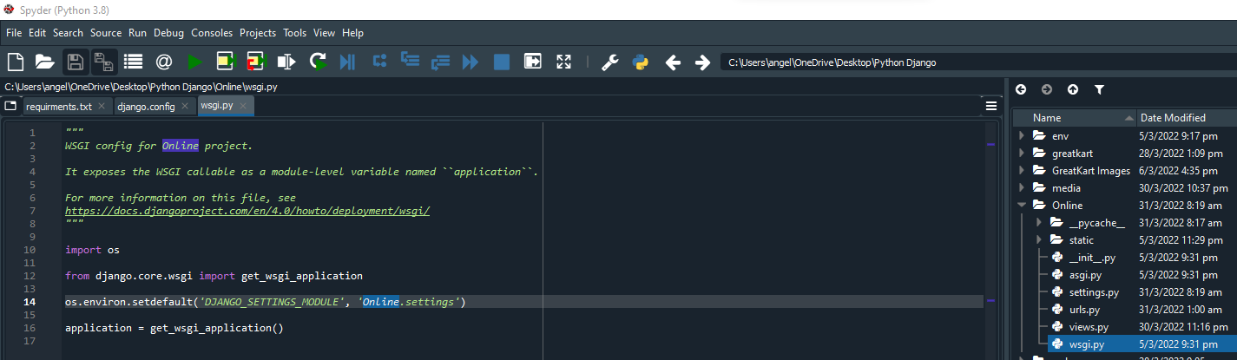

1. Replace the codes in the Django.config file in the .ebextensions folder in the online folder

WSGIPath: Online/wsgi.py

1. Deactivate the env thru CMD and return to base

deactivate

1. Enter the words in the CMD

eb init -p python-3.6 online-course

1. Press Security Credentials

Click Access keys (access key ID and secret access key)

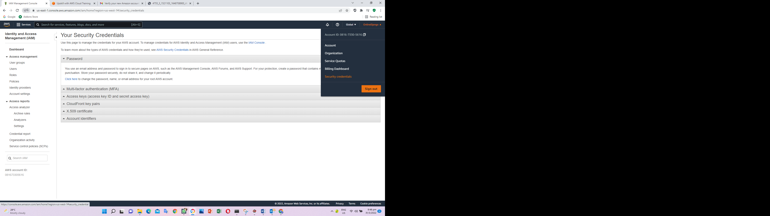

1. Copy access key ID and Secret Access Key to CMD

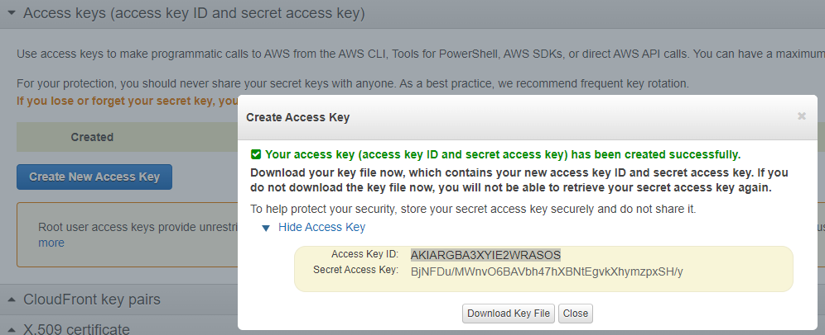

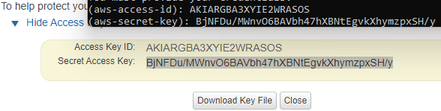

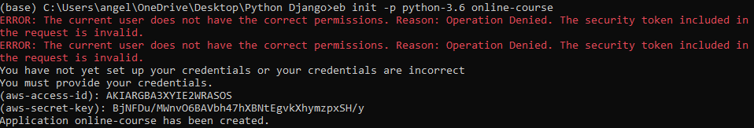

1. Enter codes in CMD

eb init

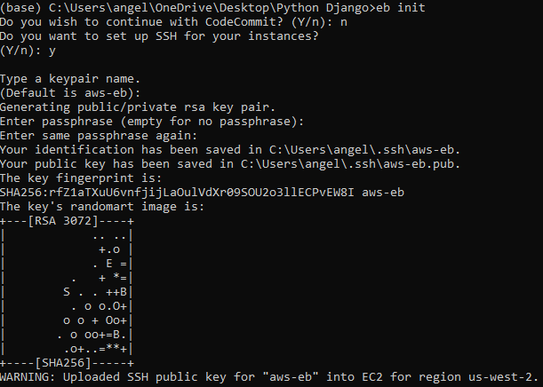

eb create online-course-env

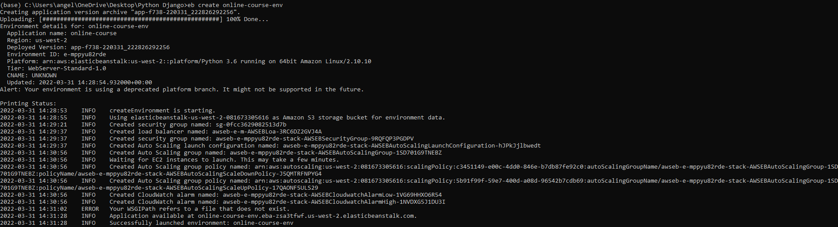

eb status

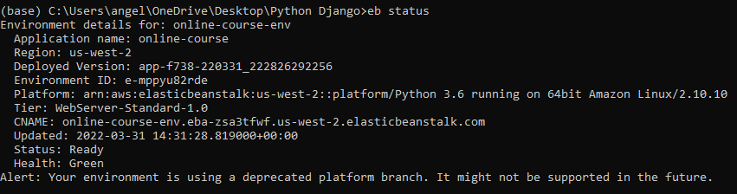

1. Add website host in the settings.py in the online folder

ALLOWED_HOSTS = ['online-course-env.eba-zsa3tfwf.us-west-2.elasticbeanstalk.com']

1. Update github

cd C:\Users\angel\OneDrive\Desktop\Python Django\env\Scripts

activate

git add –A

git commit –m “allowed host”

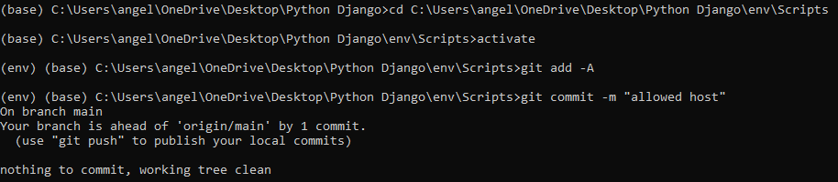

eb deploy

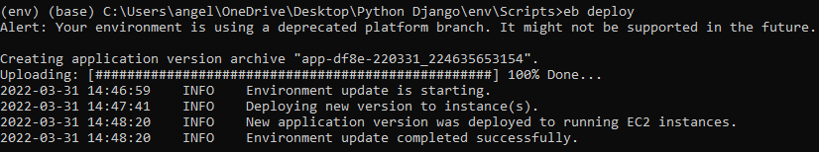

1. Click Elastic Beanstalk button

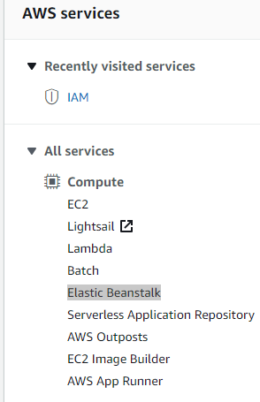

1. Select us-west-2 to display the environments

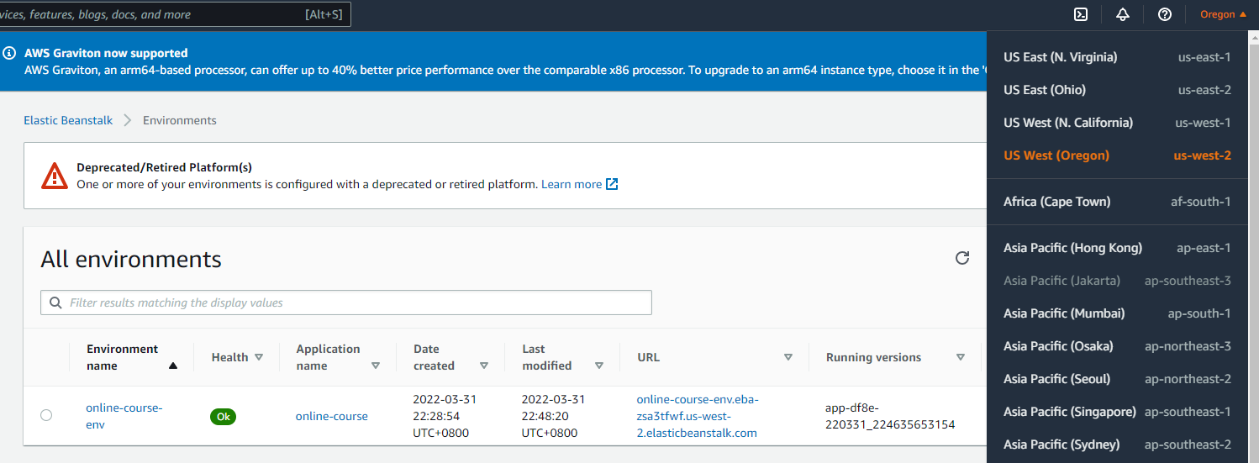

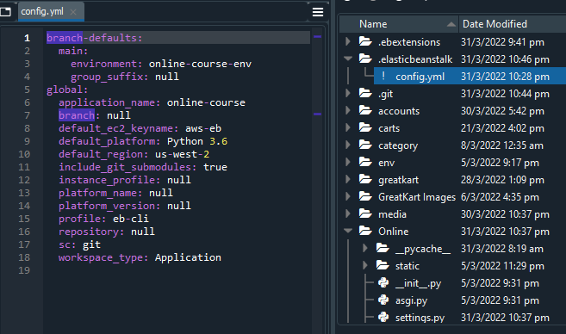

1. Click Configuration, click edit button from the software session

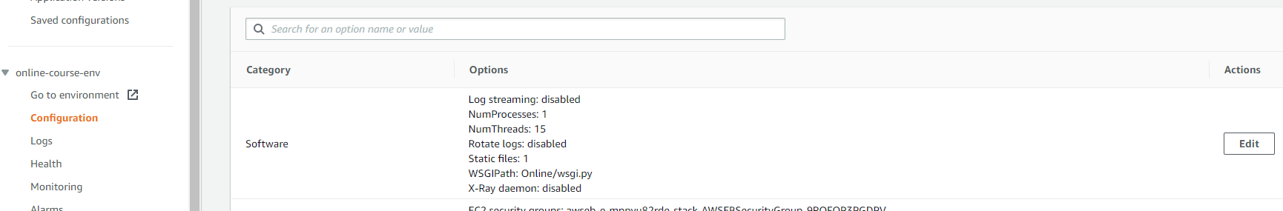

1. Enter information as follow

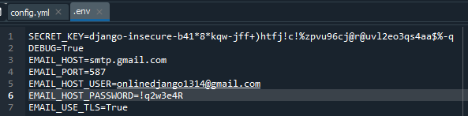

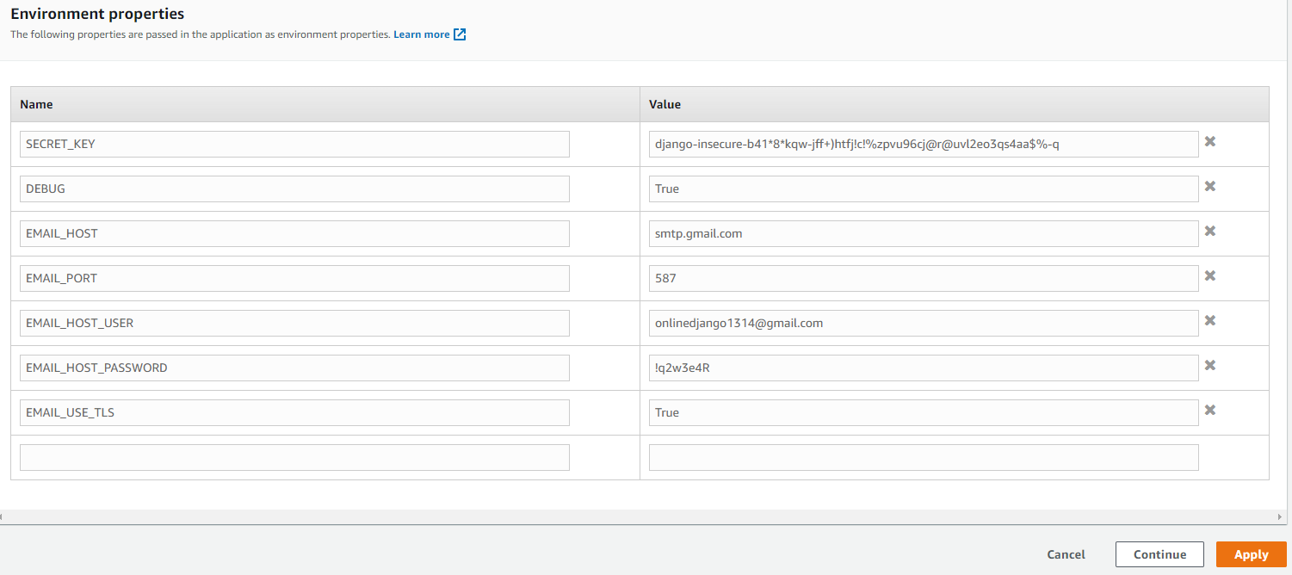

1. eb open

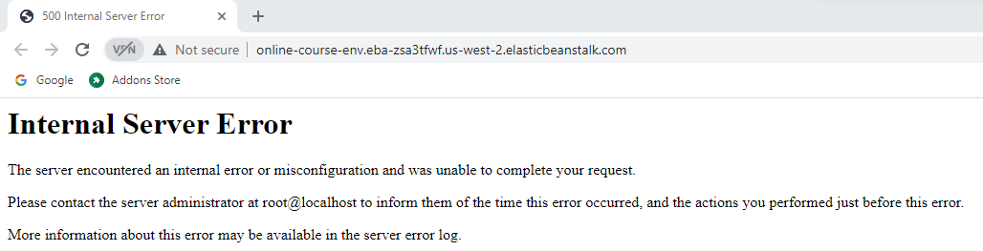

1. Click Configuration, click edit button from the database session

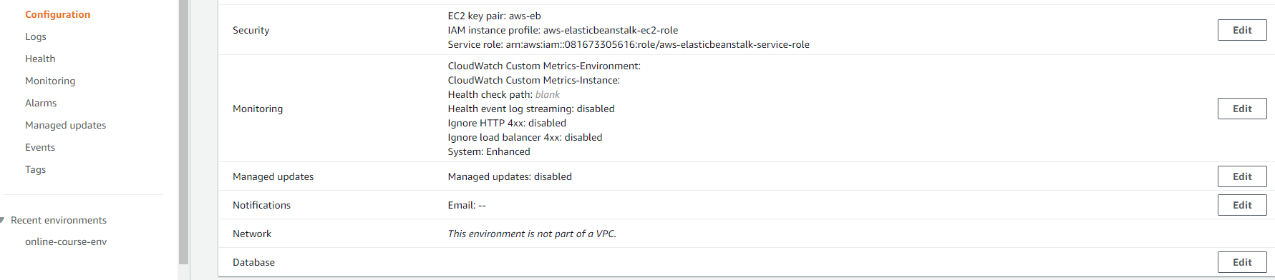

1. ID: OnlineDjango

Password: !q2w3e4R

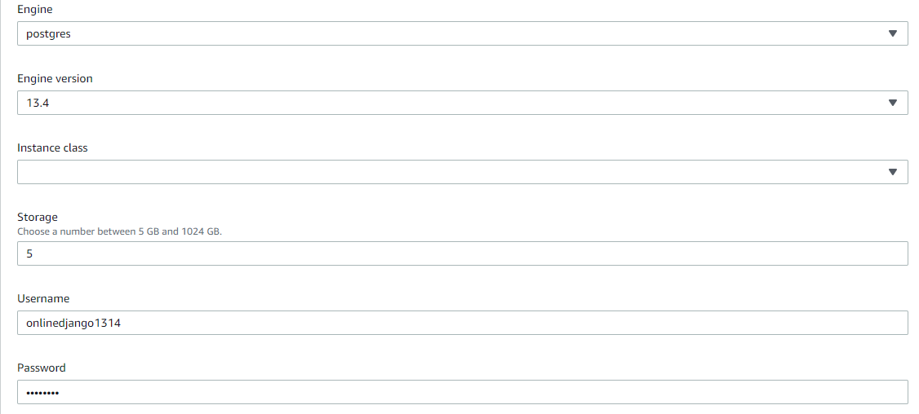

1. Replace codes from settings.py in the online folder (connect database to Postgres)

Old

DATABASES = {

'default': {

'ENGINE': 'django.db.backends.sqlite3',

'NAME': BASE_DIR / 'db.sqlite3',

}

}

New

import os

&

# Database Configuration

if 'RDS_DB_NAME' in os.environ:

DATABASES = {

'default': {

'ENGINE': 'django.db.backends.postgresql',

'NAME': os.environ['RDS_DB_NAME'],

'USER': os.environ['RDS_USERNAME'],

'PASSWORD': os.environ['RDS_PASSWORD'],

'HOST': os.environ['RDS_HOSTNAME'],

'PORT': os.environ['RDS_PORT'],

}

}

else:

DATABASES = {

'default': {

'ENGINE': 'django.db.backends.sqlite3',

'NAME': BASE_DIR / 'db.sqlite3',

}

}

1. Install python package thru CMD

pip install psycopg2-binary

pip freeze > requirments.txt

1. Create db-migrate.config in the .ebextensions folder

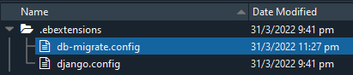

# Container Commands

container_commands:

01_migrate:

command: "django-admin.py migrate"

leader_only: true

02_createsuperuser:

command: "echo \"from accounts.models import Account; Account.objects.create_superuser('Poon', 'HuangKai', 'onlinedjango1314@gmail.com', 'Poon', '!q2w3e4R')\" | python manage.py shell"

leader_only: true

option_settings:

aws:elasticbeanstalk:application:environment:

DJANGO_SETTINGS_MODULE: greatkart.settings

1. Deploy to server

git add –A

git commit -m "postgres configuration"

eb deploy

1. 1
2. 1
3. 1
4. 1
5. 1
6. 1
7. 1
8. 1